

Doctoral Academy Updates

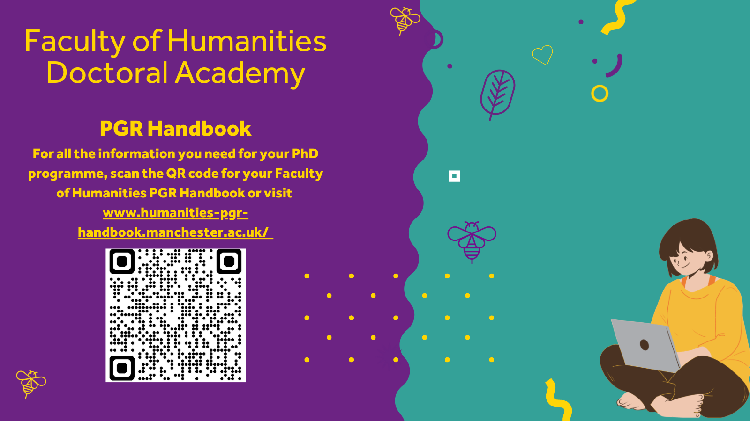

In this DA newsletter you will find the next instalment of 'Meet the Doctoral Academy Team', details on the annual conference from the School of Environment, Education and Development along with all the new workshops from the Library and Researcher Development Team.
There is also a reminder of the MDC Excellence Award nominations and we introduce your new School PGR Representatives!
As always, if you would like to feature anything in the newsletter, please let us know.
The Doctoral Academy Team
Follow us on Bluesky: https://bsky.app/profile/uom-humsdocacad.bsky.social
Join us on LinkedIn: The University of Manchester Faculty of Humanities Doctoral Academy | Groups | LinkedIn
DA Spotify Podcast

Meet the Doctoral Academy Team



This month’s “Meet the Doctoral Academy Team” feature comes from the NWCDTP team.
Hello! I’m Carole Arrowsmith, NWCDTP Manager and PGR Operations Officer in the Doctoral Academy (DA). Alongside my colleagues Leah Goldie (NWCDTP & DA Placement & Partnership Officer) and Francesca Roncoli (NWCDTP Administrator and DA PGR Coordinator), we work jointly across both the NWCDTP and the DA to support our doctoral researchers and partner institutions.
The North West Consortium Doctoral Training Partnership (NWCDTP) is an Arts and Humanities Research Council (AHRC)–funded Doctoral Training Partnership that currently supports around 230 postgraduate researchers across seven institutions in the North West. The University of Manchester is the lead institution in this partnership.
Alongside funding our students’ stipends and fees, we provide comprehensive support to help them access a wide range of DTP funding opportunities — including Research Training Support Grants (RTSG), fieldwork funds, training, placements, and Overseas Institutional Visits (OIV) — enabling them to carry out their research to the fullest possible extent.
We also design and deliver DTP-specific training, and lead cohort-development activities that help build a strong and connected research community across the consortium. We also work closely with colleagues at our 7 institutions, cultural partners, the AHRC and other UK-wide DTPs to maintain effective and collaborative relationships.
We are proud to champion an inclusive and supportive research culture. As part of our ongoing commitment to Equality, Diversity and Inclusion (EDI), we continually review and strengthen our practices to broaden access to opportunities and ensure tailored support for all researchers.

The NWCDTP has supported AHRC-funded researchers since 2014. The final cohort of students began their studies in October 2025, and the DTP will be gradually phased out over the next four years as the AHRC transitions to a new funding model.
For more information, please visit: www.nwcdtp.ac.uk
With best wishes,
Carole, Francesca and Leah
The Doctoral Partnership and Placements Team

SEED Conference 2026

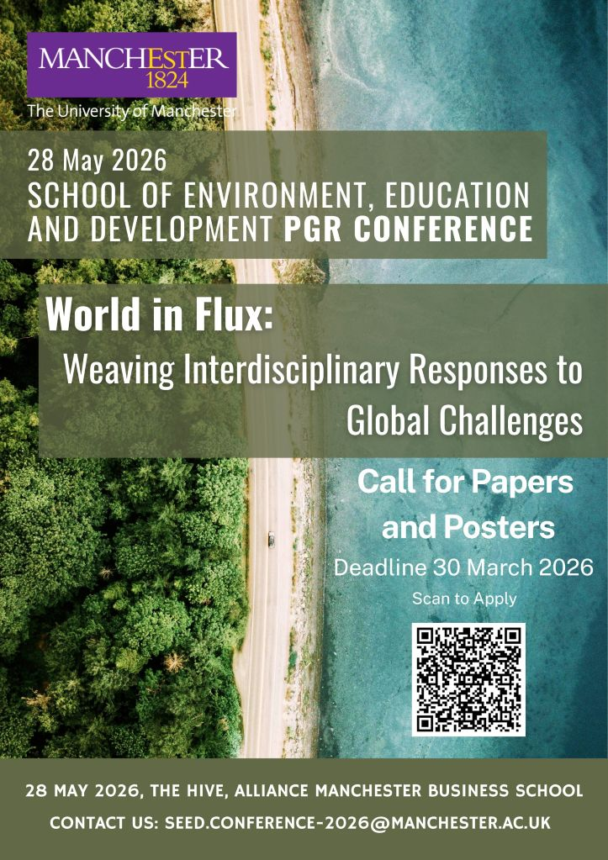

We are pleased to announce that submissions are now open for the SEED Postgraduate Researcher Conference 2026!
The SEED Conference Team welcome submissions from researchers at any stage in their postgraduate journey, from any discipline, especially those who have not presented at a conference before, and options for presentations or posters are available.
The World in Flux Conference will explore the reality of confronting global crises that continually evolve, revealing new and shifting dimensions with every attempt to address them. These challenges are not discrete problems to be solved in isolation, but interconnected expressions of geopolitical, economic, technological, and environmental forces in constant interaction.
The application deadline is Monday 30th March 2026 at 23:59
Apply here!
If you have any questions, please feel free to contact the team at:
seed.conference-2026@manchester.ac.uk

School PGR Student Representatives

We're pleased to announce we have appointed four new School PGR Representatives!
Chinaza Duke Nwosu (AMBS), Rashmi Kundu (SEED), Lily Fell (SALC) and Kumru Akdogan (SOSS) will work closely with the Doctoral Academy and the School PGR Directors to help build your PGR community, support and develop PGR training events and share examples of best practice across the board.
You can find details of their remit in your handbook along with their contact details.

Mental Health Support Team Workshop Programme

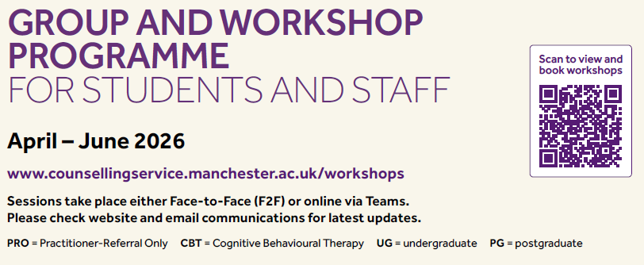

The Mental Health Support Team have released their programme of workshops for the Spring.
There are lots of sessions on offer including Managing Anxiety, Mindfulness and managing ongoing stress, as well as ACT workshops on low mood and specifically postgraduate issues.
Scan the QR code above to book, or visit their website.

Manchester Doctoral College Excellence Awards

The call for the 2026 Manchester Doctoral College (MDC) Excellence Awards is now open!

These annual Awards recognise and celebrate the achievements of our postgraduate researchers and postgraduate research supervisors. Awards will be given in the following categories:
- Best Outstanding Research Contribution
- Best Contribution to PGR Environment
- Best Contribution to Society - Local Community
- Best Contribution to Society - Research Impact
- Best Contribution to Internationalisation
- Supervisor of the Year

The call for nominations has been circulated, but you can also find all the details, including nominations forms, here.
If you have any questions about the awards and nomination process, please get in touch.

Researcher Development



The Researcher Development Team have a great programme of workshops for PGRs coming up this April.
Please click on the links below to book:
1 April 2026 Wednesday 11:00 - 11:30
Career Hacks 3: Ten top tips for your LinkedIn profile
1 April 2026 Wednesday 13:00 - 15:30
Practical Viva Preparation
21 April 2026 Tuesday 13:30 - 15:30
Effective Research Presentation
21 April 2026 Tuesday 13:30 - 16:00
Preparing for Annual Review for Humanities PGRs
23 April 2026 Thursday 10:00 -10:30
Using LinkedIn to build professional connections
23 April 2026 Thursday 11:00 - 12:30
Planning and Writing your Thesis

29 April 2026 Wednesday 11:00 -13:00
Introduction to Academic Writing for PGRs in HUMS
29 April 2026 Wednesday 13:00 - 15:30
Calm and Confident Presenting: Understanding and Managing your Presentation Anxieties

Reminder: Fees and Expenses

This is a reminder that Fees and Expenses claims (PR7 Forms) must be submitted within 3 months of the date of the expenditure, or in the case of travel and conference fees, within 3 months of the travel or conference taking place. Claims submitted after this period will not be processed unless there are exceptional circumstances, in line with the University’s financial regulations.
To avoid delays or rejection of your claim:
- Please check the date of your expenditure before submitting.
- Ensure your PR7 Form is completed and submitted promptly.
- If you believe exceptional circumstances apply, provide a clear explanation when submitting your claim
Thank you for your cooperation in helping us maintain compliance with University policy. If you have any questions or need guidance, please contact HUMS.doctoralacademy.funding@manchester.ac.uk

Updates from the Library

  We’re pleased to share the Library’s brand new Library support for PGRs webpage!
  Designed to bring together library support for PGRs in one clear, accessible place, the new page provides an overview of Library services, resources and training to help you during your doctoral journey.
  Library Support for PGRs
  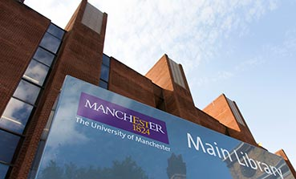

Upcoming Workshops from the Library:

Thursday 9 April 2026, 10:00 - 12:00
Shut up and write (online)

Wednesday 15 April 2026, 11:00 - 12:00
Writing your Data Management Plan - a Q&A Session (online)

Wednesday 22 April 2026, 13:00 - 14:00
Seven steps to raising your research profile (online)

Tuesday 28 April 2026, 14:00 - 15:30
Introduction to Open Research at the University of Manchester (on campus)

Wednesday 29 April 2026, 11:00 - 12:00
Introduction to Research Data Management part one: Starting your research journey (online)

Library opening hours over Easter period 2026
Library opening hours will change over the Easter period, between Friday, 3 April and Monday, 6 April 2026. Full information on opening hours is available on each of the Library sites on the Library’s locations and opening hours page.

University News
Researcher Development
Counselling Services
Research IT
PGR News

The University Of Manchester, Faculty of Humanities, Doctoral Academy
Contact Us | Tel: +44 (0) 161 306 6000 | Web: www.manchester.ac.uk
Registered Office: The University of Manchester, Oxford Rd, Manchester, M13 9PL. Royal Charter Number: RC000797

To opt out of future communications click here

