View online

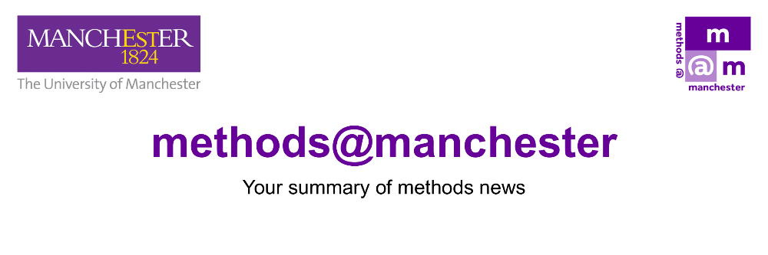

March 2026

Hello
Welcome to the March edition of Methods News.
Methods News is the regular newsletter from methods@manchester, providing a summary of our events and activities.
This month we focus on the 2026 Methods Fair and Summer School. We have extended the Methods Fair deadline to 7 April, so please do submit your brief Lightning Talk and poster abstracts as soon as possible. We have been running a series of taster sessions for our Summer School courses. If you missed out on these, visit the course materials on the Summer School website to view the recordings and meet the course team.
If you are organising a methods-related event or activity, please send us brief details by Friday 3 April to be included in next month’s issue.
Emma
Prof. Emma Banister (Director of methods@manchester)

Connect With Us

methods@manchester Events and Activities

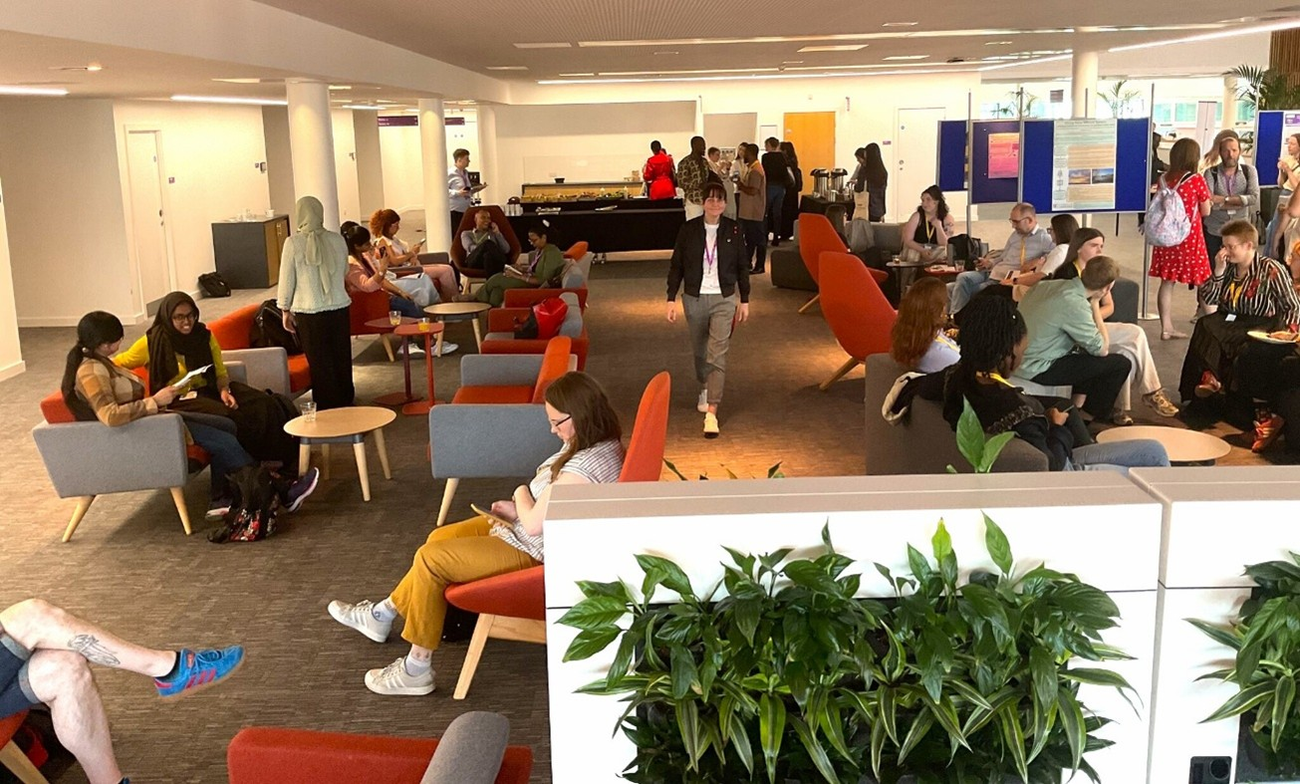

Methods Fair 2026
**Extension to Lightning Talk and Poster submission date**
The Methods Fair is a free annual one-day event organised in collaboration with Methods North West (MNW) taking place on Wednesday 27 May.
The event brings together researchers and PGRs from across the region for a day of talks, posters, and hands-on workshops. This year’s Fair includes workshops focused on drawing your research, zine making, the ethics of multi-lingual research, the Data Visualisation Observatory and many other contributions from across our MNW partnership.
The full programme will be released in mid-April but if you want to get a sense of previous Methods Fairs, please do visit our website.
We have had received a number of excellent submissions for our Lightning Talks and poster session and decision emails have now gone out. However, we still have a small number of slots available. If you missed the deadline, we warmly encourage you to submit an abstract (maximum 200 words) as soon as possible and before midnight Tuesday 7 April.
Call for Submissions

Summer School 2026

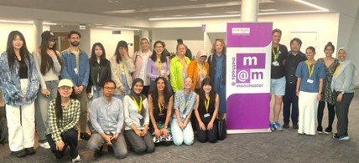

Summer School 2026
The Methods@Manchester Summer School provides a fantastic opportunity to expand your methods knowledge and research skills, with a range of courses focused on software training, qualitative and quantitative analysis, data collection techniques and much more.
The School will take place Monday 6 July to Friday 10 July. The programme includes two social events, and along with the shared breaks and lunches this means it provides a unique opportunity to meet researchers across the Summer School as a whole.
The 2026 Summer School includes the following courses:
- AI Driven Analytics
- Using NVivo for Qualitative and Mixed-Methods Analysis
- Digital Methods
- Qualitative Interviewing: Developing Confidence in Approach and Analysis
- Longitudinal Data Analysis
- Introduction to Social Network Analysis
- Mixed Methods in Social Network Analysis
- Regression Models Using Bayesian Estimation

Taster sessions
To meet the team behind the course, and see if it’s the right fit for your research, join one of our free online taster sessions:
- 26 March: Qualitative Interviewing: Developing Confidence in Approach and Analysis
- 23 April: AI Driven Analytics

We offer reduced rates for doctoral students and those working within the voluntary, charity and community sector as well as competitive bursaries.

For all the details about the Summer School, click the button below or email us at methods@manchester.ac.uk
Find out more!

artsmethods@manchester
Are you a University of Manchester PGR with an interest in arts and humanities? artsmethods@manchester is an academic programme of talks, workshops, training and events which explore approaches to arts research methods and their dissemination.
23 March 2026, 11am - 1pm
Frankfurt School Theory (A4, Samuel Alexander Building)
27 April 2026, 11am - 1pm
Translation as Research Method (A4, Samuel Alexander Building)
11 May 2026, 11am - 1pm
Critical University Studies (C.1.18, Ellen Wilkinson Building)
8 June 2026, 11am - 1pm
Sociology of Work Theory (A4, Samuel Alexander Building)

All workshops can be booked via the Training Calendar. Upcoming events include:
artsmethods Events

Methods North West

Methods North West brings together the collective strength, depth, and breadth of methodological expertise across the North West Social Science Doctoral Training Partnership (NWSSDTP) consisting of the Universities of Manchester, Liverpool, Lancaster, Keele, and Lancashire.

Lunchtime Sessions

The Methods North West online lunchtime seminar series runs on Thursdays 12-1pm, and features methods-related work and discussion across, and beyond, the partnership.
Upcoming sessions feature taster sessions for our upcoming Summer School:
26 March
Qualitative Interviewing: Developing Confidence in Approach and Analysis, with Gail Hebson
23 April
AI Data Analytics, with Ali Hassanzadeh
7 May
Autistic Voices in Higher Education: Gathering and Sharing the Lived Experiences of Autistic Learners, with Kelly Jeffery and Adam Jeffery
Contribute to the Lunchtime Seminar Programme
If you are a researcher (including experienced PGRs) who would like to contribute to the lunchtime seminar series, please see our Call for Contributions.

Lost and Found in Translation Series
The Lost & Found in Translation (L&FIT) Network is a collaboration of PGRs/ECRs based in all five Methods North West Institutes. The network explores the ethics & methodologies of qualitative and interview-based research carried out in and across different languages.
The second workshop in the series is 'Technologies of Translation: planning, processing, analysing cross-language data' and will be held on Thursday 9 April, The University of Liverpool.
In this workshop, attendees will learn how to use open-source technologies to transcribe audio and video data, translate transcripts from one language to another, and manage multilingual transcriptions.
Book your Place!

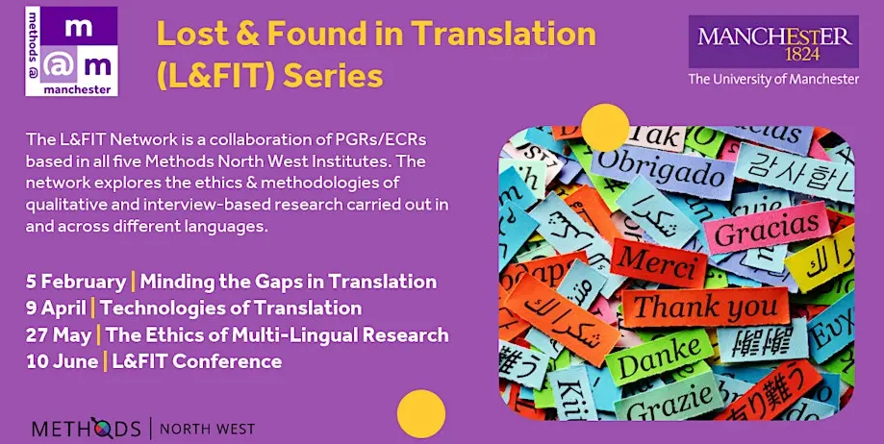

Methods North West partner events

Music and Health: Practice into Research with Dr Jacky Waldock, Dr Joanne Worsley, Georgina Aasgaard and Mandy Burvill
13 April 2026, University of Liverpool, hybrid
This workshop offers an introduction to innovative research methodologies in relation to one specific art form, music, which emerge from practice and which use arts and humanities-led and creative approaches.
For more information and to reserve a place, please contact Prof Josie Billington

National Centre for Research Methods

The National Centre for Research Methods delivers training and resources at core and advanced levels, covering quantitative, qualitative, digital, creative, visual, mixed and multimodal methods.
Upcoming online events include:
Questionnaire Design for Web, Mobile Web and Mixed-Mode Surveys wth Dr Pamela Campanelli
24 - 26 March
This online course on questionnaire design, explores question wording issues and the questionnaire-as-a-whole with a focus on web surveys and mobile-friendly web surveys.
Introduction to Longitudinal Data Analysis with Dr Alexandru Cernat
17 and 24 April
In this course you will learn both how to clean longitudinal data as well as the main statistical models used to analyse it. The course will cover three fundamental frameworks for analysing longitudinal data: multilevel modelling, structural equation modelling and event history analysis.
To register for the above courses, and for details of the NCRM full programme of events, please see here.
Upcoming NCRM Events

PGR Community Space

Are you ready to share your innovative work?
Methods News would love to draw attention to the innovative work that is taking place within our PGR community; providing a regular flexible space for methods-related pieces or profiles. Fill in the form below and we can support you with this.
PGR Community Submission Form

Subscribe to Methods News

If someone has forwarded you this edition of Methods News, please do sign up to receive it directly.
Subscribe

  
  

methods@manchester | The University of Manchester | Methods North West
Contact Us | Tel: +44 (0) 161 306 2859 Web: https://www.methods.manchester.ac.uk
Registered Office: The University of Manchester, Oxford Rd, Manchester, M13 9PL
Royal Charter Number: RC000797

To opt out of future communications unsubscribe here

