Checking Student access
You can check the Student View of your course using Student Preview button which you’ll find on the top right of every page.
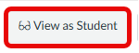
Additionally you can use the Verify Links in my Course button which you’ll find in your Course Settings on the right hand side menu at the bottom.
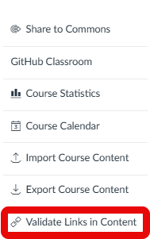
*Note: The Validate Links in Content tool will report links to sites that require log in, for example lecture recordings, as unreachable even if the link works fine.

Copying Content
You can avoid issues with student visibility by following these processes when copying content.
You have two options. Import allows you to select multiple items to copy at once.
Copy to allows you to copy individual items but allows you to place them where you want in the new course. It is also the better option if you’re copying Quizzes.
- Import content (for example from a migrated course)
Avoid importing “All Content”. Select the content you want to import.
In the new course you want to copy content into on the Homepage, click Import Existing Content
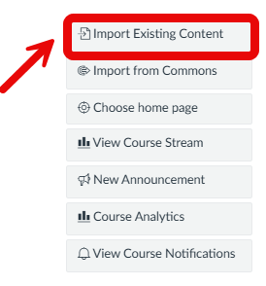
Then select Copy a Canvas Course from the options, then find the course that has the content you need.
Click Select specific content and then Add to import Queue.
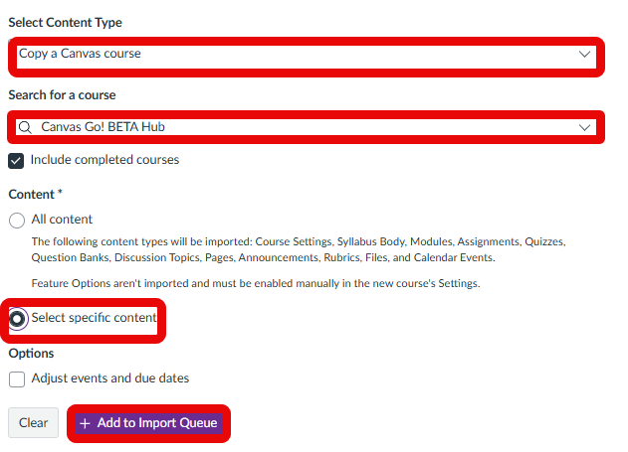
The course will now appear in your Import Queue and you can select the necessary content.
You can also follow this guide on the Canvas Go tutorial Hub.

- Copying to a course
In the course you want to copy content from, find the page, quiz, assignment or module you want to copy and click the three-dot menu on the right-hand side.
Select Copy to.
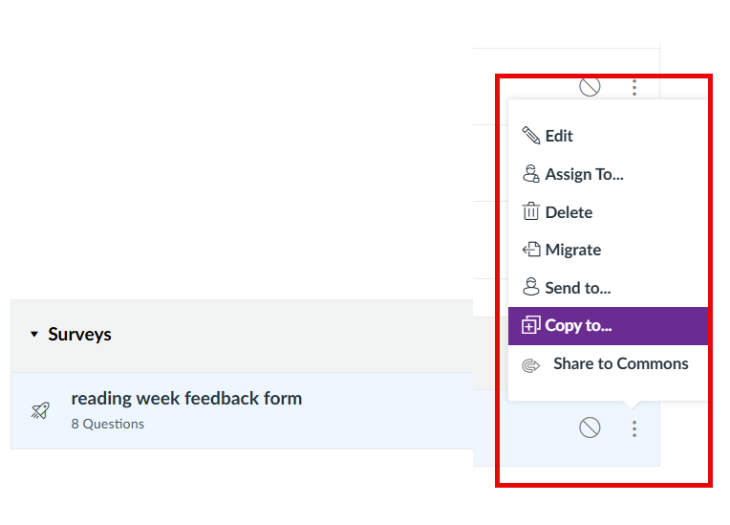
Type the name of the course you want to copy the item into. You can choose a specific module in that course or leave it blank. If you leave it blank, the item will go to the default are e.g. a Page to Pages; a Quiz to Quizzes etc.
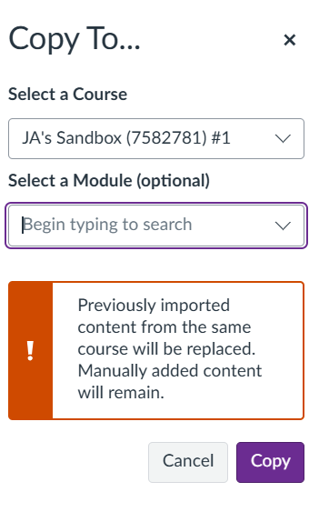
Canvas will start processing the copy and you’ll see a green notification to confirm this.
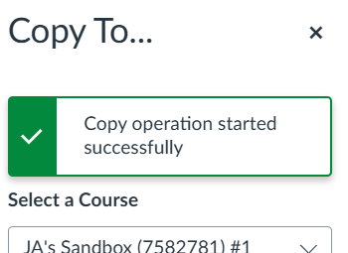

If you have copied a quiz, please check the ‘Update migrated quizzes and surveys’ guide on the Canvas Go! Tutorial Hub to ensure it’s in the correct format.

Copying Video
Using the above processes should ensure that video copies over successfully. You can check which videos exist in a course by viewing the Course Collection of video.
From the purple global navigation menu, select Studio and then from My Library select Course Collections. You will see the Course Collection of videos for all the courses you are enrolled on. From here you can check that videos have copied over successfully.
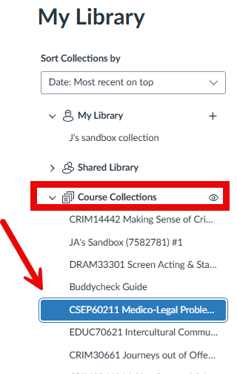
You can also access the Course Collection of video from inside a course, when you are building or editing a page.
In the rich content editor, select Studio and instead of using the default My Library select the Course Collection (the name of the Course in the dropdown menu). This will also include video copied from elsewhere.
