IT Self-Service Advice for MAP Students

Activating your account and accepting your offer

- Activate your IT Account via https://iam.manchester.ac.uk/activates - ensure you note down your username. You will need this to use some University of Manchester services throughout the programme, including accessing the library to complete your academic assignment later in the year.
- You will also be asked to generate a password, which needs to be at least 10 characters, contain at least one capital, one symbol, two numbers and not have any spaces. You will also be asked to create some security questions which you may need to use in the future if you need to recover your account. Please also remember these questions and answers.

If you have any issues with activating your account please;
- Check the details on your offer letter, including your University of Manchester ID number.
- Ensure that the spelling of your name matches the offer letter, this is taken from the information you provided on your application.
- Check that you have entered your date of birth correctly in dd/mm/yyyy.
- If either of the above is incorrect then you will need to email map@manchester.ac.uk with the correct information
- If you still cannot complete IT account setup, please email map@manchester.ac.uk with the subject ‘IT account activation issue’. Please include your full name, date of birth and University of Manchester ID number.

- Log in to Self Service using your new username and password.

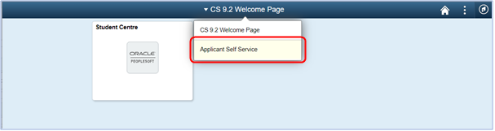You may need to change your view if it does not default to ‘Applicant Self Service’ as above. To do so, simply click on CS 9.2 Welcome Page and select Applicant Self Service:

- Once in this view, click the Applicant Self-Service tile:
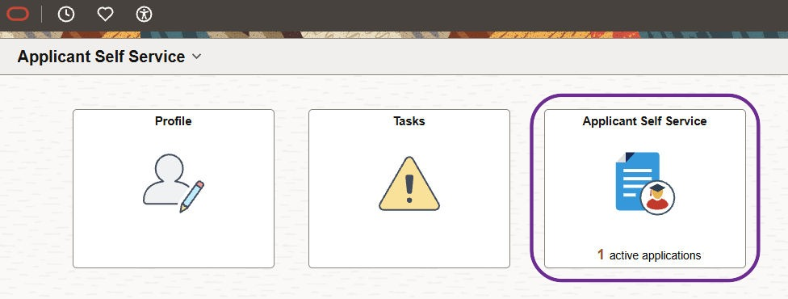
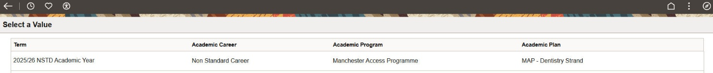
- You will see your Manchester Application Programme application – click into this to reply to your offer.

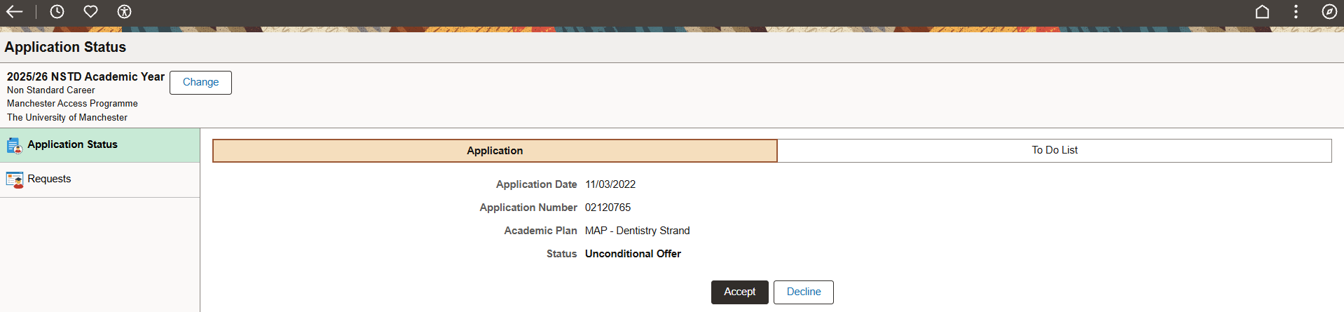
- Click Accept or Decline.

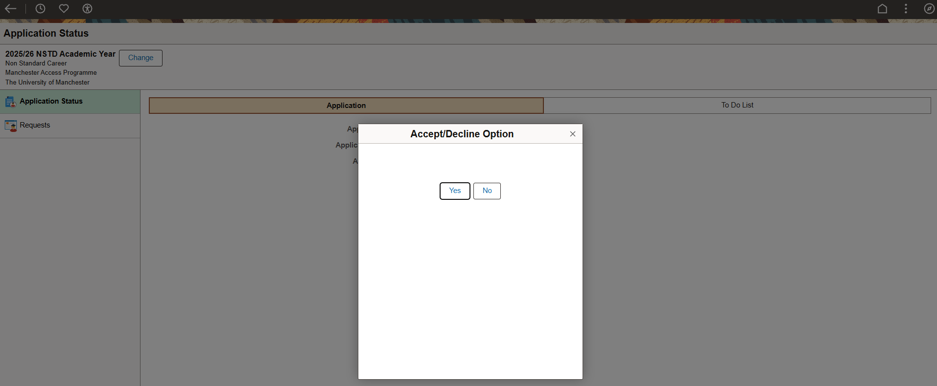
- Click Yes to confirm your decision (or No to change). This will automatically update your record.
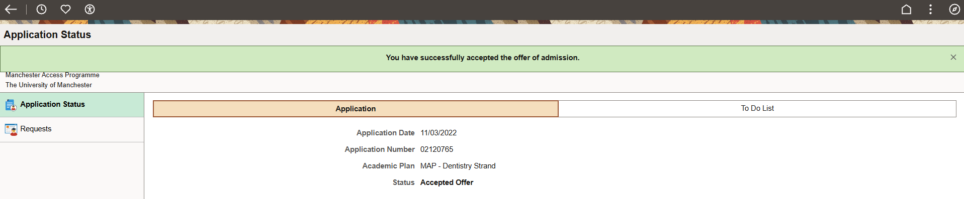

If you get asked to complete financial registration, please ignore this. You do not need to complete these steps as there is no cost to participating in the Manchester Access Programme.
Next steps
Once you have accepted your offer you will be contacted via email to complete a criminal conviction declaration. This must be completed before you are able to start the programme so it is important that you complete this as soon as possible. Please wait 24 hours for the criminal conviction email to appear.
After you have completed these steps the MAP team will send you an email with information on how to complete the MAP registration form and how to access our elearning platform called Canvas.

Issues accepting offer
If you cannot accept your offer via the steps above, please email map@manchester.ac.uk with the subject ‘Offer acceptance issues’. Please include your full name, date of birth and University of Manchester ID number.

Please do not ignore IT issues, you must complete the steps above to be able to take part in the programme, please do just let us know if you are having any issues and we will help you.

