Guide to Room 4.010, Alliance Manchester Business School (AMBS)
Booth Street West Manchester M15 6PB
Please follow the red arrows to find the main event space (room 4.010, AMBS). There are lifts available next to all the staircases, if you need any further access information or support, please contact kitty.lo@manchester.ac.uk.
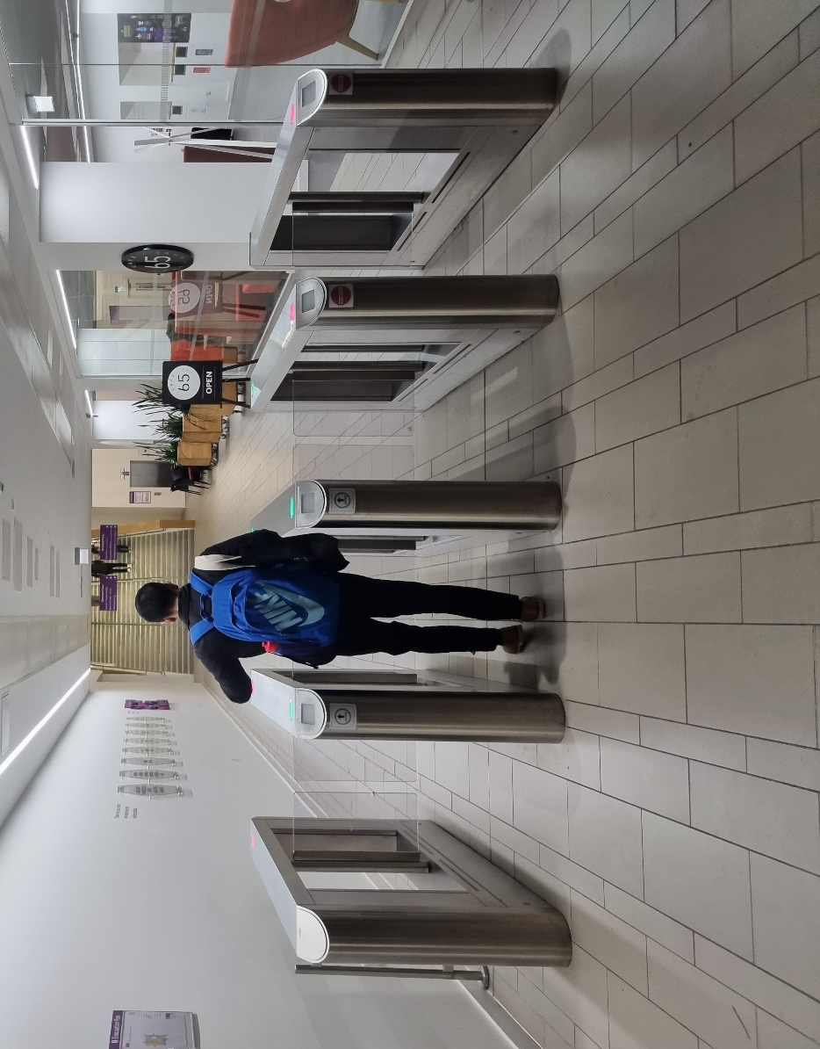
Please walk straight ahead towards the staircase, past the gates. If you don’t have access, please ask the reception to open the gates for you.

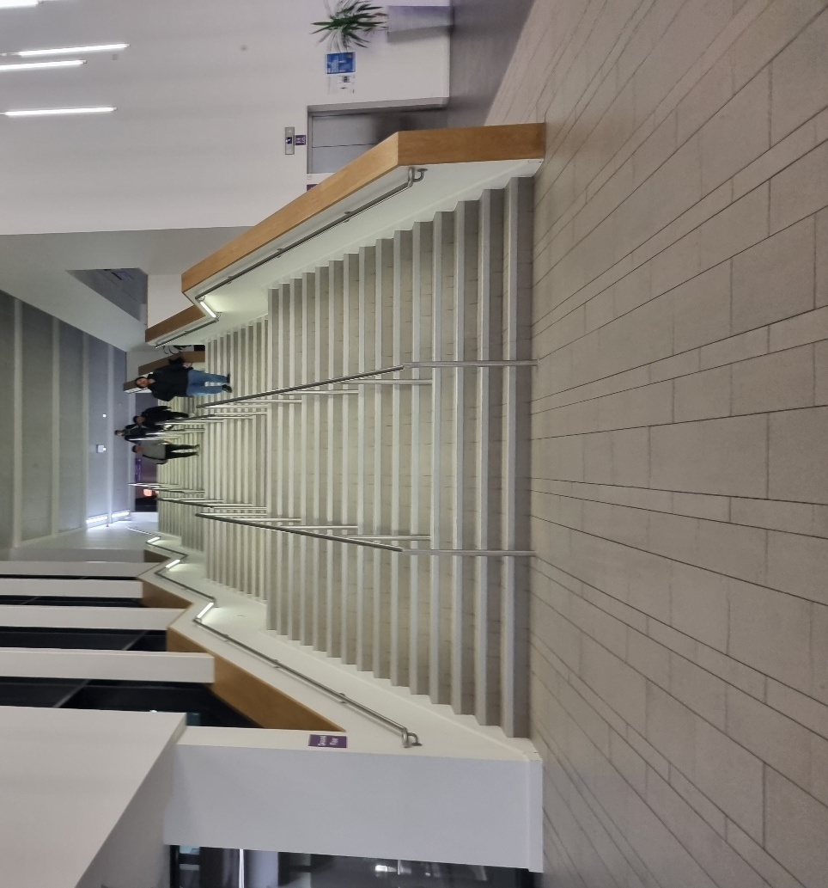
Please walk up the stairs to top (the second floor) or take the lift on the right.
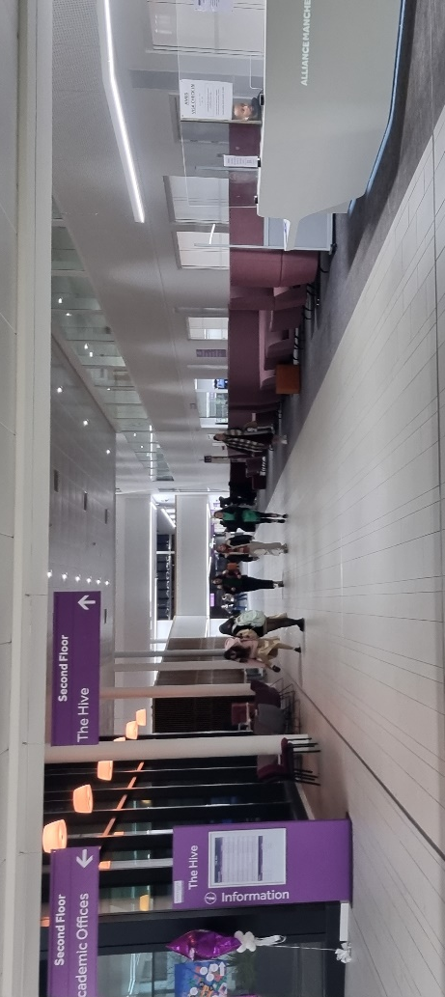
Please walk down the hallway towards the Eddie Davies Library.
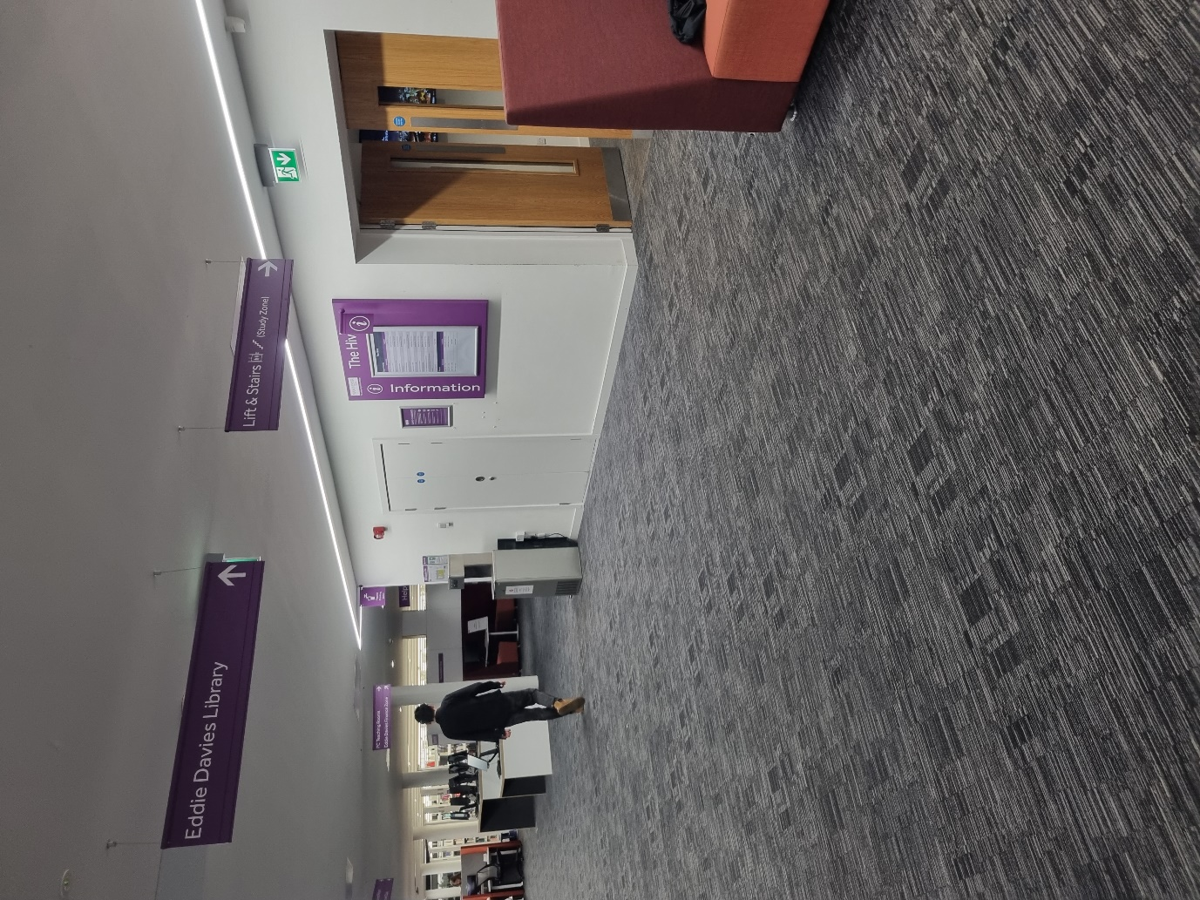
Please turn right when you reach the Eddie Davies Library to find the second staircase/lift.
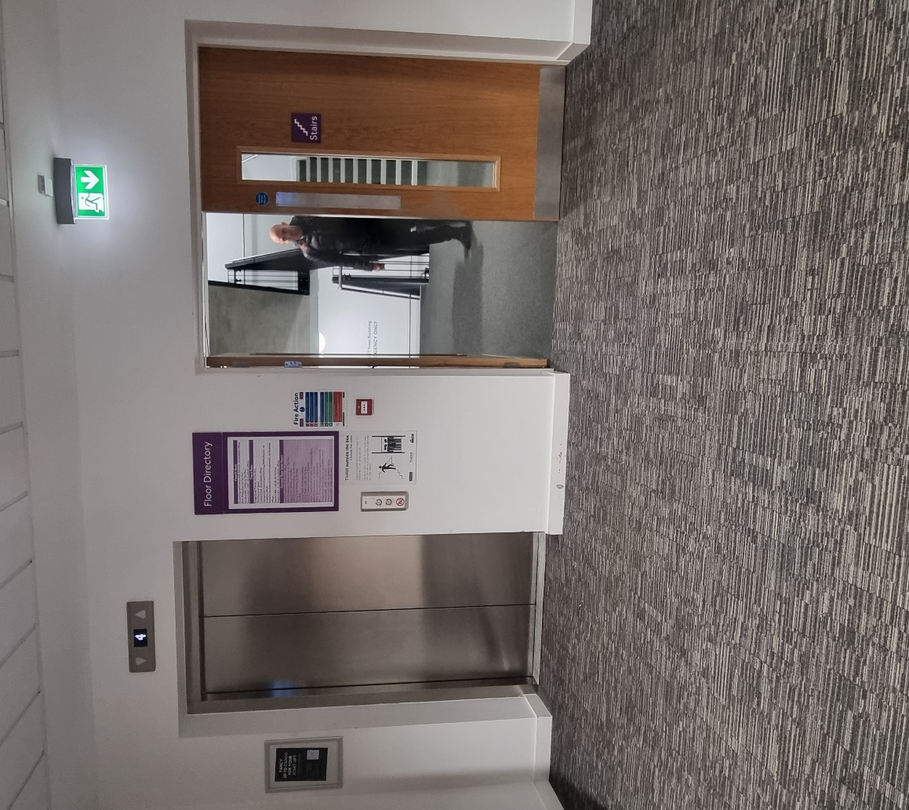
Please go to the 4th floor via the stairs or the lift.

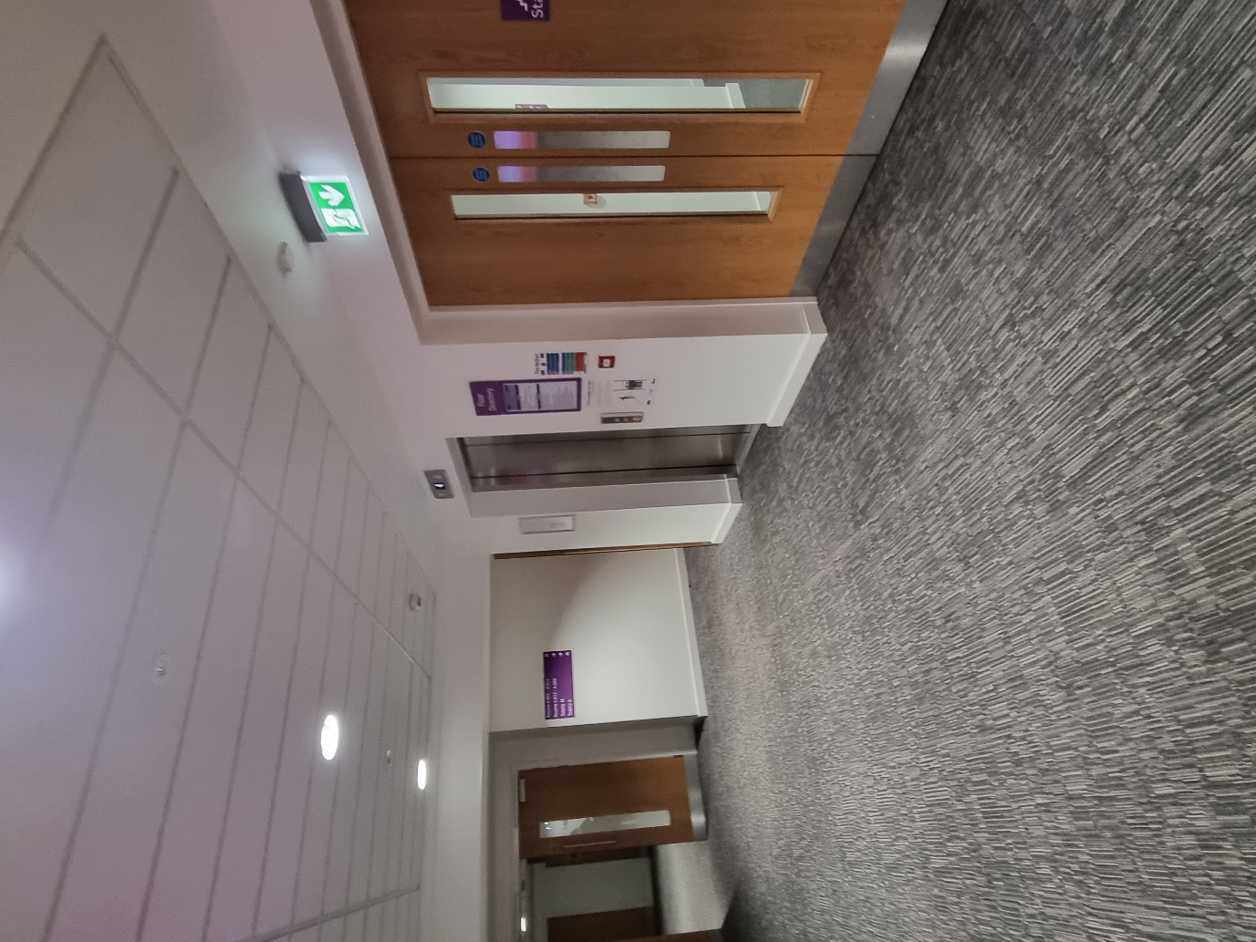
Please turn right when you exit the lift or the stairs on the 4th floor.
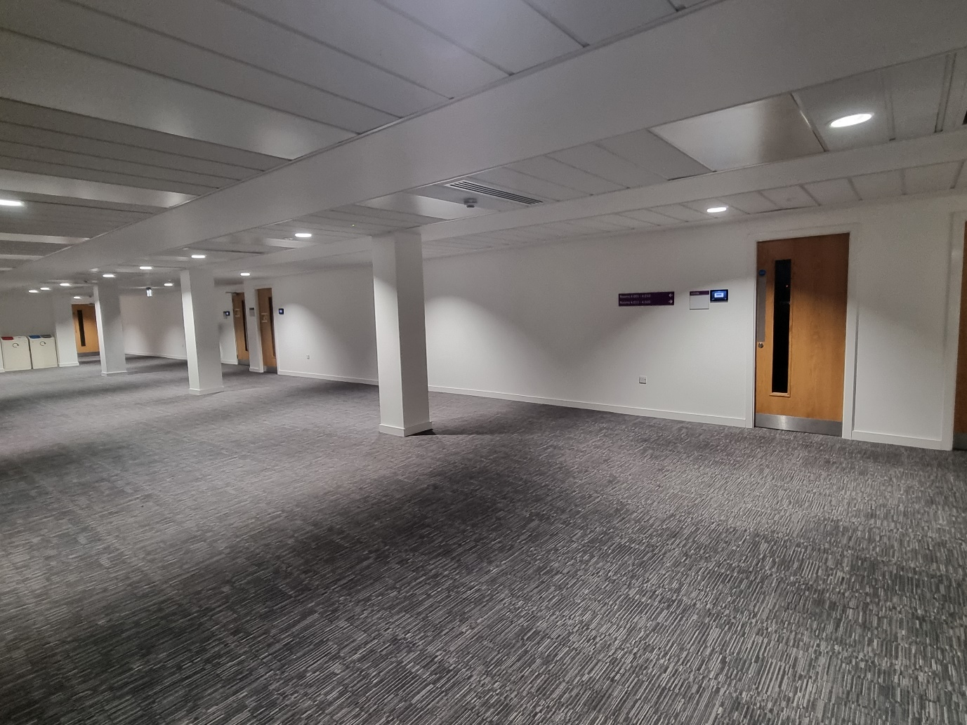
Room 4.010 is here.

