View online

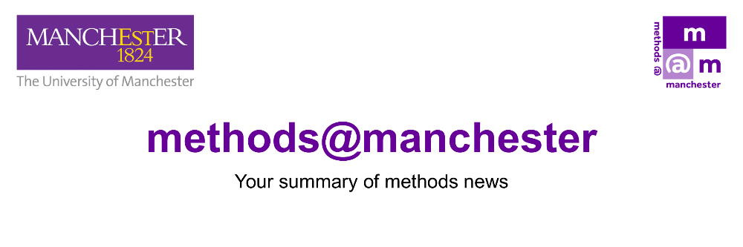

January 2026

Hello Trevor
We hope the new year has started well for you.
This month, we’re excited to announce the Call for Papers for this year’s Methods Fair including early details about our keynote speakers and the theme of their talk. Below, you’ll find full details on how to submit abstracts for Lightning Talks and Poster Presentations.
We also share the complete schedule and registration information for the Lost and Found in Translation series.
Please feel free to share this edition of Methods News across your networks. If you’re organising a methods-related event or activity, send us a brief description by 13 February to be featured in next month’s issue.

Emma
Prof. Emma Banister (Director of methods@manchester)

Connect With Us

2026 Methods Fair
Methods for Change: Connecting People, Places, and Purpose

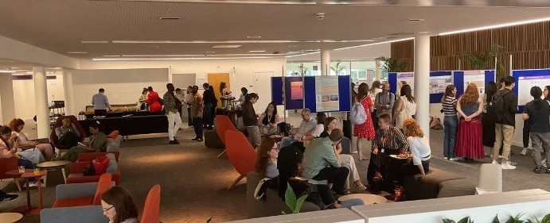

The Methods Fair is a free, one-day event designed to bring researchers together to connect, present, and share ideas, while further developing skills and knowledge. (Read about last year’s Fair here).
This year’s Fair will take place on Wednesday, 27 May, at the University of Manchester campus, and we’re delighted to announce our keynote speakers as Prof Sarah-Marie Hall and Sally Bonnie whose talk will focus on Friendship, Creativity and Collaboration.
We welcome submissions for 5-minute Lightning Talks and Poster Presentations. For full details, see our Call for Papers below. Please note: the closing date for submissions is 9am, Monday 16 March.

Call for Papers

methods@manchester Events and Activities

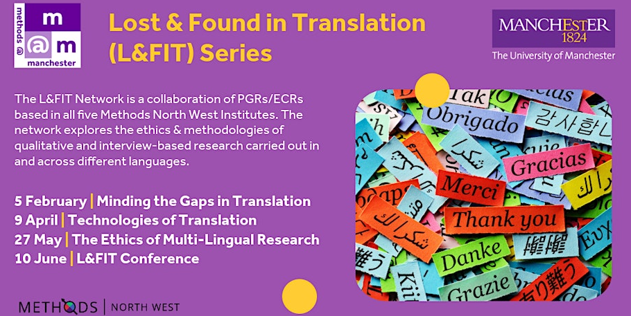

'Lost and Found in Translation' Series
Dr Ruth Abou Rached will be leading a number of events as part of the L&FIT Series over the coming months.

The first of these is on Thursday 5 February investigating how translation studies can help us navigate the realities of cross-language research.

In this workshop, we will share in-depth insights into which theoretical and applied approaches within translation studies can help researchers orientate their project and plan their data gathering accordingly.

The event will be held at the University of Manchester, Room 5.207, University Place. For the details and how to sign up, please visit the eventbrite site.

Critical Data Visualisation
Dr Luca Scholtz will be running the above staff training session 1pm - 5pm Tuesday 3 February, which invites researchers from across the humanities and sciences to engage critically and creatively with data visualisation. Participants will learn to better recognise and critique biased, oversimplified, or misleading representations of data, and to develop their own visualisations to explore and communicate data that is relevant to their research.

The session is currently full but to join the waiting list, sign up via the Training Catalogue.

artsmethods@manchester

Are you a University of Manchester PGR with an interest in arts and humanities? artsmethods@manchester is an academic programme of talks, workshops, training and events which explore approaches to arts research methods and their dissemination.

Upcoming sessions in February are:
9 February 2026, 11am - 1pm: Theoretical Frameworks (C.1.18, Ellen Wilkinson)
16 February 2026, 11am - 1pm: Using NVivo for Discourse Analysis (C.1.18, Ellen Wilkinson)
23 February 2026, 11am - 1pm: Refugees Studies Theory (A4, Sam Alex)

artsmethods Events

Methods North West

Methods North West brings together the collective strength, depth, and breadth of methodological expertise across the North West Social Science Doctoral Training Partnership (NWSSDTP) consisting of the Universities of Manchester, Liverpool, Lancaster, Keele, and Lancashire.

Methods North West website

MNW Lunchtime Seminar: Researching with Care: Flexible methods in research with disabled people, chronically ill people and beyond.
Poppy Budworth, University of Liverpool, 12pm Thursday 29 January [online]
The seminar draws on care-full research with young people with an ostomy, focusing on the importance of flexible methods when working with disabled and/or chronically ill people and demonstrating them as useful tools in qualitative research more broadly.
We will discuss how research methods can be made more bendable, how asynchronous methods offer this flexibility, and how these kinds of care-full approaches can benefit researchers as well as participants.
To sign up, please visit the eventbrite page.

Contribute to the Lunchtime Seminar Programme
The Methods North West lunchtime seminar series runs Thursdays 12 – 1pm (online), featuring methods-related work and discussion from researchers across, and beyond, the partnership.
If you are a researcher (including experienced PGRs) who would like to contribute to the lunchtime seminar series, please see our Call for Contributions.

Call for Contributions: Lunchtime Sessions

More Events

The National Centre for Research Methods (NCRM) are running the following online sessions in early February:

Radical Research Ethics with Dr Helen Kara
3rd and 4th February
This course is designed to raise your awareness of why and how you need to think and act ethically in practice throughout your research work.

Conducting Advanced Ethnographic Research with Dr Alice Stefanelli
9th and 10th February
This course moves beyond standard understandings of ethnography that depict it as a generic qualitative method founded on ‘participant observation’ to provide learners with a sophisticated, state-of-the-art approach based on cutting-edge academic research.
To register for the above courses, and for details of the NCRM full programme of events, please see here.

PGR Community Space

  This month, we meet Dilara Nihal Tunc, a PhD researcher in the School of Law.
  Dilara is the Law PGR Representative (for the second year in a row) and the founder of the Law PGR Forum.
  

My research examines relational contracts in English law, and asks whether a clearer set of legal rules and a regulatory framework can be developed to govern long-term commercial contracts that operate through ongoing cooperation, flexibility, and mutual reliance.
The thesis is grounded in contract doctrine and commercial law reasoning, and engages with relational contract theory to test how far English law can accommodate the realities of business agreements. While classical contract theory assumes bargains can be fully specified in formation, many commercial contracts are structurally incomplete and depend on relational norms such as trust, coordinated performance, and long-term collaboration. A central focus of my research is therefore the classification problem: how courts determine when a contract should be treated as relational, and what doctrinal and practical consequences follow from that classification.
Methodologically, my PhD adopts a doctrinal approach, centred on detailed case law analysis. I examine how judges identify relational characteristics and whether they respond by implying (or refusing to imply) obligations such as good faith, cooperation, transparency, and the rational exercise of contractual discretion, or by relying instead on classical implication tests (necessity, business efficacy, and the officious bystander). By comparing judicial reasoning across a substantial dataset of cases, my research maps the doctrinal thresholds courts apply and highlights the continuing tension between relational reasoning and the judiciary’s commitment to certainty and party autonomy. Ultimately, the thesis evaluates whether English contract law can move beyond sporadic recognition of relational duties towards a more coherent model of commercial contract governance, capable of operating as an alternative jurisprudential framework to classical contract law in relational settings.
Connect with Dilara: Email dilara.tunc@postgrad.manchester.ac.uk or via LinkedIn

Are you ready to share your innovative work?

Methods News would love to draw attention to the innovative work that is taking place within our PGR community; providing a regular flexible space for methods-related pieces or profiles. Fill in the form below and we can support you with this.

PGR Community Submission Form

Subscribe to Methods News

If someone has forwarded you this edition of Methods News, please do sign up to receive it directly.

Subscribe

  
  

methods@manchester, The University of Manchester, part of Methods North West
Contact Us | Tel: +44 (0) 161 306 6000 | Web: https://www.methods.manchester.ac.uk
Registered Office: The University of Manchester, Oxford Rd, Manchester, M13 9PL. Royal Charter Number: RC000797

To opt out of future communications unsubscribe here

