Lemon Balm
Cordial
Ingredients:

Water
Granulated sugar
Lemon balm leaves, freshly picked

In a pan put a roughly equal amount of water and sugar together with the same amount of lemon balm leaves. Bring to a simmer and stir carefully until the sugar dissolves in the water and the mixture thickens to a syrup. This should take a few minutes.

Allow the lemon balm leaves to sit in the syrup for 3-4 hours.

Afterwards, carefully remove the lemon balm with a slotted
spoon and transfer the mixture to a clean and sterilised bottle.

Store in a cool, dark place. The cordial should last up to a month but always check before consuming. Serve diluted with sparkling water and garnished with cucumber and lemon for a cooling and refreshing summer drink.

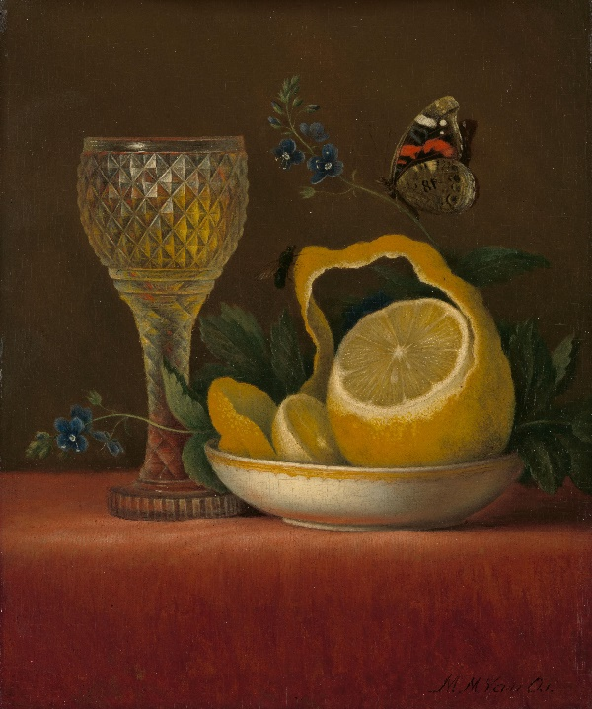

‘Still Life with Lemon and Cut Glass’, Maria Margaretha van Os, 1823-1826 Rijksmuseum, Object Number: SK-A-1107

Physician Nicholas Culpeper in 1653 noted in his book The
English Physician that lemon balm ‘strengthens the heart,
breast, and stomach, it resists melancholy’ and ‘revives the
spirits.’ It was good for digestion which, in the 16th and 17th
century was linked to good sleep. Culpeper advised that a
‘syrup made with the juice of it and sugar be kept in every
gentlewoman’s house.’ Today lemon balm is known to help
with sleep, calm anxiety, help digestion, and help with bites
and sores.

