Ingredients:
Chicken, Lettuce, and Spice Stew

Olive oil
8 chicken thighs
2 little gem, cos, or romaine lettuces, halved
800ml chicken stock
Marrowbone (optional) to thicken sauce (or oxtail / cornflower)
½ tsp each of ground mace, ground nutmeg, ground cloves
1 preserved lemon rind or the zest of 1 lemon
125 ml white wine and 125 ml sherry (or 250ml white wine)
8 dates, sliced
25g butter
Salt and pepper
Dried barberries (or dried cranberries/ goji berries)
Toast cut into squares or croutons

Brown the chicken thighs in olive oil and then add the hot chicken stock plus the mace, nutmeg, cloves, lemon, wine/sherry, and, if using, the marrowbone. Reduce the sauce down by simmering for 10-15 minutes. If using oxtail, this needs to be slow cooked instead for 3 hours.

Next add the halved lettuces, butter, and sliced dates. If using cornflour instead of marrowbone/oxtail, create a paste with a little of the cornflour and cold water and stir into the sauce to thicken. Simmer for another 15 minutes.

Serve with the toasted bread squares or croutons on top plus the dried barberries. If you can’t get dried barberries, use dried cranberries or goji berries for that tart, sour contrast.

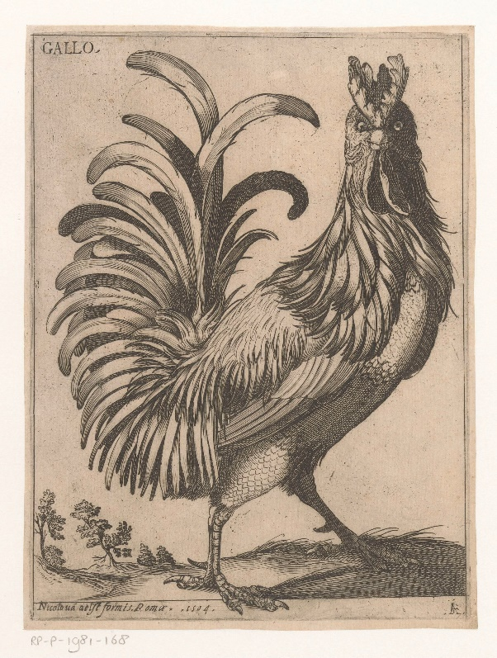
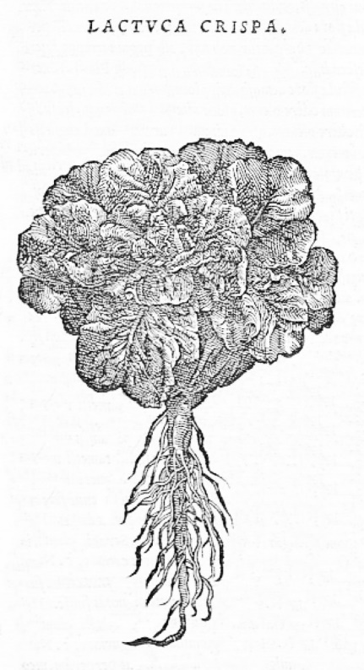

‘Haan’, Jacques de Fornazeris (1594) Rijksmuseum, Object Number: RP-P-1981-168 and
‘Lactuca crispa’, Pierandrea Mattioli (1501-1557)

This recipe is adapted from Hannah Woolley’s The Queen-Like Closet (1672). It includes several ingredients the Tudors and Stuarts associated with sleep: lettuce, spices, and bread. To this list today we can also add chicken. All of these sleepy foods are known to encourage the production of the sleep hormone melatonin in our brains. They can also work to relieve stress and anxiety.

