Ingredients:
Apple Moyse
(Apple Curd)

8 apples, peeled, cored, and chopped
2 egg yolks
2 tbsp rosewater
2 tbsp sugar
25g butter
Ground cinnamon and ginger to serve
A blender or stick blender, or a sieve to pass the mixture through to make your apple puree

Make stewed apples by boiling apple slices or chunks in a little water. Blend them together to make a smooth puree. Put the apple puree back in the pan. Mix the egg yolks with the rosewater and add to the apples with the sugar and butter. Heat slowly and stir all the time until the mixture thickens like a curd or custard-like consistency. Place in a serving dish and sprinkle with cinnamon and ginger. Keep your curd in the fridge and eat within a couple of days.
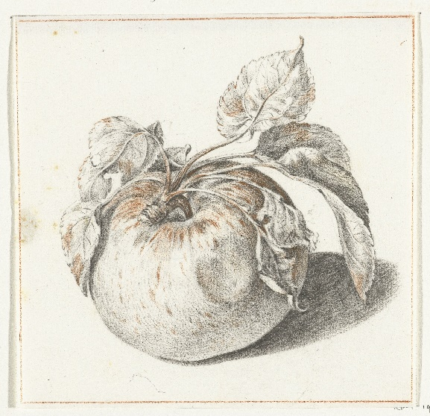

This recipe comes from a book called A Proper Newe Book of Cokerye (c.1572). Apples were believed to help you sleep in the 16th and 17th centuries due to their cool and moist properties. Serving cooked apples with warming spices helped to prevent indigestion and nightmares, which could be brought on by eating extremely cold foods, especially in winter.

Sir Francis Bacon included apples, pears, and quinces in his list of sleep inducing ingredients in 1670:

These procure quiet sleep, violets, lettuce, especially boiled, sirrup [syrup] of dried roses, saffron, balm [lemon balm], apples, at our going to bed; a sop [a small piece] of bread in Malmsey [wine], specially where musk-roses have been first infused: therefore it would not be amiss to make some pil, or small draught of these things, and to use it familiarly. Also those things which shut the mouth of the stomach close, as coriander-seed prepared, quinces and wardens [pears] roasted, do induce sound sleep…

Sir Francis Bacon, Sylva Sylvarum (1670)

