Staff Wellbeing Champion Bulletin Monday 8th December 2025
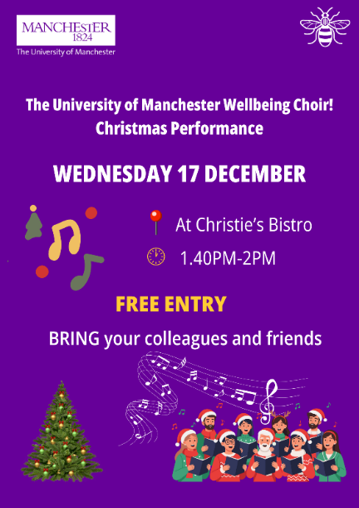
Join us for the Wellbeing Choir festive performance, Wednesday 17th December, 13:40 – 14:00, Christies Bistro: access information here.
Free to attend, all colleagues welcome.

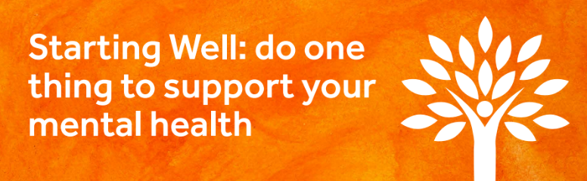
Our Starting Well in 2026 colleague wellbeing campaign will take place in January, our focus this year is ‘Do one thing to support your mental health’. There will be a programme of free activity throughout January, look out for the launch on Monday 5th January 2026.

Here is a taster of what’s on offer:
Saturday 3rd January to Saturday 31st January
FREE Active Manchester Membership
UoM Sport ‘Recharge in 2026’ offer is designed to promote wellbeing for our staff and student community, giving staff the opportunity for physical movement in the new year via free gym and class access. (registration opens from 1st January, please note this offer does not apply if you have an existing paid Active Manchester membership).
How staff get started:
- Select free Active Manchester membership online via the join link
- Once the membership is activated, you can book on to classes.
- On your first visit to the gym, activate staff card at reception
Read full details for Recharge in 2026
For questions contact sport@manchester.ac.uk
Understanding Anxiety Webinar, Tuesday 13th January, 13:00 – 14:00
This webinar explores what anxiety is, how it affects us, and the cycle that keeps it going, including common signs, symptoms, and triggers. Attendees will explore practical tools to help manage anxiety and support themselves or others at work and at home.
Find out more and register your place here.


Thursday 8th January, 11:00 – 14:00, The Atrium, University Place. Access information here.
ASESD Staff Wellbeing Champions are running a Swap Shop again this January.
Buy a bake, swap unwanted gifts, or buy an item for £3 (items must be as new). All proceeds will go to two charities Multiple Sclerosis Society and The Little Green Sock Project Any leftover items will also be donated to charity.
All staff and students are welcome.
Contact: jennifer.enobakhare@manchester.ac.uk or marieta.mikulevic@manchester.ac.uk.

Reminders and Opportunities
- Watch the recording: Your Pocket-Savvy Power Hour Webinar 2.0, view here.
- Join the Staff Bereavement Café mailing list: find out when the recently launched Staff Bereavement Café dates and locations will be in 2026.
- Find out more about the café here
- Register for mailing list here
- Are you a people manager with some time available for training in January? Spaces available on the mental health and wellbeing training offer for people managers:
- ‘Mental Health and Wellbeing in the Workplace’, is a self-paced digital learning course. Access training via Canvas
- ‘Managing with Wellbeing in Mind’ one-day course is designed to empower line managers to feel confident in supporting mental health and wellbeing at work. Book your place
- ‘UoM Introduction to Stress Management for Managers and Leaders’ This is a half-day workshop that provides the opportunity for line managers to understand the role they play in supporting work-related stress. Book your place

Maizy Jenner She/Her
Wellbeing Manager (For Staff)
University of Manchester |People Directorate, John Owens Building | Oxford Road | Manchester | M13 9PL | email: maizy.jenner@manchester.ac.uk
Staff wellbeing | StaffNet | The University of Manchester
Location map can be accessed via this link map.

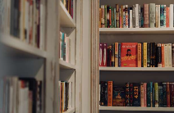
Delve into the UoM Wellbeing Collection
at the Library this winter: Discover more here.

Please note: I work flexibly and when I send emails outside office hours, there is no expectation that you should reply outside your normal working hours.

Confidentiality and Legal Privilege: The contents of this e-mail and its attachment(s) are confidential to the intended recipient and may be legally privileged. It may not be disclosed, copied, forwarded, used or relied upon by any person other than the intended addressee. If you believe that you have received the e-mail and its attachment(s) in error, you must not take any action based on them, nor must you copy or show them to anyone. Please respond to the sender and delete this e-mail and its attachment(s) from your system

