From: Maizy Jenner <maizy.jenner@manchester.ac.uk>
Sent: 18 November 2025 10:07
Subject: Staff Wellbeing Champion Bulletin Tuesday 18th November 2025
Staff Wellbeing Champion Bulletin Tuesday 18th November 2025
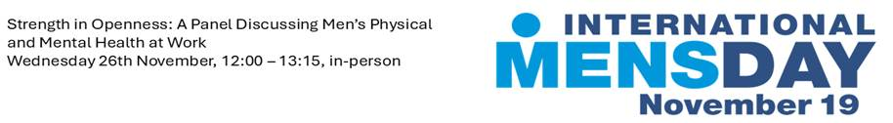
The month of November marks important campaigns focused on men’s physical and mental health, including International Men’s Day UK Tuesday, 19 November and Movember.
We are hosting an in-person men’s panel event ‘Strength in Openness: A Panel Discussing Men’s Physical and Mental Health at Work’ Wednesday 26th November, 12:00 – 13:15.
Join us for an open, honest conversation on the experiences, challenges and opportunities around men’s health and mental wellbeing in today’s workplace.
Who Should Attend:
Everyone: male colleagues, allies, managers, leaders, support service colleagues. We open the door to all colleagues and ask you to join this important conversation on men’s health and wellbeing.
Register your place here
Read our Men’s Health Awareness Staffnet article here.

Reminder Happening Tomorrow: Your Pocket-Savvy Power Hour Webinar 2.0, Wednesday 19th November, 11:00 – 12:00
Register your place here.
We will delve into 'What's New' in the full range of staff benefits and exclusive discounts designed to help your money go further. This time of year offers lots of opportunities to take advantage of offers, discounts and benefit from great savings.
We do also recognise this time of year can increase financial pressure and stress for some people - we will be discussing this important topic often skipped over during the bright lights of Christmas.

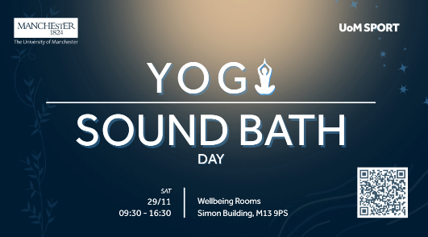
Yoga and Sound Bath Day
Saturday 29th November, The Wellbeing Studios, Simon Building.
Doors open at 9:15 until 17:00 – main session start 10:30 – 16:30
Hosted by UoM affiliated instructor Elanie Waller (Theyogaflowclub), Come and enjoy a great day of Yoga, Sound Bath, relaxation, and socialising. This day will include:
- Three styles of Yoga- Hatha Yoga, Yin Yoga with Sound bath and Vinyasa flow Yoga.
- 10-minute massage or Reflexology
- Refreshments and a light vegetarian/Vegan lunch at Benugo café will be provided.
- Finish the day with a relaxing sound bath and healing sounds.
Read more about this event here.
Or book your place directly here.

Help make Christmas special for a local care leaver: Our University community has been involved with The Christmas Dinner for many years, with colleagues volunteering to make this a special day, ensuring that no care leaver feels alone at Christmas.
UoM colleagues could support by:
- Purchasing a small gift from the care leavers wish list
- Financial contribution to support the event
- Support the touring raffle taking place across campus on various dates
To find out more on how you can support and the relevant links, read this staffnet article.
Watch this short video from the 2024 Christmas Dinner.

Reminders
- Next Language Café: Wednesday 26 Nov, 10 Dec,12:00pm-14:00 at Benugo Café, Simon Building
- Spaces Available: New Mental Health and Wellbeing Training Offer for Managers:
- ‘Mental Health and Wellbeing in the Workplace’, is a self-paced digital learning course. Access training via Canvas
- ‘Managing with Wellbeing in Mind’ one-day course is designed to empower line managers to feel confident in supporting mental health and wellbeing at work. Book your place
- ‘UoM Introduction to Stress Management for Managers and Leaders’ This is a half-day workshop that provides the opportunity for line managers to understand the role they play in supporting work-related stress. Book your place
- Join the Wellbeing Choir: Wednesdays 1:05-1:55pm, Simon Building, Wellbeing rooms, G.065. Watch a taster of what you could be involved in and sign-up here.
- Next Free Health Screening Clinics: Wednesday 19th November, 1:30 – 3:30pm, G.66 Wellbeing Rooms, Simon Building

Maizy Jenner She/Her
Wellbeing Manager (For Staff)
University of Manchester |People Directorate, John Owens Building | Oxford Road | Manchester | M13 9PL | email: maizy.jenner@manchester.ac.uk
Staff wellbeing | StaffNet | The University of Manchester
Location map can be accessed via this link map.

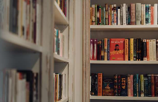
Delve into the UoM Wellbeing Collection
at the Library this summer: Discover more here.

Please note: I work flexibly and when I send emails outside office hours, there is no expectation that you should reply outside your normal working hours.

Confidentiality and Legal Privilege: The contents of this e-mail and its attachment(s) are confidential to the intended recipient and may be legally privileged. It may not be disclosed, copied, forwarded, used or relied upon by any person other than the intended addressee. If you believe that you have received the e-mail and its attachment(s) in error, you must not take any action based on them, nor must you copy or show them to anyone. Please respond to the sender and delete this e-mail and its attachment(s) from your system

