Canvas Catalog Sub Catalog Admin Guidance

Version | Date Published | Notes
1.0 | 30/10/25
1.01 | 18/11/25 | Connect links updated

Contents
Requesting a Sub-Catalog 2
Connect Form Guidance 2
Sub-Catalog Admins 3
Setting Up a Sub-Catalog 4
Sub-Catalog Settings 4
Branding & Appearance 6
Configuring a Vanity URL 7
Creating a Catalog Course 8
Creating a Course/Programme Listing 8
Paid Courses 9
Catalog Support Process 10
User Support Pathways 10
Escalation Process 11

Requesting a Sub-Catalog
Sub-catalogs which sit directly beneath root are created by the VLE team. Please use the Connect form linked below to request a new sub-catalog. Please note that sub-catalog admins can create downstream sub-catalogs from the level at which they have permissions. There is further guidance below to help you in completing this form.
Canvas - Technical Service Request - Connect

Connect Form Guidance

Parent Catalog
- Identify which entry from the hierarchy of the UoM catalog structure you would like your sub-catalog to sit beneath.

Sub-Catalog Name
- The name of your sub-catalog.
  - This is primarily for administrative purposes but will appear for external users as the browser tab heading (see example below).
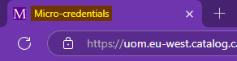

URL
- Sub-Catalogs can be configured with either their own unique domain (e.g. lifelonglearning.manchester.ac.uk) or a path URL connecting to its Parent Catalog URL (e.g. /engineering)
  - Please see ‘.manchester.ac.uk’ sub-domain guidance here.
- If chosen, a unique domain must be valid with an optional port and be approved by the Marketing team.
- If chosen, a path URL must only contain lower-case letters, numbers and dashes.
- Please see details on how to configure your vanity URL here.

Owner
- Who is the named business owner for the Sub-Catalog.

Area
- Which UoM business area is responsible for maintaining the Sub-Catalog.

Approval
- A new sub-catalog requires approval from an eLearning manager. Please confirm that this has been obtained.

Sub-Catalog Admins
A sub-catalog admin is a role with administrative rights limited to a specific sub-catalog and any downstream sub-catalogs beneath it. Sub-catalog admin permissions are enabled via the VLE team and can be requested using the Connect form below.
Canvas - Technical Service Request - Connect
A sub-catalog admin can:
- Manage Listings - View and manage course and program listings.
- Manage Catalogs - View and manage catalogs and sub-catalogs.
- Manage Promotions - View and manage all catalog-specific or listing-specific promotion codes for course or program enrolments.
- View Analytics - View analytics and generate reports for listings, enrolments, orders, and users.
The sub-catalog admin permissions listed below can be toggled to on/off and are set by the VLE team and should be outlined when submitting your Connect form (TBD).
Note: If you assign the same person to multiple sub-catalogs across different branches of the Catalog hierarchy, they will still only have one set of permissions. These toggles are managed centrally in the Sub-Catalog Admin area and apply across all catalogs that person is associated with. In other words, a user can only have one consistent set of toggle permissions, no matter how many sub-catalogs they manage.
- Cross Listings - Allows the admin to create listings that appear in multiple catalogs simultaneously. (Note: The admin must also be an admin in any Catalog they want to cross-list into)
- Manage Revenue - Currently enables the Promotions tab in the listing editor.
- Manage Tags - View, manage, and create listing tags.
- Theme Editor - Grants access to the Theme Editor for branding and layout changes.

Setting Up a Sub-Catalog
Once your Sub-Catalog has been created, and Sub-Catalog Admins have been assigned, you are ready to start setting up your Sub-Catalog.

Sub-Catalog Settings
Note: It is the responsibility of a Sub-Catalog Admin to maintain appropriate settings within their sub-catalog. Downstream Sub-Catalogs can also be affected by settings changes if they have ‘Inherit Parent Setting’ selected, and it is worth considering this before making any changes.
Note: Sub-catalog testing should be carried out in the beta environment, which is separate from production. Changes made in beta do not affect the live production system and are reset each weekend to mirror the current production environment.
As a Sub-Catalog Admin, you have the ability to change/the responsibility to maintain the following settings within your Sub-Catalog:
Note: Where settings are marked with ●, these settings should remain as ‘Inherit Parent Setting’.

Parent Catalog
- Toggle whether courses listed within the Sub-Catalog show in its parent Catalog.

● Time Zone (for unauthenticated users)
- UTC (+00:00) - inherit parent setting

● Language
- English (United Kingdom) - inherit parent setting.

● Country
- United Kingdom - inherit parent setting.

Measurement
- The "Measurement" label helps to define the unit of completion or achievement. It does not link to Canvas credit systems and is mainly cosmetic, showing up in the following locations:
  - Catalog Listings: Displayed alongside course listings
  - Student Dashboard: Visible to learners enrolled in a course
  - Transcripts: May appear if transcripts are enabled
- This option should be left blank when creating a course listing as to not show in the above places for a user.
- More information on the measurement setting can be found here.

About
- A brief description of your sub-catalog, purely for administrative purposes.

Meta Description
- The meta description is an HTML tag that you can define for a webpage. It provides a summary about the content of the page. Search engines display this description below your page's title in the search results, helping you attract users by indicating that your page contains the information they're seeking.

Restrictions on Registration Email Domains
- You can choose this to limit which email domains can be used for new user registration/enrolment. Only domains you allow will be able to register/enrol. For example, "schoolname.edu" or "gmail.com". More info

Require authentication to access Catalog and its sub-catalogs
- When authentication is required for a catalog or sub-catalog, users will be redirected to the Canvas LMS authentication method. More info

Enable bulk purchase/enrolment for this Catalog and its sub-catalogs
- Allow organisations to enrol multiple users at once or purchase in bulk. More info

Enable User Defined Fields during enrolments
- Allows Sub Catalog admins to add custom questions or data fields to the enrolment form (e.g. department, job role). User defined fields allow you to customize the information you gather during new user registration in addition to the default fields of Full Name and Email.

● Enable SKU Upload
- Inherit parent setting.

Hide Self-paced Label on Details page and Storefront
- When you hide the Self-paced label for a sub-catalog, the label does not display on any self-paced listings in the storefront or in the listing details page. More info

Allow Multiple Promotion Codes
- Promotional codes can be created to offer discounts on listings. Sub-Catalog Admins can define the discount amount, usage limits, and expiration dates. These apply only to the listings within their assigned catalog.

Branding & Appearance
Note: All branding for external facing catalogs must be approved by the University’s central design team - design@manchester.ac.uk. Internal facing catalog branding must also be approved by the appropriate design team. Please see University brand | StaffNet | The University of Manchester for guidance.
Sub-Catalogs can either inherit their direct parent catalog’s theme or have a custom theme created. Navigating to the Customisations tab when editing a catalog will allow the following elements to be customised.
- Header Image – Displayed in Top left and bottom left of the main landing page.

- Logo – appears on:
  - Course Listing tile;
  - Listing description;
  - Email notification;
  - Enrolment form;
  - Student Dashboard.
- UoM logo guidance

- Favicon – Used in:
  - Browser tab
  - Browser bookmarks
  - Mobile bookmarks

- Colours – Enter HEX values for:
  - Primary colour – Used on main navigation and call to action buttons
  - Filter Pill colour – used on the course filtering options on the main listings page
- UoM core colour guidance

- Header & Footer Settings
  - Header Background – This sets the Header colour. Two options, default or inverse.
  - Width – Full or Content Wide (stretches your header image across the full width of the screen if Full)
  - Enable Cover Image toggle. Turn on and add a Cover image.
  - Separator Options
    - Height: Thin or Extended
    - Colour: HEX input

- Cover Image Guidelines:
  - Recommended Aspect Ratio: 6:1 (Width: Height)
  - Best results with a high-resolution landscape image
  - Ideal image height: 190 pixels
  - A wider image works best for optimal display
  - Appears only on the homepage

- Email Templates - Customise the experience users receive when they interact with the platform. More Info
  - Email Branding – Adds styling to all templates below (extends header and footer styling).
  - Registration Email
  - Enrolment Email
  - Listing Completion Email
  - Failed Payment Email
  - Certificate Email
  - Waitlist Invite Email
  - Enrolment Invite Email
  - Bulk Purchase Email

Configuring a Vanity URL
If a vanity URL is requested follow the below steps to configure a custom URL:
- Approval of sub-domains are required from the central marketing team prior to this work being progressed. Please see details here.

- Select the sub-catalog for connection. Any existing or new sub-Catalog can be configured to have a custom URL.

- Send Instructure the required info for CSR creation
  - Institution Country Name (2 letter code)
  - Institution State or Province Name
  - Institution Locality Name (city)
  - Institution Organization Name (institution name)
  - Institution Organizational Unit Name (could also be institution name or a specific institution department)

- Using the information in steps 2 and 3 Instructure will then create and send a CSR file to you.

- Submit a Connect ticket to create a SSL certificate using the CSR created by Instructure. Instructure have a tool, which can be used to check the validity of the SSL certificate, avoiding further potential delays.

- Submit a Connect ticket to create a CNAME record on the new Custom Domain and point it to [specific URL provided by Instructure, i.e. uom-vanity.eu-west.catalog.canvaslms.com/example [uom-vanity.eu-west.catalog.canvaslms.com]]. This allows Instructure to install the certificate on their domain. They own *eu-west.catalog.canvaslms.com [eu-west.catalog.canvaslms.com]

- Instructure then check the CNAME has propagated, and they install the certificate onto their servers

Creating a Catalog Course
Courses that are published through Canvas Catalog are first created within the Canvas LMS and then linked to the appropriate catalog for enrolment.

Internal-Facing Courses
Courses intended for internal audiences (staff or students) can be created within any LMS subaccount as long as the relevant teaching and support staff have the appropriate permissions, to create, maintain, and manage courses within their chosen subaccount.
Sub-catalog admins should ensure that internal-facing listings are directed to the appropriate catalog without needing to follow any special subaccount structure.

External-Facing Courses
Courses that are open to external users must be created in the appropriate subaccount within the designated zone root account: External_Catalog. If access is required to a subaccount within External_Catalog zone, you can request this using the Connect form below.
Note: It is the responsibility of sub-catalog admins to ensure that only courses created within the External_Catalog subaccount are listed publicly and made accessible to external users.

Creating a Course/Programme Listing
Sub-Catalog Admins can create and manage both individual course listings and multi-course program listings. It’s recommended that the SIS ID is used when searching for a course within the LMS to list on Catalog. Course listings include details such as title, description, price, and enrolment settings. Program listings allow you to group multiple courses together and define completion requirements (e.g. whether all courses must be completed).
Note: It is a requirement that all course listings provide details on where/who to go to for support to ensure a smooth user experience.
Admins can set visibility options, add images, link to Canvas courses, and control display settings such as the “Show in Parent” toggle. Both course and program listings are created through the Catalog UI and published to the relevant catalog once configured.
Note: Sub-Catalog Admins can list any course from Canvas in their Catalog, regardless of sub-account permissions in the LMS. This means there is a risk of unintentionally listing courses that were not designed for public visibility, potentially exposing incorrect or incomplete content to users. Such listings can lead to confusion and a poor user experience, as not all Canvas courses are intended for Catalog. Sub-Catalog Admins must take care to only list courses that are within their remit and explicitly intended for access via Catalog.
More Info:
- How do I add a course listing in Canvas Catalog?
- How do I add a program listing in Canvas Catalog?
- How do I add a requirement to a Catalog program?

Paid Courses
Note: The information below is subject to change following the implementation of a new, Catalog-supported payment gateway. While this work is ongoing, the process outlined below utilising eStore should be followed.
Sub-Catalog Admins are responsible for ensuring that paid courses are correctly set up using the following process:
- Configure a Holding Section in the Canvas Course
  - Set up a holding area that all Catalog enrolees see by default.
  - This page should:
    - Inform users that full course access will be granted upon payment confirmation.
    - Reiterate the payment instructions and eStore link.

- Set the Course as ‘Free’ in Canvas Catalog
  - When creating your course listing in Catalog, set the enrolment type as "Free". Note: This allows users to enrol without automatic payment.

- Create a Parallel Listing in eStore
  - Contact Store@manchester.ac.uk to help set up a listing in eStore.

- Add eStore Payment Details in the Catalog Course Description
  - In the Course Listing Description field (see example below):
    - Include a clear message that the course requires payment.
    - Add the eStore link where users must make the payment.
    - Clearly state the course fee, any relevant deadlines or refund policies, and that the user will be enrolled onto a holding space until their payment is processed.
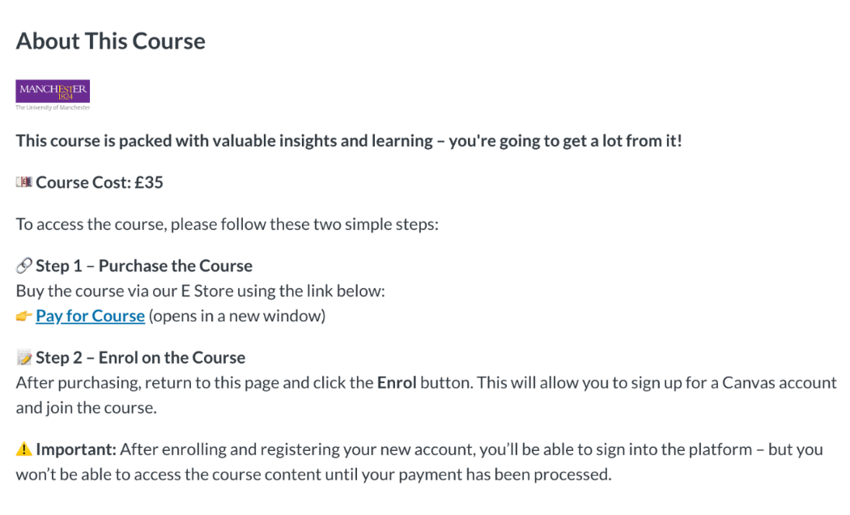

- Manage Enrolments After Payment
  - Once payment is confirmed through eStore, move the user from the holding section to the full course content area.

Catalog Support Process
The support model for Canvas Catalog is designed to ensure that users receive the right support through the most appropriate channel. When users encounter an issue or have a query, the below process should be followed.

User Support Pathways

Self-Service Guidance
All Catalog pages include a link in the footer directing users to self-service support materials (see image below). Users should be encouraged to check this guidance first, as it addresses the most common questions and issues.
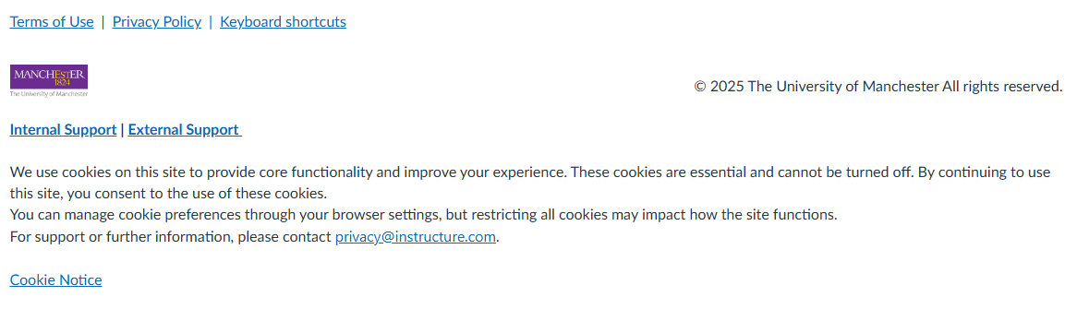

Contact Listed on Course/Programme Listing
If the self-service guidance does not resolve the issue, users should next contact the support email within the course or programme listing.
eLearning and VLE teams can access the below KBA to help support external users with the most common issues.
Canvas: Supporting External Canvas Catalog Users

If No Contact Is Listed
  - Internal Users: If no contact is listed, internal users are directed (via the support document linked in the Catalog footer) to submit a Connect ticket. The request will automatically be routed to the appropriate eLearning resolver group.
    - Canvas Catalog Course Enquiry - Connect
    - Something not working? - Connect

  - External Users: External users cannot raise Connect tickets directly. If no contact is listed on the listing, they are directed to email the IT Services Service Desk (Guest-ServiceDesk@manchester.ac.uk) using the address provided in the Catalog footer support document. The Service Desk will use the details provided by the user (as instructed in the support document) to determine the appropriate team (eLearning or VLE) to forward the query to in Connect.

Escalation Process
Sub-Catalog Admins (eLearning) should escalate issues in the following cases:
- MFA or Password Reset Required: Escalate to the VLE Team via Connect. These issues cannot be resolved at sub-catalog level.

- System Errors or Unresolved Technical Faults: If the issue cannot be resolved locally, escalate to Instructure.

