From: Maizy Jenner <maizy.jenner@manchester.ac.uk>
Sent: 27 October 2025 16:53
Subject: Staff Wellbeing Champion bulletin Monday 25th October 2025
_________________________________________________________________________

Your Pocket-Savvy Power Hour Webinar 2.0, David and Paul back by popular demand!
Wednesday 19th November, 11:00 – 12:00
Register your place here.
We will delve into 'What's New' in the full range of staff benefits and exclusive discounts designed to help your money go further. This time of year offers lots of opportunities to take advantage of offers, discounts and benefit from great savings.
We do also recognise this time of year can increase financial pressure and stress for some people - we will be discussing this important topic often skipped over during the bright lights of Christmas.

Language Café is back!
Wednesdays, 12 Nov, 26 Nov, 10 Dec,12:00pm-14:00 at Benugo Café, Simon Building
Language Café is a relaxed space for anyone who speaks or is learning a language, including English, to drop-in along and practice their speaking and listening skills with fellow learners. Staff and students are all welcome. There will be vouchers for a free drink or snack from Benugo Café to enjoy while you chat! Keep an eye out on our Instagram for updates.

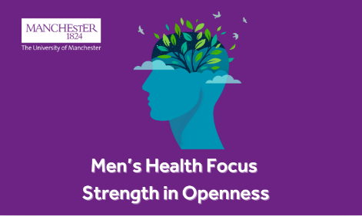
Strength in Openness: A Panel Discussing Men’s Physical and Mental Health at Work
Wednesday 26th November, 12:00 – 13:15, in-person
Register your place here

Join us for an open, honest conversation on the experiences, challenges and opportunities around men’s health and mental wellbeing in today’s workplace.
We’ll explore:
- The pressures men experience in relation to work, family life, and personal wellbeing
- The stigma that keeps so many silent – and steps we can take to break it
- Practical insights for creating workplaces where men’s health and wellbeing feels supported.
Who Should Attend:
Everyone: male colleagues, allies, managers, leaders, support service colleagues. We open the door to all colleagues and ask you to join this important conversation on men’s health and wellbeing.

Reminder to Register: New Mental Health and Wellbeing Training Offer for Line Managers
A new training offer has been launched to support line managers with the tools, skills, and confidence they need to support mental health and wellbeing in the workplace. Read the staffnet article here.
What’s on offer:
- ‘Mental Health and Wellbeing in the Workplace’, is a self-paced digital learning course. Access training via Canvas
- ‘Managing with Wellbeing in Mind’ one-day course is designed to empower line managers to feel confident in supporting mental health and wellbeing at work. Book your place
- ‘UoM Introduction to Stress Management for Line Managers and Leaders’, This is a half-day workshop that provides the opportunity for line managers to understand the role they play in supporting work-related stress. Book your place

Reminder to Register and Watch the New Wellbeing Choir Video: Join the Wellbeing Choir
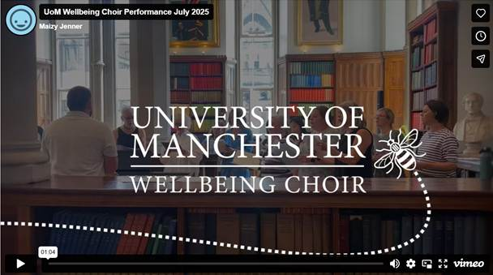
🕛 Wednesdays (1:05-1:55pm)
📍 Simon Building, Wellbeing rooms, G.065
💜 Open to all staff and students and all abilities (reading music not necessary).
👉 Sign up here (various options available)

Reminder: Free Health Screening Clinics – Open to All Staff and Students!
As part of the University’s Pharmacy undergraduate curriculum, our Year 3 pharmacy students will be running Health Screening Clinics right here on campus. No need to book – just pop in!
📅 Upcoming Clinic Dates (1:30 – 3:30pm), G.66 Wellbeing Rooms, Simon Building
- Wed 12 Nov 2025
- Wed 19 Nov 2025

Free Blood Pressure Checks at the Whitworth Art Gallery
Wednesday 5th November, 10:30 – 13:30, Gallery 3 WAG
The Whitworth Art Gallery is hosting a stall from Manchester-based charity and UoM research partner Natalie Kate Moss Trust, conducting free blood pressure checks. The charity works to raise awareness of brain haemorrhages, and blood pressure is an important factor. The checks are available for staff, students, and members of the public visiting the Whitworth.

Reminder to Register: Financial wellbeing and retirement planning sessions (multiple dates available)
To help colleagues better plan and manage their finances, the University have teamed up with a new partner Affinity Connect, to offer you expert-led financial planning sessions which include Planning for Retirement and Taking Control of your finances on offer between October 2025 – July 2026. Find out more about this offer and register for a session.

Maizy Jenner She/Her
Wellbeing Manager (For Staff)
University of Manchester |People Directorate, John Owens Building | Oxford Road | Manchester | M13 9PL | email: maizy.jenner@manchester.ac.uk
Staff wellbeing | StaffNet | The University of Manchester
Location map can be accessed via this link map.
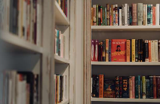
Delve into the UoM Wellbeing Collection
at the Library this summer: Discover more here.

