BUILDING ARRANGEMENTS
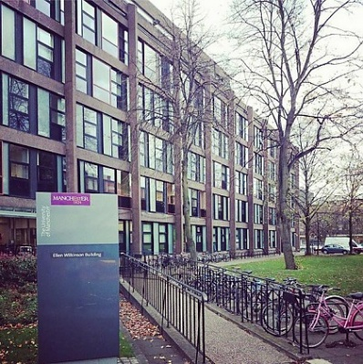
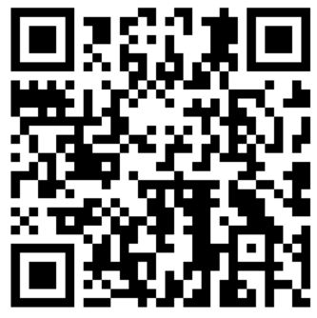
ELLEN WILKINSON BUILDING

The University of Manchester,
Devas Street, Manchester, M13 9PL

AccessAble Guide to Ellen Wilkinson:
https://www.accessable.co.uk/the-university-of-manchester/access-guides/ellen-wilkinson

what3words: https://what3words.com/noise.doors.spends

Building 77 on the interactive campus map:
https://www.manchester.ac.uk/about/maps/interactive-map/?id=73

Building Occupancy | Faculty of Humanities (HUM)  - Ellen Wilkinson Commons (School of Environment, Education and Development (SEED), Professional Services (PS))  - Block C  - Floor G  - School of Arts, Languages and Culture (SALC)  - Block C  - Floor 1  - School of Environment, Education and Development (SEED) – Manchester Institute of Education (MIE), Professional Services (PS)  - Block A  - Floors G, 1, 2, 5, 6  - Block B  - Floors G, 3, 4  - Block C  - Floors G, 2, 3  - Faculty Office Doctoral Academy (DA)  - Block C  - Floor G
Building Occupancy | Faculty of Biology, Medicine and Health (BMH)  - School of Health Sciences (SHS) / Division of Psychology, Communication and Human Neuroscience (PCHN)  - Block A  - Floors 3, 4  - Block B  - Floors G, 1, 2  - School of Health Sciences (SHS) / Division of Population Health, Health Services Research & Primary Care (PHHSRPC)  - Block C  - Floor 4
Building Occupancy | People Directorate  - People Partners  - Block C  - Floor 2
Head of School / Directorate | HUM:  - Head of School, SEED: https://www.seed.manchester.ac.uk/about/people/senior-staff/  - Head of School, SALC: https://www.alc.manchester.ac.uk/about/people/professional-support-staff/  - Head of Research and Business Engagement, DA – page to follow  BMH:  https://www.staffnet.manchester.ac.uk/bmh/about-fbmh/our-structure/  Head of School (SHS)  https://www.staffnet.manchester.ac.uk/bmh/about-fbmh/our-structure/schools-and-divisions/shs/  PEOPLE DIRECTORATE:  Contacts: https://www.staffnet.manchester.ac.uk/people/aboutpeopleod/contact-us/peopleod-partners/
Safety Advisors | The contact names included below were correct on June 2025. For up-to-date contact information please use the links provided.  HUM:  Humanities Executive Compliance and Support Officer (ECSO):  - Lynda Rowlinson: lynda.rowlinson@manchester.ac.uk  Local and School Safety Advisors (LSA / SSA):  - SEED - Jonny Brewster: jonny.brewster@manchester.ac.uk  - SALC - Osen Kilic-Yildirim: Osen.Yildirim@manchester.ac.uk  - FO/DA - Cherie Leung: cherie.leung@manchester.ac.uk  Humanities Contacts:  https://www.staffnet.manchester.ac.uk/humanities/support-services/planning-compliance-governance/compliance/health-and-safety/  BMH:  School Compliance and Risk Manager (SHS):  - Brent Collins: Brent.Collins@manchester.ac.uk  Local Safety Advisors:  - PCHN – Jacqueline O'Brien: jackie.obrien@manchester.ac.uk  - PHHSRPC – Stefan Jahr: stefan.jahr@manchester.ac.uk  BMH Contacts:  https://www.staffnet.manchester.ac.uk/bmh/ps-activities/health-safety/local-arrangements/laboratory-safety/safety-advisors/  People Directorate:  Safety Advisor Nicola Evans: Nicola.evans@manchester.ac.uk

EMERGENCY RESPONSE
SafeZone | 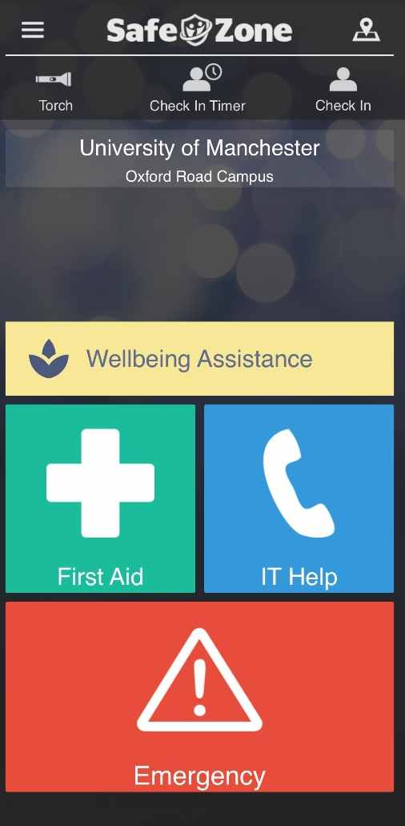  Our mobile app SafeZone is designed to give employees and students extra peace of mind when on campus or in university accommodation. The app is free to download, easy to use, and connects with the University’s Campus Support and Security team at the touch of a button if employees/students are in an immediate emergency or require first aid. To download the app and find out more:  https://www.welcome.manchester.ac.uk/get-ready/health-wellbeing-safety/safezone/  There are now SafeZone watches being launched due to accessibility issues reported by our disabled colleagues and students, to ensure everyone in our community can utilise it and feel safer on campus.  To enquire about being issued with a watch, please contact the Disability Advisory and Support Service (DASS) to discuss your needs:  Website: https://www.dass.manchester.ac.uk/  Email: dass@manchester.ac.uk
SafeZone for Lone Working | Employees can set a pre-alarm on SafeZone which will activate if it runs down while working alone?  In addition to this, fall detection can be enabled to activate if this function may be useful.  Please click here for a 3-minute video explaining the check-in timer function on the app.  How is it different from how SafeZone is usually used at UoM?      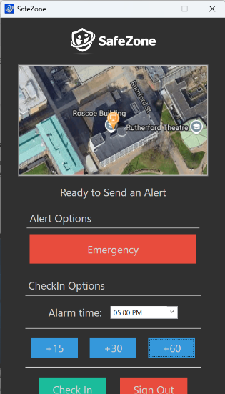  - Can increase your safety while working from home  - Supervisors will be aware of incidents while employees work  - Campus Support and Security are not the first port of call  How does it work?  - Sign up for use on Desktop or Phone  - Set up a working group with each team  - Agree with supervisors that they are happy to receive alerts if triggered  Benefits:  - Much easier than waiting for messages sent with a buddy system  - Dedicated app to improve employee safety  - Able to keep phone on Do Not Disturb but allow emergency alerts from SafeZone

Fire Safety
Fire Alarm | Single stage alarm  On hearing a continuous alarm, you MUST EXIT the building IMMEDIATELY.  DO NOT wait to be asked to leave.  Campus Support and Security Service will ‘validate’ an alarm activation.  DO NOT re-enter a building until you are told it is safe to do so.
Fire Alarm Test | Wednesday at 11:30 am  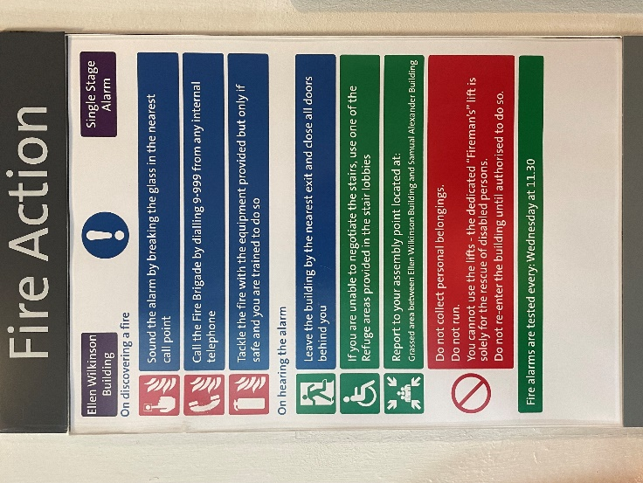
Assembly Points | Grassed area between Ellen Wilkinson and Samuel Alexander buildings.
Fire Evacuation Marshals (FEM) | FEMs are volunteers who are sought and recruited by each Faculty / School / Directorate occupying the building. They may be called upon to attend a fire evacuation call within the building regardless of the Faculty / School / Directorate.  FEMs will ‘sweep’ their designated area before making their way out.  The role of a FEM is described on page 13 in the following arrangements chapter:  https://documents.manchester.ac.uk/display.aspx?DocID=13925
General Emergency Evacuation Plan (GEEP) | A GEEP gives information on the layout, location of assembly points, evacuation procedures, available equipment, and communication devices in the building.  Many of these details are available through the information above and the online platform AccessAble, which provides detailed access guides for University buildings. It includes detailed information about a venue’s access and if a place is going to be accessible to you.  Website: https://www.accessable.co.uk/
Personal Emergency Evacuation Plan (PEEP) | Some people may need help and assistance to leave a building in the event of an emergency evacuation. These people should have a personal emergency evacuation plan (PEEP) in place, which is tailored to the individual’s needs and explains the method of evacuation as a stage-by-stage process, for all parts of the University they may use. It is applicable to staff, students and visitors.  https://www.healthandsafety.manchester.ac.uk/toolkits/fire/peeps/  HUM  Help can be sought from Local and School Safety Advisors:  https://www.staffnet.manchester.ac.uk/humanities/support-services/planning-compliance-governance/compliance/health-and-safety/  BMH  https://www.staffnet.manchester.ac.uk/bmh/ps-activities/health-safety/local-arrangements/emergency-procedures/peep/
Evac-Chairs | Information To Be Confirmed
ResQmats | Information To Be Confirmed

First Aid Provisions
First Aid Signage | 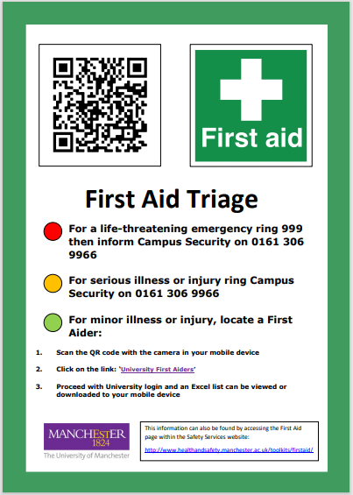  https://documents.manchester.ac.uk/protected/display.aspx?DocID=65115
First Aiders | List of trained first aiders  Spreadsheet: https://documents.manchester.ac.uk/display.aspx?DocID=11029 (downloads a copy)  PDF: https://documents.manchester.ac.uk/protected/display.aspx?DocID=57290  In the event of being unable to contact a First Aider, please contact Campus Support and Security Services (Tel: +44(0) 161 275 2728) or use the SafeZone app.
First Aiders | First Aiders are volunteers who are sought and recruited by each Faculty / School / Directorate occupying the building. They may be called upon to attend any first aid incident within the building regardless of the Faculty / School / Directorate.  The role of first aiders is described in the following arrangements chapter:  https://documents.manchester.ac.uk/protected/display.aspx?DocID=20832
AED / Defibrillator | Located on the ground floor in the Ellen Wilkinson C Block entrance:  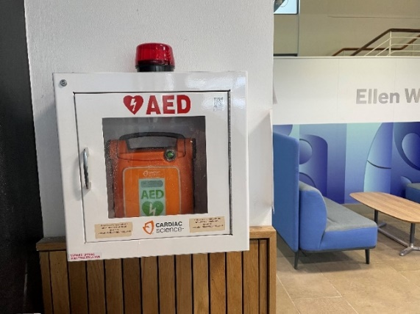  The location of other nearby defibrillators can be found on the interactive map:  https://www.manchester.ac.uk/about/maps/interactive-map/
Building
Building issues | Contact the Estates Helpdesk to report defects / faults and for general estates enquiries:  estates@manchester.ac.uk  Tel: +44 (0) 161 275 2424  Monday to Friday, 8am - 4pm
Building issues | For the escalation of queries that have been reported to the Helpdesk but have not been carried out, please contact your Faculty Estates Team:  https://www.estates.manchester.ac.uk/services/fet/
Building issues | In case of emergency and out of hours, you should report any problems to the Main Security Office Tel: +44(0) 161 275 2728
Building issues | House Services contacts:  https://www.estates.manchester.ac.uk/services/operationalservices/houseservices/house-services---contact-us/
Building User Groups (BUG) | For each building on campus used by staff and students, there are dedicated Building User Groups (BUGs) designed to ensure that colleagues are kept up to date with developments and estates projects that impact their building. They are a forum to share information regarding upcoming events and raise building related concerns.  For more information or to join the BUG for this building, please contact the relevant Estates Partner:  FHUM: TBC  FBMH: https://www.staffnet.manchester.ac.uk/bmh/about-fbmh/our-structure/ps-functions/estates/
Room Bookings | The Central Teaching Spaces (CTS) team manage and book the central teaching and meeting rooms and other spaces at the University. These rooms are available to book for any University member of staff for any University related event.  CTS StaffNet pages: https://www.estates.manchester.ac.uk/services/centralteachingspaces/  CTS rooms available for Ellen Wilkinson Building are:  - A2.16  - A2.6  - A2.7  - A3.6  - A3.7  - B2.4  - C1.53  - C5.1  Resource Booker is the service that can be used to book various rooms and services across campus. If you are unable to see the rooms you are looking for, then they are likely not booked through Resource Booker. Please check locally within your Faculty / Directorate.  The Central Computer Clusters bookable through Resource Booker are:  - Ellen Wilkinson_B3.1  - Ellen Wilkinson_B3.17  - Ellen Wilkinson_B3.3
Ellen Wilkinson Commons | There is additional space available to book on the ground floor of C Block, as follows:  - Event space (150-180)  - CG.38 Jarrow (5)  - CG.40 Darlington (5)  - CG.41 Leeds (5)  - CG.43 Nottingham Boardroom (9)  - CG.45 Northampton (5)  - CG.46 London (3)  Details of how to book these spaces (which are managed by SEED) can be found in the Ellen Wilkinson Commons Standard Operating Procedure Document:  https://documents.manchester.ac.uk/protected/display.aspx?DocID=76893

Assessments
Display Screen Equipment (DSE) Assessments | Safety Services  DSE Toolkit: https://www.healthandsafety.manchester.ac.uk/toolkits/dse/  HUM  SALC: https://forms.office.com/e/fcxnYU6QUW  SEED: https://www.qualtrics.manchester.ac.uk/jfe/form/SV_bad9v3Dg2LcBKu2  HUM FO / DA:  - Office DSE assessment: DSE assessment  - Homeworking checklist: Home-working checklist  BMH  https://www.staffnet.manchester.ac.uk/bmh/ps-activities/health-safety/local-arrangements/risk-assessments/dse-assessments/  (do we need to include for People Directorate?)
Risk Assessments | Safety Services  Risk Assessment Toolkit: https://www.healthandsafety.manchester.ac.uk/toolkits/ra/  Building Risk Assessment: (to follow)  HUM  Support is available through your Local / School Safety Advisor and your Executive Compliance Support Officer.  BMH  Visit the BMH H&S pages  https://www.staffnet.manchester.ac.uk/bmh/ps-activities/health-safety/local-arrangements/risk-assessments/  Support is available through your Compliance and Risk Manager

OTHER SUPPORT AVAILABLE
IT issues | Get in Touch  Telephone IT support is available 24 hours a day, 7 days a week.  Tel: +44 (0) 161 306 5544  In-person IT support  Visit an IT support desk for face to face, practical advice. No appointment necessary.  https://www.itservices.manchester.ac.uk/help/in-person/  Staff support  Face-to-face support is available on the ground floor of the Kilburn building.  - Building 39 on the campus map  - Monday to Friday, 8am to 5pm  - Appointments are not necessary, however they can be requested in some circumstances  Student support  On site student IT support is available at the Main Library and Alan Gilbert Learning Commons 9am-5pm, Monday to Friday.  Find out more about student IT support on the Library's website:  https://www.library.manchester.ac.uk/services/library-it-services/it-support/
Training | Talent Development: https://www.staffnet.manchester.ac.uk/talent-development/  Training catalogue: https://app.manchester.ac.uk/training/default.aspx  It is your line manager’s responsibility to ensure you receive the appropriate training for your role and work activities.
Induction | New Starters Induction:  https://www.staffnet.manchester.ac.uk/people/new-staff/induction/  HUM  Faculty of Humanities Induction Guide:  https://rise.articulate.com/share/VEOL0o_aauH88Gsy-NpLA_wGze_B6OFw#/  Local and School Safety Advisors:  https://www.staffnet.manchester.ac.uk/humanities/support-services/planning-compliance-governance/compliance/health-and-safety/  BMH  Faculty of Biology, Medicine and Health Induction Guide:  New staff | Faculty of Biology, Medicine and Health | StaffNet | The University of Manchester

WELLBEING AND INCLUSION
Wellbeing
Wellbeing | Wellbeing assistance is available via the SafeZone app (screenshot below):  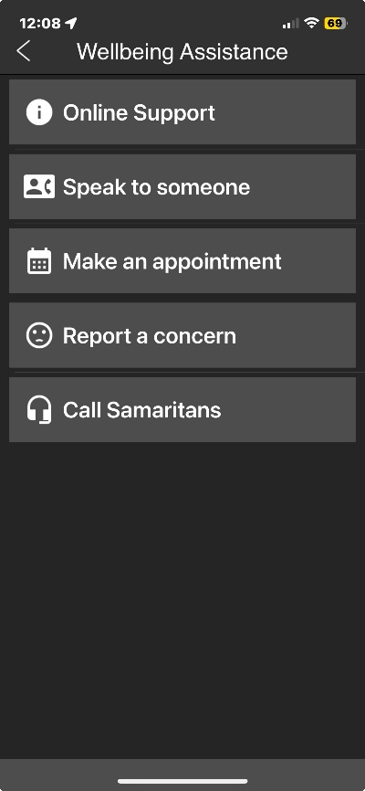  Staff Wellbeing  Website: https://www.staffnet.manchester.ac.uk/wellbeing/  Email: wellbeing@manchester.ac.uk  Student Wellbeing  Website: https://manchesterstudentsunion.com/wellbeing-support  Email: info.su@manchester.ac.uk  HUM:  https://www.staffnet.manchester.ac.uk/humanities/support-services/planning-compliance-governance/compliance/wellbeing/  BMH:  (to be confirmed)
Quiet Rooms | Quiet spaces booklet:  https://livemanchesterac.sharepoint.com/:b:/r/sites/UOM-EDI-NeurodivergentStaffNetwork/  Shared%20Documents/General/Quiet%20Spaces%20Booklet%20(1).pdf?csf=1&web=1&e=77ecU8  Quiet spaces on campus:  https://livemanchesterac.sharepoint.com/:w:/s/UOM-DSN-NeurodiversityNetworkPRIVATE/EU9hxllysj5AnAOTni2kMV4ByHtQg6jWvoSRQGZtNTLJWw?e=upcCwg
Welfare Rooms | Welfare rooms can be filtered on the interactive map – there are currently no welfare rooms in Ellen Wilkinson:  https://www.manchester.ac.uk/about/maps/interactive-map/
Prayer Rooms | Places of worship can be filtered on the interactive map:  https://www.manchester.ac.uk/about/maps/interactive-map/  Spaces for faith and worship:  https://www.residents.manchester.ac.uk/support-and-wellbeing/faith-and-worship/
Water Dispensers | Water dispensers can be highlighted on the interactive map:  https://www.manchester.ac.uk/about/maps/interactive-map/
Food and Drink | Unicafe:  Website: https://www.unicafe.manchester.ac.uk/  Email: unicafe@manchester.ac.uk  Please note that all of our cafes are now cashless. You can pay by card or use your staff / student ID card to save 10% (staff) 20% (students) on all food and drink purchases.  Please use our map showing all of our University of Manchester campus outlets to find your closest cafe.  Vending machines are available in Ellen Wilkinson Commons on the ground floor in C Block.
Cosy Campus Spaces | The Cosy Campus initiative was created in 2021 response to the rising cost of living. There are several spaces across the University that have been transformed to create comfortable and welcoming environments where students and staff can relax, work, and spend time at on campus for group work or leisure time. A full list of Cosy Campus spaces and the facilities available is available in a dedicated information document.  In June 2025, located on the ground floor in C Block, the newly refurbished facility in ‘Ellen Wilkinson Commons’ opened and includes:  - Hot water for tea, coffee and meals.  - Washing up and hand washing facilities.  - 2 x microwave stations to heat up your own food.  - Warm and cosy seating for group study or leisure time.  - Power sockets for charging devices.  https://www.staffnet.manchester.ac.uk/news/display/?id=32487
Inclusive Events / Meetings | At the heart of our community is a commitment to creating spaces where everyone feels valued, respected, and able to thrive. This page is your gateway to understanding how we foster inclusion through events that celebrate diversity and ensure accessibility for all.  Whether you are attending or organising, or promoting an event or meeting, our resources and guidance are here to help you make every gathering welcoming and equitable.  Let’s work together to ensure every event is a step towards a more inclusive community. For more on best practices and strategies, see https://livemanchesterac.sharepoint.com/:p:/s/UOM-EDI-Team/ESNrTUDLu6hDuHAaJ00iK80BJ4myh2kW4Pubo4zaf00cxg?e=u6whcA.
Hidden Disabilities Sunflower Programme |   Not all disabilities are visible, conditions such as autism, chronic pain, mental health conditions, hearing loss, or mobility issues may be hidden. The Hidden Disabilities Sunflower is a globally recognised symbol for individuals with non-visible disabilities. Wearing a Sunflower lanyard, badge, or card signals that a person may need extra time, patience, or assistance.  You can collect a Hidden Disabilities sunflower lanyard from the following locations:  https://www.staffnet.manchester.ac.uk/equality-diversity-inclusion/equality-groups/disability/hidden-disabilities-sunflower-scheme/
  Waste and Recycling on campus | We are on a mission to recycle 45% of our campus waste, but we need your help! Whilst 100% of our waste is diverted from landfill, too many recyclables are ending up in the general waste and are therefore being incinerated. We have great recycling infrastructure both on campus and in our residences. But all these resources can be overwhelming! There is further information and resources on our website.  https://www.estates.manchester.ac.uk/services/operationalservices/envsvcs/waste/  NB: Waste facilities across campus and residences were audited 12/02/2025. Please contact es@manchester.ac.uk if you want to report a change to any facilities, know of a facility that is not included, or have any questions about where to recycle certain items.  Battery collections can be found at receptions in all buildings, and food waste collection points in all café areas and student kitchens. Some of these may not be included here as the busiest areas of campus were prioritised when creating this guide.  The document link below details the disposal / recycling arrangements for all these wastes, listed in alphabetical order:  https://www.estates.manchester.ac.uk/media/services/estatesandfacilities/A%20to%20Z%20of%20Waste%20Types%20update%20July%202024.pdf

Document Control Box
Title | Building Arrangements Document – Ellen Wilkinson Building
Date Approved: | August / September 2025
Approving Body: | FBMH and Humanities FCC
Implementation date: | 01/11/2025
Version: | Draft 0.3
Next Review Date: | 01/09/2026
Owner: | FBMH / Humanities
Document ID: | https://documents.manchester.ac.uk/display.aspx?DocID=77302

