PGR Practical Competency Assessment Framework
Process
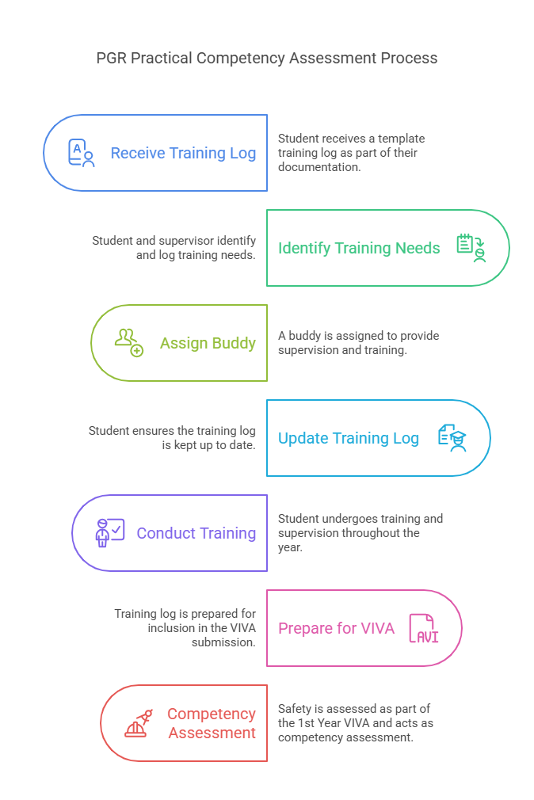
- Start of PhD
  - Student receives template training log as part of their starting documentation set.
  - Student and supervisor identify training needs and add to log and this will happen continuously when new activities are introduced.
  - Buddy is assigned to take on supervision and training.

- Student takes ownership of the training log and ensures it is kept up to date. Student is trained and supervised throughout the year.

- 1st Year VIVA
  - 1st part of the assessment will be around Safety and will be their competency assessment.
  - The training log is to be added at the start of the VIVA submission/report.
  - This will be incorporated into the VIVA decision form and logged on eProg.
Note: The competency assessment can be carried out prior to the 1st Year VIVA but requires a discussion with the Supervisor AND an academic external to the supervisory team. And if the PGR project is purely theoretical, this assessment will not be required.
Buddy role descriptor

Qualifications

• The Buddy must be an experienced individual well-versed in the relevant activities and processes. This should not default to technical staff or inexperienced students.

• They should have undergone comprehensive training and demonstrated proficiency in the tasks they will oversee.

• The Buddy should possess strong communication and mentoring skills to effectively guide and support the student.

Responsibilities

• Provide supervision and guidance to the student during their training period.

• Assist the student in maintaining and updating the training log, ensuring that all necessary signatures are obtained.

• Act as a liaison between the student and the supervisory team, relaying any concerns or progress updates as needed.

• Support the student in developing the necessary skills to work independently post-1st Year VIVA, while ensuring adherence to safety protocols.

Accountability

• While the Buddy provides essential support and guidance, the ultimate responsibility for the student's training and competency assessment lies with the supervisors.

•The supervisors will review and sign off on the competency assessments, based on the Buddy's input and the student's performance.

Example Training Log
Subject of Training | Date of Training | Trainer's Sign-Off | Trainee's Sign-Off

Document Control Box
Document Title: | PGR Competency Assessment Framework FSE
Version: | 1.0
Author: | Sylvester Boon
Effective Date: | 26/03/2025
Review Date: | 01/05/2025

Approved By:

