

ITEM
THE UNIVERSITY OF MANCHESTER

ENVIRONMENTAL SUSTAINABILITY COMMITTEE

7 OCTOBER 2025

ENVIRONMENTAL SUSTAINABILITY ANNUAL PERFORMANCE REVIEW 2024-25

SPONSOR: Professor Nalin Thakkar, Vice-President (Social Responsibility)
AUTHOR: Julia Durkan, Head of Environmental Sustainability

EXECUTIVE SUMMARY
This paper summarises annual performance against the commitments set out in ‘Our Sustainable Future,’ the University’s Environmental Sustainability (ES) Strategy. Key milestones include completion of the Corporate Power Purchase Agreement, a major step toward reducing our carbon emissions. However, emissions fell by only 5% compared to 2023, leaving us behind on the reduction pathway required to meet our 2038 zero carbon target. Water and investment goals remain on track, while progress on energy, waste, labs, aviation and training is falling behind. A review of the ES Strategy will be required in the coming year to align with Manchester 2035 and reset targets and commitments, many of which have 2025 end dates.

DECISIONS REQUESTED
To note progress against University environmental sustainability commitments.

COMMUNICATION REQUIREMENTS
- To be published on external facing University environmental sustainability webpages.
- To SRC for information.
APPENDICES
Appendix A: Summary of progress against headline commitments from the ES Strategy

DETAIL OF REPORT

INTRODUCTION
This year has seen some significant achievements, including:
- Townhall meeting with President to discuss our commitment to sustainability and integration with Manchester 2035. A follow-up podcast was recorded with Professor Carly McLachlan and Professor Mike Shaver to answer colleague’s questions.
- Global recognition in rankings: #1 in the UK and Europe, #2 globally in the Times Higher Education Impact Rankings; 9th in QS World University Sustainability Rankings; 71st in People & Planet Rankings.
- Signed the Concordat for the Environmental Sustainability of Research and Innovation Practice.
- Completion of the Corporate Power Purchase Agreement (cPPA) with energy purchasing started on 1 September 2025.
- The cPPA project won multiple awards, including the AUDE Sustainability Impact Initiative Award and a University Making a Difference Award.
- Shortlisted as Green Gown Award finalists for the Furniture Reuse Store and the transformation of the Old Quad into a new green, biodiverse space.
- Completion of a high-level heat network study to inform decarbonisation pathways.
- Launch of a new Travel Plan including updated car parking policy, trial of free bus travel from Victoria, and rollout of a new EV salary sacrifice scheme.
- Awarded Fairtrade University two-star status.
- Launch of the Bee Cup reusable cup scheme with 10% reduction in disposable cups recorded.
Despite these successes, challenges persist. Carbon emissions fell by only 5% compared to 2023, leaving us behind on the reduction pathway required to meet our 2038 zero carbon target. Achieving this goal now requires a 17% annual reduction to remain within our science-based carbon budget, as set by the Tyndall Centre and aligned with Greater Manchester’s climate ambitions. There is a need to review the ES Strategy over the coming year to align with Manchester 2035 and reset targets and commitments, many of which had 2025 end dates.

ZERO CARBON
Scope 1&2 Target: Achieve zero carbon emissions in our operations by 2038 and without exceeding our ‘carbon budget’.
Figure 1: Actual and forecast carbon emissions until 2028 vs our carbon budget pathway
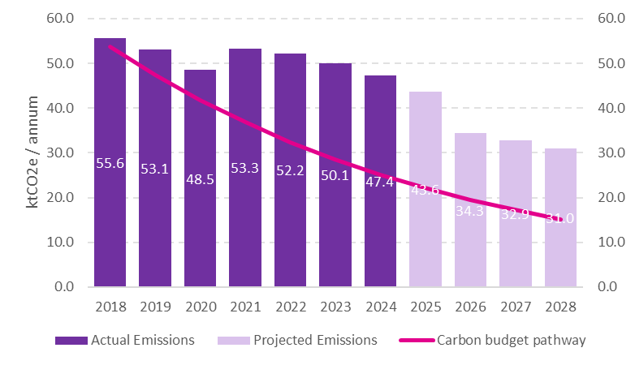
Our original target to achieve zero carbon by 2038, while staying within our allocated carbon budget, requires an annual emissions reduction of 13%, illustrated by the carbon budget pathway in Figure 1. However, since 2018, we have achieved an average annual reduction of just 3% with a 5% reduction in 2024 compared to 2023.
Between 2018 and 2024, the University used 80% of its overall science-based carbon budget of 450,000 tonnes, putting us on track to exceed the budget by the end of 2027 without accelerated reductions.
The Corporate Power Purchase Agreement (cPPA) has been finalised and from 1st September 2025 we started to purchase energy from the ‘new to earth’ solar farm. It is expected to cover around 65% of the University’s electricity demand and reduce carbon emissions by 12,000 tonnes per year.
The lighting project at Carys Bannister has been completed and expected to provide annual carbon savings of 10 tonnes.
Progress on major capital projects continues to advance. At the Rutherford building, works on site are progressing with fit-out, external envelope and roof repairs, with completion estimated for Q1 2026. Once complete, the project is expected to deliver annual carbon savings of 26 tonnes. The zero-carbon retrofit of the Zochonis Building is also underway, with enabling works now 100% complete. Project completion is projected for Q3 2026, with anticipated annual carbon savings of 220 tonnes.
The North Campus Energy Centre incorporates high-temperature heat pump technology, avoiding the need for costly upgrades to radiators and pipework. This provides a more cost-effective and less disruptive “plug and play” solution to decarbonise retained buildings such as John Garside and George Begg simultaneously, with the flexibility to expand to the Masdar Building in future. Stage 4 of the project has been completed, with overall completion expected by Q2 2027 and annual carbon savings of 520 tonnes.
Challenges remain with the whole-building, “fabric-first” approach, which is complex, costly and disruptive, often requiring full building decants. Aligning these projects with long-term maintenance (LTM) works has proved difficult, slowing delivery and limiting impact on the carbon budget. By contrast, the technology-first approach adopted at North Campus is proving better value for money, scalable and less disruptive supporting faster progress towards decarbonisation.
A high-level heat decarbonisation report has been completed, highlighting how various technologies could decarbonise our heat networks at scale. These recommendations will be integrated into the emerging integrated infrastructure plan, supported by further techno-economic and commercial assessments.
To achieve zero carbon by 2038, the annual emissions reduction rate must rise to 17 percent. Progress is expected to occur in step changes, with the cPPA and the North Campus Energy Centre delivering significant reductions in 2026 and 2027. Decarbonisation of heat networks will likely provide the next major step change. Integration of these projects within the wider infrastructure plan will be essential to establish a clear view of costs, funding requirements and the carbon reduction trajectory.
To date, £6.4m of the £175m zero carbon budget has been spent, of which £3.8m was Salix funding. Spend budget for 2024/25 was £5.8m with actual spend £4.5m. Underspend largely due to delays with the LTM programme. Forecast spend on zero carbon works for 2025/26 is £10m.

Scope 3 Target: Net-zero by 2050
This year we have calculated our Scope 3 emissions for 2023/24.
Table 1: Total Scope 3 Carbon emissions
Year | 2023/24 | 2022/23 | 2018/19
Scope 3 Carbon emissions | 617,090 | 459,142 | 390,283

The Environmental Sustainability Committee decided to include three pension schemes (USS, UMSS and the Greater Manchester Pension Fund) rather than just one. This significantly increased our Scope 3 carbon footprint, with the investments category now more than five times greater than it would have been without USS and GMPF. Overall, this expanded scope makes our total Scope 3 emissions 29% bigger than they would otherwise appear.
We also undertook a Scope 3 materiality assessment, including interviews with key staff and a survey open to all staff and students. Combining these insights with our carbon data enabled us to identify and prioritise the top 10 Scope 3 categories. In the next academic year, we will focus on reducing emissions from these priority areas and allocate fewer resources to collecting Scope 3 data. Some categories, such as travel, are already well developed, but most will require new plans, targets and actions.

RESOURCE MANAGEMENT
Energy Target: Reduce our consumption by 10% against a 2018 baseline by 2025.
Total energy consumption for 2024/25 was 250 GWh, a 2% increase compared to 2023/24 (248 GWh) and 1% higher than the 2018/19 baseline. While electricity use has remained steady, supported by the optimisation of our combined heat and power system and stabilisation of the Nancy Rothwell building, the 10% reduction target is unlikely to be achieved. Looking ahead, achieving meaningful reductions will require a stronger focus on energy efficiency across our estate, investment in building optimisation and refurbishment, and greater engagement with staff and students to embed energy-conscious behaviours.
Figure 2: Energy consumption: Progress against target, baseline, and two-year trend
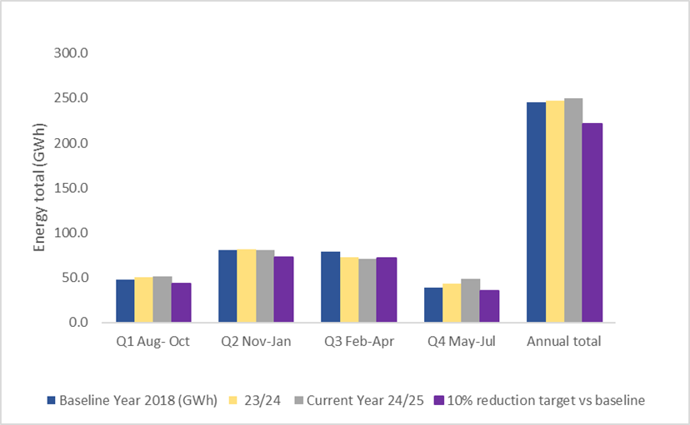

Water Target: Reduce our consumption by 15% against a 2022 baseline by 2028.
Water consumption in 2024/25 was approximately 700,000 m³, representing a 7% increase compared to 2023/24 but remaining 12% lower than the 2022 baseline year. A key challenge continues to be the limited granularity of data across different operational areas of the University, which restricts our ability to fully understand consumption patterns. To address this, automatic meter reading data loggers have now been installed on 20 water supplies, providing half-hourly data to support closer monitoring, improved identification of usage trends and early detection of leakage.
Figure 3: Water consumption: Progress against target, baseline, and two-year trend
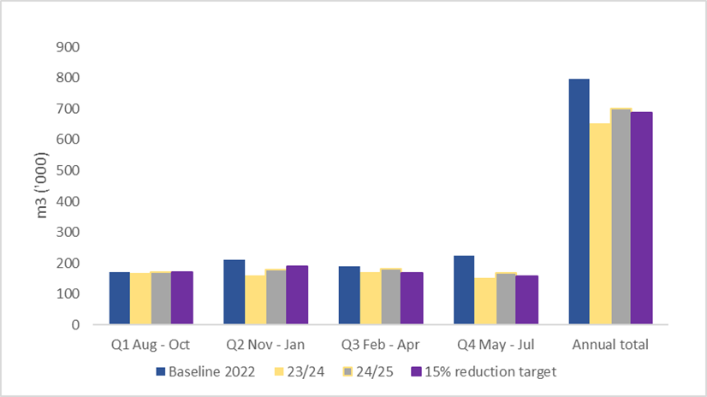

Waste Target: Recycle 45% of the waste produced because of campus operations by 2025.
In 2024/25 the University has made steady progress, with the recycling rate increasing from 39% to 40%, supported by expanded food waste recycling and the Bee Cup scheme, which saved over 63,000 single-use coffee cups and lids. More than 80 tonnes of furniture were reused via the Furniture Store, alongside 2 tonnes of lab equipment rehomed or donated through the UniGreen Scheme and the LabGood4Reuse initiative, initiated by FBMH. Looking ahead, our focus will be on developing a three-year waste and circular economy plan to set clear goals and actions that will drive bigger change.
Figure 4: Recycling rates: Progress against target and three-year trend
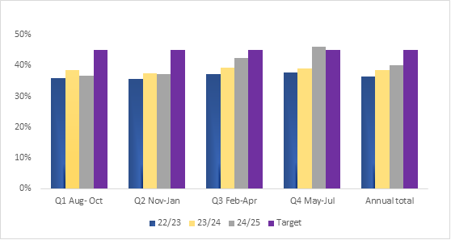

Labs Target: All labs to achieve a LEAF bronze and 25% achieve LEAF silver by 2025.
By the end of 2024/25, 46% of University labs had achieved LEAF accreditation, marking significant progress from 15% in the previous year. Building on this momentum, the focus is shifting to fostering collaboration across Faculties through the development of a central SharePoint resource hub and training to support embedding sustainable practices in labs. With funders increasingly requiring evidence of sustainable operations, it is essential that we take a more holistic approach to LEAF, motivating labs to view sustainability as integral to research and ensuring they are equipped to adopt more efficient and responsible ways of working.
Figure 5: Percentage of Labs with LEAF certification
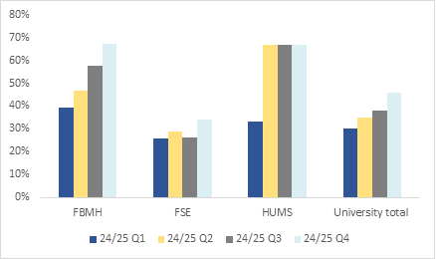

RESPONSIBLE PROCUREMENT
Procurement Target: Develop appropriate Scope 3 emissions targets in relation to the procurement supply chain and measure estimated emissions against these targets.
As part of our work to identify our top 10 Scope 3 categories, we analysed the purchased goods and services data to understand where our biggest impacts are. This will help inform the action plan we are developing in the next academic year around Scope 3. Whilst we haven’t yet developed targets, we have made a start on measuring estimated emissions and determining where we should prioritise. This area is moving very slowly, and action needs to accelerate to meet our Scope 3 target.

TRAVEL AND TRANSPORT
Following a thorough impact assessment and review, a new 5-year University travel plan was published in February.
Business Travel Target: Aim to limit emissions from air travel to 50% of our 2018/19 level.
After a significant reduction in 2022/23, when our aviation emissions fell by 46% compared with the 2018/19 baseline, emissions increased again in 2023/24, representing a reduced 34% decrease against baseline levels.
In 2025, DEFRA aviation emission factors were approximately 20% lower than in the 2019 baseline year. As a result, reported emissions from business air travel fell from 12,390 tonnes CO₂e in 2023/24 to 9,257 tonnes CO₂e in 2024/25, meaning the University is now within its current target threshold of 9,321 tonnes CO₂e.
However, overall kilometres travelled, alongside the mix of flight class and haul length, remained broadly similar to 2023/24 levels. This suggests the reduction is primarily due to changes in emissions factors rather than significant changes in travel behaviour.
In light of this, we are reviewing whether the current target remains fit for purpose and whether it is driving the right behavioural changes needed to support the University’s long-term carbon reduction ambitions.
Figure 6: Aviation emissions: Progress against baseline, target and three-year trend

Commuting Target: Reduce staff car commuting from 32% in 2024 to 27% by 2030.
To support the launch of the new travel plan, a range of commuting incentives were introduced to encourage a shift towards more sustainable transport including short-term, one-off trials aimed at car park users, a pilot trialling free bus travel between Manchester Victoria, launch of the electric vehicle salary sacrifice scheme and enhanced Cycle to Work scheme.
Fleet Vehicles Target: Replace all University fleet vehicles with electric vehicles by 2030.
A new working group is shaping the University’s electric vehicle charging plan, a key enabler toward the 2030 fleet target. Key actions include assessing current assets and planning future EV charging solutions.

VALUING NATURE
Biodiversity Net Gain Target: Achieve 20% BNG on all major construction and refurbishment projects.
Fallowfield Residences Redevelopment Project is on track to achieve 11% biodiversity net gain.
Greenspace Target: Increase the quality and quantity of existing green space, achieving a 10% increase in urban green space by 2028, from 2018 levels.
The Valuing Nature Action Plan, launched at the start of the 2024/25, is now focused on implementing actions to achieve its objectives. This includes planting guidelines and best-practice use of green space to inform the upcoming integrated infrastructure strategy. An ecological audit of bird, bat, and insect habitats has provided recommendations for enhancing biodiversity, which will be costed and implemented this year. In parallel, a campus-wide audit of compost and peat use is underway to ensure compliance with our peat-free policy.

ENDOWMENT INVESTMENTS
Investment Targets: see appendix 1
This year saw good progress on our investment target. We exceeded our 50% target for reduction in the weighted averaged carbon intensity (WACI) of equity holdings by 2027. We achieved a 59% reduction from 31 December 2019 to 31 July 2024. We almost hit our 40% target for reduction in the WACI within the investment grade credit allocation by 2027. We achieved a 39% reduction from the benchmark figure between 31 December 2019 and 31 July 2024. Additionally, we had no direct shareholdings in coal, oil or gas companies, companies producing tobacco or manufacturing controversial weapons, or companies with the lowest ESG rating (as defined by MSCI) throughout 2024. More details on these can be found in the Responsible Investment Report 2024.

ENGAGEMENT
In October 2024, we established the Sustainability Squad, a group of passionate individuals across the University to lead or influence the design and delivery of sustainability engagement initiatives. The group focused on delivering three key events across the year: nature month in April, end of year reuse in June and sustainable travel in October. This focused approach has been successful with increased engagement across campus.
Our student Sustainability Champions go from strength to strength. This year saw 40 students deliver a range of sustainability related events including upcycling, food waste reduction, digital clean ups, litter picking and clothes swaps. This is a Step Up and Lead accredited programme through Stellify.
In 2025 we appointed an IT company to provide us with a digital engagement platform for all staff and students. This will be launched in Autumn 2025 and has received positive feedback from users during the testing stage.
Training Target: Provide staff with environmental training, with senior staff prioritised.
Collaboration with the Learning & Development Team has begun, with development time scheduled in the coming year to create a 30-minute “Introduction to Environmental Sustainability at The University of Manchester” essentials learning module.

Priority​ | Commitments​ | Target Date​ | Progress​ for 24/25
Zero Carbon ​ | Achieve zero carbon emissions in our operations (Scopes 1&2) by 2038 and without exceeding our “carbon budget”​ | Aug 2038, carbon budget​monitored annually​ | Red​ | Scope 1 & 2 total emissions for 2024 were 47 kilotonnes, exceeding the carbon budget target by 24 kilotonnes (102% excess). From 2018 to 2024, 80% of the carbon budget was spent.
Energy​ | Reduce our energy consumption by a total of 10% against a 2018 baseline, achieved by joint working across the University led by The Directorate of Estates & Facilities and IT Services.​ | Aug-25​ | Red​ | Total energy consumption for 2024/25 was 250 GWh, a 2% increase compared to 2023/24 (248 GWh) and 1% higher than the 2018/19 baseline.
Travel​ | Aim to limit annual emissions from air travel to 50% of our 2018/19 level (pre the Covid-19 pandemic) with immediate effect | Aug-24​ | Red​ | Aviation emissions decreased by 32% compared to the baseline.
Waste​ | Recycle 45% of the waste produced as a result of campus operations​ | Aug-25​ | Red​ | We recycled 40% of our waste from campus operations.
Procurement​ | Develop appropriate Scope 3 emissions targets in relation to the procurement supply chain and measure estimated emissions against these targets​ | Develop target: Dec 2023; measure emissions Aug 2024​ | Green​ | We identified our top 10 Scope 3 emissions categories and will develop a plan with focus on targets and actions to reduce emissions from these top 10 categories.
Training​ | Provide staff with environmental training, with senior staff prioritised.​ | SLT trained by Aug 24, all staff trained by Aug 26​ | Red​ | Content still in development.
Biodiversity​ | Achieve 20% biodiversity net gain on all major construction and refurbishment projects.​ | Aug-25​ | Amber​ | BNG targets included in major construction projects.
Biodiversity​ | Increase the quality and quantity of existing green space, achieving a 10% increase in urban green space, from 2018 levels.​ | Aug-28​ | Amber​ | An audit of the quantity of green space on campus will be conducted in 25/26.
Laboratories​ | Require all laboratories to achieve a LEAF award to a minimum of Bronze and adopt a 6R "responsible plastic protocol" by August 2025. 25% of labs to achieve minimum of LEAF silver. ​ | Aug-25​ | Red​ | 45% of our labs achieved Bronze or above in LEAF certification.
Investment​ | Reach net zero on investment portfolio​ | Aug-38​ | Green​ | Absolute emissions of our investment portfolio was 6,948 tCO2e (up from 5,144 tCO2e) on 31 July 2024 but the weighted average carbon intensity (WACI) of our investment portfolio (tCO2e/£Revenue) excluding property has fallen by 16% on the previous year.
Investment​ | Reach 100% renewable energy use within the endowment investment property portfolio ​ | Aug-27​ | Green​ | The property portfolio has 100% REGO backed renewable energy.
Investment​ | Reduce weighted average carbon intensity of public equity holdings by at least 50% against 2019 baseline.​ | Aug-27​ | Green​ | The University has reduced the WACI in the equity portfolio by c59% relative to the University's portfolio baseline 2019 position. The University has therefore already met its 2027 target of a 50% reduction.
Investment​ | Reduce carbon intensity within the investment grade credit allocation by 40%​ | Aug-27​ | Green​ | The fixed income assets has a WACI which is c39% lower than the baseline 2019 position and is therefore on track to achieve the 2027 target of 40%.
Investment​ | Reduce energy consumption within the investment property portfolio by 10%​ | Aug-27​ | Green​ | 6% reduction compared to the target for 2027 of 10%.
Appendix A Summary of progress against headline commitments from the ES Strategy:

