Evidence Briefing
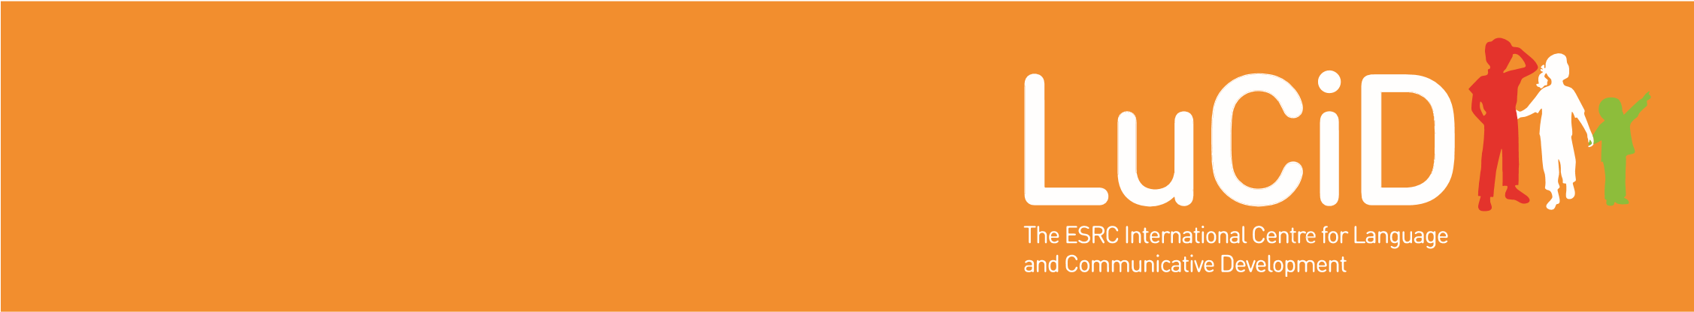
Myths and misconceptions about language development in multilingual children
Prof Ludovica Serratrice, ESRC LuCiD Centre
l.serratrice@reading.ac.uk
Multilingual children are defined as children who are exposed to English and to one or more additional languages (henceforth called home languages) either simultaneously from birth or successively.

Introduction
According to the 2016 school census, 20% of primary school children in the UK speak English as an additional language. It is crucial then that early years professionals (e.g. nursery staff, health visitors) are capable of giving honest, accurate advice to parents and to other professionals about what we might expect of these children in terms of language development, expectations, and readiness for school.
This document details and debunks a number of misconceptions that early years staff sometimes have with regard to multilingual language development. These should be targeted, and corrected, in training material for early years practitioners.

Multilingual language learning is neither quick nor effortless
There is a widespread belief that children can learn a second or third language quickly and effortlessly. Therefore, there is often an expectation that children should make rapid progress and should catch up with monolingual (single language learning) children of the same age after a few months of exposure to a new language It is true that age of exposure to a second language is a significant predictor of ultimate attainment, especially when it comes to sounding like a native speaker. It is also true that children do have an advantage over adults in this¹.
Nevertheless, longitudinal studies of immigrant children have consistently shown that it takes second language learners years to achieve the language standards of monolingual children². It is consequently unreasonable to expect that children who have only been exposed to English for a few months will have language skills comparable to their monolingual peers.

The speed of language acquisition depends on the amount of input children receive in each language
No two multilingual children will be alike, even those learning the same two languages. This is because different children receive different amounts of input, as well as input of differing quality. This will ultimately affect their rate of development in both English and their first language.
In general, even children who have a relatively balanced exposure to two languages (i.e. hear each language roughly 50% of the time) typically have smaller vocabularies than monolingual children of the same age in each of their languages. Some studies suggest that multilinguals need to hear a language 60% or more of the time in order to mirror the attainment of monolinguals in that language^{3,4}. So, when trying to work out if a child is delayed in a particular language, it is important first to discover how much exposure they have had to that language (you can download a Language Exposure Questionnaire to help with this, see: www.psy.plymouth.ac.uk/babylab/leq).
However, there is also evidence that, when adding the number of words that children know across their two languages, the size of these children’s total conceptual vocabulary (i.e. the sum of the concepts for which they have words in either language) is comparable to the size of the vocabulary of monolingual peers. This is because children may learn some words in one language (e.g. fork, spoon) and other words in another (e.g. circle,time). Therefore, an alternative way to measure the language development of a multilingual child is to sum how many unique words the child knows in both languages combined.

Code-switching is an integral part of the multilingual language experience
Switching between languages in the same conversation, or even in the same sentence (code-switching), is a common
LuCiD Evidence Briefing: Misconceptions about language development in multilingual children July 2016
behaviour for both multilingual children and adults. Sometimes this mixing is perceived as a sign of confusion or of linguistic incompetence. However, decades of research on both children’s and adults’ code-switching have now shown that multilingual speakers are anything but confused.
The reasons why children and adults code-switch are numerous and systematic and include, but are not limited to, assessment of the listener’s language knowledge (switching to a language the listener knows better), the (non-) existence of translation equivalents across their two languages (an idea may be expressed better in one language but not the other), and lexical gaps (switching because you know the word in one language not another)^{5,6} . This means that code-switching is a sophisticated strategy that requires a wealth of linguistic knowledge; the exact opposite of linguistic confusion.
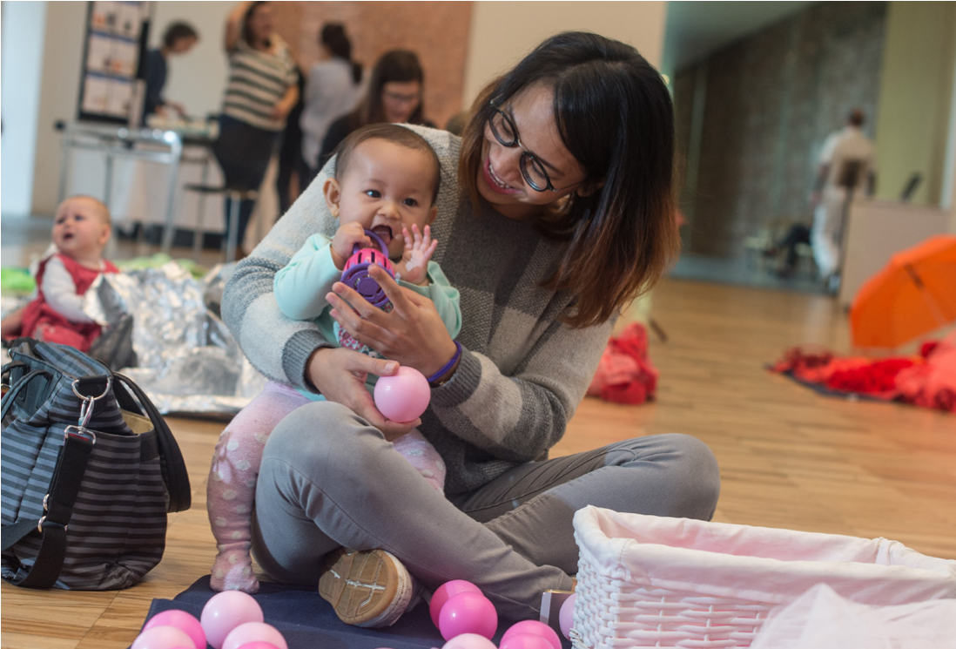

Maintaining the home language is important
English is the language of schooling, and it is crucial for academic success. It is therefore understandable that parents of multilingual children should be concerned about their children’s English skills. Unfortunately this may mean that parents sometimes decide to stop speaking the home language and favour the use of English instead.
The evidence shows that dropping the home language is not advisable. This is partly because the parent’s own English may not be of good enough quality to support the child’s English learning. When non-native speakers use English with their children, these children do not have better English than children whose parents use their mother tongue⁷. In fact, the opposite is true; interacting with a large number of different native (non-English) speakers in a variety of contexts (e.g. in nursery, with the childminder, with family members, with older children) is so beneficial that it can have a positive impact on a child’s language skills in all their languages⁸.
At the same time, maintaining a linguistic and cultural identity, and fostering relationships with members of the extended family, are important reasons for speaking the home language. Home language use can have additional cognitive and linguistic benefits for multilingual children⁹ including the transfer of literacy skills from the home language to the language of schooling¹⁰. Thus, home language and English can happily co-exist and feed off each other in a mutually beneficial relationship.

How to deal with developmental language disorder (DLD) in multilingual children
All too often, parents of multilingual children who may have language and communication difficulties are advised by wellintentioned professionals to drop the home language. This is almost certainly not good advice. Being multilingual does not appear to put children at a particular advantage or disadvantage when it comes to DLD^{11,12}.
There have been no studies to date on the frequency of DLD in multilingual children, but it is logical to expect that the prevalence of DLD will be the same as in monolingual children, approximately 7% of the child population¹³. We also know that DLD will affect both languages of a multilingual child, and that DLD manifests itself early on in the acquisition process. Children who have DLD will be slow babblers and slow word learners, although please note that not all slow word learners have a DLD. However, the diagnosis of DLD in multilingual children is a challenge for professionals in the absence of assessment tools standardised on multilingual populations¹⁴. The advice to parents and teachers who may be concerned about the atypical development of a multilingual child is:
- Closely observe the child’s communication skills, including gestures, with particular attention to comprehension. Children with good comprehension skills are likely to have a better prognosis when they have DLD.
- Evaluate the child’s language skills in the context of the amount of language exposure. If a child is hardly exposed to English it is only to be expected that her skills in the language will be minimal. If however the child also has very limited skills in the home language despite extensive exposure, then referral to a speech and language therapist may be warranted.

References
- DeKeyser, R. M. (2013). Age effects in second language learning: Stepping stones toward better understanding. Language Learning, 63(1), 52-67.
- Paradis, J., & Kirova, A. (2014). English second-language learners in preschool: Profile effects in their English abilities and the role of home language environment. International Journal of Behavioral Development, 38(4), 342-349.
- Thordardottir, E. (2011). The relationship between multilingual exposure and vocabulary development. International Journal of Multilingualism, 15(4), 426-445.
- Cattani, A., Abbot-Smith, K., Farag, R., Krott, A., Arreckx, F., Dennis, I., & Floccia, C. (2014). How much exposure to English is necessary for a multilingual toddler to perform like a monolingual peer in language tests? International Journal of Language & Communication Disorders, 49(6), 649-671. 5. Genesee, F., Nicoladis, E. & Paradis, J. (1995). Language differentiation in early bilingual development. Journal of Child Language, 22(3), 611-631
- Ribot, K. M., & Hoff, E. (2014). “¿ Cómo estas?”“I’m good.” Conversational code-switching is related to profiles of expressive and receptive proficiency in Spanish-English multilingual toddlers. International Journal of Behavioral Development, 38(4), 333-341.
- Paradis, J. (2011). Individual differences in child English second language acquisition: Comparing child-internal and child-external factors. Linguistic Approaches to Multilingualism, 1(3), 213-237.
- Gollan, T. H., Starr, J., & Ferreira, V. S. (2015). More than use it or lose it: The number-of-speakers effect on heritage language proficiency. Psychonomic Bulletin & Review, 22(1), 147-155. 9. Winsler, A., Burchinal, M. R., Tien, H. C., Peisner-Feinberg, E., Espinosa, L., Castro, D. C., ... & De Feyter, J. (2014). Early development among dual language learners: The roles of language use at home, maternal immigration, country of origin, and socio-demographic variables. Early Childhood Research Quarterly, 29(4), 750-764.
- Oller, D.K. & Eilers, R. (eds), (2002). Language and literacy in multilingual children. Clevedon, England: Multilingual Matters.
- Paradis, J., Crago, M., Genesee, F., & Rice, M. (2003). French-English Multilingual Children With SLI: How Do They Compare With Their Monolingual Peers?. Journal of Speech, Language, and Hearing Research, 46(1), 113-127.
- Windsor, J., Kohnert, K., Lobitz, K. F., & Pham, G. T. (2010). Cross-language nonword repetition by multilingual and monolingual children. American Journal of Speech-Language Pathology, 19(4),
298-310.
- Tomblin, J. B., Records, N. L., Buckwalter, P., Zhang, X., Smith, E., & O’Brien, M. (1997).
Prevalence of specific language impairment in kindergarten children. Journal of Speech, Language, and Hearing Research, 40(6), 1245-1260.
- Kohnert, K. (2010). Multilingual children with primary language impairment: Issues, evidence and implications for clinical actions. Journal of Communication Disorders, 43(6), 456-473.

Further Information
Find out more about LuCiD at: www.lucid.ac.uk

