Evidence Briefing

How can parents influence their
children’s language development?
Julian Pine & Caroline Rowland
The ESRC LuCiD Centre, University of Liverpool

Introduction
Here at the LuCiD Centre we are often asked to recommend good quality research papers on the role that parents have in their children’s language development. This is an important topic since there is ample evidence that parents have a huge impact on how well their children learn to communicate, and how quickly they learn language. So we have compiled a list of some of the most influential research papers below.
If you find it hard to get hold of these papers, try emailing the corresponding author to ask for a copy. Most researchers are only too keen to send out their papers!

Summaries
First, we recommend two review articles which summarise some of the more important results, including summaries of how parents talk to children in different cultures and societies around the world (see Hoff, 2006, page 58+), and of how parents differ who come from different socio-economic backgrounds (see Hoff, 2006, page 60+):
- Julian M Pine, ‘The Language of Primary Caregivers’, in
Input and Interaction in Language Acquisition, ed. by Claire Gallaway and Brian J. Richards (Cambridge: Cambridge University Press, 1994), pp. 15–37.
- Erika Hoff, ‘How Social Contexts Support and Shape Language Development’, Developmental Review, 26 (2006), 55–88 <https://doi. org/10. 1016/j. dr. 2005. 11. 002>.

Differences across families
We also recommend the following research papers that focus on differences across families from more affluent and disadvantaged backgrounds. Some of these paper detail differences in the language ability of children:
- Rose I. Arriaga and others, ‘Scores on the MacArthur Communicative Development Inventory of Children from Low and Middle-Income Families’, Applied Psycholinguistics, 19. 2 (1998), 209-223 <https://doi. org/10. 1017/ S0142716400010043>.
- Ann Locke, Jane Ginsborg and Ian Peers, ‘Development and Disadvantage: Implications for the Early Years and beyond’, Int. J. Lang. Comm. Dis, 37. 1 (2002), 3–15 <https://doi. org/10. 1080/1368282011008991>.
- Anne Fernald, Virginia A. Marchman and Adriana Weisleder, ‘SES Differences in Language Processing Skill and Vocabulary Are Evident at 18 months’, Developmental Science, 16. 2 (2013), 234–48 <https://doi. org/10. 1111/desc. 12019>. Michelle L. McGillion, Jane S. Herbert, Julian Pine, and others, ‘What Paves the Way to Conventional Language? The Predictive Value of Babble, Pointing and SES’, Child Development, 2016, 1–5 <https://doi. org/10. 1007/s13398014-0173-7. 2>.
Other papers detail differences across parents:
- Erika Hoff, ‘The Specificity of Environmental Influence: Socioeconomic Status Affects Early Vocabulary Development via Maternal Speech’, Child Development, 74. 5 (2003), 1368 <https://doi. org/10. 1111/1467-8624. 00612>.
- Meredith L. Rowe, ‘Child-Directed Speech: Relation to Socioeconomic Status, Knowledge of Child Development and Child Vocabulary Skill. ’, Journal of Child Language, 35. 1 (2008), 185–205 21p <https://doi. org/10. 1017/ S0305000907008343>.
These papers show that children from different backgrounds can experience very different home-life environments, especially in terms of the type of language input they receive. The Hoff (2003) paper above, in particular, shows how important this difference can be; Hoff reports that differences between affluent and disadvantaged children’s language ability at two years of age can be explained almost entirely in terms of differences in the complexity and diversity of the speech these children hear from their mothers.
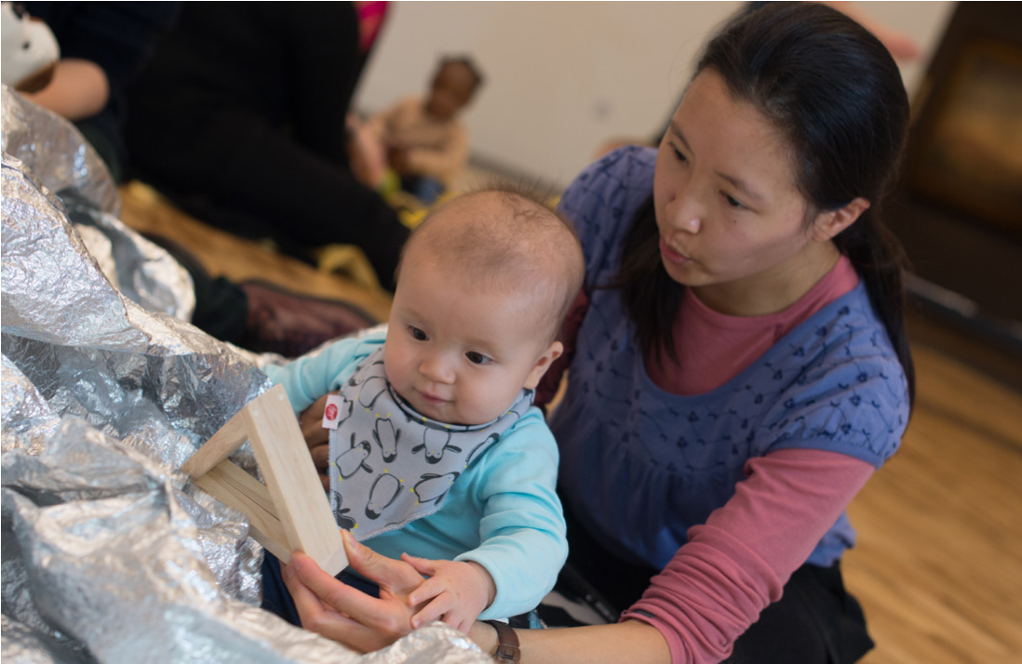


Strategies for optimizing the input

Complexity and variety
The complexity and diversity of the speech that children hear seems to have a particularly strong effect on how easily children learn language. The three papers below all detail the benefits of having caregivers who model a variety of words, and who use a range of quite complex sentence structures:
- Janellen Huttenlocher, Marina Vasilyeva, and others,
‘Language Input and Child Syntax’, Cognitive Psychology, 45. 3 (2002), 337–74 <https://doi. org/10. 1016/S00100285(02)00500-5>.
- Janellen Huttenlocher, Heidi Waterfall, and others, ‘Sources of Variability in Children’s Language Growth’, Cognitive Psychology, 61 (2010), 343–65 <10. 1016/j. cogpsych. 2010. 08. 002>.
- Meredith L Rowe, ‘A Longitudinal Investigation of the Role of Quantity and Quality of Child-Directed Speech in Vocabulary Development’, Child Development, 83. 5 (2012), 1762–74 <https://doi. org/10. 1111/j. 1467-8624. 2012. 01805. x>.

Contingent Talk
However, other strategies are equally advantageous. Here are four papers that detail the benefits of caregivers noticing what children are paying attention to, and talking about those things that children are interested in (‘contingent talk’). These all suggest that talking about the child’s current focus of attention promotes vocabulary growth:
- M Tomasello and M J Farrar, ‘Joint Attention and Early Language. ’, Child Development, 57. 6 (1986), 1454–63 <https://doi. org/10. 2307/1130423>.
- Pamela Rosenthal Rollins, ‘Caregivers’ Contingent Comments to 9-Month-Old Infants: Relationships with Later Language’, Applied Psycholinguistics, 24 (2003), 221–34 <https://doi. org/10. 1017. S0142716403000110>. 12, and 30 months. Language comprehension (at 12 and 18 months
- Elise Frank Masur, Valerie Flynn and Doreen L Eichorst, ‘Maternal Responsive and Directive Behaviours and Utterances as Predictors of Children’s Lexical Development. ’, Journal of Child Language, 32. 1 (2005), 63–91 <https://doi. org/10. 1017/S0305000904006634>.
LuCiD Evidence Briefing: How can parents influence their children’s language development? |  | December 2016
- Michelle L. McGillion, Jane S. Herbert, Julian M. Pine, and others, ‘Supporting Early Vocabulary Development: What Sort of Responsiveness Matters’, IEEE Transactions on Autonomous Mental Development, 5. 3 (2013), 240–48 <https://doi. org/10. 1109/TAMD. 2013. 2275949>.

Expansions and Recasts
Finally, there are quite a few papers that demonstrate the benefits of two specific strategies for responding to children’s own attempts at communication - expansions and recasts. Confusingly, these two terms are sometimes used interchangeably in the literature, but in essence both refer to utterances that model adultlike way of conveying information; the adult takes something the child has just said and either expands on it by provide additional information (e.g. if the child has just said “the dog”, the adult may say “yes, the dog is barking”) or recasting it in a more adultlike way (e.g. if the child has just said “trucks big” the adult may say “yes, the trucks are big”). Here are four papers on the benefits of recasts and expansions. The Cleave et al. (2015) paper is particularly interesting because it describes a recent meta-analysis that focuses on the benefits of using expansions in interventions for children with language impairments:
- Keith E. Nelson, ‘Facilitating Children’s Syntax Acquisition.’, Developmental Psychology, 13.2 (1977), 101–7 <https://doi. org/10.1037//0012-1649.13.2.101>.
- M J Farrar, ‘Discourse and the Acquisition of Grammatical Morphemes’, Journal of Child Language, 17. 3 (1990), 607–24 <https://doi. org/10. 1017/S0305000900010904>.
- Patricia L Cleave and others, ‘The Efficacy of Recasts in
Language Intervention: A Systematic Review and MetaAnalysis. ’, American Journal of Speech-Language Pathology, 24. 2 (2015), 237–55 <https://doi. org/10. 1044/2015_ AJSLP-14-0105>.
- Mele Taumoepeau, ‘Maternal Expansions of Child Language Relate to Growth in Children’s Vocabulary’, Language Learning and Development, 5441.April (2016), 1–19 <https://doi.org/10.1080/15475441.2016.1158112>.

Author contact details
Prof Julian Pine: julian.pine@liverpool.ac.uk

More Information
For more information about LuCiD, visit:
www.lucid.ac.uk

