Evidence Briefing

What Works to Support Parent Child
Interaction in the Early Years?
Anna Theakston and Caroline Rowland
The ESRC LuCiD Centre & Universities of Manchester & Liverpool
This briefing summarises the evidence presented in the Early Intervention Foundation’s report, Foundations for Life: What works to support parent child interaction in the early years. It was first published as a blog on the EIF’s website in August 2016.

Background
Have you ever had that feeling of starting a task, expecting it to be easy, and then realising you have no idea what you’re doing? Being a parent is a lot like this. Helping your children learn and develop is a lot more complicated than it looks.
Take language learning. From the outside, it can seem like parents effortlessly and instinctively help their children learn to talk. But it’s a lot harder than it looks, and many parents struggle to create the rich language learning environment that children need. In fact, a large number of children in the UK start school without the language skills they need to understand even simple instructions (“Before you sit down please hang up your coat”) and they definitely don’t have the building blocks that are so essential for learning to read and write. These children start off at a disadvantage and many never catch up. This has a knockon effect on their education, their chances of going to university, their likelihood of getting a good job, and ultimately their adult quality of life.
The EIF’s report, Foundations for Life: What works to support parent child interaction in the early years, is going to help change that. It gives early years teachers, health visitors, and health and education authorities the information they need to decide how best to support parents in raising their children. The report summarises and evaluates a wide range of intervention programmes that have been shown to help parents build strong relationships with their children, teach their children good behaviour, and boost their children’s language and cognitive development.

Highlights of the report
Two things are ground-breaking in this report. The first is that the EIF have focused on programmes that are available in the UK. This means that the programmes they assess are largely ready and waiting for UK health and education practitioners to use. For example, the REAL programme (Raising Early Achievement in Literacy), which has a level 3 strength of evidence rating in the report (a good rating) can be accessed within seconds at the REAL website (real-online.group.shef.ac.uk). So, with the right resources, practitioners could start to plan a REAL programme for their local area today.
The second is that the EIF have worked hard to evaluate the programmes, applying robust but easy-to-follow evidence standards that will guide commissioners and practitioners towards the best programmes for them. Parenting programmes have often had a bad press – sometimes quite rightly, since they can be costly and very ineffective. Choosing the right programmes can be tricky. It’s not a good idea to choose an intervention programme like you might choose a holiday: because it has a convincing website, or because your friend recommended it. We should, instead, be choosing programmes in the
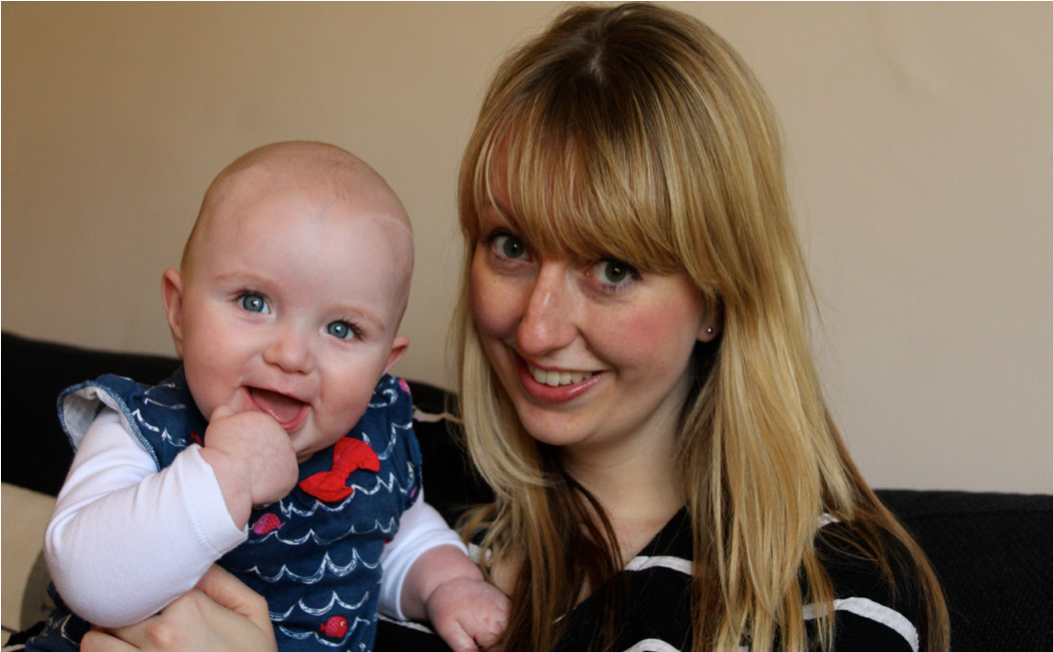
same way that doctors choose which drug to prescribe: by checking whether there is clear, robust evidence that it will actually work, and by determining whether it is right for the person or population concerned.
The EIF has done this for us. As researchers who spend our working lives figuring out exactly how children learn to communicate, we’re particularly pleased that the EIF has studied the evidence for 20 language and cognitive development programmes. We have summarised the details of these programmes in the table on page 2. The EIF found two with good evidence, seven that are promising, and one that seemed to have no effect at all, at least in its current form. This isn’t many, but it’s enough to be going on with. Others may turn out to be effective, but at the moment we don’t have enough evidence to really tell.

What LuCiD and other research groups are doing to help
We at LuCiD and other researchers must now work on improving the evidence base to give practitioners a wider range of robust, effective programmes to choose from. We are convinced that this is the most effective way to improve parenting and developmental outcomes and to make best use of the limited resources available.

Further information
Read the EIF report: www.eif.org.uk/publication/foundations-for-lifewhat-works-to-support-parent-child-interaction-in-the-early-years Find out more about LuCiD: www.lucid.ac.uk

Author contact details
Prof Anna Theakston: anna.theakston@manchester.ac.uk
Prof Caroline Rowland: crowland@manchester.ac.uk

Summary: EIF review of Language & Cognitive Development Programmes
Key Points from Review:
Cognitive programmes defined as those with “primary aim to support children’s cognitive development by teaching parents age-appropriate methods for structuring or ‘scaffolding’ learning tasks” (p.39).
LuCiD Evidence Briefing: What works to support parent child interaction in the early years? | June 2017
Only programmes involving a clearly documented parenting component were included. Activity delivered primarily through Early Years settings, and programmes considered ‘therapy’ excluded.
Surprisingly little evaluation of programmes in this area, given clear longer term impact of early language & cognitive development on life chances & the considerable investment in Early Years over recent decades. Development of evidence base & improved evaluation of programmes must be prioritised and properly resourced.
Critical to recognise and support positive interactions between Early Years settings & parents/caregivers; both provide complementary support for child’s language and cognitive development.
Evidence basis | Programmes
Evidence-based (replicated) (4)  At least two high-quality evaluations (RCT/QED) demonstrating a consistently positive impact across populations and environments: includes RCT/QED evidence of a child outcome lasting a year or longer. | - No ‘Cognitive Development’ programmes identified that currently meet this level of evidence But,  - Family Nurse Partnership (primarily aimed at improving attachment, but with positive language outcomes at 12-24 months)
Evidence-based (single) (3/3+)  At least one rigorously conducted RCT/QED demonstrating a statistically significant positive impact on at least one child outcome. | - Let’s Play in Tandem  - Raising Early Achievement in Literacy Project (REAL)  Plus,  - Child First (primarily aimed at improving attachment, but with improvements in language after 1yr in programme)
Preliminary (2/2+)  Pilot study demonstrating a statistically significant positive impact on at least one child outcome with sufficiently large and representative sample (>20 participants, representing at least 60%) & independently validated measures. | - Getting Ready  - Home Instruction Program for Preschool Youngsters (HIPPY)  - Learning Together Programme – Foundation PEEP: 3s level  - Learning Together Programme – Foundation PEEP: 4s level  - Lidcombe Program  - Parents as (first) Teachers (PAFT)  - Reach out and Read (ROR)
No evidence yet at Level 2 (NL2)  No direct evidence about the scale of impact of the programme at a “preliminary” level. | - Bookstart Baby  - Bookstart Corner  - Born to Move  - It Takes Two to Talk  - Kaleidoscope Play & Learn  - Learning Together Programme – Early PEEP: 1s level  - Learning Together Programme – Early PEEP: 2s level  - Learning Together Programme – Early PEEP: Baby PEEP  - TalkAbility  - Target Word
Found not to be effective in at least one rigorously conducted study (NE)  At least one high-quality evaluation (Level 3 RCT/QED) indicating no benefits for children or parents. | • Let’s Learn Language
Features of Evidence-based Cognitive Programmes
REAL | - Targets children aged 3-5yrs over 12-18 month period  - Delivered by qualified teachers  - Home visits & group sessions approx. every 3 weeks  - Focus – strategies to support early literacy development  - Outcome: Improved literacy & letter recognition
Let’s Play in Tandem | - Targets children aged 3 yrs over 1 year period  - Delivered by qualified teachers  - Weekly home visits & Centre-based sessions  - Focus – scaffolding early learning & behaviour  - Outcome: Improved school readiness including listening & communication

