
Evidence Briefing
How can our responses to babies’ gestures help with their language development?
Laura Boundy, Thea Cameron-Faulkner & Anna Theakston
ESRC LuCiD Centre & University of Manchester

Introduction
A few months before they begin to talk, babies produce a range of gestures in order to draw attention to objects and events that they find interesting. Initially, these gestures may take the form of holding out or showing objects, and then slightly later involve more conventional gestures such as pointing. These communicative gestures provide caregivers with valuable opportunities to engage with their infants and provide rich verbal input. While some caregivers naturally respond to their infants’ gestures in meaningful ways, other caregivers do not, meaning that important opportunities for language learning may be missed. This briefing summarises the evidence regarding the role of these gestures for communication and language development.
Why are early gestures so important?
At 10-11 months, very few infants produce intelligible speech and so will generally communicate through naturally occurring actions and gestures. These gestures are important because they represent an infant’s first attempts to initiate meaningful communication, and so represent the first steps towards language production. At around 10 months, infants communicate their interest by holding out (showing) objects to their caregivers. It is quite common for caregivers to interpret these early communicative gestures as giving actions; in this situation the infant will often pull back the object from the caregiver’s grasp¹. By 12 months, infants begin to use pointing gestures to share an interesting object or event with their social partner², to provide information such as an object’s location³, or as a request for information⁴. These early gestures reflect an infant’s readiness to share and learn about aspects of their environment and therefore have the potential to form rich social contexts whereby the infant and caregiver can share and enjoy a common focus of attention.

A number of studies have shown that gestures such as pointing at objects or events, or holding out objects, are linked to later language milestones⁵. For example, the frequency of pointing gestures at 12 months predicts the size of an infant’s productive vocabulary at 20 months⁶. In particular, the use of pointing to share attention (declarative pointing) between 9-33 months predicts both
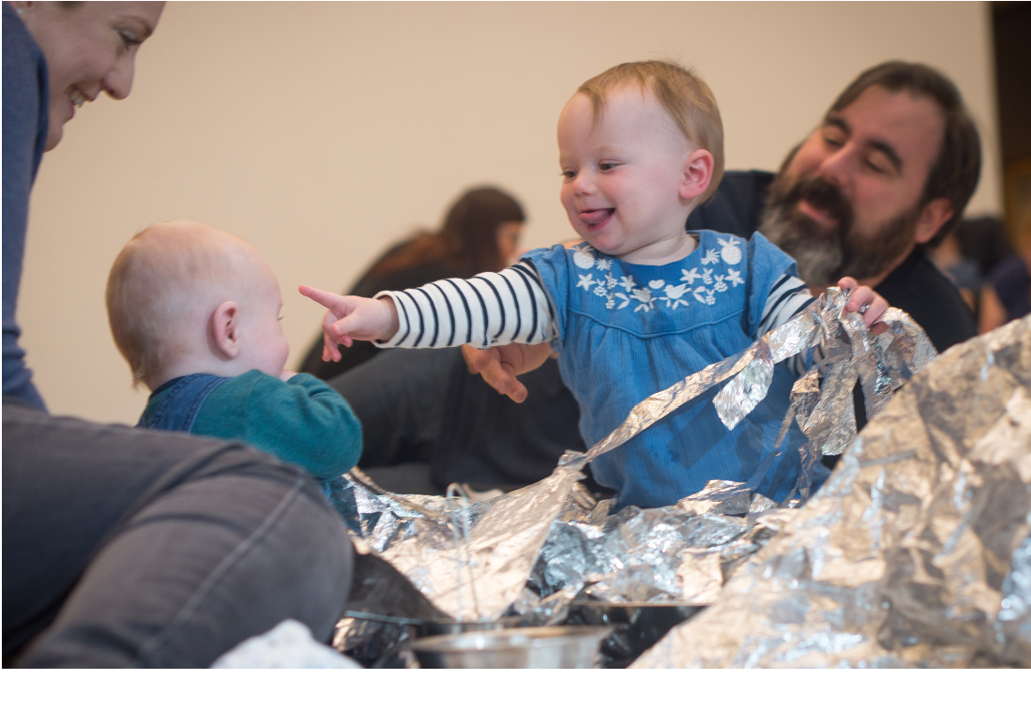
comprehension and production of language from 9-54 months⁷. Interestingly, the relationship between early gesture use and later language outcomes appears to be mediated by caregiver input, and we turn to this area in the next section.
How can caregivers help?
It has been suggested that the developmental value of infant pointing may originate from the act of jointly attending to and sharing objects, which is often initiated through holdout and give gestures. These gestures may form a practice ground for social exchanges with others, allowing babies to connect new words they have heard to the object or event that they are interested in⁸. Research has found that the caregiver speech received by infants during “joint attentional frames” (i.e. where the infant and adult are attending to the same object/event in their environment) is more likely to be related to their later language skills than the caregiver language infants hear outside of these frames⁹. Furthermore, caregivers who engage in talk about their infant’s focus of attention (semantically contingent talk) and respond quickly to their
infant’s gesture (temporally contingent talk) during these joint attentional frames at 12 months have infants who achieve language milestones, such as first words and two-word utterances, 4-6 months earlier than infants who do not receive such contingent responses¹¹. Subsequently, both kinds of contingent responses at 12 months are associated with larger expressive vocabularies at 18
months¹⁰.
LuCiD Evidence Briefing: How can our responses to babies’ gestures help with their language development?
This relationship between caregiver input during these joint attentional frames and later language development has led to an investigation into the specific features of this input, in an attempt to understand precisely how these interactions facilitate language development.
What type of caregiver responses help with language learning?
i. Quantity of caregiver input
Several studies have highlighted a direct link between the number of words an infant hears, and the number of words within their first word repertoire¹². Infant gestures can establish a shared context between the infant, caregiver and the object/ event of interest. A caregiver who talks about this focus of shared interest exposes the infant to a higher frequency of labels and comments about the object/event and translations of the infants’ gesture. However, simple exposure to language within these joint attentional frames does not appear to tell the full story. The quality of input, including the turn-taking structure of the joint exchanges and the diversity of language used, appears to be a stronger predictor of later language learning.
ii Quality of caregiver input: nature of the interaction To identify which features of caregiver-infant-object interactions are important for language learning, researchers have considered their communicative foundations. This includes levels of caregiver engagement, routines, and the fluency of exchanges, that is, how connected the infant and caregiver are in their use of verbal and non-verbal actions to share a focus of attention and the level of turn-taking occurring during these back-and-forth exchanges. The fluency of exchanges appears to be a strong predictor of later language as higher fluency, connectedness, and turn-taking during interactions with 24-month-old infants are associated with higher expressive language scores at 36 months¹³. The importance of shared exchanges has also been highlighted in infants at 11 months; their use of holdout and give gestures often establishes lengthy give and take sequences, with the length of these exchanges relating to the frequency of pointing gestures at 12 months¹. Interestingly, the importance of turn-taking is also reflected in later language development, as the number of conversational turns during joint interactions with 4-year-olds continues to be a strong predictor of verbal ability in the same children at 6 years of age, and may influence brain development by eliciting greater activation of brain areas important for language processing (e.g. Broca’s area)¹⁴. Thus, interactions which include a high frequency of turn-taking between an infant and caregiver and maintain a connection over one attentional focus appear to facilitate preverbal communicative gestures (e.g. pointing), word acquisition and later verbal abilities throughout early childhood.
Furthermore, infants as young as 10 months appear to be sensitive to these exchanges. Following their production of a holdout gesture, infants often attempt to reengage a social partner if their interaction is disrupted or their partner becomes unresponsive¹⁵. These disruptions can have a negative impact on word learning. For example, a recent study found that when mothers attempted to teach their 24-month-olds a new word, but were distracted by a phone call during the interaction, the children failed to learn the new word, whereas those in the uninterrupted condition did¹⁶. Thus, fluent joint attentional exchanges appear to be important to infants, helping them to map words onto specific objects or events.
In addition to the features of the interaction, the quality, in terms of the diversity and complexity of the language produced by caregivers, also appears to play an important role in language learning. For instance, there are clear parallels between the variety of words and phrases produced by caregivers and the breadth of their infant’s later vocabulary¹⁷. Furthermore, specific types of words produced in response to preverbal infants’ gestures (in particular caregivers’ provision of object labels) have been found to predict the types of words infants produce within their first words repertoire¹⁸. One theory is that the object labels provided by the caregiver for things that the infant has gestured at allow the infant to build up associations between the word and the object of interest.

Summary
Infants use gestures as a way to communicate their interests before they can speak, and the relationship between the frequency of these gestures and subsequent language learning appears to be mediated by input from the caregiver. This relationship is particularly apparent with infants’ pointing, however earlier gestures, such as holdouts and gives, also appear to be communicative. The key role of these gestures appears to be the initiation of a joint attentional frame between the infant and caregiver, and the success of these interactions depends on the caregiver being able to follow the attentional focus of their infant and promote a fluent back-and-forth exchange in which they provide comments about the object or event of interest. It is therefore crucial that caregivers are aware of the communicative signals and gestures displayed by their infants and understand how to respond appropriately to these during interactions.

References
- Cameron-Faulkner, T., Theakston, A., Lieven, E., & Tomasello, M. (2015). The relationship between infant holdout and gives, and pointing. Infancy, 20(5), 576-586.
- Liszkowski, U., Carpenter, M., Henning, A., Striano, T., & Tomasello, M. (2004). Twelvemonth-olds point to share attention and interest. Developmental Science, 7, 297–307.
- Liszkowski, U., Carpenter, M., & Tomasello, M. (2008). Twelve-month-olds communicate helpfully and appropriately for knowledgeable and ignorant partners. Cognition, 108(3), 732-739. 4. Lucca, K., & Wilbourn, M. P. (2019). The what and the how: information-seeking pointing gestures facilitate learning labels and functions. Journal of Experimental Child Psychology, 178,
417-436
- Iverson, J. M., & Goldin-Meadow, S. (2005). Gesture paves the way for language development. Psychological Science,16(5), 367-371.
- Goldin‐Meadow, S., Goodrich, W., Sauer, E., & Iverson, J. (2007). Young children use their hands to tell their mothers what to say. Developmental Science, 10(6), 778-785.
- Colonnesi, C., Stams, G. J. J., Koster, I., & Noom, M. J. (2010). The relation between pointing and language development: A meta-analysis. Developmental Review, 30(4), 352-366.) 8. Carpenter, M., Nagell, K., Tomasello, M., Butterworth, G., & Moore, C. (1998). Social cognition, joint attention, and communicative competence from 9 to 15 months of age.
Monographs of the Society for Research in Child Development, 63(4), 162-174.
- Tomasello, M., Carpenter, M., & Liszkowski, U. (2007). A new look at infant pointing. Child Development,78, 705–722.
- McGillion, M. L., Herbert, J. S., Pine, J. M., Keren-Portnoy, T., Vihman, M. M., & Matthews, D. E. (2013). Supporting early vocabulary development: What sort of responsiveness matters?. IEEE Transactions on Autonomous Mental Development, 5(3), 240-248.
- Tamis-LeMonda, C. S., Kuchirko, Y., & Song, L. (2014). Why is infant language learning facilitated by parental responsiveness?. Current Directions in Psychological Science, 23(2), 121-126. 12. Goodman, J. C., Dale, P. S., & Li, P. (2008). Does frequency count? Parental input and the acquisition of vocabulary. Journal of Child Language, 35(3), 515-531.
- Hirsh-Pasek, K., Adamson, L. B., Bakeman, R., Owen, M. T., Golinkoff, R. M., Pace, A., ... & Suma, K. (2015). The contribution of early communication quality to low-income children’s language success. Psychological Science, 26(7), 1071-1083.
- Romeo, R. R., Leonard, J. A., Robinson, S. T., West, M. R., Mackey, A. P., Rowe, M. L., & Gabrieli, J. D. (2018). Beyond the 30-million-word gap: children’s conversational exposure is associated with language-related brain function. Psychological Science, 29(5), 700-710. 15. Boundy, L., Cameron‐Faulkner, T., & Theakston, A. (2018). Intention or Attention Before Pointing: Do Infants’ Early Holdout Gestures Reflect Evidence of a Declarative Motive?.Infancy.1-21. 16. Reed, J., Hirsh-Pasek, K., & Golinkoff, R. M. (2017). Learning on hold: Cell phones sidetrack parent-child interactions. Developmental Psychology, 53(8), 1428.
- Rowe, M. L. (2012). A longitudinal investigation of the role of quantity and quality of childdirected speech in vocabulary development. Child Development, 83(5), 1762-1774.
- Olson, J., & Masur, E. F. (2015). Mothers’ labeling responses to infants’ gestures predict vocabulary outcomes. Journal of Child Language, 42(6), 1289-1311.

Further information
Author contact: laura.boundy@manchester.ac.uk
For more information about LuCiD, visit: www.lucid.ac.uk

