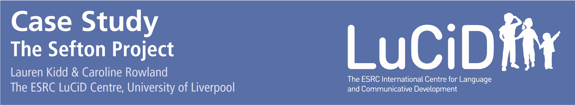
Sefton Local Authority School Readiness Team enlisted researchers from the ESRC LuCiD Centre to test the effectiveness of their language and communicative development training of early years practitioners. This case study details the project and highlights the importance of evaluating early years training and interventions.

Background
Language learning in the early years is crucial. Children who start school with good language skills have a better chance of succeeding in school, of accessing higher education and of being economically successful in adulthood. As a result, improving children’s language and communication before they reach school can be one of the most effective things we can do to boost their ability to succeed.
Good quality childcare, delivered by practitioners trained to use language boosting techniques in their interactions with children, can go a long way to mitigate the risks of language delay. Thus, local authorities often invest heavily in language and communicative development training for early years practitioners. However, practitioners often find it hard to judge the success of these training programmes. Do these training programmes actually improve practitioners’ knowledge and change the way they interact with children? Could they be changed or adapted to be more successful? These questions are difficult to answer, since designing robust assessments of the effect of training programmes often requires specialist research expertise. This is where links with a local University can be useful.

The Sefton Project
Recently, researchers from the ESRC LuCiD Centre at the
University of Liverpool joined up with Sefton Local Authority School Readiness Team to test the effectiveness of their language and communicative development training. They ran two studies.

Study 1
In the first study, they determined whether the language and communicative development training in Sefton improves practitioners’ knowledge of how to support children’s language and communicative development. The researchers created a questionnaire to evaluate the practitioners’ knowledge, and the School Readiness team

disseminated it to early years settings across the local authority. The answer was yes: practitioners retain the knowledge they have been taught, both about how children learn and about how to promote this learning.

Study 2
In the second study, they tested whether practitioners’ behaviour reflected this knowledge, by testing whether they implemented the language-boosting techniques they had been taught. For this, the researchers video-recorded practitioners interacting while

playing, one-to-one, with 2- and 3- year old children in their childcare settings. They concluded that, in the main, the training was effective. Trained practitioners used more language enhancing behaviours when interacting with children in early years settings.
As well as highlighting areas of good practice, the evaluation also identified some areas in which training could be improved. For example, contrary to expectations, trained practitioners did not give children more opportunity to lead the play, and take turns in conversations, than untrained practitioners. The findings have been communicated to Sefton Local Authority, who are using them to make their training more effective. A first draft of the paper describing the results of this project can be downloaded from here: https://osf.io/preprints/psyarxiv/2tj7y

