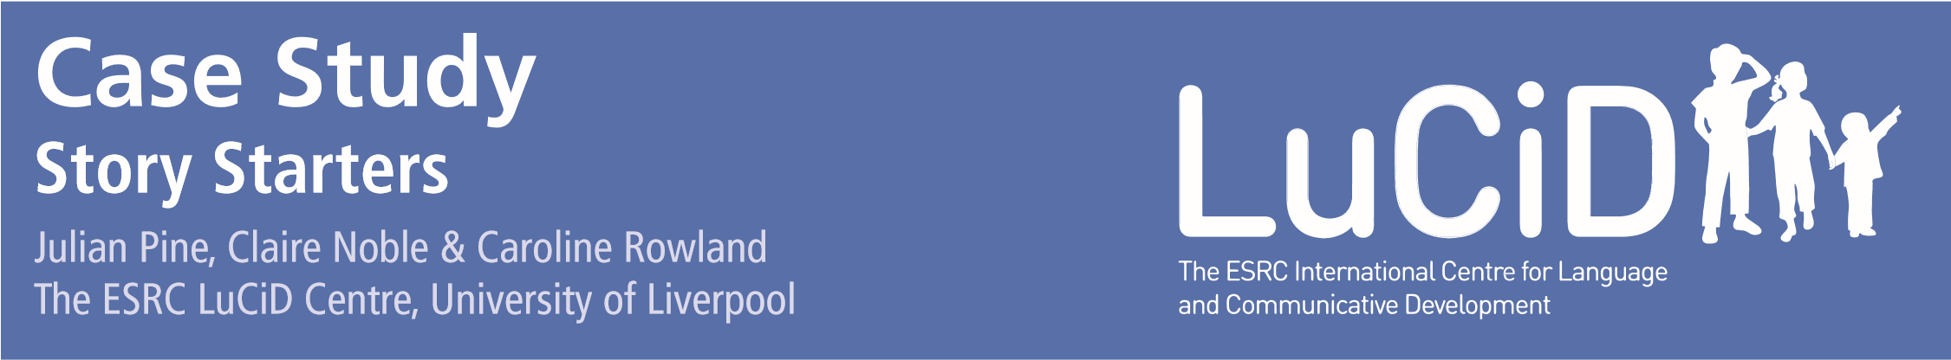
Using joint book reading to promote disadvantaged children’s language in the run up to school entry.

Background
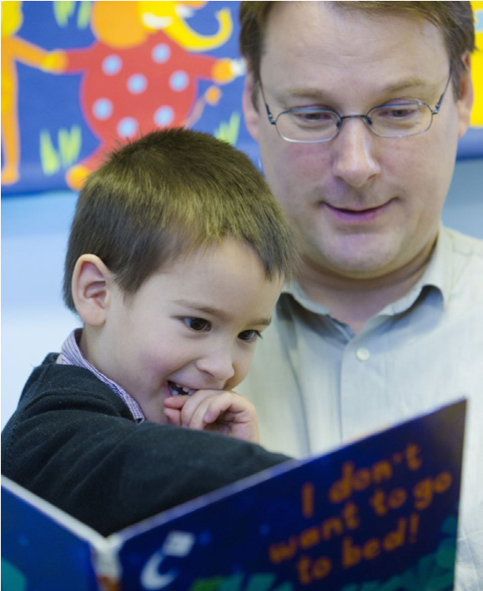
It is a sad fact that many disadvantaged children enter school without the language skills they need to succeed in the classroom. For example, one recent study in the UK found that almost 60% of children from low-income families were already delayed in their language development by the time they started school. The most vulnerable of these children can be as far as 19 months behind their more affluent peers in terms of their vocabulary development – and 19 months is a long way when you are only 5 years old.
One way of boosting toddlers’ language development is to engage them in joint book reading. This doesn’t mean trying to teach them to read; it means interacting with them over books, talking to them about what is going on in the pictures, and giving them plenty of opportunity to contribute to the conversation by telling parts of the story in their own words. As a colleague of mine is fond of saying, this kind of one-to-one interaction over books is like ‘rocket fuel’ for language development. This is partly because it exposes children to a much wider range of different words and sentence types than they would hear in normal conversation; and partly because it encourages them to use their language to talk about a favourite story or series of illustrations, and so helps them to learn to tell meaningful stories of their own.
For many families, joint book reading is already a highly enjoyable part of their daily routine. But reading books with small children can feel alien to some parents – and there is some evidence that book reading interventions are less effective with low-income families. So how can we bring the benefits of joint book reading to disadvantaged children?

The Story Starters Project
Recently, researchers from the ESRC LuCiD Centre at the University of Liverpool were approached by two reading charities: Beanstalk and Dolly Parton’s (yes, the Dolly Parton’s) Imagination Library (DPIL), and asked to help design a project to do just this. The aim was to develop a joint book reading intervention that could be delivered by trained volunteers in preschool settings,
and to test its effectiveness in increasing the language skills of disadvantaged 3- and 4-year-olds.
What the three partners developed was ‘Story Starters’, a project that harnessed Beanstalk’s experience recruiting and training reading volunteers, DPIL’s experience selecting and providing age-appropriate books to children, and LuCiD’s knowledge about child language development, and about how to evaluate language interventions effectively.
How Story Starters works
The Story Starters project, which is funded by the players of the People’s Postcode Lottery, will work like this.
- Beanstalk will recruit and train 600 reading volunteers from all over the UK, each of whom will engage in one-to-one joint book reading twice a week with 3 different children over a six-month period.
- The children will also receive age-appropriate books carefully chosen by DPIL, which will be sent both to their homes and to their preschools once a month over a twelve-month period.
- The progress of these 1800 children will be monitored by researchers from the LuCiD Centre immediately before and after the intervention, and also six months after the intervention has ended.
- At the same time, the effects of the intervention will be more rigorously assessed by randomly assigning 200 children in the Merseyside area either to an intervention group that will receive the intervention immediately or to a control group that will not receive the intervention until later.
- Testing these children both before and after the first group has received the intervention, will allow us to tell whether children who receive the intervention make more progress than an equivalent group of children who have yet to receive it – and hence whether the intervention works.
Working together to develop evidence-based interventions
Although work on the Story Starters project has already begun, the intervention will not have been completed until June 2018, so whether or not it is effective has yet to be determined. That’s the nature of science. But what the project does provide is a good example of how charities and academic researchers can collaborate to develop and evaluate evidence-based interventions. Charities often have a very strong sense of the needs that exist out in the real world (for example, the need to promote language learning in children from low-income families in the run-up to school entry). They also tend to have critical expertise that can be used to address these needs (for example, in recruiting and training volunteers and selecting age-appropriate books). But what they don’t tend to have is access to the latest research findings (for example, on what style of book reading is most effective), or the expertise to evaluate whether the intervention that they are delivering actually works (for example, in testing children or designing a randomised controlled trial).
Collaborations between charities and academic researchers are therefore an excellent way of bringing together these complementary kinds of expertise. This allows academic researchers to benefit from charities’ understanding of the situation out in the real world and their ability to deliver interventions effectively; it also allows charities to benefit from academic researchers’ knowledge about how children learn, and about how to assess the effects of an intervention to make sure that it really works. Perhaps most crucially, it encourages all partners to think about what effects the intervention is likely to have, and how they are going to measure these effects while the intervention is actually being designed, rather than at some later date, when it has already been decided what form the intervention will take. Thinking about the likely effects of an intervention and how to measure these effects during the design phase is essential for developing evidence-based interventions that are effective in the real world. We would therefore encourage other charities to follow Beanstalk and DPIL’s lead and seek collaborations with research centres such as LuCiD and encourage other academic researchers to work with charities like Beanstalk and DPIL to help them develop and evaluate what they are offering.
Author Contact Details
LuCiD Case Study: Story Starters | September 2017
Prof Julian Pine: julian.pine@liverpool.ac.uk

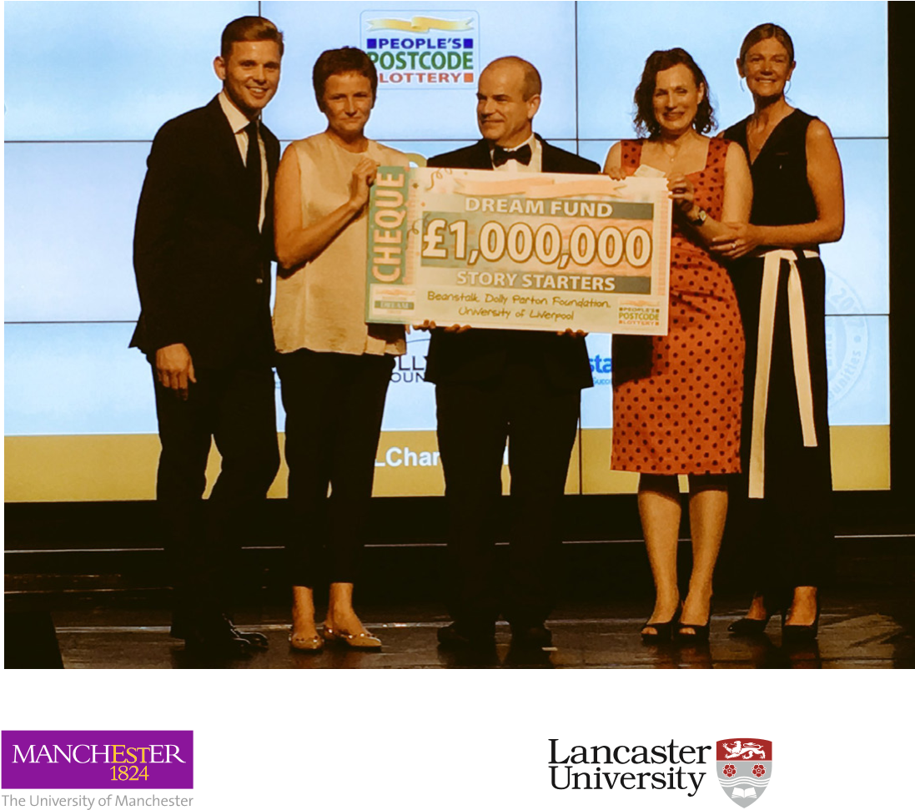

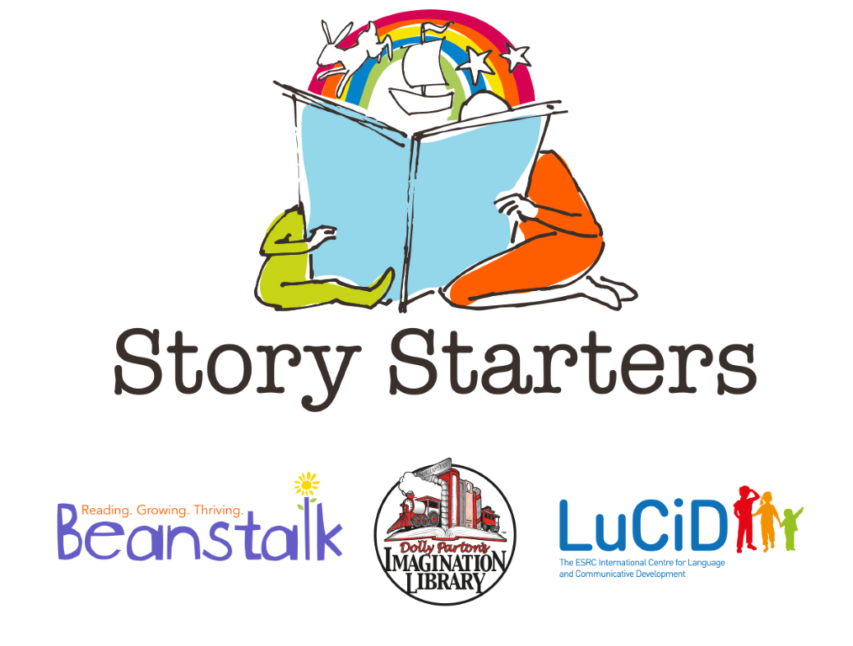

Further Information

Story Starters
Stay up to date on the latest from Story Starters:
www.storystarters.org.uk

Shared book reading
Find out more about how shared book reading boosts children’s language development in this evidence briefing by Prof Caroline Rowland and colleagues:
www.lucid.ac.uk/media/1885/eb_shared_reading_rowland-et-al.pdf

Developing and using evidence
Find out more about choosing evidence-based interventions and programmes in this blog by Prof Caroline Rowland:
www.thecommunicationtrust.org.uk/posts/2016/caroline-rowland

Story Starters is a partnership between LuCiD, Beanstalk and Dolly Parton’s Imagination Library UK:

The ESRC International Centre for Language and Communicative Development (LuCiD) is a research collaboration working to transform our understanding of how children learn to communicate with language.
www.lucid.ac.uk

Beanstalk recruits, trains and supports volunteers to provide oneto-one literacy support in early years settings and primary schools to children who have fallen behind with their reading. www.beanstalkcharity.org.uk
Dolly Parton’s Imagination Library UK promotes early childhood literacy for children by providing free age appropriate books from birth to age 5. They work in partnership with communities to universally serve children under 5. www.uk.imaginationlibrary.com

