





Coping with...

problematic anger and aggression
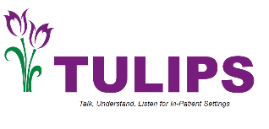
In this section, we will look at your
understanding of anger. We will then work out a plan to help you to deal with anger. The aims of this section are:

- To find out if and how anger is a problem for you
- To look at the difference between helpful and unhelpful anger
- To help you to understand your anger
- To help you to deal with anger more effectively

Please go through this section at your own pace, there’s no pressure to finish it quickly. Ask your nurse for help with anything you’re not sure about





Coping with...
problematic anger and aggression

SECTION 1
Understanding problematic anger and aggression



Coping with…
problematic anger and aggression

What is anger?

Anger is an emotion that we all feel at some time or another. It can happen for lots of different reasons, and can build up slowly or happen very quickly. Some people feel angry for most of the time. Other people hardly ever feel angry.

Anger is a type of feeling, just like feeling sad or worried. It often happens when something upsets us, for example when we feel threatened, when we are treated badly, when someone has hurt us for no reason, or when we see someone doing bad things to other people, things or animals.

Being angry isn’t always a negative thing, it can be positive. It can make us take action if we see something going on that we are unhappy with. It can give us the strength to change things and to stand up for ourselves.




What sorts of things can make people feel angry?

The table below shows some of the things that can make people feel angry. Please tick if any of these things have been a trigger for your anger, and add any others you have experienced. Don’t worry if you’d rather not.

Experiences that can cause anger
Please tick where appropriate:
Seeing someone you love being hurt
People being rude or disrespectful to you
Getting cheated out of your money
Being overwhelmed by problems
Thinking that people are talking about you behind your back
People not taking notice of your viewpoint
People making fun of you
Losing someone close to you
People being racist or sexist towards you
Please add your own experiences below:

Coping with…
problematic anger and aggression

What happens when we become angry?

Anger can have lots of different effects.

The tables below and on the next page show some examples of how people react when something makes them angry. These are often things that are connected with our thoughts, feelings and behaviours. Please tick any that apply to you and add any others you can think of.

Common thoughts in anger
Please tick where appropriate:
It’s not fair that people treat me like that
I need to protect myself from unpleasant people
How can someone be so unkind?
The people that make me angry need to be taught a lesson
My only way to cope with these feelings is to smash things
I am confident that I can overcome these people who are making me angry
If people upset me they deserve to be paid back
I can’t control the way I feel
I can’t stop myself from hitting out
Please add your own examples below:

Common emotional feelings in anger
Please tick where appropriate:
Furious
Terrified
Stressed
Irritable
Panicky
Agitated
Please add your own examples below:

Common physical feelings in anger
Please tick where appropriate:
Heart pounding
Hot and sweaty
Powerful
Tense and wound up
Restless
Full of energy
Please add your own examples below:

Coping with…
problematic anger and aggression

Common behaviours or actions in anger
Please tick where appropriate:
Walk away from the situation
Argue with people
Try to calm myself down
Hit out at things or people
Shout out loud
Reliving situations that have caused anger
Try and do relaxing things
Please add your own examples below:
Some of these reactions can be positive, while others can be negative. It can be helpful to work out which parts of your anger are positive and which are negative. Your nurse can then help you to find ways to deal with the negative aspects of anger.
Sam had been experiencing anger for some time due to being under pressure at work, difficulties sleeping, additional challenges at work and worries about his partner having an affair. Sam completed the table below to identify the helpful and unhelpful things about his anger:

Sam’s anger
Helpful things | Unhelpful things
It gives me lots of energy | I row more with my partner
My muscles feel strong | I can sometimes smash things
I can concentrate better | I can harm myself
It stops me from sitting down and doing nothing | It makes me feel really anxious and upset

If you can, try to fill in the table below to show the positive and negative things about your anger.

Your anger
Helpful things | Unhelpful things

We have looked at the ways that anger can affect you. We will now try to help you to understand your anger.

Coping with…
problematic anger and aggression

Understanding your anger

Sam

Sam had recently been under pressure at work as he had been promoted and was managing extra staff. He had difficulty sleeping and had been drinking more than usual. He hadn’t been getting on well with his partner, Jenny, either, and she had started to go out more often without Sam (triggers). Sam thought that Jenny had been having an affair with a man from work (they both worked in the same office). He thought that everyone in the office knew about it and were laughing at him behind his back (thoughts). This made him feel really angry and upset towards Jenny and the people at work (feelings). He accused everyone at work of being involved in a conspiracy to cover up for Jenny. He ended up arguing with his boss and leaving his job (behaviours).

Sam became convinced that the people at work had bugged his house to listen in on what he was doing. He began to hear voices of his work colleagues telling him that Jenny was being unfaithful, that he deserved it, and that Jenny was only staying with him for his money. His worries and anger continued to worsen and one day he became abusive and threatening towards Jenny (behaviours).

Jenny called the police and Sam was admitted to hospital. The mental health staff also denied the things that Sam said, and said they were due to an episode of psychosis. The fact that no one believed his experiences made Sam even angrier. This caused more conflict with Jenny and the mental health staff and he was sections for several months. The vicious cycle on the next page kept Sam feeling angry. The diagram showed how Sam’s triggers, thoughts, feelings and behaviours are interlinked.

Sam’s vicious cycle
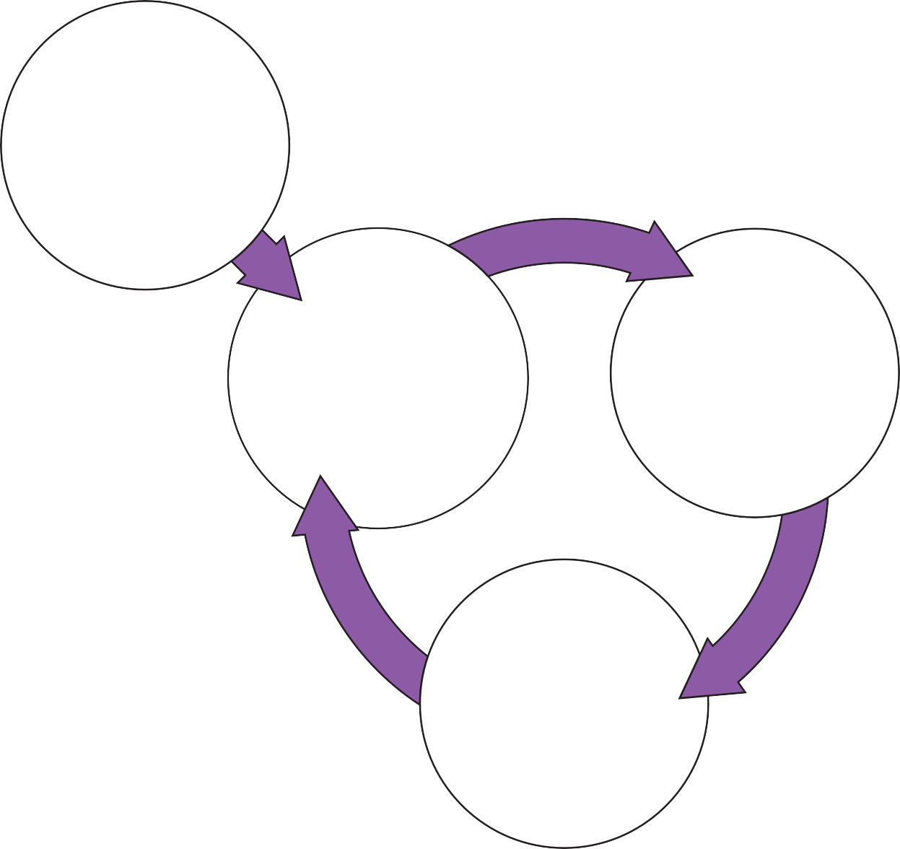
Trigger/Event
Work stress
Lack of sleep
Drinking
Voices of people at work
Thoughts
‘Jenny’s up to no good’
‘She no good for me’
‘It’s not fair that they treat me like this’
‘’I can’t let them get away with this’
Feelings
Fury
Palpitations
Sweating
Butterflies
Tense muscles

Behaviours
Starting arguments and fights
Being aggressive
Storming away from situations
Giving up at work

It can be helpful to get an idea of how triggers, thoughts, feelings and behaviours link together for you. This may help you to think about what you would like to change. You could now try to build up your own diagram of what happens with your anger. If you like you could discuss it with your nurse.

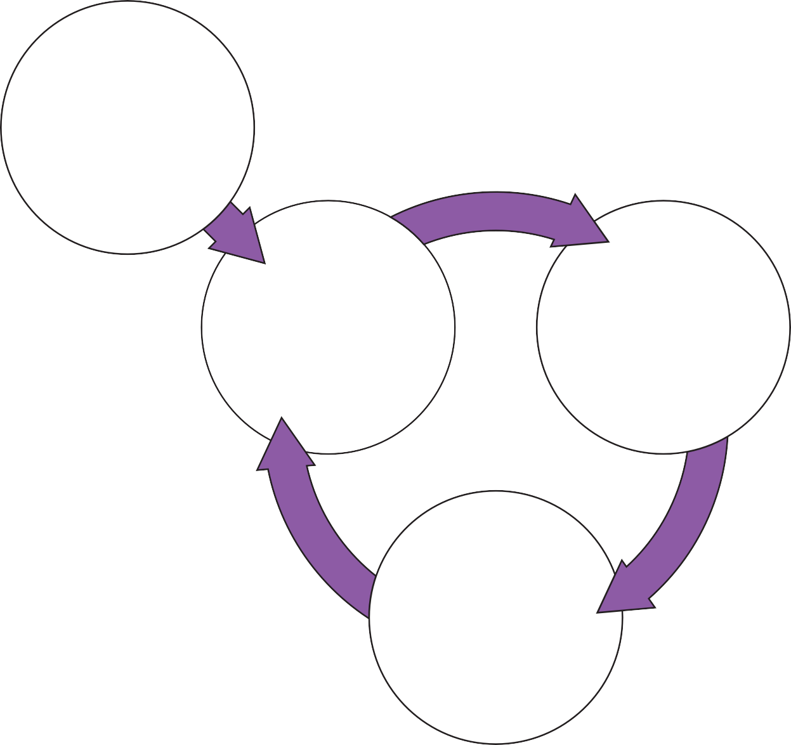
Triggers
Thoughts
Feelings
Behaviours

Coping with…
problematic anger and aggression

Dealing with problematic anger

The first step to overcoming anger is to identify your triggers, thoughts, feelings, and behaviours and how they interlink, as described previously. You can then identify which things you would like to change. Finally, you can build on any strategies that you have found helpful for dealing with these. You can also learn to use new strategies that are helpful in dealing with the thoughts, feelings, and behaviours that you are experiencing.

Identifying your anger triggers and signs

At the beginning of this section we looked at common triggers and signs of anger. You might have already started to work out what your triggers and signs of anger are.
Sometimes people find it hard to tell when or why they are becoming angry. If this is the case, it can help to monitor your anger using the diary method. This can help you to become more aware of your anger triggers, thoughts, feelings and behaviours.

Sam

Sam was asked by his nurse to keep a diary of his experiences of anger and aggression. It helped to show how his triggers affected his thoughts, feelings, and behaviours. An example of Sam’s diary is shown on the next page.



Example of Sam’s diary
- Triggers
  - What was the situation?
  - Where were you?
  - What were you doing?
  - What happened?
  - Who were you with?
At home with Jenny, watching TV. Jenny had been out late the night before, her phone bleeped with a text message.
Voices saying ‘she’s been at it again’, ‘she’s taking the mickey out of you’, don’t’ be a fool, say something to her’
- Thoughts
  - What thoughts, ideas or images went through your mind?
  - If this is true, what does this say about you, others, the world, the future? Rate how much you believed each thought was true on a scale of 0-100%
‘She’s been out with that man, they’ve been laughing at me stuck at home’ (100%) ‘She doesn’t respect me, how dare she treat me like that’ (90%)
‘The voices are right, I am a fool and should do something about it’ (100%) ‘I’ve got to confront her again, I can’t let her get away with it’ (100%)
- Feelings
  - How did you feel?
  - Describe each feeling in one word
Rate how distressing each of these feelings were on a scale of 0-100%
Upset that Jenny had been out late, angry that she hadn’t said who she was with and where she’d been
80% at start, 95% when phone bleeped
- Behaviours
  - What did you do?
  - What action did you take?
  - What helped you to cope?
Saw ‘red’ and shouted at Jenny, shouted and lost control, accused her of having another affair, told her to leave or I would kill her, smashed plates and glasses Ran out of house to park and stayed till I could control myself

Coping with…
problematic anger and aggression

Using the diary method for yourself

You might find the diary helpful for you. If you like, for the next week or so, each time you feel angry you could use the diary on the next page to make a note of:

Trigger/s The situation you are in
Thoughts The thoughts that go through your mind
Feelings How you feel
Behaviours What this leads you to do

If you need extra copies of diaries then please ask your nurse.

You can write as little or as much as you like, it’s up to you. You could then use the diaries to talk things over with your nurse. This might help you to see whether you could overcome some of the problems that occur because of your anger. Remember that feeling angry is not always a bad thing. Being angry can cause us to do helpful as well as unhelpful things. Keeping a diary can help you to see what is helpful/not helpful about your anger.

Four section diary for monitoring triggers, thoughts, feelings and behaviours
- Triggers
  - What was the situation?
  - Where were you?
  - What were you doing?
  - What happened?
  - Who were you with?
- Thoughts
  - What thoughts, ideas or images went through your mind?
  - If this is true, what does this say about you, others, the world, the future? Rate how much you believed each thought was true on a scale of 0-100%
- Feelings
  - How did you feel?
  - Describe each feeling in one word
Rate how distressing each of these feelings were on a scale of 0-100%
- Behaviours
  - What did you do?
  - What action did you take?
  - What helped you to cope?

Coping with...
problematic anger and aggression

SECTION 2
Goals and obstacles

Coping with…
problematic anger and aggression

Choosing obstacles and goals to work on

A good starting point in dealing with anger is to think about which thoughts, feelings or behaviours are most problematic for you, or things that are obstacles to your recovery. It is also a good idea to set clear, realistic goals. You might want to start with one or two small goals, and build these up over time to longer-term goals. Rating obstacles and goals is also useful. This is so that you can see if things have changed, after you have tried some of the strategies for overcoming problematic anger.

Sam’s obstacle and goal list

Sam’s long-term goal was to overcome his anger and enjoy life again. He broke this up into two smaller steps to begin with. Sam’s initial obstacle and goal list was:

Sam’s obstacle and goal list
Obstacle | Goal
Angry and aggressive towards Jenny all the time | Learn strategies to control my aggression towards Jenny so that I am not verbally or physically aggressive.
Lost my job because of anger | To get a new job and now allow anger to ruin it for me.

My obstacle and goal list

In the boxes below write your long-term goal(s) to do with your anger. Then think about how you could break this down into smaller steps, and write these in the ‘initial obstacle’ and goal list.

My long-term goals are:

My initial obstacle and goal list is:
Obstacle | Goal
If you are unsure what specific goals to set, you could discuss this with your nurse if you like.


Coping with...
problematic anger and aggression

SECTION 3
Coping strategies

Coping with…
problematic anger and aggression

Choosing strategies for coping with your anger

There are probably things that you do already that help you to cope with your anger. There may also be things you do that are not so helpful, and that you would like to change. You may have already identified some.

It might be helpful to group these into the following headings:

- Things to do with the triggers
- Things to do with the thoughts
- Things to do with the feelings
- Things to do with the behaviours

It can be difficult to separate these out but it gets easier with practice. Your nurse could help you to do this. Filling in Box 1 below might help you to see what you are doing that is already helpful. Using Box 2 you might find out what is not so helpful and what you would like extra help with.

Box 1. What things do I do already that help me to cope with anger?
Things that help with the triggers
Things that help with the thoughts
Things that help with the emotional feelings
Things that help with the physical feelings
Things that help with the behaviours

Box 2. What things do I do that are not helpful for my anger?
Please tick if you would like extra help in any of these areas |  | Tick
Things that do not help with the triggers
Things that do not help with the thoughts
Things that do not help with the
emotional feelings
Things that do not help with the physical feelings
Things that do not help with the behaviours

Other strategies that can be helpful in dealing with anger

The table below shows strategies that can be helpful in dealing with anger:

Triggers | Try not to get into situations that trigger the experience
Thoughts | Use strategies to test out how real thoughts are in response to situations
Feelings | Use strategies to improve negative emotions and distressing physical symptoms
Behaviours | Using strategies to change actions

Coping with...
problematic anger and aggression

SECTION 4
Working on THOUGHTS

Coping with…
problematic anger and aggression

Working on unhelpful thoughts

As we have seen, your thoughts can affect your anger. Some thoughts are helpful and can reduce anger. Other thoughts are unhelpful and can worsen anger. One useful way of dealing with unhelpful thoughts is to learn to look at them differently.

Thoughts in anger tend to be:

- Automatic (i.e. they pop into your mind without warning)
- Believable
- Habitual (a bad habit)
- Sometimes unreasonable and unhelpful

Because thoughts are often automatic, the first step to overcoming them is to become more aware of them. Because they are believable, the second step is to begin to look at them in a more balanced way. This means looking objectively at the thoughts to see whether or not they are true. We often think that thoughts are facts.

For example, consider these thoughts:

- I think everyone’s against me • I think my partner is cheating

These are just thoughts, so thinking that everyone is against you does not mean that they are. In the same way, thinking that your partner is cheating on you does not make it fact. When you are feeling angry and having angry thoughts, they don’t feel like just thoughts, they feel like facts. Try to remember that they are just thoughts, not fact.

Using thought diaries can help you to view thoughts in anger in a more balanced way. Next, we will look at how to do this.

Identifying problematic thoughts

Hopefully you will now have had some practice at using the diary method. You may be more aware of the thoughts that contribute to your anger, and how they affect your feelings and behaviours.

When you do this, it becomes clear that thoughts aren’t always accurate or true.
When we are upset, or distressed or angry, our thoughts can become a bit distorted or unbalanced. Common way of thinking in anger are listed below. You could tick any that are familiar to you.

Ways of thinking and their meanings
Way of thinking | What does this mean? | Tick
Catastrophising | Blowing things out of proportion
Overgeneralisation | When you think someone is against you, you think everything and everyone is against you
Selective attention | Focusing on just the things that wind you up and ignoring other things
All or nothing thinking | Thinking in absolutes e.g. if that person is provoking me, then everyone will provoke me
Jumping to conclusions | Assuming things with little evidence e.g. I won’t be able to cope with my feelings!
Living by fixed rules | Tending to have fixed rules about situations - i.e. regularly saying to yourself ‘I must; should; ought; can’t’

Checking out your problematic thoughts

It can be helpful to check out whether any of your unhelpful thoughts in anger are unbalanced. Your diary can help you with this. Once you have identified these thoughts, you can then begin checking out how true they are. By using this you can look at evidence for and against the unhelpful thoughts. Checking out thoughts takes practice. Sam found that the following strategy helped. It might help you too!

The courtroom technique

Sam’s nurse asked him to pretend that a thought that increased his anger was on trial in court. The nurse suggested he look at the evidence for and evidence against the thought. Sam was also asked to be as objective as possible. Below is an example of how Sam used the courtroom technique. His thought to be tested was ‘She’s been out with that man, they’ve been laughing at me stuck at home’.

Doing this helped Sam to realise that he often jumped to conclusions and overgeneralised in situations that provoked him. His unbalanced thoughts led him to feel bad and his anger to increase. Anger can make it more difficult to think things through clearly. This means that the thoughts never get checked out see if they really are true.
Looking at evidence for and against thoughts might help you to see whether your thoughts are unbalanced. If they are, you can try to challenge these thoughts when they happen and make your thoughts more balanced.

Thought to be tested:
‘She’s been out with that man, they’ve been laughing at me stuck at home’
Prosecution (Evidence for) | Defence (Evidence against)
- I feel tense, shaky, …and like I did when I shouted at Jenny  - She’s home late and not said where she has been  - She didn’t say goodbye this morning so she probably doesn’t care about me | - Feeling like this doesn’t make it true, these are symptoms of anger  - She’s probably just called at a friend’s on the way home  - There’s nothing to suggest she has been with another man, I am  catastrophising (blowing things out of proportion)


Coping with…
problematic anger and aggression

Thinking about things in a more balanced way

Now you have checked out your thoughts, you could try to think of a more balanced response based on your evidence. Sam used the questions below to help him to think about his thoughts in more detail. Your nurse could help you to think about these things.

- What real evidence do I have to support these thoughts?
- Are these thoughts helpful?
- What thoughts might be more helpful?
- Am I confusing thoughts with facts?
- Am I using thinking errors? If so which ones e.g. am I jumping to conclusions or catastrophising?
- Am I being too hard on myself?

It could be helpful to try and practise this in different situations that make you angry. It can be easier to do it in situations that make you just a little angry at first. By changing the way you are thinking, the way you feel and act should also change. Finding out that some of the thoughts that make you angry aren’t accurate can make you feel better. This can make it less likely that you do something negative because of your anger. Practising this is like training yourself to react differently to these situations in the future

Rate how you feel now

Changing your thoughts may have helped you not to feel as angry. Has checking your thoughts out in this way changed the way you feel? If so what do you make of this? You can write down how you feel now in section 7 of your diary.

Don’t worry if you are finding it difficult to check out your thoughts or find that the diaries are not working for you. This might take time and practice. Sam’s seven section diary is on the next page and following this there is a blank version for you to try.

Sam’s seven section diary

Seven section diary for checking out thoughts
1. Triggers
At home with Jenny, watching TV. Jenny had been out late the night before, her phone bleeped with a text message.
Voices saying ‘she’s been at it again, she’s taking the mickey out of you, don’t be a fool, say something to her’

2. Feelings
Rate how distressing each of these feelings were on a scale of 0-100%
Upset, angry
80% at start, 95% when phone bleeped

3. Thoughts
Rate how much you believed each thought was true on a scale of 0-100%
She’s been out with that mat, they’ve been laughing at me stuck at home 100%
She doesn’t respect me, how dare she treatment like that 90%
The voices are right, I am a fool and should do something about it 100%
I’ve got to confront her again, I can’t let her get away with it 100%

4. Evidence for this thought
Circle the thought you want to test from section 3.
Write only the factual evidence you have to support this thought.
I feel tense, shaky, and like I did when I shouted at Jenny.
She’s been home late and not said where she’s been.
She didn’t say goodbye this morning.

5. Evidence against this thought
What is the evidence that this thought might not be completely true?
Feelings like this doesn't make it true, these are symptoms of anger.
She’s probably just called at a friend’s on the way home.
There’s nothing to suggest she’s been with another man, I am catastrophizing.

6. More balanced Response
Is there another way to explain the situation?
Rate how much you believe the more balanced response on a scale of 0 to 100%
Jenny didn’t tell me where she was so I felt like she might be having an affair, however there is no evidence for this and I am likely catastrophizing.

7. How do you feel now?
Rate each of these feelings on a scale of 0 to 100%
Calmer 50%

Seven section diary for checking out thoughts
1. Triggers
2. Feelings
Rate how distressing each of these feelings were on a scale of 0-100%
3. Thoughts
Rate how much you believed each thought was true on a scale of 0-100%
4. Evidence for this thought
Circle the thought you want to test from section 3.
Write only the factual evidence you have to support this thought.
5. Evidence against this thought
Use the strategies in the Recovery Guide to help you discover evidence that does not support the thought
6. More balanced Response
Is there another way to explain the situation?
Rate how much you believe the more balanced response on a scale of 0 to 100%
7. How do you feel now?
Rate each of these feelings on a scale of 0 to 100%

Coping with...
problematic anger and aggression

SECTION 5
Working on FEELINGS

Coping with…
problematic anger and aggression

Working on the unhelpful feelings

By now, you might have an idea of how anger affects you. When people are angry, they often don’t notice when these changes begin. Sometimes they seem uncontrollable by the time we have noticed them. Your diary may help you to recognise your early signs of becoming angry. This can then signal to you that you need to do something to deal with the situation. Trying to reduce the intensity of the feelings and the physical reactions can help.

This physical reaction is often called an increased level of arousal. Arousal means the way your body is when it is alert and responsive to its surroundings. Arousal can be a good thing, e.g. when we need to pay attention or deal with a difficult situation.
Sometimes though, we can have too much arousal, which can make us more likely to get angry. Levels of arousal can increase due to stress and things that change the chemical balance in our brains. These include caffeine, alcohol, drugs, cigarettes, tiredness and poor diet. Reducing your levels of arousal can make unwanted anger less likely.

Sam

Sam noticed that when he was starting to feel angry he felt very tense and sweaty, and his heart beat fast. He also noticed that he had been feeling very tense generally, even when he wasn’t really thinking about being angry. As a result, one of his initial goals was to feel more relaxed (reduce his levels of arousal). He decided to try the techniques
On the next page to help. If you find that your levels of arousal are high and that this plays a key part in your anger, you could use these strategies too.

Lowering your levels of arousal

You can lower your levels of arousal by changing your behaviours. This can be done in two ways:

- By changing the amount you have of things that affect arousal
- By learning breathing and relaxation techniques We will now look at each of these strategies in turn. Changing the things that affect arousal
You could try to change your behaviours by having less of things that increase your levels of arousal. Firstly, try to think about whether you are having:

- Too much of things that increase your arousal levels
- Too little of things that help to keep your arousal levels balanced

You could think about the questions in the table below to help you with this. If you like, you can discuss these things with your nurse.

Things that can increase arousal |  | ▲
Caffeine | How many caffeinated drinks do you have daily?  (including tea, coffee, cola and other soft drinks with caffeine)
Cannabis | Do you smoke cannabis?
Alcohol | How many units of alcohol do you have in a week?
Things that can help to keep arousal levels balanced |  | ►◄
Exercise | Are you getting enough exercise?
Sleep | Are you getting enough sleep?
Healthy diet | Are you getting enough high-energy foods?  Do you eat regularly? Do you eat a healthy diet?

Some of the substances in the table (e.g. caffeine) may be making your anger worse. You may find it difficult to give them up though. This is because when we have any drug that enhances what our bodies do, we begin to rely on it. For example, if you stop having caffeine, you may find that you feel very tired and have headaches. However, these symptoms will eventually pass. Exercise can also help to decrease some of the effects of withdrawal.

Grounding and distraction

Grounding exercises use mental distractions to help redirect your thoughts away from distressing feelings and back to the present. Examples:

- Use 5,4,3,2,1: Think about 5 things you can see, 4 things you can hear, 3 things you can touch (and touch them), 2 things you can smell or like the smell of, and 1 slow, deep breath
- Grounding using senses - what can see, hear, feel (e.g. clothes on skin, feet on floor, back against the chair etc.. or walk and focus on those sensations, or hold a warm drink and notice the warmth on your hands)
- Focusing on a single object and describing it self - looks, feel and smells like.
- Grounding object or smell (e.g. aftershave)
- Focusing on feet to move attention from unpleasant sensations to more neutral ones
- Focus on all the colours you can see and name them
- Counts/notice sounds around you
- Count objects e.g. any objects in the room
- Music, TV, Youtube
- Pictures of loved ones
- Fidget spinners/tangle fidget
- Run your hands under cold water or put your face in a bowl of cold water, or hold a cold pack on your eyes and cheeks. Hold for 30 seconds. Keep water above 50 degrees Fahrenheit (to calm down fast)

Breathing and relaxation techniques

When using any of these techniques, if you feel you are becoming more anxious rather than less, stop, and speak to your nurse.

Breathing and relaxation techniques can also help with lowering arousal levels. When you breathe in a shallow way, your body tries to take in more oxygen to prepare the body for action (the fight/flight response). People who are aroused by anger often breathe in this shallow way (too fast and not deeply enough). This type of breathing is often called over-breathing or hyperventilation. Sometimes people do this due to habit (they have learnt to breathe like this). They may also do this because there is too much adrenaline pumping around their body, due to the fight/flight response.

These techniques can help to keep you calm generally. They could also help in situations that increase your arousal levels e.g. situations that make you angry. Below are descriptions of different relaxation techniques for you to read and practise.

It can help to become more aware of your breathing. You may notice that your breathing is shallow, and that your chest rises up and down when you breathe (you are over- breathing). If you are over-breathing, diaphragmatic (pronounced ‘diaframatic’) breathing can help you to breathe in the correct way. How to do this is described on the next page. It may seem difficult at first, because it takes practise to learn how to breathe correctly. Once you have mastered it though, you may see the beneficial effects straightaway.

Coping with…
problematic anger and aggression

Technique for diaphragmatic breathing
First check whether you are breathing correctly:
- Place one hand on your chest and another on your abdomen
- Exhale (breathe out), and then inhale (breathe in)

If you are breathing correctly your abdomen (not your chest) should rise at the start of your in breath. If your chest is rising then you are shallow breathing. You may then want to try diaphragmatic breathing.
Diaphragmatic breathing
- Practise deep breathing
- Try to breathe so that when you breathe all the movement is in your abdomen, with very little in the chest
- When you breathe out let out a long sigh, like a balloon deflating
- After breathing out, pause for a moment, then let the in breath come in just as much as your body wants
- Try to practise your deep breathing regularly, and in the end you should be able to breathe like this the majority of the time
Relaxation techniques can also reduce levels of arousal. Our muscles immediately tense for action when the brain recognises danger (our levels of arousal increase). Sometimes our muscles can be tense without us even realising it. Learning to release muscle tightness can reduce our levels of arousal. This is because it is impossible for us to be both tense and calm at the same time. One of the most effective methods of relaxation is Differential Muscle Relaxation (DMR).

DMR involves a systematic routine of tensing (contracting) groups of muscles and then rapidly releasing the tension (relaxing the muscles). This can help you to recognise the difference between tense and relaxed muscle. When you let go of the tension, you
should find that the muscle feels much more relaxed than before. With regular practice, you should be able to recognise tension within yourself and be able to let that tension go. Don’t worry if you feel as though you are becoming more tense when you practise relaxation. What is happening is that you are drawing your attention to tension that you were not previously aware of.

Technique for differential muscle relaxation
Using the list below, tense, observe and then relax all the muscle groups in your body. Practise a few times using the list so that you become familiar with the different exercises:
Hands | Tense your hands by making a fist and relax. Repeat.
Forearms | Bend your hands at the wrists and point your fingers upwards and relax. Repeat.
Upper arms | Bring your wrists towards your shoulders, feel the tension and relax. Repeat.
Shoulders | Bring your shoulders up towards your ears, feel the tension and relax. Repeat.
Forehead | Raise your eyebrows up toward the top of your head, feel the tension and relax. Repeat.
Face | Tightly wrinkle your nose and shut your eyes tightly, feel the tension and relax. Repeat.
Mouth | Clench your teeth tightly, feel the tension and relax. Repeat.
Neck | Press your head back into the pillow, feel the tension and relax. Repeat
Stomach | Press your stomach flat into your spine by breathing it inwards, feel the tension and relax. Repeat .
Legs | Raise your legs up off the floor, feel the tension and relax. Repeat.
Calves and feet | Curl your toes upwards towards your ankles, feel the tension and relax. Repeat.

If you have been using the techniques described here regularly you may now be feeling more relaxed. You may feel that you are not making much progress with lowering your levels of arousal. If so, you might wish to discuss this further with your nurse.

Coping with...
problematic anger and aggression

SECTION 6
Working on BEHAVIOURS

Sam’s wind up list
 | How provoking
Hearing Jenny’s phone bleep | 95%
Seeing people from work | 90%
Hearing voices saying that there is a conspiracy going on | 80%
Jenny answering the phone at home | 70%
Jenny being late home | 65%
Meetings going on at work that don’t include me | 50%
People checking their email at work | 50%
Bumping into people I know from work | 50%
Bumping into other people I know | 40%
Chores in the house not getting done | 30%
Being on my own for a few hours | 20%
Going out of the house, seeing people looking at me | 10%

Sam used this list to practise the techniques that he had learnt in each situation in turn. He did this gradually, starting with the lowest ‘wind-up rating’ first. When he coped well with the lowest wind-up, he moved onto the next one and so on, gradually building up to the highest ‘wind-up’. You might find it helpful to do a list for yourself. You can discuss this with your nurse if you like.

Coping with…
problematic anger and aggression

My wind up list
How provoking
You can then use this list in the way that Sam did. This can help you to give you confidence to deal with tricky and uncomfortable situations. It can make it less likely that your anger will become unmanageable. To start with, you could practise each situation using your imagination or do a role-play. A role-play involves asking another person to practise a scenario with you. You could talk this over with your nurse if you like and decide whether a provocation hierarchy would be helpful for you.

