






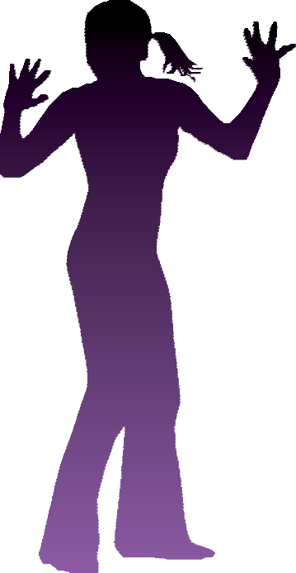

Coping with...

anxiety

(c) 2025 Greater Manchester Mental Health NHS Foundation Trust. All rights reserved.
Not to be reproduced in whole or in part without the permission of the copyright owner.
In this section, we will look at understanding your anxiety. We can then work out a plan together to help you with anxiety. This section aims to help you to:

- Find out more about anxiety
- Understand how anxiety can affect you
- Plan how to deal with your anxiety

Please go through this section at your own pace, there’s no pressure to finish it quickly. Ask your nurse for help with anything you are not sure about.

Coping with...
anxiety

SECTION 1
Understanding anxiety


Coping with...
anxiety

What is anxiety?

- Anxiety is a normal bodily response to stress.
- It is a physiological reaction called the fight or flight response.
- Everyone experiences anxiety in certain situations.
- The fight or flight response is a useful and important survival mechanism. It helps people to either fight or run away when they sense danger or threat.

The fight or flight response would be useful if, for example, a person was threatened when walking down the street. It would help the person to make a quick decision about what to do. It would also give them the energy and power to either stay and fight, or to run away. This means that anxiety is not always a negative thing!

Anxiety can be a problem when we experience this stress response in situations that are not threatening. For example, when we are stuck in traffic, when we are arguing with our partner, or when things do not go the way we want them to.
- The reason that people sometimes experience anxiety in non-threatening situations is that the fight/flight response is a primitive reaction (like a reflex).
- Our minds sometimes cannot tell the difference between different types of threat.
- Sometimes, just thinking about a threat can make people feel anxious as our minds do not always know the difference between a real or a perceived threat.

As soon as any danger is recognised, our muscles immediately tense for action. This is an instant reflex action. The brain receives the ‘danger’ message, and then dramatic bodily changes take place. Many of them happen in a split second. The table on the next page shows the changes that take place in our bodies during fight or flight, and the experiences these lead to. You could tick the ones that you have experienced.


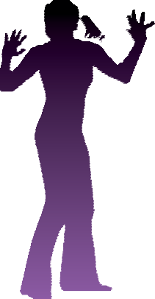

Bodily changes and symptoms in anxiety
Please tick where appropriate:
Blood moves to all the major organs (e.g. heart, lungs etc) | - Heart pounds  - Skin becomes pale  - Numbness or tingling in hands or feet  - Chest pains  - Feeling faint
Digestion slows down or is halted | - Dry mouth  - Feeling sick  - Upset stomach
Lungs take in more air to provide oxygen | - Breathing becomes faster, deeper or gasping  - This can cause dizziness
Adrenal glands produce adrenaline to keep the reaction going | - Muscles tense  - Feelings of being pumped up
The skin constricts | - Sweating  - Crawling feeling on the scalp or down the  back of the neck
Blood changes composition | - Feelings of unreality, detached from the world
Muscles become more responsive | - Pupils dilate  - Clumsiness  - Trembling

The signs of anxiety shown above are physical (to do with the body). Psychological factors (emotional feelings, thoughts, and behaviours) are also important to understanding anxiety. Some examples of the psychological factors
involved in anxiety can be seen on the next page:

Coping with...
anxiety

Feelings and emotions

When people are anxious they are likely to have unpleasant emotional feelings. Common feelings and emotions in anxiety are listed below. Please tick the ones that apply to you.

Common feelings in anxiety
Please tick where appropriate:
Frightened |  | Nervous |  | Stressed
Embarrassed |  | Scared |  | Distressed
Self-conscious |  | Panicky |  | Petrified
Worried |  | Terrified |  | Impending doom

Ways of thinking

When feeling anxious, people are more likely to see everything in a dangerous or threatening way, our thoughts can become a bit distorted or biased. Common ways of thinking in anxiety are listed below. You could tick any that are familiar to you.

Ways of thinking and their meanings
Way of thinking | What does this mean? | Tick
Catastrophising | Blowing things out of proportion and thinking that the very worst will happen
Overgeneralization | When you think something is dangerous, you think everything associated with it is dangerous
Selective attention | Focusing on threat and danger in situations
All or nothing thinking | Thinking in absolutes e.g. something is either dangerous or safe
Jumping to conclusions | Assuming e.g. I won’t be able to cope!
Living by fixed rules | Tending to have fixed rules about situations - i.e. regularly saying to yourself ‘I must; should; ought; can’t’

People who are anxious tend to have more worrying and catastrophic thoughts than other people (they overestimate threat and danger to themselves and others). They also underestimate their ability to cope with these thoughts. Common thoughts in anxiety are listed below. You could tick the ones that apply to you.

Common thoughts in anxiety
Please tick where appropriate:
I am vulnerable
People will notice
People will think I am weird
I am going to make a fool of myself
I can’t cope with this situation
This situation is dangerous
Something awful is going to happen
Something bad is going to happen to a loved one
There is something wrong with me
I am going to lose my mind
I am going to lose control
I am going to die
I must get out of this situation
I have not done things properly
I must get it right or something awful will happen
I must not put myself in this situation again or something bad will happen

Coping with...
anxiety

Behaviours

When people are anxious, their thoughts and feelings can also make coping difficult. Their behaviour is likely to change. We all cope with anxiety in different ways, some common behaviours people might use are listed below. Please tick the ones that apply to you.

Common behaviours in anxiety
Please tick where appropriate:
Avoiding things, situations or people that increase anxiety
Escaping from things, situations and people that increase anxiety
Reliving or reviewing situations that have caused anxiety
Avoiding speaking in certain situations
Trying to do things perfectly
Checking things over and over again
Trying to control situations to prevent danger
Carrying lucky charms
Holding on to things
Saying things to self to calm myself down in certain situations
Being extremely organized e.g. planning, writing lists, researching, preparing
Becoming aggressive towards things or other people

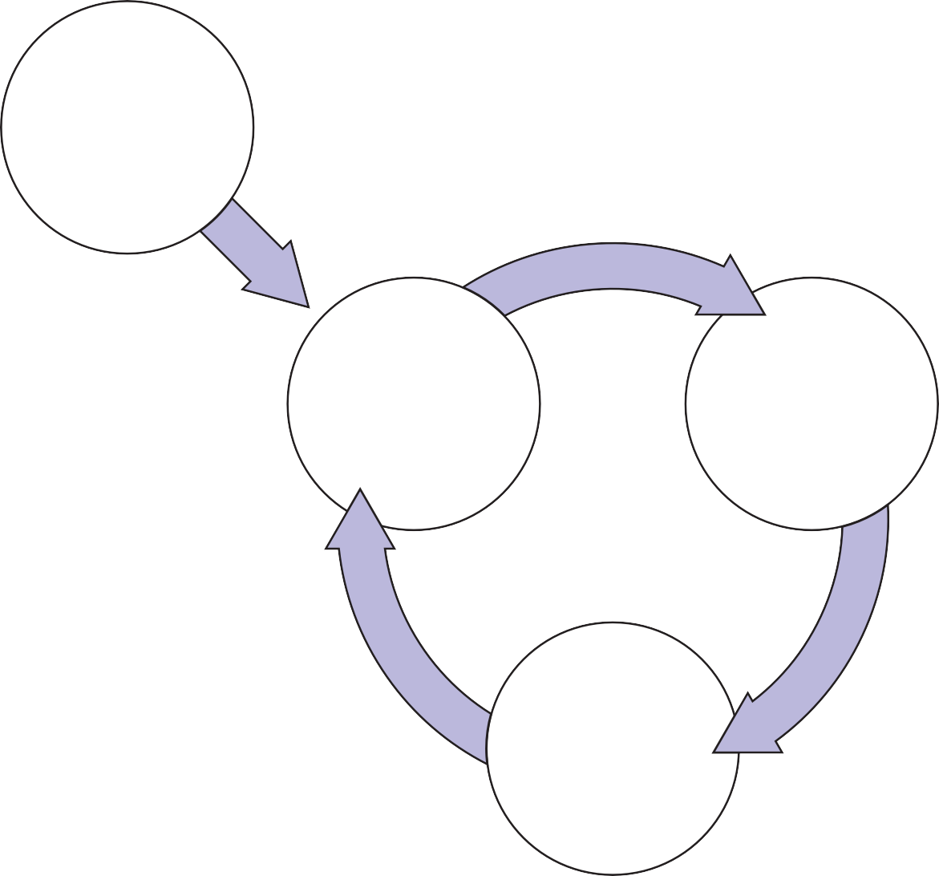

Mary

When Mary went out of her house (trigger) she often experienced her heart pounding, dizziness, sweating and feeling light headed (physical feelings). These made her feel scared, frightened and anxious (feelings). These experiences and feelings led to thoughts that something awful was going to happen. She thought that if she met anyone she would not be able to speak, as she would make a fool out of herself. She also thought that her physical experiences might be due to a physical illness, or a sign that she was going to lose her mind. Her behaviours were that she started to avoid situations where she felt anxious, such as going out. This helped Mary in the short-term, as her physical feelings reduced. But in the long-term, this made her believe that her thoughts were true and closed the vicious
circle. This led to more anxious thoughts, more unpleasant feelings and more unhelpful behaviours. The vicious circle
Trigger/Event kept Mary feeling anxious. The diagram below shows this.

Crowded shops Lots of people

Feelings Thoughts

Scared ‘I’ll make a fool
Frightened out of myself’
Anxious
Sweating
Dizzy ‘I might be losing
my mind’

Behaviours

Get out of situation as quickly as possible Avoid situations like this in the future

Coping with...
anxiety

Dealing with anxiety

The first step to overcoming anxiety is to identify your triggers, feelings, thoughts, behaviours and physical changes and how they interlink. You can then identify which of these you would like to change. Finally, you can build on any strategies that you have found helpful for dealing with these. You can also learn to use new strategies that are helpful in dealing with the feelings, thoughts, and behaviours that you are experiencing.

Identifying your anxiety triggers and symptoms

At the beginning of this section we looked at common symptoms of anxiety. You might have already started to work out what your own triggers and experiences of anxiety are. You might find it difficult to identify them. The diary method can be helpful in identifying triggers and experiences. It can help you to be more aware of what your own anxiety triggers, thoughts, feelings and behaviours are. Everyone experiences anxiety in different ways. Using the diary method could help you to identify other symptoms that you are not so aware of.

Mary

Mary was asked by her nurse to keep diaries for a couple of weeks of occasions when she felt anxious.This was to help her to identify her triggers, anxious thoughts, feelings and behaviours. Examples of these are shown on the next pages.

Mary’s Diary

1. Triggers
Went out of the house to go to the shop
2. Feelings
Rate how distressing each of these feelings were on a scale of 0-100%
Heart pounding (100%)
Dizziness (100%)
Sweating (50%)
Feeling light headed (25%) Scared (100%)
Frightened (100%)
Anxious (100%)
3. Thoughts
Rate how much you believed each thought was true on a scale of 0-100%
Something awful is going to happen (100%)
If I meet anyone I will not be able to speak (95%)
I might lose control or make a fool out of myself (50%)
These physical symptoms might be a sign of an underlying physical illness (75%) I am going to lose my mind (100%)
4. Behaviour
Ran home Lay down

Coping with...
anxiety

Using the diary method for yourself

For the next week or so, each time you feel anxious you could use the diary on the next page to make a note of:

Trigger/s The situation you are in
Feelings How you feel
Thoughts The thoughts that go through your mind
Behaviours What this leads you to do

Extra copies are available. Please ask your nurse for these.

Daily Diary

1. Triggers
2. Feelings
Rate how distressing each of these feelings were on a scale of 0-100%
3. Thoughts
Rate how much you believed each thought was true on a scale of 0-100%
4. Behaviour

Coping with...
anxiety

My description of what happens when I am anxious

Hopefully you will now have a good idea of what your own experiences of anxiety are.

To see how your thoughts, feelings and behaviours link together and keep the anxiety going, you could fill in the boxes in this diagram. Your nurse could help you with this if you wish.
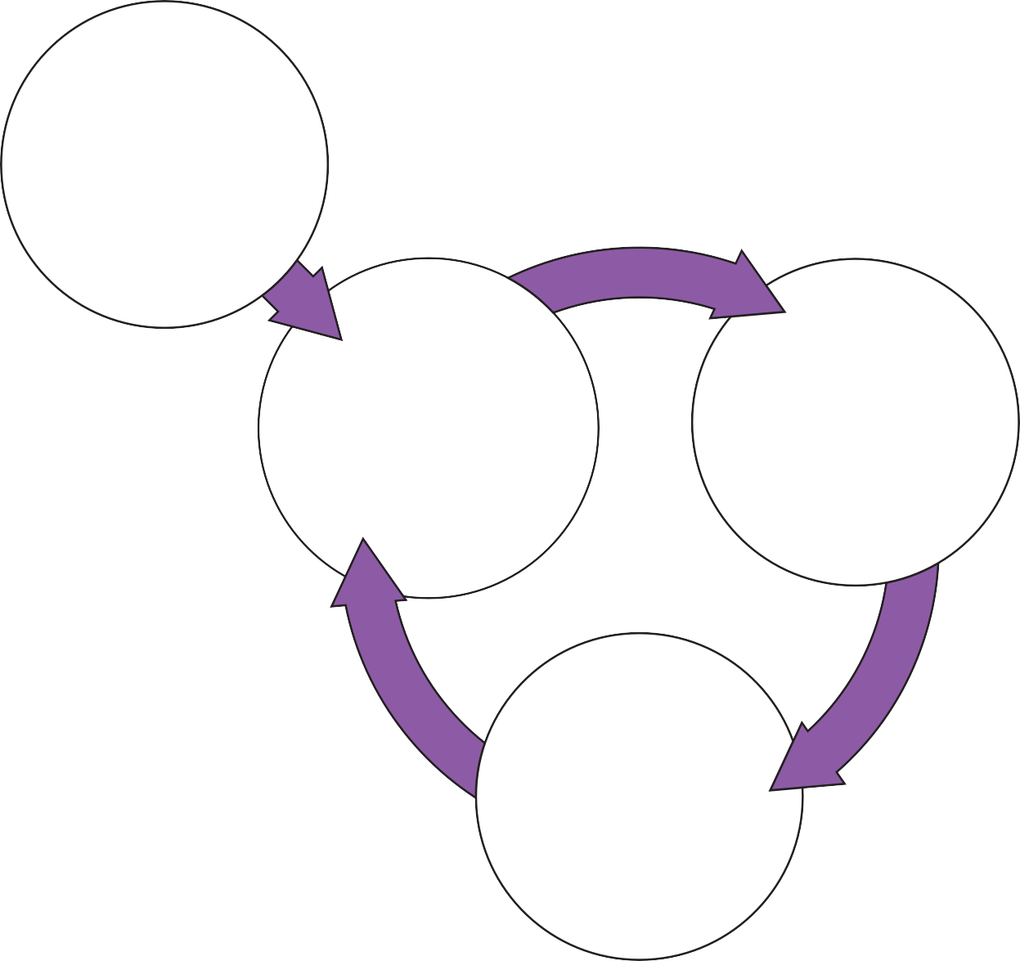
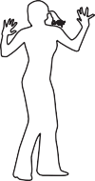
Triggers
Feelings
Thoughts
Behaviours

Coping with...
anxiety

SECTION 2
Goals and obstacles

Choosing obstacles and goals to work on

A good starting point in overcoming anxiety is to think about which feelings, thoughts or behaviours are the main obstacles for you. Obstacles are things that can get in the way of recovery. Recovery means different things to different people, so it is important to think about what this means to you.

It is also a good idea to set clear, realistic goals. You might want to start with one or two small goals, and build these up over time to longer-term goals. Rating obstacles and goals is also useful. This is so that you can see if things have changed after you have tried some of the strategies for overcoming anxiety (these will be looked at in other sections of the workbook if you choose to do them).

Once she had completed her diagrams, Mary discussed her obstacles and goals with her nurse. An example of her obstacle and goal list for overcoming anxiety is shown below.

Mary’s obstacle and goal list

Mary’s long-term goal was to overcome her anxiety and enjoy life again. She broke this up into two smaller steps to begin with. Mary’s initial obstacle and goal list for overcoming anxiety was:

Mary’s obstacles and goals
Obstacle | Goal
Overwhelming fear that something bad will happen in the future. | To learn strategies to evaluate my anxious predictions using ‘Working on Thoughts’ section of workbook before discharged.
Feeling extremely anxious on my own. | To be able to go the local shops, stay in shop for 10 minutes and buy items on shopping list.

Coping with...
anxiety

My obstacle and goal list

In the boxes below write your long-term goal(s) to do with your anxiety. Then think about how you could break this down into smaller steps, and write these in the ‘initial obstacle’ list.

My long-term goals are:

My initial obstacle and goal list is:
Obstacle | Goal

If you are unsure what specific goals to set, you could discuss this with your nurse if you like.



Coping with...
anxiety

SECTION 3
Coping strategies

Coping with...
anxiety

Choosing strategies for dealing with anxiety

You have now defined your obstacles and chosen your priority goals. The next step is to choose the best strategy for dealing with these. You may already have some strategies that you find helpful. Mary had her own ways of dealing with some of her experiences.

With the help of her nurse, she also learned to use new strategies to help her with her anxiety. These strategies aim to change the feelings, thoughts and behaviours that occur when people experience anxiety and have been shown to help. Different people find that different things help, so you need to decide what is going to work best for you.

Mary identified one goal of getting out to the shops, so she chose to use a behavioural strategy. If you are finding anxious feelings your biggest problem, you might want to use strategies which reduce your arousal levels. If you are finding anxious thoughts the biggest problem, you might want to use strategies which focus on your thoughts. If you are finding doing things the biggest problem, you might want to focus on your behaviours. Or, you might choose
to use a mixture of these. Whichever you choose it should still help in the other areas, because what we do affects the way we think and vice versa.

You may have some idea of what strategies to use. You could discuss what area you would like to work on with your nurse and think about what to do next. The strategies could involve your thoughts, feelings and behaviours; there is more information below and you can discuss this with your nurse if you wish.

What can you do to cope with your anxiety?

There are probably things that you do already that help you to cope with your anxiety. There may also be things you do that are not so helpful, and that you want help with changing. It might be helpful to group these into the following headings:

- Things to do with the triggers
- Things to do with the feelings
- Things to do with the thoughts
- Things to do with the behaviours

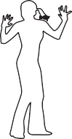
It can be difficult to separate these out but it gets easier with practice. Your nurse could help you to do this. Filling in Box 1 on the next page might help you to see what you are doing that is already helpful. Using Box 2 you might find out what is not so helpful and what you would like extra help with.

Coping with...
anxiety

Box 1. What things do I do already that help me to cope with anxiety?
Things that help with the triggers
Things that help with the emotional feelings
Things that help with the physical feelings
Things that help with the thoughts
Things that help with the behaviours

Box 2. What things do I do that are not helpful for my anxiety?
Please tick if you would like extra help in any of these areas |  | Tick
Things that do not help with the triggers
Things that do not help with the
emotional feelings
Things that do not help with the physical feelings
Things that do not help with the thoughts
Things that do not help with the behaviours

Other strategies that can be helpful in dealing with anxiety

The table below shows strategies that can be helpful in dealing with anxiety:

Triggers | Trying not to get into situations that trigger the experience
Feelings | Using strategies to improve negative emotions and distressing  physical symptoms
Thoughts | Using strategies to test out how realistic thoughts are in  response to situations
Behaviours | Using strategies to change actions



Coping with...
anxiety

SECTION 4
Working on THOUGHTS

Coping with...
anxiety

Checking out anxious thoughts

One useful way of dealing with worrying thoughts is to learn to look at thoughts in a more balanced way. As we have seen, when we are anxious, we tend to see things in a more threatening way.

Thoughts in anxiety tend to be:

- Automatic (involuntary and ‘pop up’)
- Believable
- Habitual (a bad habit)
- Unreasonable and unhelpful

Because anxious thoughts are automatic, the first step to dealing with them is to become more aware of them. Because they are believable, the second step is to begin to look at them more realistically. This means looking at the thoughts in a more balanced way to see whether or not they are realistic. We often think that thoughts are facts.

For example, consider these thoughts:
- I think it will be a bad day • I think I am going to lose control

These are just thoughts, so thinking that it will be a bad day does not mean that it will be. In the same way, thinking that you are going to lose control is only a thought, it does not make it fact. When you are feeling anxious and have anxious thoughts, they don’t feel like just thoughts, they feel like facts. They feel like they are the truth about us, and our current situation. Try to remember that they are just thoughts, not fact.

Using thought diaries can help you to view anxious thoughts in a more balanced way. Next, we will look at how to do this.

Step 1: Identifying anxious thoughts

Hopefully you will now have had some practice at using the diary method. For the next week or so, every time you notice yourself feeling anxious, use the first three sections of the thought diary to write down the situation, how you feel, what anxious thoughts are going through your mind, and what this leads you to do. This will help you to become more aware of what your anxious thoughts are, how much you believe them, and how they affect your feelings and behaviours.



Step 2: Checking out anxious thoughts

Once you can identify anxious thoughts, you can then begin checking out how true they are. To do this, complete sections 4 and 5 of the thought diary. These sections ask you to give the evidence you have to support the anxious thoughts and any evidence that does not support them. Checking out anxious thoughts takes practice.
Mary found that the following strategies helped. They might help you too!

The courtroom technique

Mary’s nurse asked her to pretend that the anxious thought to be tested was in
the dock at court. He asked her to look at the evidence for and evidence against the thought. Mary was also asked to be as objective as possible. Here is an example of how Mary used the courtroom technique. Her anxious thought to be tested was ‘I am going to lose my mind’.

Thought to be tested: ‘I am going to lose control’
Prosecution (Evidence for) |  | Defence (Evidence against)
- I feel tense, shaky, …and like I am going to lose my mind when I am at the shops. |  | - I am normally a calm person  - These are symptoms of anxiety not a sign of losing my mind  - I feel these symptoms every day and have never lost my mind  - I am catastrophising  - I am focusing on the symptoms, not what is happening around me when I am at the shops. This makes the symptoms worse.

Coping with...
anxiety

Step 3: Thinking about things in a more balanced way

Now you have checked out your thoughts, you could try to think of a more helpful or balanced response. Mary used the questions below to help her think about her thoughts in a more balanced way. An example of the diary Mary used to do this is on the next page. Your nurse could help you to think about these things.

- What real evidence do I have to support these thoughts?
- Are these thoughts helpful?
- What thoughts might be more helpful?
- Am I confusing thoughts with facts?
- Are my thoughts biased? If so in what ways e.g. am I jumping to conclusions or catastrophising (thinking that the very worst will happen)?
- Am I being too hard on myself?
- If a friend in the same situation told me this anxious thought, would I agree?
- How would someone else view this?
- How would I have viewed this situation in the past when I was not feeling so anxious?

Try to think of a more balanced response. You could discuss this with your nurse. When you have come up with a more balanced response, write this in section 6 of the diary.

Step 4: Rate how you feel now

Write down how you feel now in section 7 of the diary. Has checking your thoughts out in this way changed the way you feel? If so, what do you make of this? Don’t worry if you are finding it difficult to check out your thoughts or find that the diaries are not working for you. This might take time and practice.

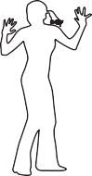

Example of Mary's diary

1. Triggers
Went to the local shop while on leave
2. Feelings
Rate how distressing each of these feelings were on a scale of 0-100%
Heart pounding (100%)
Dizziness (100%)
Sweating (50%)
3. Thoughts
Rate how much you believed each thought was true on a scale of 0-100%
Something awful is going to happen (100%) I am going to lose my mind (100%)
4. Evidence for this thought
Circle the thought you want to test from section 3.
Write only the factual evidence you have to support this thought.
My thoughts were racing like I couldn’t cope anymore.
5. Evidence against this thought
Use the strategies in the Recovery Guide to help you discover evidence that
does not support the thought
- I am normally a calm person
- These are symptoms of anxiety not a sign of losing my mind
- I feel these symptoms every day and have never lost my mind
- I am catastrophising
- I am focusing on the symptoms not what is happening around me when I am at the shops. This makes the symptoms worse.
6. More balanced response
Is there another way to explain the situation?
Rate how much you believe the more balanced response on a scale of 0 to 100%
I am not going to lose my mind (60%)
7. How do you feel now?
Rate each of these feelings on a scale of 0 to 100%
Calm (75%)

Coping with...
anxiety

1. Triggers
2. Feelings
Rate how distressing each of these feelings were on a scale of 0-100%
3. Thoughts
Rate how much you believed each thought was true on a scale of 0-100%
4. Evidence for this thought
Circle the thought you want to test from section 3.
Write only the factual evidence you have to support this thought.
5. Evidence against this thought
Use the strategies in the Recovery Guide to help you discover evidence that
does not support the thought
6. More balanced response
Is there another way to explain the situation?
Rate how much you believe the more balanced response on a scale of 0 to 100%
7. How do you feel now?
Rate each of these feelings on a scale of 0 to 100%

Coping with...
anxiety

SECTION 5
Working on BEHAVIOURS

Coping with...
anxiety

Working on your behaviours

This section will focus on your behaviour. Firstly, we will think about how you can test out some of your anxious thoughts and how accurate they are (behavioural experiments). Then, we will look at how exposing yourself to situations that cause you to feel anxious in a gradual way can help you overcome anxious feelings (graded exposure).

Behavioural Experiments

When people are anxious they tend to make anxious predictions about what they can or can’t do, or what might happen in the future. For example, Mary had the anxious thought ‘If I meet someone I know and go over to them I will not be able to speak’.

The problem with predictions like this is that they stop you from doing anything to find out whether or not they are true. Therefore you begin to believe them more, avoid more things, feel more anxious, and so on. One way of checking out anxious predictions is to change what you do. In Mary’s case this would be to stop avoiding people she knows when she is out and go up to them to start a conversation.

Anxious predictions can be tested using behavioural experiments to find out how true the predictions are. Mary set up an experiment to test out her anxious prediction that if she would not be able to make it through the relaxation group on the ward because her anxiety would get in the way. This is shown in the diary on the following page.



Coping with...
anxiety

Mary's anxious prediction

Behavioural Experiment Diary
Step 1 | Write down the thought that you want to test below. Rate how much you currently believe this thought to be true on a scale of 0-100%.
Thought:
‘I can’t go to the groups, I’m too anxious’
Belief....... 100%
Step 2 | Think of a way to check out the thought. Write down how you plan to test the thought.
Experiment to test the belief. What are you going to do?
Try going to the anxiety group on the ward on Tuesday.
Given your negative thought what do you predict will happen?
I will get too anxious and have to leave early.
Step 3 | Identify any problems and solutions. Write down what problems might get in  the way of checking it out. How can you overcome these?
What might make the experiment difficult? How might you solve this?
Anxiety - Remind myself that: The physical feelings I am experiencing are only anxiety. It does not mean anything bad is actually going to happen. Try using some breathing techniques if I feel overwhelmed and like I need to leave.
Step 4 | Outcome. Write down what actually happened. What was the result of the  experiment?
I went to the group on Tuesday. I felt very anxious but reminded myself several times that anxiety cannot harm me, it is just a feeling. I managed to stay until the end and I managed to speak to someone in the group.
Step 5 | How much did the outcome support the thought to be tested? Write down  whether what really happened fitted with your original prediction.
It did not support the thought. I was able to go.
Step 6 | Write down how much you believe the thought to be tested now from 0-100%.
Thought:
‘I can’t go to the groups, I’m too anxious’
Belief....... 20%
Step 7 | What do you make of this? Write down any alternative thoughts.
Alternative thought:
I can go to the anxiety group and sit all the way through even if I feel anxious.

Checking out your own anxious predictions

Behavioural Experiment Diary
Step 1 | Write down the thought that you want to test below. Rate how much you currently believe this thought to be true on a scale of 0-100%.
Thought:

Belief....... %
Step 2 | Think of a way to check out the thought. Write down how you plan to test the thought.
Experiment to test the belief. What are you going to do? Given your negative thought what do you predict will happen?
Step 3 | Identify any problems and solutions. Write down what problems might get in  the way of checking it out. How can you overcome these?
What might make the experiment difficult? How might you solve this?
Step 4 | Outcome. Write down what actually happened. What was the result of the  experiment?
Step 5 | How much did the outcome support the thought to be tested? Write down  whether what really happened fitted with your original prediction.
Step 6 | Write down how much you believe the thought to be tested now from 0-100%.
Thought:

Belief....... %
Step 7 | What do you make of this? Write down any alternative thoughts.
Alternative thought:

Coping with...
anxiety

Graded Exposure

Exposure therapy is an effective behavioural technique for treating anxiety. It involves the person being exposed (coming into contact with) to the thing that causes them anxiety. The most effective form of exposure is called real life, graded exposure. This is where a person confronts their feared situations gradually, working from their least feared situation up to their most feared situation.

Avoiding situations reinforced Mary’s thoughts that the safe situation (going shopping) was actually dangerous. This is because she got short-term relief from her anxiety by escaping and avoiding. In the long-term though, her anxiety became worse and she felt that she couldn’t go out to the shops, even though she had no evidence for this. Mary came up with some graded exposure tasks with support from her nurse to help build her confidence.

In the next section, we will show you how to design your own exposure programme. Facing the situations that cause anxiety can seem difficult in the short-term, but can help to reduce anxiety in the long-term. You may be worried about doing this, which is normal, as you are going to try facing some fears. You may think you will make a fool of yourself (anxious thought), or you may not want to relive the anxious feelings that you have had before. At first, it can help to ask someone you know to practise your exercises with you. After a while, you could then try to do them on your own. Remember you are going to start with your least feared situation and work your way up to your most feared over time.
Coping with...
anxiety

How do I design my own individual exposure programme?
1 | Identify your problem areas (the situations or thoughts that you avoid)
2 | Decide what you are going to confront (targets)
3 | Write a list of your goals starting with the easiest and finishing with the most difficult
4 | Work your way through the list starting with your least anxiety provoking situations or thoughts
5 | Measure your anxiety before and after each exposure session to monitor your progress
6 | Do not move on to the next target until your anxiety has reduced (measure this using the scores taken at each session)
7 | In order for exposure treatment to be effective, expose yourself to something that causes you moderate but, manageable anxiety (ideally on a scale of 0-100 your anxiety level should be between 50 and 75). This is so you can relearn that there is nothing to be afraid of. You need to stay in your chosen situation or with your target thought until this anxiety reduces (up to 30 minutes). If your anxiety is  unbearable at any time during the exposure STOP. The target you have set is too high, so choose a more manageable target.

In the next section you’ll see how Mary set up her own exposure programme. Look at Mary’s example, and if you wish you could try something similar for yourself. You might also wish to discuss this further with your nurse.

Mary’s individual graded exposure programme Step 1. Identifying problems, targets and rewards
Problems | Targets | Rewards
Unable to go to the shops  at all | To go out for an afternoon shopping in a busy shopping centre | To praise myself for each small step that I complete towards my end target  When I get to my end target to buy myself something nice at the shopping centre

Step 2. Choosing which problem area to begin with.

It is useful here to choose the problem that is restricting your life the most. For Mary, this was not being able to get out on her own. Below is Mary’s graded exposure programme for getting out to the shops from problem to target.

Coping with...
anxiety

1 | To go to the smallest local shop twice a day for a week with a staff member
2 | To go to the smallest local shop twice a day for a week, once accompanied and once with staff waiting outside
3 | To go to the smallest local shop twice a day for a week with a friend waiting outside each time
4 | To go to the smallest local shop twice a day for a week, once accompanied and once alone
5 | To go to the smallest local shop unaccompanied three times a day for a week
6 | To go to the local shops with a friend and walk round at least three shops every day for a week
7 | To go to the local shops unaccompanied and walk around at least three shops alone
8 | To go to the local shops unaccompanied and walk around all of the shops
9 | To go to a busier shopping centre or superstore with a friend everyday for a week for one hour
10 | To go to a busier shopping centre or superstore unaccompanied every day for a week for one hour
11 | To go to the Trafford Centre with a friend for one hour
12 | To go to the Trafford Centre with a friend for three hours
13 | To go to the Trafford Centre accompanied, walk around for 45 minutes alone then meet friend
14 | To go to the Trafford Centre unaccompanied for 45 minutes
15 | To go to the Trafford Centre unaccompanied for ½ a day

The exposure programme can be flexible. In the above example, Mary felt confident enough to move from number 2 to number 5 without needing the steps in between. If you feel able, try to move on as much as you can. If you feel too overwhelmed to do the next step, try doing the step you are on a few more times until the anxiety you feel reduces.

My individual graded exposure programme

Step 1. Identify your individual problems, targets and rewards

Problems | Targets | Rewards

Coping with...
anxiety

Step 2. Developing your own graded exposure programme

Choose the area you wish to begin working on from your problem and target table. You can then use the Daily record of exposure therapy on the previous page to note down your anxiety levels for each task. On the sheet on page, start with your problem as Mary did. Then write small manageable steps that you can take to work towards your target. If you have a number of problems use a separate sheet for each. Start with one and move on to the next when that one has been achieved.

Hopefully, you will now be on your way to overcoming some of your difficulties with anxiety. You may even have achieved these. If so, you could now review your problem and goal list. If you feel that you are not making much progress, you might want to discuss this with your nurse.

Daily record of exposure therapy
Problem
Target
Date | Task | Highest anxiety level | Anxiety after

Coping with...
anxiety

SECTION 6
Working on FEELINGS

Coping with...
anxiety

Anxiety and levels of arousal

Anxiety can be related to our levels of arousal. Arousal means the way your body is when it is alert and responsive to its surroundings. Arousal can be a good thing, e.g. when we need to pay attention. Sometimes we can have too much arousal, which can cause symptoms of anxiety. Levels of arousal can increase due to stress and things that change the chemical balance in our brains. These include caffeine, alcohol, drugs, cigarettes, tiredness and poor diet. Reducing your levels of arousal can make anxiety symptoms less likely to happen.

One of Mary’s goals was to feel more relaxed (reduce her levels of arousal). She decided to try the techniques below to help with her anxiety. If you are finding it difficult to relax, you could use these strategies too. It is important to practise them, rather than just using them as a one-off.

Lowering your levels of arousal by changing your behaviours

Below are two ways you can learn to reduce arousal.

- By changing the amount you have of things that affect arousal
- By learning breathing and relaxation techniques

We will now look at each of these strategies in turn.

Coping with...
anxiety

Changing the things that affect arousal

Firstly, try to think about whether you are having:

- Too much of things that increase your arousal levels
- Too little of things that help to keep your arousal levels balanced

You could think about the questions in the table below to help you with this. If you like, you can discuss these things with your nurse.

Things that can increase arousal |  | ▲
Caffeine | How many caffeinated drinks do I have daily?  (including tea, coffee, cola and other soft drinks with caffeine)
Cannabis | Do I smoke cannabis?
Alcohol | How many units of alcohol do I have in a week?
Things that can help to keep arousal levels balanced |  | ►◄
Exercise | Am I getting enough exercise?
Sleep | Am I getting enough sleep?
Healthy diet | Am I getting enough high-energy foods? Do I eat regularly? Do I eat a healthy diet?

Some of the substances in the table (e.g. caffeine) may be making your anxiety worse. You may find it difficult to give them up though. This is because when we have any drug that enhances what our bodies do, we begin to rely on it. For example, if you stop having caffeine, you may find that you feel very tired and have headaches. However, these symptoms will eventually pass. Exercise can also help to decrease some of the effects of withdrawal.

Breakfast can be an important meal, but this depends on what you are eating for breakfast! Eating sugary foods such as chocolate can cause a rapid energy rush. This is because they produce a sugar rush as soon as we eat them. Our sugar levels soon come crashing down, which can produce anxiety symptoms. It is better to eat food and snacks that give you a slow release of energy (carbohydrates). Try swapping your
chocolate bars for cereal bars, or snack on fruit and nuts.

Breathing and relaxation techniques

When using any of these techniques, if you feel you are becoming more anxious rather than less, stop, and speak to your nurse.

  - Breathing and relaxation techniques can also help with lowering arousal levels.
  - When you breathe in a shallow way, your body tries to take in more oxygen to prepare the body for action (the fight/flight response).
  - People who are anxious often breathe in this shallow way (too fast and not deeply enough). This type of breathing is often called over-breathing or hyperventilation.
  - Sometimes people do this due to habit (they have learnt to breathe like this). They may also do this because there is too much adrenaline pumping around their body, due to the fight/flight response.

Below, we have included descriptions of different relaxation techniques for you to read and practise. You may find it helpful for your nurse to guide you through them at first.

It can help to become more aware of your breathing. You may notice that your breathing is shallow, and that your chest rises up and down when you breathe (this means you are over- breathing). If you are over-breathing, diaphragmatic (pronounced ‘diaframatic’) breathing can help you to breathe in the correct way. How to do this is described on the next page. It may seem difficult at first, because it takes practise to learn how to breathe correctly.

Coping with...
anxiety

Technique for diaphragmatic breathing
First check whether you are breathing correctly:
- Place one hand on your chest and another on your abdomen (in the middle, just below your ribcage)
- Exhale (breathe out), and then inhale (breathe in)

If you are breathing correctly your abdomen (not your chest) should rise at the start of your in breath. If your chest is rising then you are shallow breathing. You may then want to try diaphragmatic breathing.
Diaphragmatic breathing
- Practise deep breathing
- Try to breathe so that when you breathe all the movement is in your abdomen, with
very little in the chest
- When you breathe out let out a long sigh, like a balloon deflating
- After breathing out, pause for a moment, then let the in breath come in just as much
as your body wants
- Try to practise your deep breathing regularly, and in the end you should be able to
breathe like this the majority of the time

Relaxation techniques can also reduce levels of arousal. Our muscles immediately tense for action when the brain recognises danger (our levels of arousal increase). Sometimes our muscles can be tense without us even realising it. Learning to release muscle tightness can reduce our levels of arousal. This is because it is impossible for us to be both tense and calm at the same time. One of the most effective methods of relaxation is Differential muscle relaxation (DMR).

DMR involves a systematic routine of tensing (contracting) groups of muscles and then rapidly releasing the tension (relaxing the muscles). This can help you to recognise the difference between tense and relaxed muscle. When you let go of the tension, you
should find that the muscle feels much more relaxed than before. With regular practise, you should be able to recognise tension within yourself and be able to let that tension go. Don’t worry if you feel as though you are becoming more tense when you practise relaxation. What is happening is that you are drawing your attention to tension that you were not previously aware of.

You may want to try this lying down, or if you’d prefer, you can sit in a chair. Avoid any areas where you have pain or injury.

Technique for differential muscle relaxation
Using the list below, tense, observe and then relax all the muscle groups in your body. Practise a few times using the list so that you become familiar with the different exercises:
Hands | Tense your hands by making a fist and relax. Repeat.
Forearms | Bend your hands at the wrists and point your fingers upwards and relax. Repeat.
Upper arms | Bring your wrists towards your shoulders, feel the tension and relax. Repeat.
Shoulders | Bring your shoulders up towards your ears, feel the tension and relax. Repeat.
Forehead | Raise your eyebrows up toward the top of your head, feel the tension and relax. Repeat.
Face | Tightly wrinkle your nose and shut your eyes tightly, feel the tension and relax. Repeat.
Mouth | Clench your teeth tightly, feel the tension and relax. Repeat.
Neck | Press your head back into the pillow, feel the tension and relax. Repeat
Stomach | Press your stomach flat into your spine by breathing it inwards, feel the tension and relax. Repeat .
Legs | Raise your legs up off the floor, feel the tension and relax. Repeat.
Calves and feet | Curl your toes upwards towards your ankles, feel the tension and relax. Repeat.

When you have had some practice with the breathing and muscle relaxation techniques, you can try complete relaxation as described on the next page.

Coping with...
anxiety

Technique for complete relaxation
To begin with, try lying down or sitting comfortably in a quiet place. As you become more familiar with the exercises try to practise doing them anywhere.

- Using your differential muscle relaxation as a guide, tense and relax (twice each) all
the muscle groups in your body
- As you breathe in, tense the muscles
- As you breathe out, let them go, whilst at the same time saying the word ‘relax’ to yourself in your mind
- After relaxing each muscle group, notice the difference between the tense and relaxed muscles, and how relaxed and soft your muscles feel whilst you breathe the tension away
- When you have worked through all the muscle groups and you are feeling relaxed, gently focus the mind away from your everyday stresses whilst keeping alert and awake. As thoughts come into your mind do not try to block them. Just observe that they are there and let them pass through without engaging with them. Try
to imagine a pleasant scene using all your senses. Lie there for a few minutes enjoying the feeling. Then gradually become aware of the sounds in the room and get up slowly.

If you have been using the techniques described here regularly you should now be feeling more relaxed. You may feel that you are not making much progress with lowering your levels of arousal. If so, you might wish to discuss this further with your nurse.
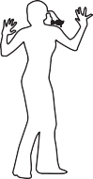
Coping with...
Anxiety

ADDITIONAL WORKSHEETS

Coping with...
Anxiety
Extra Diaries

1. Triggers
2. Feelings
Rate how distressing each of these feelings were on a scale of 0-100%
3. Thoughts
Rate how much you believed each thought was true on a scale of 0-100%
4. Behaviour

1. Triggers
2. Feelings
Rate how distressing each of these feelings were on a scale of 0-100%
3. Thoughts
Rate how much you believed each thought was true on a scale of 0-100%
4. Behaviour

Coping with...
anxiety

1. Triggers
2. Feelings
Rate how distressing each of these feelings were on a scale of 0-100%
3. Thoughts
Rate how much you believed each thought was true on a scale of 0-100%
4. Behaviour

1. Triggers
2. Feelings
Rate how distressing each of these feelings were on a scale of 0-100%
3. Thoughts
Rate how much you believed each thought was true on a scale of 0-100%
4. Behaviour

Coping with...
anxiety

1. Triggers
2. Feelings
Rate how distressing each of these feelings were on a scale of 0-100%
3. Thoughts
Rate how much you believed each thought was true on a scale of 0-100%
4. Evidence for this thought
Circle the thought you want to test from section 3.
Write only the factual evidence you have to support this thought.
5. Evidence against this thought
Use the strategies in the Recovery Guide to help you discover evidence that
does not support the thought
6. More balanced response
Is there another way to explain the situation?
Rate how much you believe the more balanced response on a scale of 0 to 100%
7. How do you feel now?
Rate each of these feelings on a scale of 0 to 100%

1. Triggers
2. Feelings
Rate how distressing each of these feelings were on a scale of 0-100%
3. Thoughts
Rate how much you believed each thought was true on a scale of 0-100%
4. Evidence for this thought
Circle the thought you want to test from section 3.
Write only the factual evidence you have to support this thought.
5. Evidence against this thought
Use the strategies in the Recovery Guide to help you discover evidence that
does not support the thought
6. More balanced response
Is there another way to explain the situation?
Rate how much you believe the more balanced response on a scale of 0 to 100%
7. How do you feel now?
Rate each of these feelings on a scale of 0 to 100%

Coping with...
anxiety

1. Triggers
2. Feelings
Rate how distressing each of these feelings were on a scale of 0-100%
3. Thoughts
Rate how much you believed each thought was true on a scale of 0-100%
4. Evidence for this thought
Circle the thought you want to test from section 3.
Write only the factual evidence you have to support this thought.
5. Evidence against this thought
Use the strategies in the Recovery Guide to help you discover evidence that
does not support the thought
6. More balanced response
Is there another way to explain the situation?
Rate how much you believe the more balanced response on a scale of 0 to 100%
7. How do you feel now?
Rate each of these feelings on a scale of 0 to 100%

1. Triggers
2. Feelings
Rate how distressing each of these feelings were on a scale of 0-100%
3. Thoughts
Rate how much you believed each thought was true on a scale of 0-100%
4. Evidence for this thought
Circle the thought you want to test from section 3.
Write only the factual evidence you have to support this thought.
5. Evidence against this thought
Use the strategies in the Recovery Guide to help you discover evidence that
does not support the thought
6. More balanced response
Is there another way to explain the situation?
Rate how much you believe the more balanced response on a scale of 0 to 100%
7. How do you feel now?
Rate each of these feelings on a scale of 0 to 100%

Coping with...
anxiety

Behavioural Experiment Diary
Step 1 | Write down the thought that you want to test below. Rate how much you currently believe this thought to be true on a scale of 0-100%.
Thought:

Belief....... %
Step 2 | Think of a way to check out the thought. Write down how you plan to test the thought.
Experiment to test the belief. What are you going to do? Given your negative thought what do you predict will happen?
Step 3 | Identify any problems and solutions. Write down what problems might get in  the way of checking it out. How can you overcome these?
What might make the experiment difficult? How might you solve this?
Step 4 | Outcome. Write down what actually happened. What was the result of the  experiment?
Step 5 | How much did the outcome support the thought to be tested? Write down  whether what really happened fitted with your original prediction.
Step 6 | Write down how much you believe the thought to be tested now from 0-100%.
Thought:

Belief....... %
Step 7 | What do you make of this? Write down any alternative thoughts.
Alternative thought:

Behavioural Experiment Diary
Step 1 | Write down the thought that you want to test below. Rate how much you currently believe this thought to be true on a scale of 0-100%.
Thought:

Belief....... %
Step 2 | Think of a way to check out the thought. Write down how you plan to test the thought.
Experiment to test the belief. What are you going to do? Given your negative thought what do you predict will happen?
Step 3 | Identify any problems and solutions. Write down what problems might get in  the way of checking it out. How can you overcome these?
What might make the experiment difficult? How might you solve this?
Step 4 | Outcome. Write down what actually happened. What was the result of the  experiment?
Step 5 | How much did the outcome support the thought to be tested? Write down  whether what really happened fitted with your original prediction.
Step 6 | Write down how much you believe the thought to be tested now from 0-100%.
Thought:

Belief....... %
Step 7 | What do you make of this? Write down any alternative thoughts.
Alternative thought:

Coping with...
anxiety

Behavioural Experiment Diary
Step 1 | Write down the thought that you want to test below. Rate how much you currently believe this thought to be true on a scale of 0-100%.
Thought:

Belief....... %
Step 2 | Think of a way to check out the thought. Write down how you plan to test the thought.
Experiment to test the belief. What are you going to do? Given your negative thought what do you predict will happen?
Step 3 | Identify any problems and solutions. Write down what problems might get in  the way of checking it out. How can you overcome these?
What might make the experiment difficult? How might you solve this?
Step 4 | Outcome. Write down what actually happened. What was the result of the  experiment?
Step 5 | How much did the outcome support the thought to be tested? Write down  whether what really happened fitted with your original prediction.
Step 6 | Write down how much you believe the thought to be tested now from 0-100%.
Thought:

Belief....... %
Step 7 | What do you make of this? Write down any alternative thoughts.
Alternative thought:

Behavioural Experiment Diary
Step 1 | Write down the thought that you want to test below. Rate how much you currently believe this thought to be true on a scale of 0-100%.
Thought:

Belief....... %
Step 2 | Think of a way to check out the thought. Write down how you plan to test the thought.
Experiment to test the belief. What are you going to do? Given your negative thought what do you predict will happen?
Step 3 | Identify any problems and solutions. Write down what problems might get in  the way of checking it out. How can you overcome these?
What might make the experiment difficult? How might you solve this?
Step 4 | Outcome. Write down what actually happened. What was the result of the  experiment?
Step 5 | How much did the outcome support the thought to be tested? Write down  whether what really happened fitted with your original prediction.
Step 6 | Write down how much you believe the thought to be tested now from 0-100%.
Thought:

Belief....... %
Step 7 | What do you make of this? Write down any alternative thoughts.
Alternative thought:

Coping with...
anxiety

Daily record of exposure therapy
Problem
Target
Date | Task | Highest anxiety level | Anxiety after

Daily record of exposure therapy
Problem
Target
Date | Task | Highest anxiety level | Anxiety after

Coping with...
anxiety

Daily record of exposure therapy
Problem
Target
Date | Task | Highest anxiety level | Anxiety after

Daily record of exposure therapy
Problem
Target
Date | Task | Highest anxiety level | Anxiety after

