Oracle Financials Upgrade 12.1–12.2
iProc Requisitioner | Oracle Financials


This guide is intended for Oracle Requisitioners to highlight the changes to iProcurement screens between Oracle Financials 12.1 and 12.2.

Summary of changes

- The look and feel of Oracle HTML screens have changed​
- ​The Shopping Cart has been updated, and contains more Information​
- ​The checkout process has been simplified to one page​
- ​Edit Lines has been replaced by Update Lines and simplified

Screen Changes

- Log in page
- Oracle Navigator Page
- iProcurement Shop Tab
- My Purchasing Options Tab
- Requisitions Tab
- Receiving Tab
- Feedback Tab

Functionality Changes

- Raise a Non-Catalogue Requisition
- Raise an eMarketplace Requisition
- Copy to Cart an Existing Requisition
- Error message

Functionality not affected

The following functionality has not changed and remains the same:
Shop/Shopping Lists
Shop/Vacation Rules
My Purchasing Options
Requisitions
Requisitions/Notifications
Receiving
Receiving/Receive Items
Receiving/Return Items
Receiving/Correct Items
Receiving/View Receipts
- Log in page

Oracle Financials  12.1 | 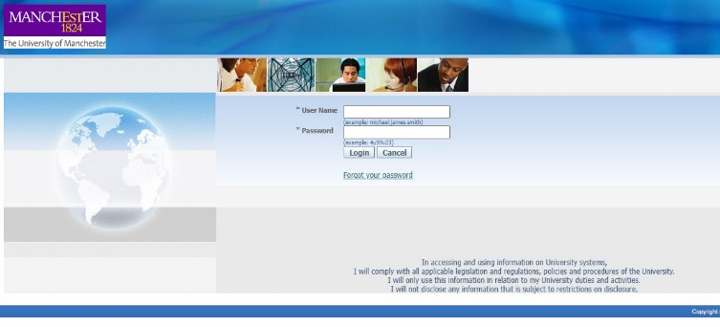
Oracle Financials  12.2 | 
Changes | - Colour scheme changes  - Option to now enable Accessibility

- Oracle Navigator Page

Oracle Financials  12.1 | 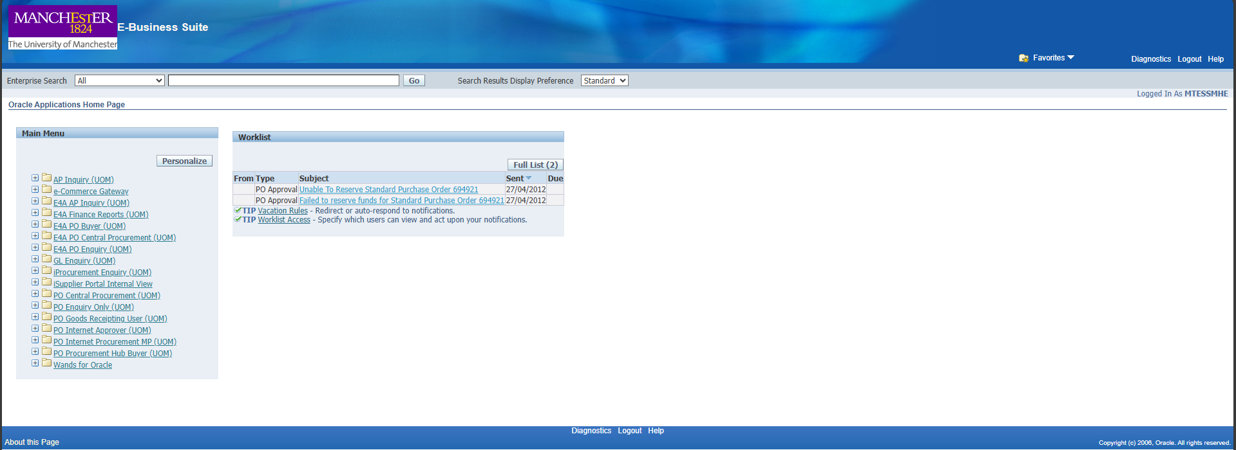
Oracle Financials  12.2 | 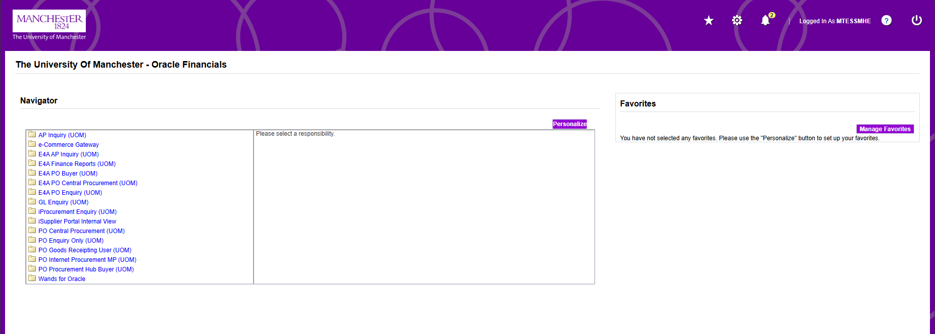
Changes | - Colour scheme changes  - Worklist from 12.1 no longer appears, moved to Notifications

- iProcurement Shop Tab

Oracle Financials  12.1 | 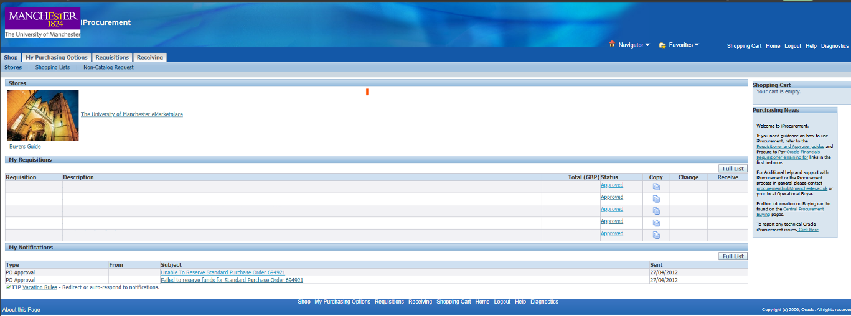
Oracle Financials  12.2 | 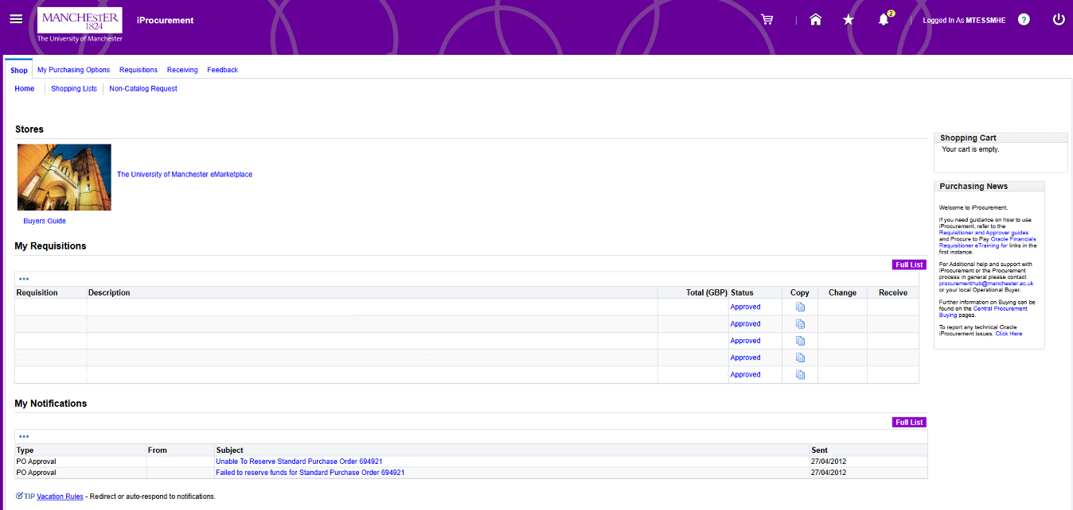
Changes
  - Colour scheme changes
  - New shopping cart icon top of page | 
  - New Notification icon top of screen | 
  - New Favourites icon top of screen | 

- My Purchasing Options Tab

Oracle Financials  12.1 | 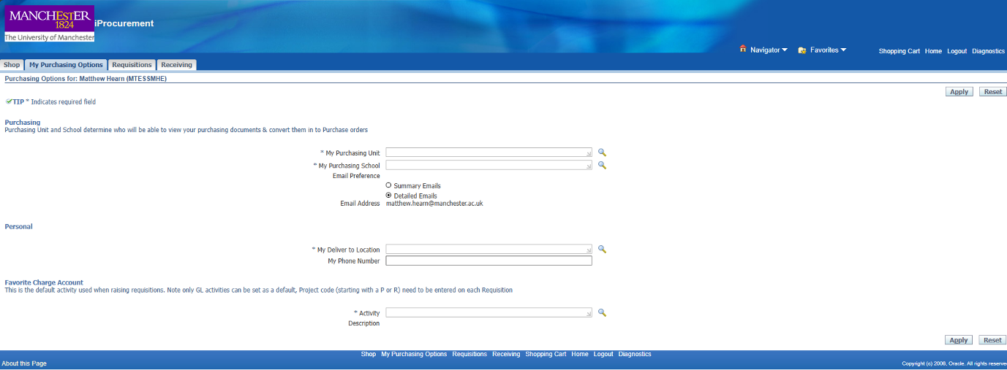
Oracle Financials  12.2 | 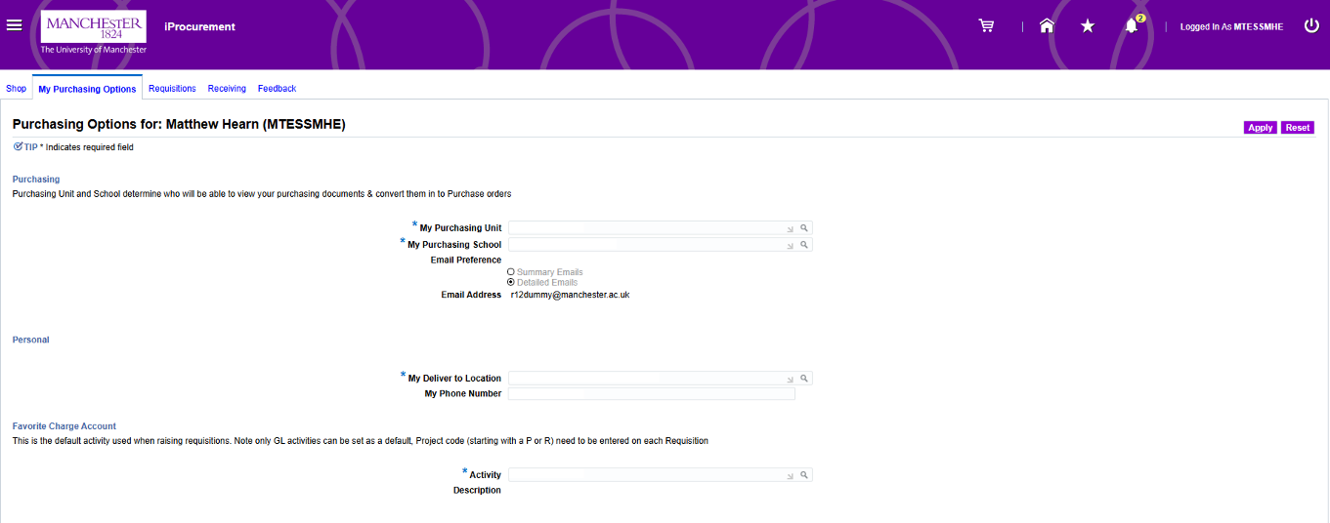
Changes | - Colour scheme changes

- Requisitions Tab

Oracle Financials  12.1 | 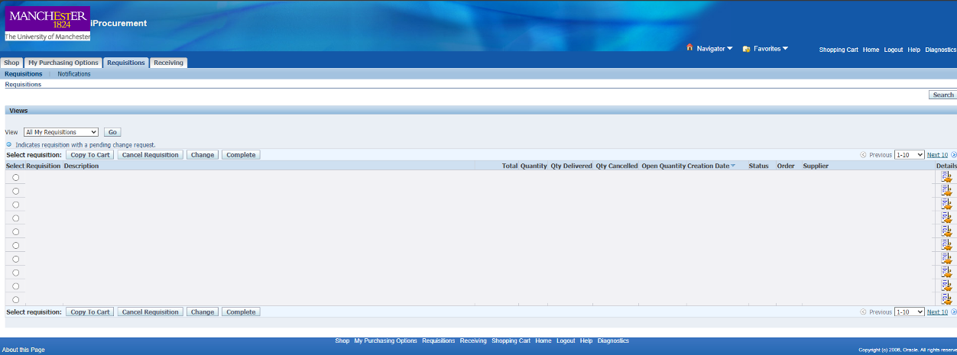
Oracle Financials  12.2 | 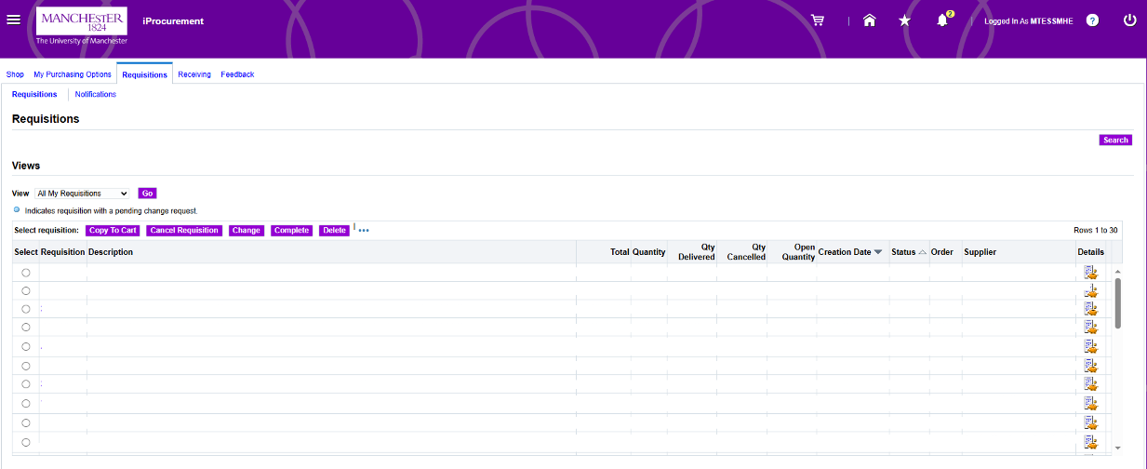
Changes
  - Colour scheme changes
  - New Delete option
  - New Table sort option
  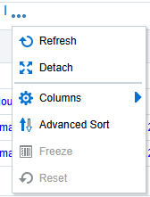

- Receiving Tab

Oracle Financials  12.1 | 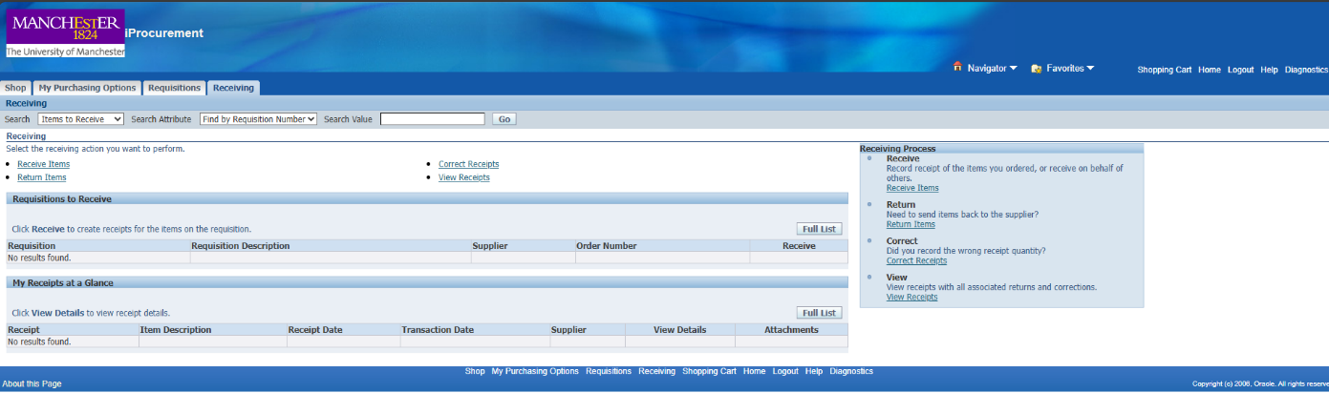
Oracle Financials  12.2 | 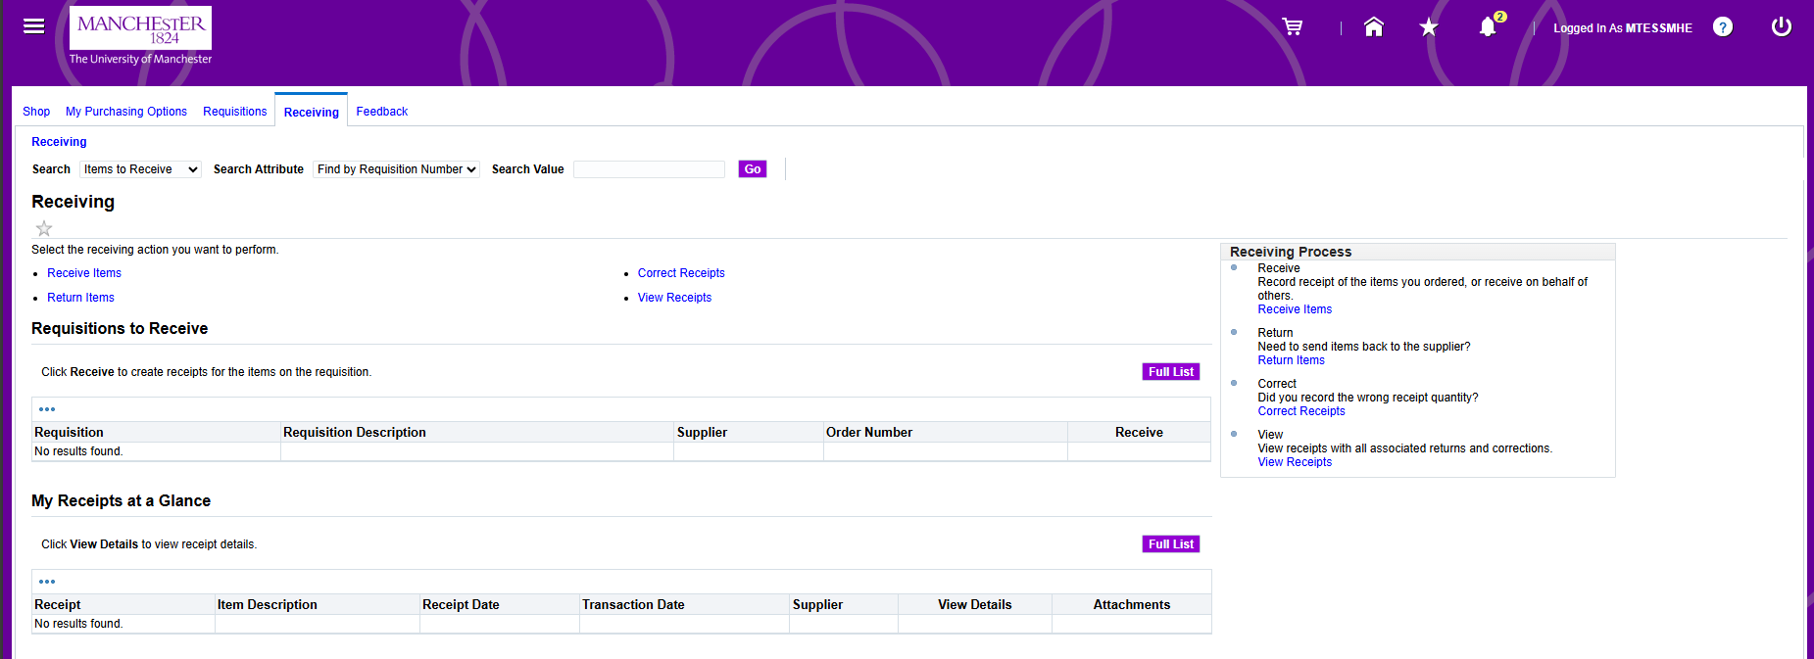
Changes | - Colour scheme changes

- Feedback Tab

Oracle Financials  12.1 | - Did not exist
Oracle Financials  12.2 | 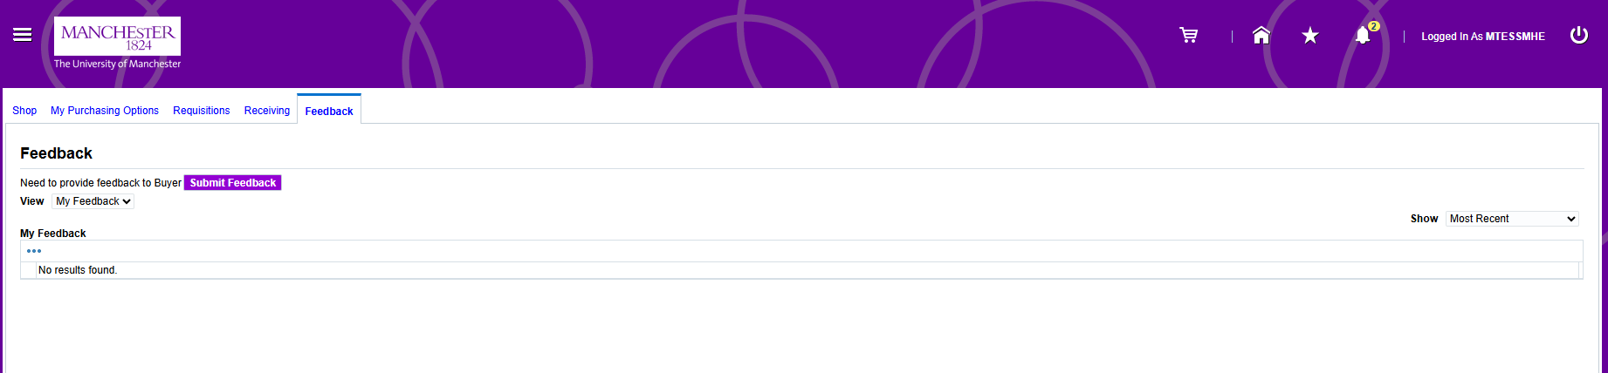
Changes | - New functionality  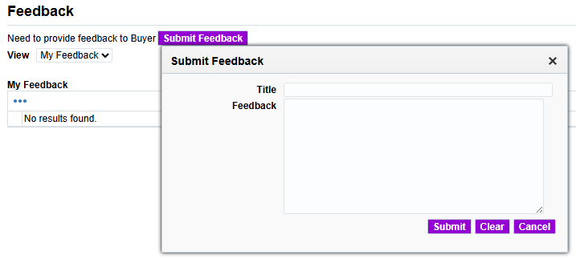  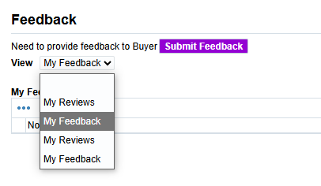

- Raise a Non-Catalog Requisition

- Login to Oracle Financials

- Select PO Internet Procurement MP (UOM)

- Select Shop tab, and click Non-Catalog Request

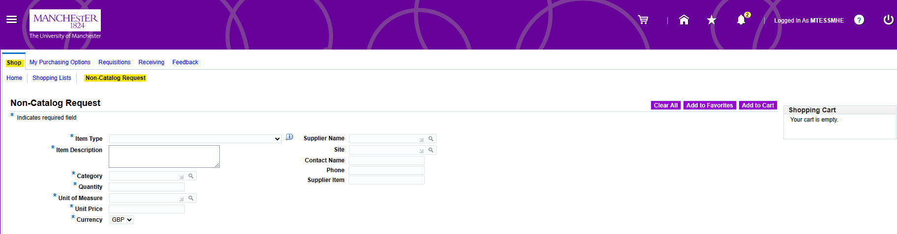
- Blank Non-Catalog page is displayed

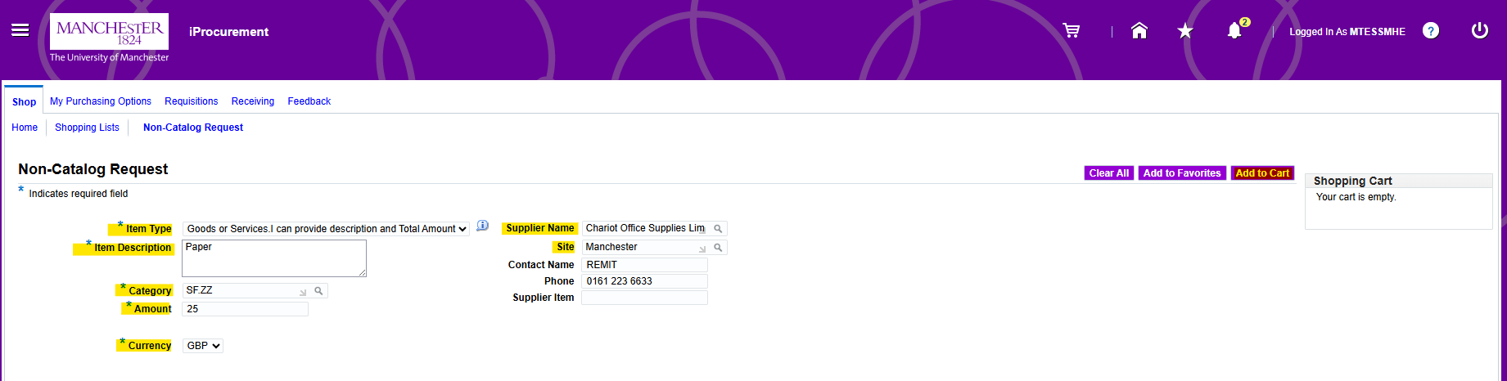

- Complete the highlighted fields and select Add to Cart

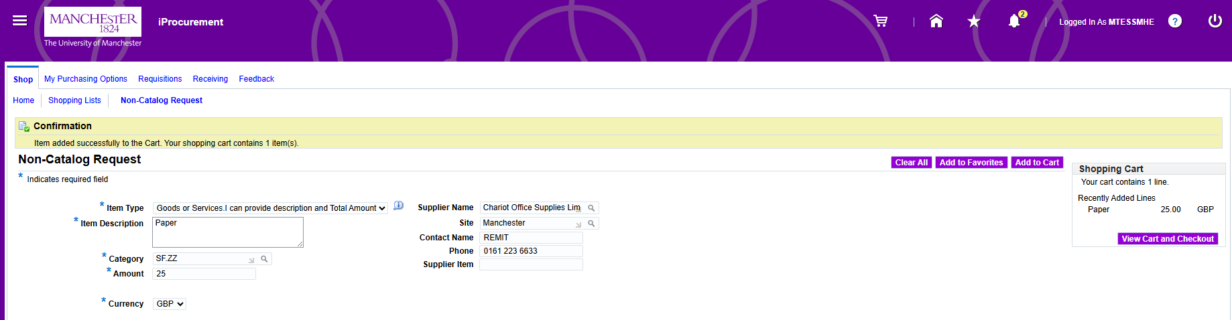

- Confirmation of item added to cart displayed

- If additional items are required, repeat the previous step to add more items to Cart

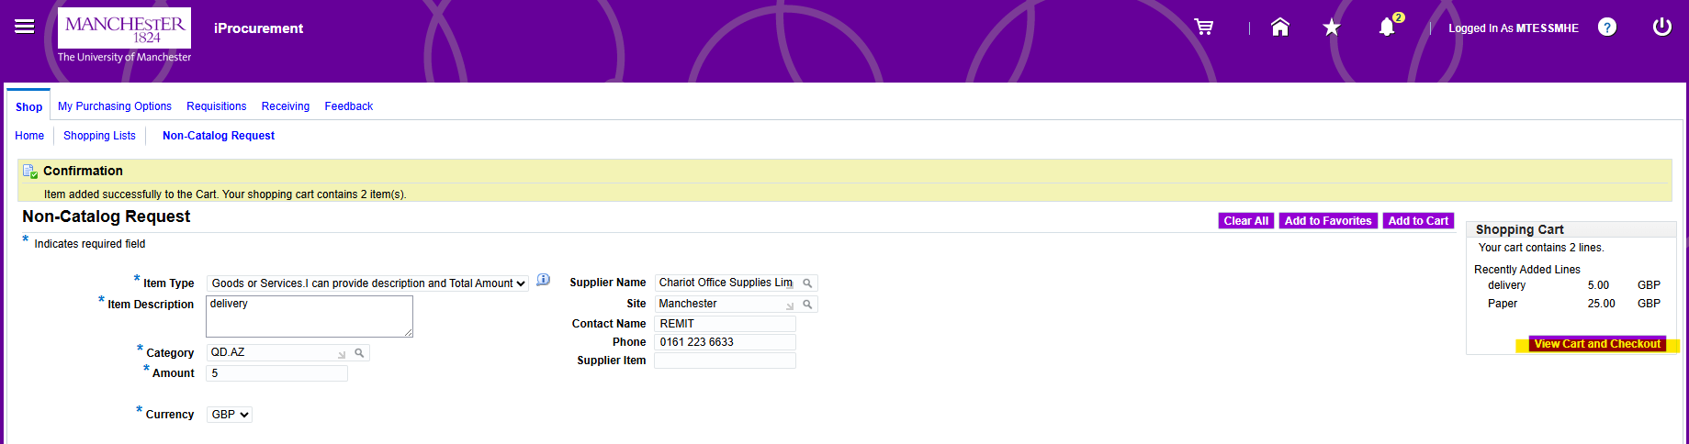

- When shopping cart is complete, select View Cart and Checkout

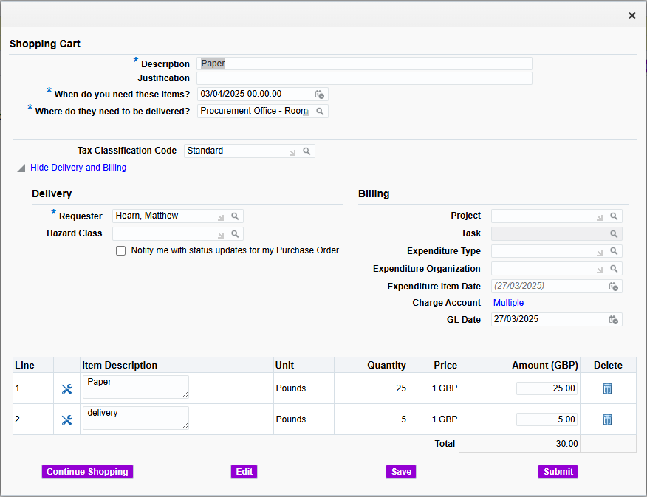

- New Shopping Cart page is displayed

- You can change the Description at this stage if you wish. This will default to the first line on the requisition. It may be helpful to amend this to identify this requisition again quickly within your main requisitions list.

- Update Justification field, this is visible by the approver and is where you need to populate any justification required for this purchase.

- When do you need these items? this is defaulted to 7 days, if you need to amend update this field.

- Where do they need to be delivered? will default according to your account settings but can be changed if necessary.

- The Tax Classification Code defaults as Standard.
  - If the purchase includes items of both Standard and Zero-rated (Or any other combination) you must create separate lines for each item and classify them individually.

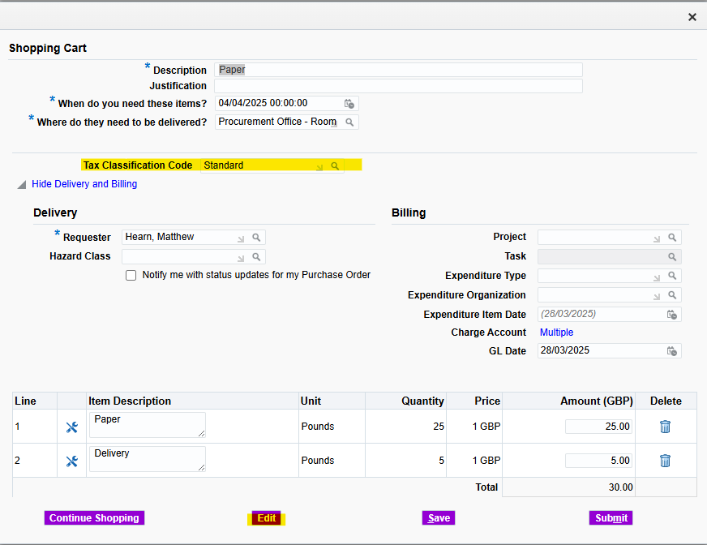
  - Select Edit to update the Tax Classification Code

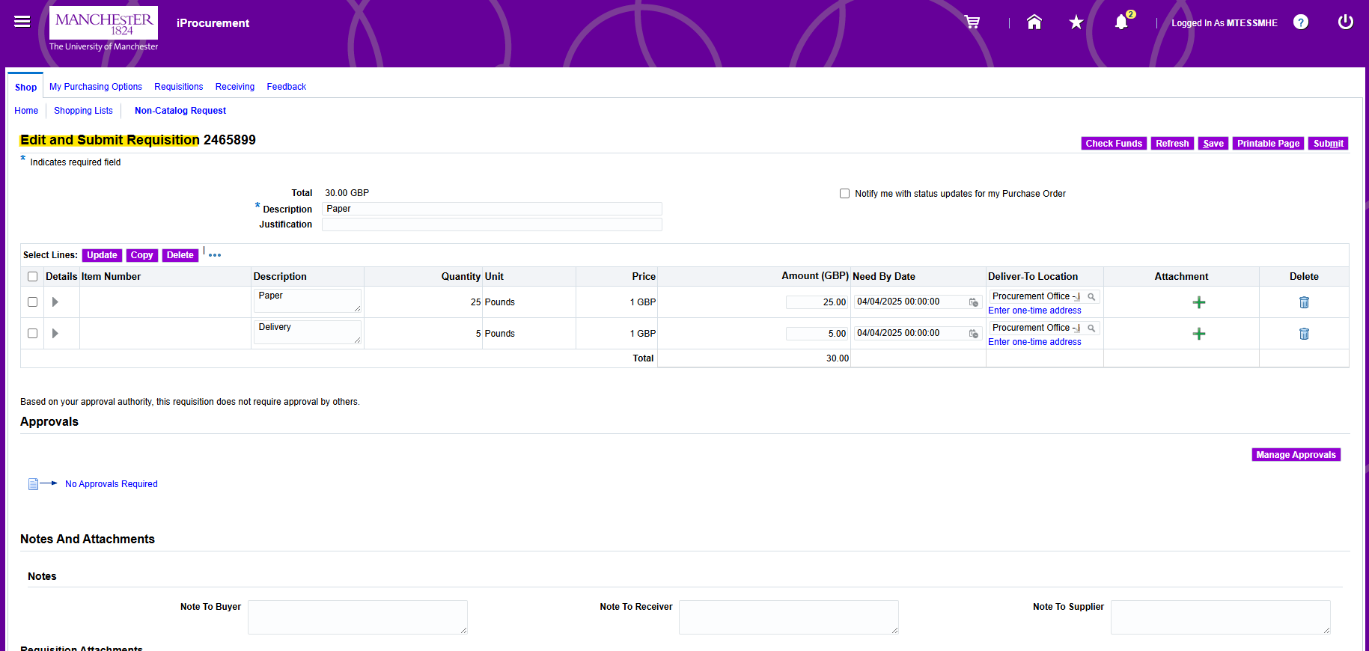
  - Edit and Submit Requisition page is displayed

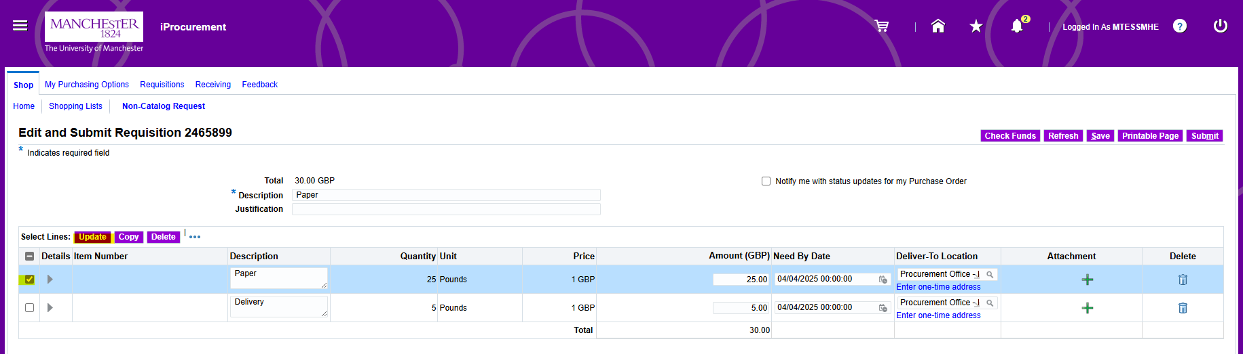
  - Select Line to be updated and click Update.

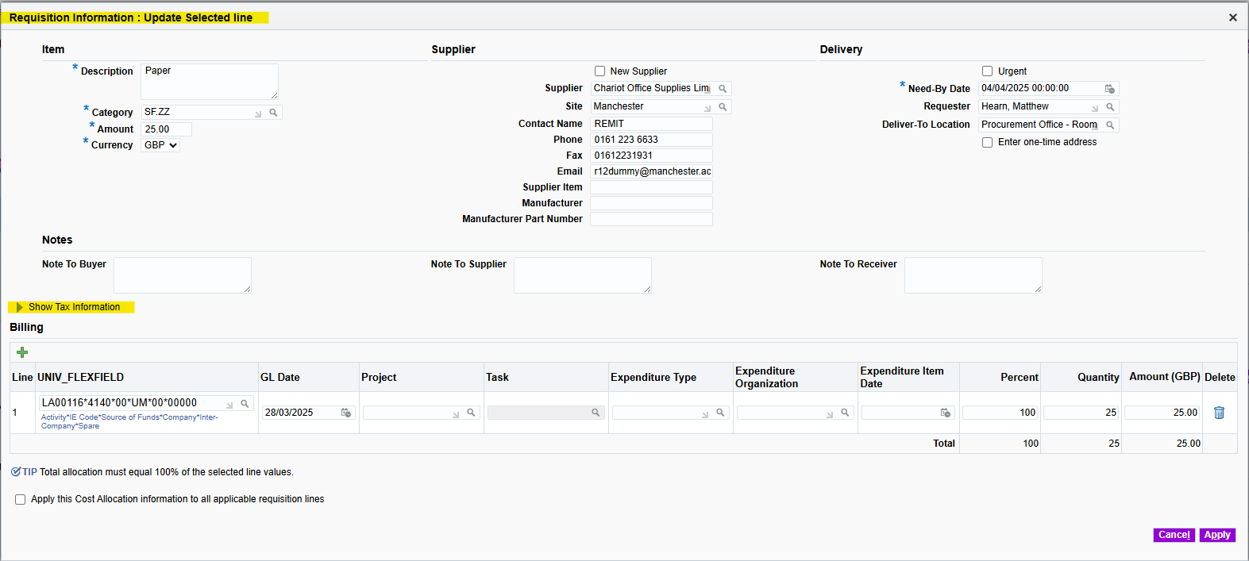
  - Requisition Information : Update selected line page is displayed.
  - Click to expand the section Show additional Tax information.

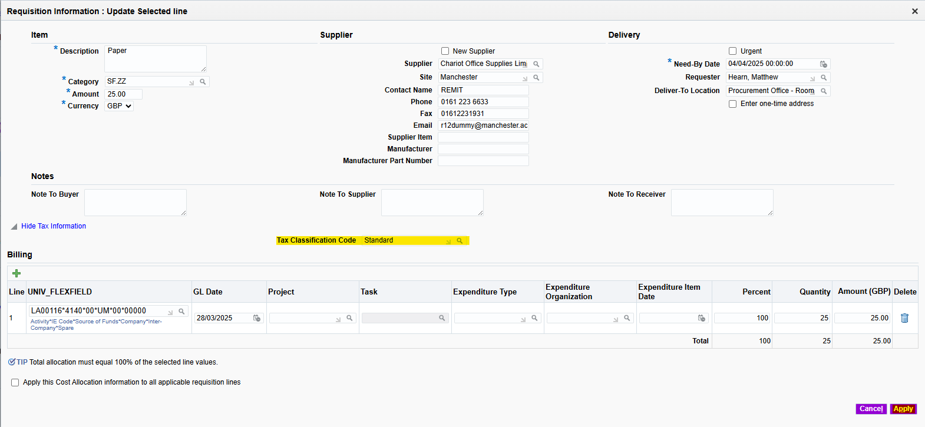

  - Use the Torch icon to update the tax code for that row and select Apply.

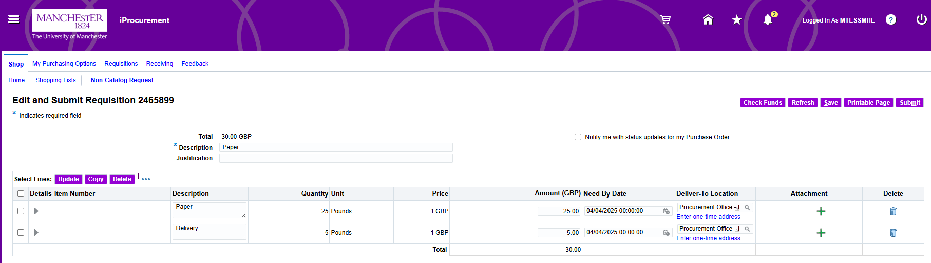
  - Edit and Submit Requisition Page is displayed.
  - Repeat steps if necessary to update any additional rows.

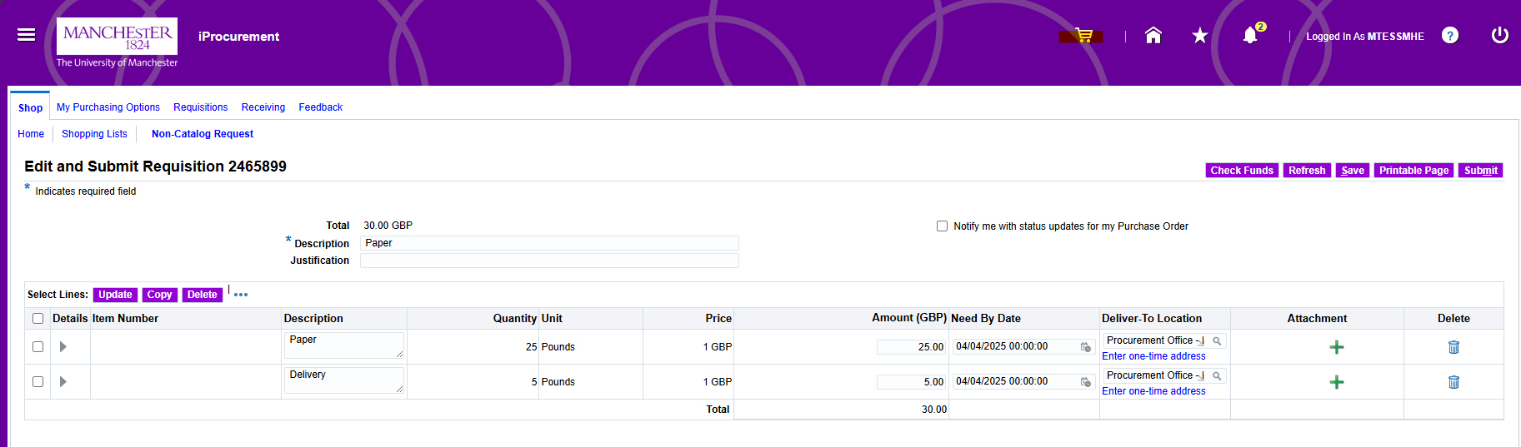
  - Click at top of page to return to Shopping Cart page to continue to review and submit requisition.

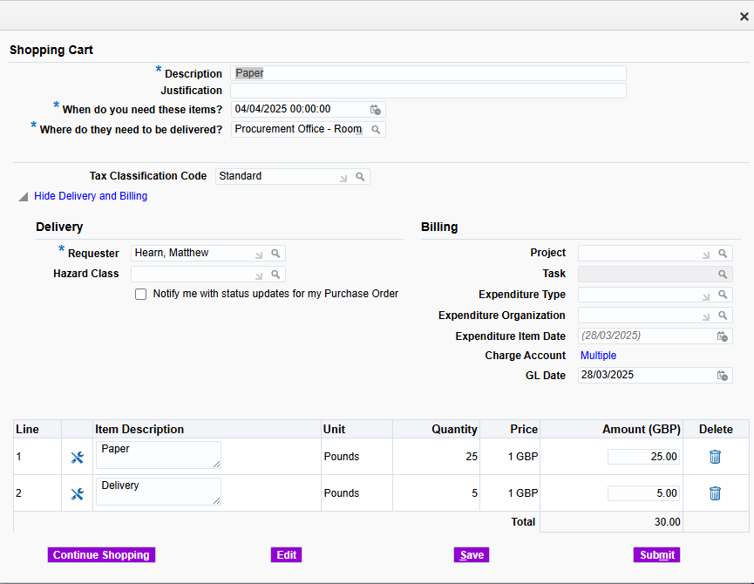

- Shopping Cart page is displayed
- Review and update Delivery information:
  - Requestor
  - Hazard Class

- Review and Update Billing information:
Project | Only complete these 5 fields if you are using a Project/Research code, entering these details will override the Charge Account. If using a Charge Account, ensure these 5 fields remain blank
Task
Expenditure Type
Expenditure Organisation
Expenditure Item Date
Charge Account | GL Codes

- The Charge Account from your Purchasing Options will be defaulted in.

- The GL date (General Ledger date) is the date the finance code is charged for accounting purposes. This date should never be amended.

- To add any of the following information select Edit then update the relevant fields:
  - Add Notes to Buyer: Enter any information you wish to pass to the Operational Buyer.
  - Add Notes to Receiver: This field is used to send a note only to the person receipting the goods on the system e.g. Stores team members.
  - Add Notes to Supplier: Enter any information you require to be passed onto the supplier. Please try to keep this message concise. Please note this will appear on the Purchase Order.
  - Add Attachments: Use the Add Attachments button to add attachments to the requisition if necessary. Enter a Description and then click Browse to locate and attach the file. Finally, click Apply to save the attachment. If the total of the requisition is over £5,000 there is a need for 3 quotations, as per the Financial Regulations and Procedures. The quotes could be scanned in and attached to the requisition.

- To update the Billing information to:
- Split the cost of the line to multiple charge codes
- Split the cost of the line to multiple project codes
- Split the cost of the line to multiple charge and project codes
- Assign different Charge/Project accounts to different lines

- Select the relevant line and click Update, select + to add an additional line, then complete the fields to split the costs as required. Once you have made the necessary changes select Apply

- Click Submit.

- Review the information a select Submit and the requisition will be submitted for approval.

- Raise an eMarketplace Requisition

- Login to Oracle Financials

- Select PO Internet Procurement MP (UOM)

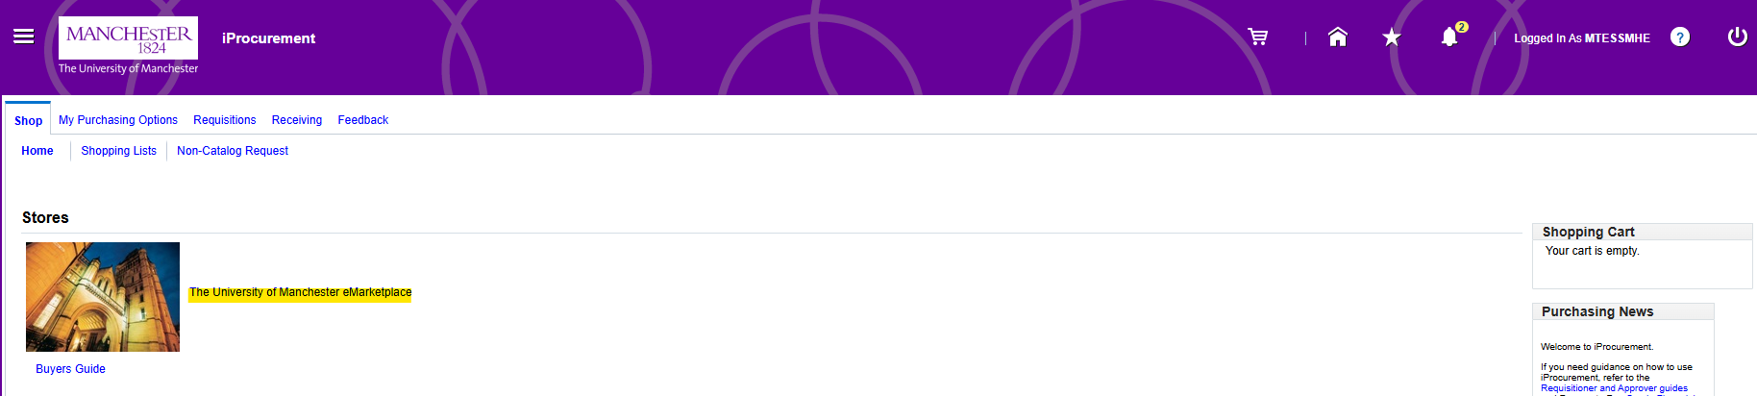
- Select Shop tab, and click The University of Manchester eMarketplace link

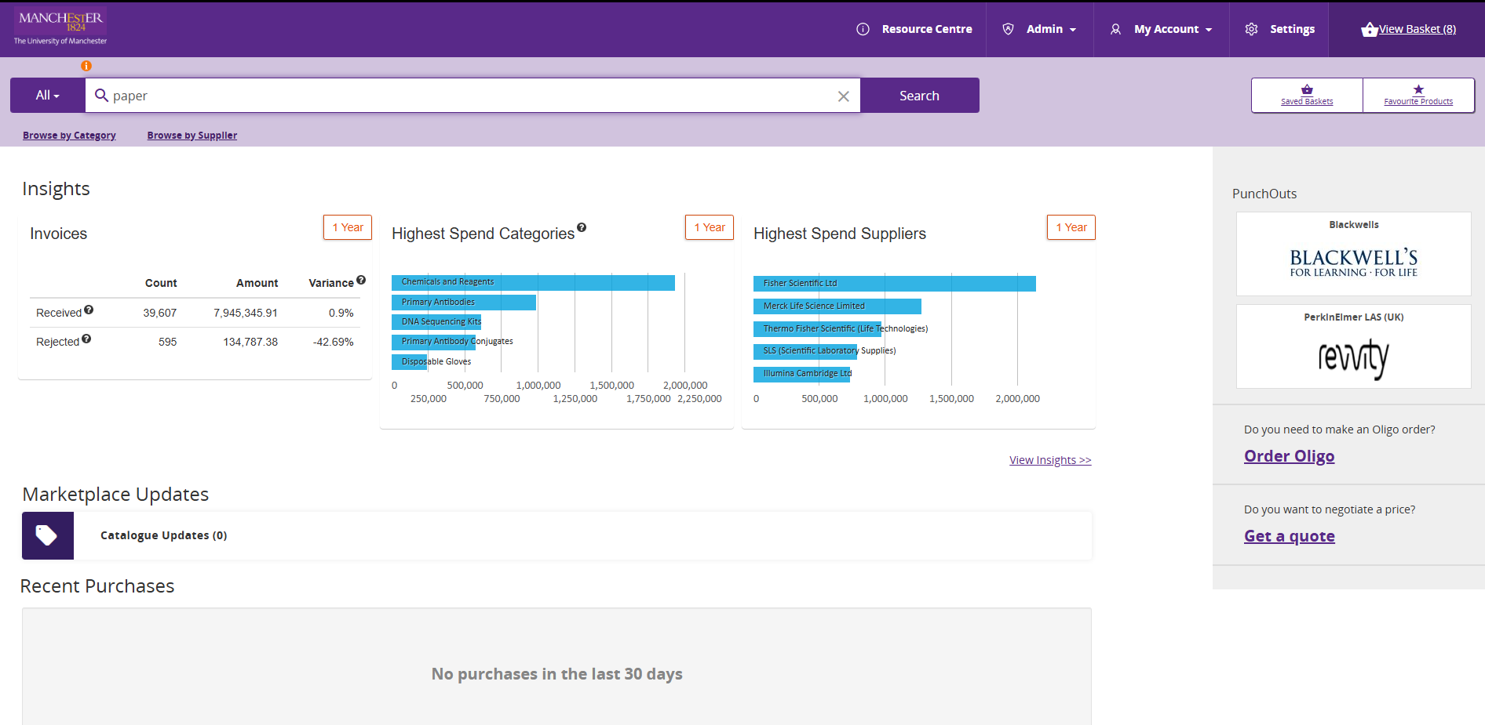

- Create a basket of goods within eMarketplace, View Basket, and Checkout.

- Basket of goods is returned to iProcurement

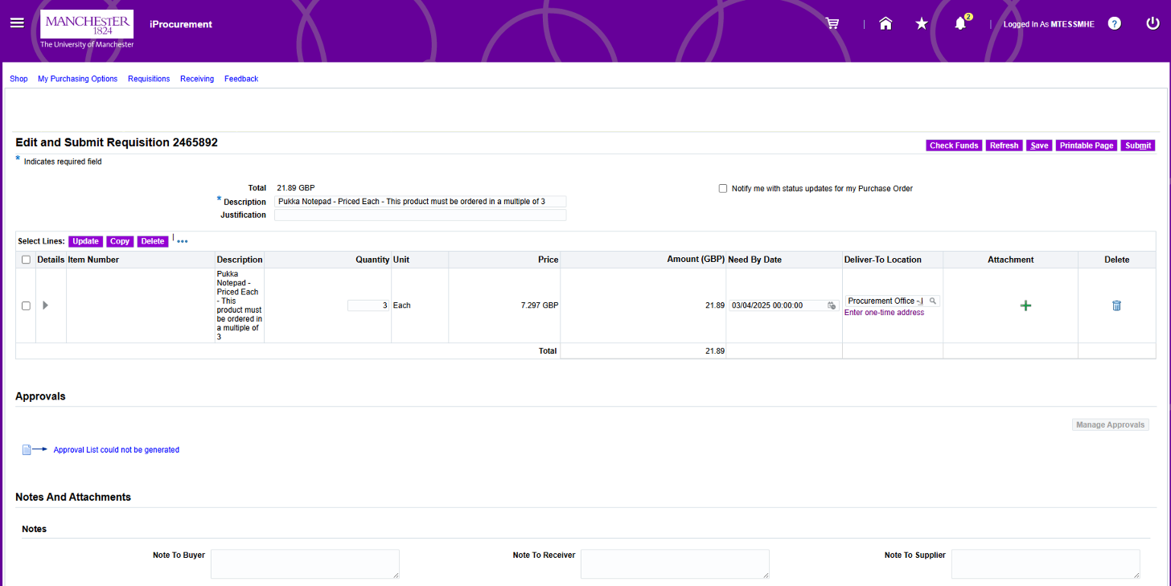

- Edit and Submit Requisition page is displayed

- Review basket, and select Submit

- If it is a single row, or multiple row purchase and you wish to make updates to any field on any of the rows select the shopping cart icon at the top of the page.



- Shopping Cart page is displayed

- You can change the Description at this stage if you wish. This will default to the first line on the requisition. It may be helpful to amend this to identify this requisition again quickly within your main requisitions list.

- Update Justification field, this is visible by the approver and is where you need to populate any justification required for this purchase.

- When do you need these items? this is defaulted to 7 days, if you need to amend update this field.

- Where do they need to be delivered? will default according to your account settings but can be changed if necessary.

- The Tax Classification Code defaults as Standard.
  - If the purchase includes items of both Standard and Zero-rated (Or any other combination) you must create separate lines for each item and classify them individually.

  - Select Edit to update the Tax Classification Code

  - Edit and Submit Requisition page is displayed

  - Select Line to be updated and click Update.

  - Requisition information : Update selected line page is displayed.
  - Click to expand the section Show additional Tax information.

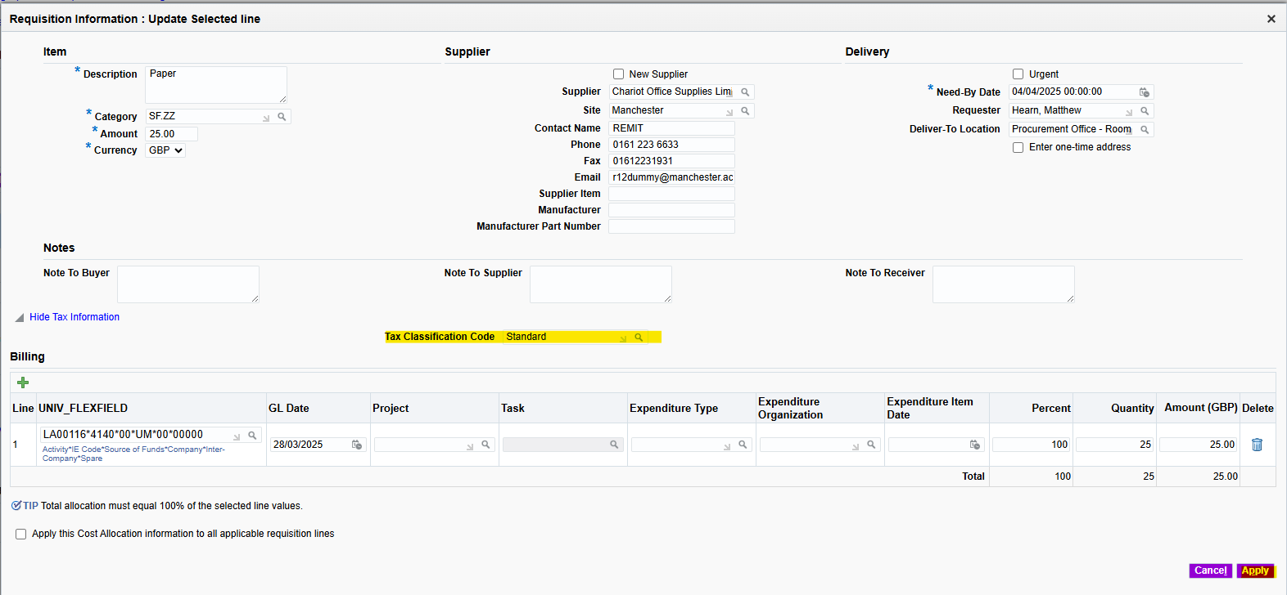
  - Use the Torch icon to update the tax code for that row and select Apply.

  - Edit and Submit Requisition Page is displayed.
  - Repeat steps if necessary to update any additional rows.

  - When all lines have been updated, click at top of page to return to Shopping Cart page to continue to review and submit requisition.

- Shopping Cart page is displayed

- Review and update Delivery information:
  - Requestor
  - Hazard Class

- Review and Update Billing information:

Project | Only complete these 5 fields if you are using a Project/Research code, entering these details will override the Charge Account. If using a Charge Account, ensure these 5 fields remain blank
Task
Expenditure Type
Expenditure Organisation
Expenditure Item Date
Charge Account | GL Codes

- The Charge Account from your Purchasing Options will be defaulted in.

- The GL date (General Ledger date) is the date the finance code is charged for accounting purposes. This date should never be amended.

- To add any of the following information select Edit then update the relevant fields:
  - Add Notes to Buyer: Enter any information you wish to pass to the Operational Buyer.
  - Add Notes to Receiver: This field is used to send a note only to the person receipting the goods on the system e.g. Stores team members.
  - Add Notes to Supplier: Enter any information you require to be passed onto the supplier. Please try to keep this message concise. Please note this will appear on the Purchase Order.
  - Add Attachments: Use the Add Attachments button to add attachments to the requisition if necessary. Enter a Description and then click Browse to locate and attach the file. Finally, click Apply to save the attachment. If the total of the requisition is over £5,000 there is a need for 3 quotations, as per the Financial Regulations and Procedures. The quotes could be scanned in and attached to the requisition.

- To update the Billing information to:
- Split the cost of the line to multiple charge codes
- Split the cost of the line to multiple project codes
- Split the cost of the line to multiple charge and project codes
- Assign different Charge/Project accounts to different lines

- Select the relevant line and click Update, select + to add an additional line, then complete the fields to split the costs as required. Once you have made the necessary changes select Apply

- Click Submit.

- Review the information a select Submit and the requisition will be submitted for approval.

- Copy to Cart an Existing Requisition

- Login to Oracle Financials

- Select PO Internet Procurement MP (UOM)

- Navigate to Requisitions tab, select the relevant Requisition, and select Copy to Cart

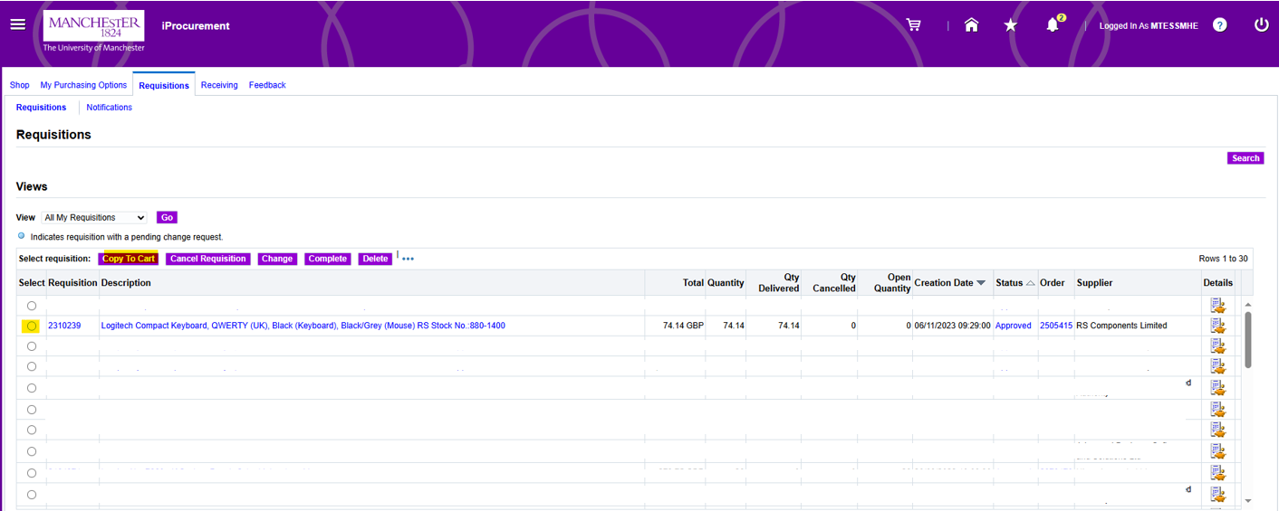
- Edit and Submit Requisition page is displayed
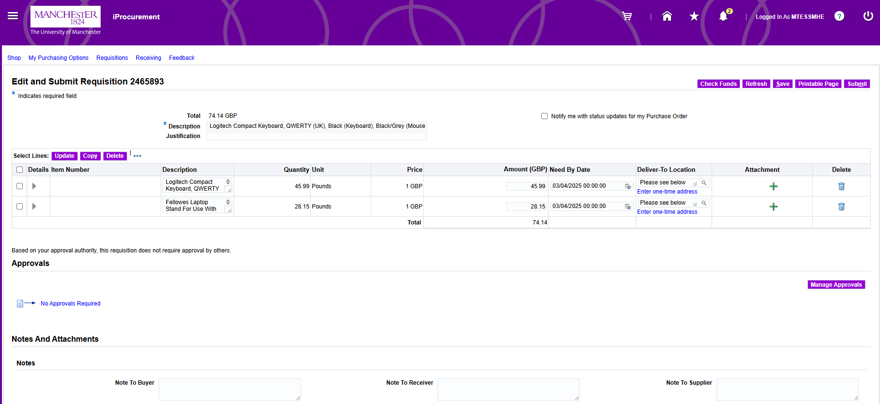
- Review basket, and select Submit

- If it is a single row, or multiple row purchase and you wish to make updates to any field on any of the rows select the shopping cart icon at the top of the page.

- Shopping Cart page is displayed

- You can change the Description at this stage if you wish. This will default to the first line on the requisition. It may be helpful to amend this to identify this requisition again quickly within your main requisitions list.

- Update Justification field, this is visible by the approver and is where you need to populate any justification required for this purchase.

- When do you need these items? this is defaulted to 7 days, if you need to amend update this field.

- Where do they need to be delivered? will default according to your account settings but can be changed if necessary.

- The Tax Classification Code defaults as Standard.
  - If the purchase includes items of both Standard and Zero-rated (Or any other combination) you must create separate lines for each item and classify them individually.

  - Select Edit to update the Tax Classification Code

  - Edit and Submit Requisition page is displayed

  - Select Line to be updated and click Update.

  - Requisition information : Update selected line page is displayed.
  - Click to expand the section Show additional Tax information.

  - Use the Torch icon to update the tax code for that row and select Apply.

  - Edit and Submit Requisition Page is displayed.
  - Repeat steps if necessary to update any additional rows.

  - When all lines have been updated, click at top of page to return to Shopping Cart page to continue to review and submit requisition.

- Shopping Cart page is displayed

- Review and update Delivery information:
  - Requestor
  - Hazard Class

- Review and Update Billing information:

Project | Only complete these 5 fields if you are using a Project/Research code, entering these details will override the Charge Account. If using a Charge Account, ensure these 5 fields remain blank
Task
Expenditure Type
Expenditure Organisation
Expenditure Item Date
Charge Account | GL Codes

- The Charge Account from your Purchasing Options will be defaulted in.

- The GL date (General Ledger date) is the date the finance code is charged for accounting purposes. This date should never be amended.

- To add any of the following information select Edit then update the relevant fields:
  - Add Notes to Buyer: Enter any information you wish to pass to the Operational Buyer.
  - Add Notes to Receiver: This field is used to send a note only to the person receipting the goods on the system e.g. Stores team members.
  - Add Notes to Supplier: Enter any information you require to be passed onto the supplier. Please try to keep this message concise. Please note this will appear on the Purchase Order.
  - Add Attachments: Use the Add Attachments button to add attachments to the requisition if necessary. Enter a Description and then click Browse to locate and attach the file. Finally, click Apply to save the attachment. If the total of the requisition is over £5,000 there is a need for 3 quotations, as per the Financial Regulations and Procedures. The quotes could be scanned in and attached to the requisition.

- To update the Billing information to:
- Split the cost of the line to multiple charge codes
- Split the cost of the line to multiple project codes
- Split the cost of the line to multiple charge and project codes
- Assign different Charge/Project accounts to different lines

- Select the relevant line and click Update, select + to add an additional line, then complete the fields to split the costs as required. Once you have made the necessary changes select Apply

- Click Submit.

- Review the information a select Submit and the requisition will be submitted for approval.

- Error Message

This message will arise when you have not input a valid activity code for the expenditure. Please check the billing details in your requisition. It you frequently purchase using the same code (not Projects or research) you can update your personal default code in My Purchasing Options.

You will need to:
- Update your current requisition with an active Project/ Activity code and submit.
- Update you Purchasing Options to add an active Activity code to default future requisitions to (Please note you can not add a Project code (Codes starting with a P or R) as a default).

If you only order against Project codes and/or do not currently have a default Activity code then you must ensure you code each requisition as you raise them, otherwise you will continue to get this error as it will try to charge to WH00187 and fail.

- Update your current requisition with an active Project/ Activity code

If you are raising a Non-Catalog Request update the Charge Account field with a valid code, or if using a Project code complete the 5 project fields and select Submit.

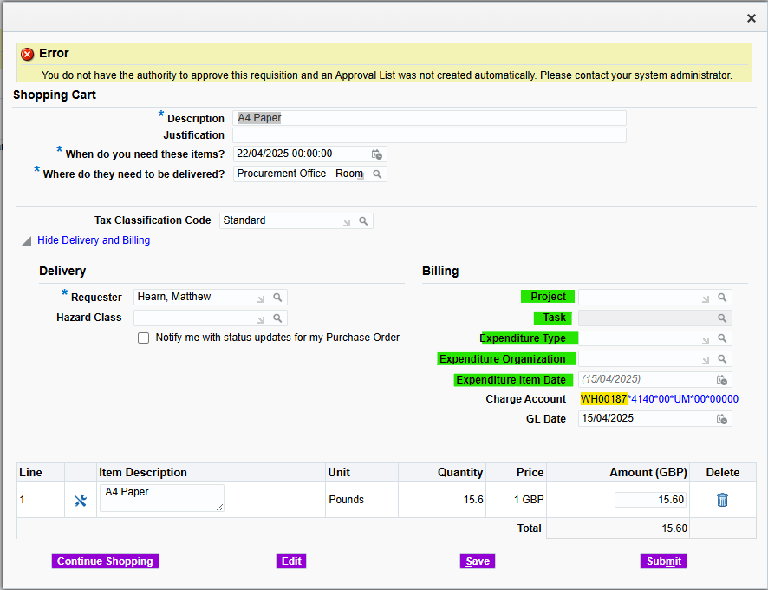

If you are raising an eMarketplace requisition, select the shopping cat icon at top of page

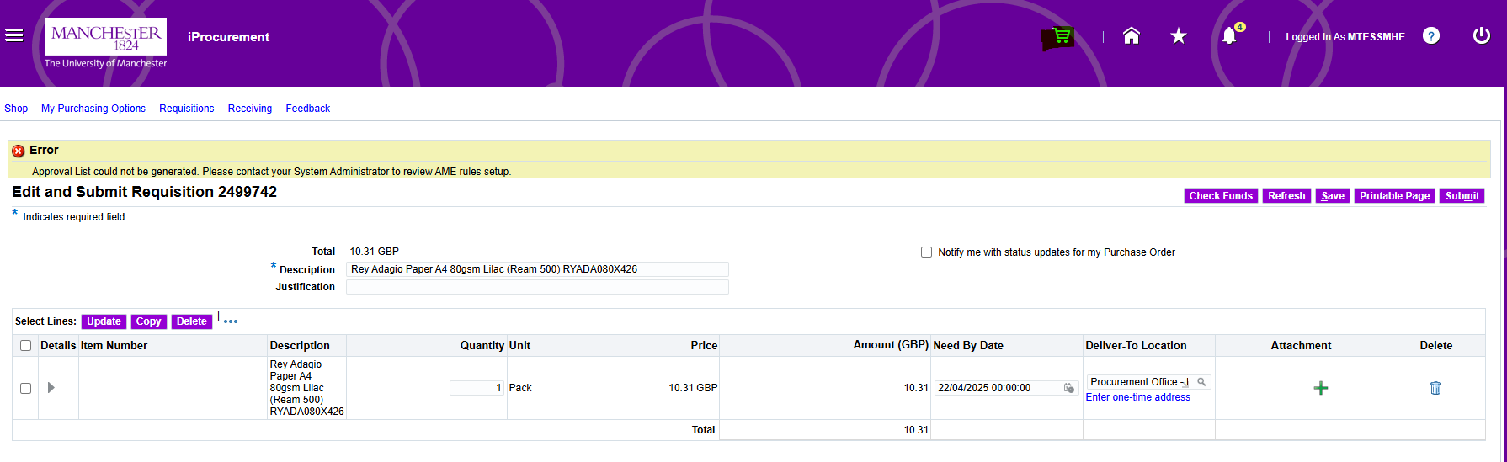

It will return you to the shopping cart page, update the Charge Account field with a valid code, or if using a Project code complete the 5 project field and select Submit.

If you want to charge to multiple codes or split the transaction, select the row/s, and click Update

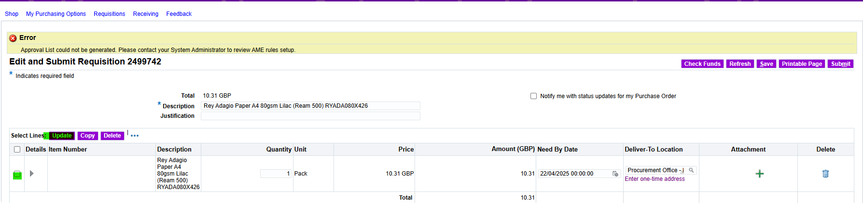

You can now update the UNIV_FLEXFIELD with a valid Activity Code, or if using a Project code complete the 5 project field and select Apply.

To split the transaction, select the icon and update accordingly and select Apply.

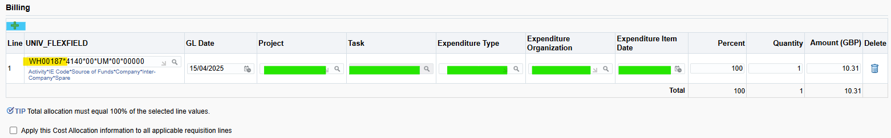

- Update you Purchasing Options to add an active Activity code to default future requisitions to (Please note you can not add a Project code (Codes starting with a P or R) as a default).

Navigate to My Purchasing Options tab



Update the Activity field with a valid Activity code and select Apply.
Please note you can not add a Project code (Codes starting with a P or R) as a default.

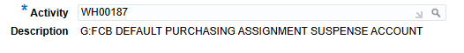

All future requisitions will be defaulted to the new code you have entered, you can change this if required by following step 1.

