KEY COLLECTION FOR UNSWORTH PARK, FALLOWFIELD CAMPUS

MAP
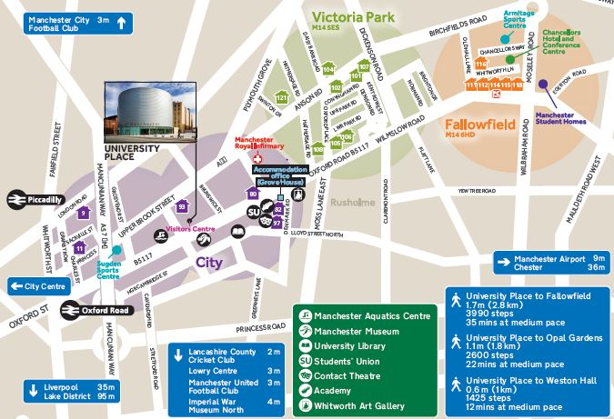
Unsworth Park
(Building not shown)
UCAE
Samuel Alexander
Building (67 not shown)

Location of the hall of residence can be viewed using Google Maps
In enquiry box, enter MANCHESTER M14 6FZ for the UNITED KINGDOM and press FIND.
To get directions from the hall to the University of Manchester, use post code MANCHESTER M13 9PL.

KEY COLLECTION
Check in is available after 10am on the scheduled date of arrival. The hall reception is open from 9am to 5pm Monday to Friday (excluding bank holidays).

OUT OF HOURS KEY COLLECTION
Students arriving out of hours must follow the instructions advertised at reception to collect keys. All students collecting keys will require a mobile telephone to contact the out of hours team – number advertised at reception.

ARRIVING IN HALL
Unsworth Park is based on the Fallowfield Campus. The entrance to Fallowfield Campus is directly off the main road. Please go straight to the Reception to collect your room keys.

PROOF OF BOOKING
Please ensure that you bring a copy of the email received at the time of booking for your proof of booking.

BY ROAD Fallowfield Campus is situated on Wilmslow Road which is a main road. Wilmslow Road is a continuation of Oxford Road which leads from the City Centre and also connects (via Upper Brook Street) to the Mancunian Way (A57M) which links into the M56, M6, M60 (Manchester Orbital Motorway), M61, M62, M66, M67 and M602 Motorways. From the A57M, follow the signs for the University of Manchester.

PARKING: Parking is available on Fallowfield Campus free of charge for summer guests. Parking must be arranged prior to arrival if you intend to bring a car.

BY AIR Manchester International Airport is 12 km to the south of the city. Taxis cost around £20 - £25 from International Arrivals to the hall. There is also an express Rail Shuttle running every 10 minutes or so from the Airport Station to Piccadilly Station. Taxis are cheap and available from Piccadilly to the Fallowfield Campus. A bus runs from Oxford Road to the airport.

BY COACH Fallowfield Campus is approximately 10 minute drive from Manchester International Express Coach terminal on Chorlton Street. Taxis are cheap and available from the bus station to Fallowfield Campus.

BY RAIL Piccadilly main line station is approximately 3 miles away from the Fallowfield Campus.
National Rail Enquiries: 08457 484950, National Rail Enquiries from overseas (Please note: International rates apply): +44(0)20 7278 5240 or web link: http://www.nationalrail.co.uk/contact/

Unsworth Park, Fallowfield Campus, The University of Manchester, Old Hall Lane, Fallowfield, Manchester, M14 6FZ.
Telephone +44 161 306 9900
Email: accommodation@manchester.ac.uk

