UNSWORTH PARK - FALLOWFIELD
En-suite Self-Catering Accommodation - £210.00 per week, per person
Location | Fallowfield Residences
Bedroom | Small double bedded room with en-suite bathroom
 | Wardrobe
 | Desk and chair
Bathroom Facilities | Within bedroom includes shower, washbasin and toilet. Toilet tissue is not provided.
Flats/Corridors | 10 bedrooms share one flat. Single and mix gender flats.
Kitchen/Lounge | 10 bedrooms share kitchen / lounge facilities.
Kitchen | Cooker x 1
 | Fridge / Freezer x 1
 | Microwave x 1
 | Kettle x 1
Iron and Ironing Board x 1

Residents must supply their own kitchen utensils, cutlery, crockery, pots and pans

Bedding | Residents must supply their own bedding and take it with them upon departure. Bedding Packs can be purchased from Unikitout UniKitOut - #1 Student Pack supplier Trusted by over 250 Universities. Get a 10% discount code by using: KITMEOUT.
Cleaning | Kitchens/lounge and communal areas typically cleaned twice weekly. Bedrooms, kitchen pots/pans must be cleaned by residents. Residents are also responsible for removing rubbish and recycling to appropriate receptacles outside the accommodation blocks.
Hall Reception Opening Hours | Reception - Situated at Richmond Park Park (within the Fallowfield campus) Open 0800 – 1800 hours Monday to Friday.
Arrival | We do not require you to inform us of your expected arrival time unless you are arriving out of normal office hours. Office hours are Monday to Friday, 0900hrs to 1700hrs or if you are arriving later than your booked arrival date.  Further details regarding arrival will be sent to students prior to arrival.
ResLife Team (pastoral care) | Available outside of office hours seven days a week. Contact details for ResLife Team will be given to you on arrival and can also be found in your bedroom pack.
Internet / Wi-Fi | All bedrooms have access to extensive Wi-Fi coverage.
Hall Administration Office | Situated at Richmond Park (within the Fallowfield campus)  Open: 0900hrs – 1700hrs Monday to Friday.
Laundry | The Laundrette is located in Meadow building. Guests must download the app to use the machines. Information on how to download the app will be available in the bedroom pack issued on arrival.
Computer Cluster | Located in the Meadow Building.
Sport Facilities  Hall Maintenance | Please see sport facilities at the University of Manchester.  The halls will be carrying out building maintenance during the summer. The University will endeavour to cause at least disruption as possible to guests. All Workers will carry a form of Identification.

Booking Dates and Fees

Course Code | Room  Available  From | Room  Available  To** | Weeks | En-suite  Self-catering  Price
PS10 | Not available | Not available | 10
PS6 | Saturday 26 July 2025 | Saturday 6 September 2025 | 6 | £1260.00
PS4 | Saturday 9 August 2025 | Saturday 6 September 2025 | 4 | £840.00

**PLEASE NOTE THAT ROOMS MUST BE VACATED BY 10:00HRS ON THE DATES SHOWN ABOVE**

All students are advised to read and understand the Terms and Conditions before making a booking.

Summer hall accommodation is not guaranteed and therefore students should apply for accommodation as early as possible. Where accommodation cannot be arranged through UCAE, students are asked to make their own arrangements.

Location of the University, Halls of Residences and City of Manchester can be viewed here.
University Accommodation Map

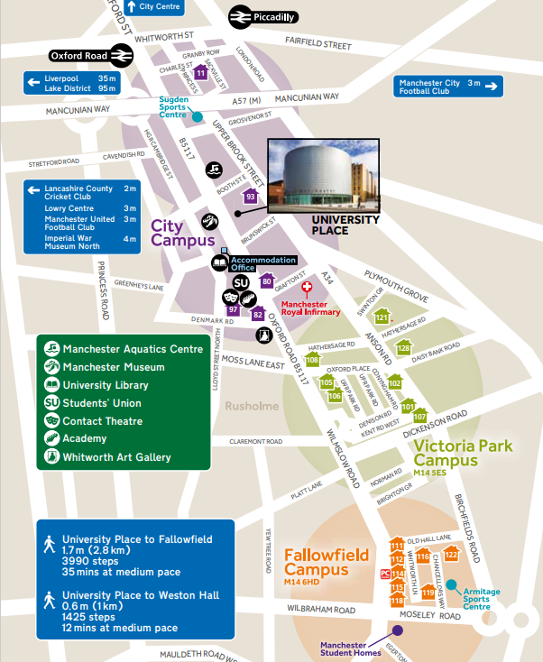
Unsworth Un House
En-Suite Accommodation (112)

UCAE
Samuel Alexander
Building (67 not shown)

