

Allergen Matrix Information

This guide contains information on the 14 allergens, as recognised by the Food Standards Agency, for our products.

We are proud to freshly prepare some of our food in our shops every day, but as we use many ingredients, shared equipment and shared display cabinets, we are unable to guarantee that our food is allergen free due to the risk of cross-contamination.

We take food allergies seriously and want to make sure that you feel safe when enjoying our products. This allergen guide has been provided so that you can make an informed choice. Please find the product name in the guide, which will show you the allergen detail.

If you need further help, please ask a member of staff.

DISHES AND THEIR ALLERGEN CONTENT

Bread | 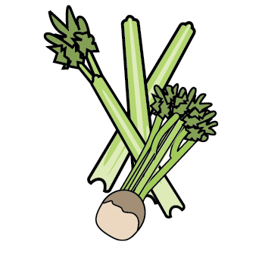 | 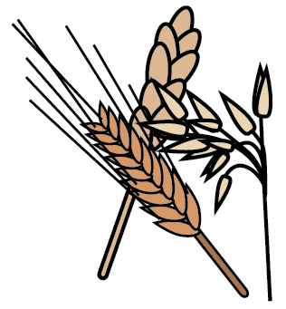 | 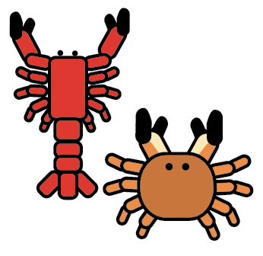 | 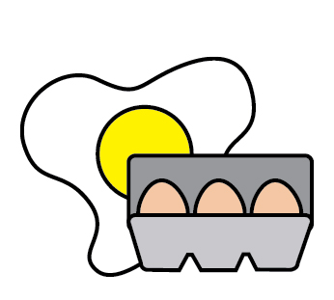 | 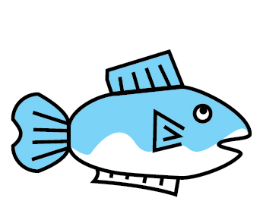 | 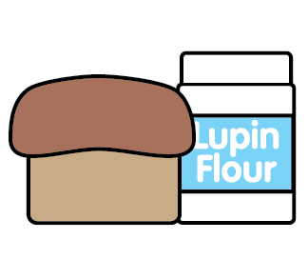 | 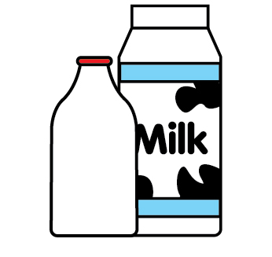 | 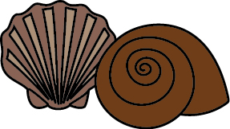 | 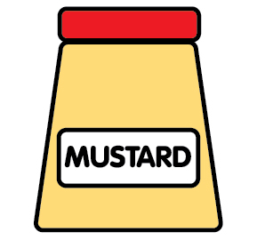 | 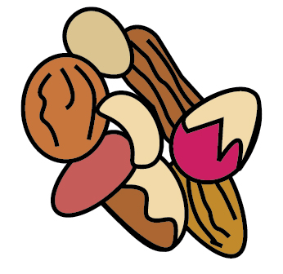 | 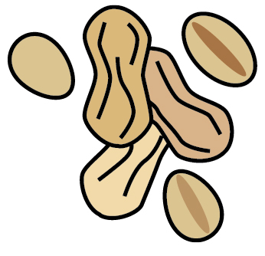 | 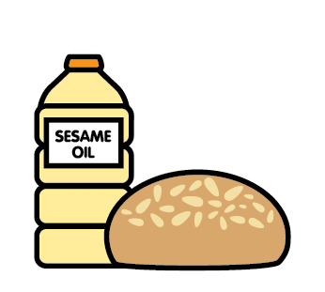 |  | 
 | Celery | Cereals containing gluten | Crustaceans | Eggs | Fish | Lupin | Milk | Mollusc | Mustard | Nuts | Peanuts | Sesame seeds | Soya | Sulphur Dioxide
Soup Roll – Fricopan & Mothers pride |  | RYE, WHEAT, BARLEY, OAT FLAKES |  | MAY CONTAIN |  |  | MAY CONTAIN |  |  | MAY CONTAIN |  | YES | MAY CONTAIN
Butter |  |  |  |  |  |  | YES
White Sliced Loaf – Chorlton Sourdough |  | RYE, WHEAT, BARLEY, OAT |  |  |  |  | YES
Granary Sliced Loaf – Granary Sourdough |  | RYE, WHEAT, BARLEY, OAT |  |  |  |  | YES
Strawberry Jam
Marmalade
Soup Roll La Boulangerie |  | WHEAT, BARLEY |  |  |  |  |  |  |  |  |  | MAY CONTAIN

Review date: | 18/08/2025 | Reviewed by: | F. Gonzalez |  | You can find this template, including more information at www.food.gov.uk/allergy

DISHES AND THEIR ALLERGEN CONTENT

Soup
 | Celery | Cereals containing gluten | Crustaceans | Eggs | Fish | Lupin | Milk | Mollusc | Mustard | Nuts | Peanuts | Sesame seeds | Soya | Sulphur Dioxide
Little & Cull Sweet Potato, Coconut & Chilli Soup |  |  |  |  |  |  | YES
Little & Cull Pea & Mint Soup |  |  |  |  |  |  | YES
Little & Cull Tomato & Basil Soup |  |  |  |  |  |  | YES
Little & Cull Carrot, Red Lentil & Coriander Soup
Little and cull chicken and winter veg

Review date: | 14/11/22 | Reviewed by: | T.Topliss |  | You can find this template, including more information at www.food.gov.uk/allergy

DISHES AND THEIR ALLERGEN CONTENT

Cakes & Pastries
 | Celery | Cereals containing gluten | Crustaceans | Eggs | Fish | Lupin | Milk | Mollusc | Mustard | Nuts | Peanuts | Sesame seeds | Soya | Sulphur Dioxide
Barbakan
Lemon & Poppy Seed Muffin |  | WHEAT |  | YES |  |  | YES
Chocolate Chip Muffin |  | WHEAT |  | YES |  |  | YES
Dbl Chocolate Muffin |  | WHEAT |  | YES |  |  | YES |  |  |  |  |  | YES
Pineapple & Orange Muffin |  | WHEAT |  | YES |  |  | YES
Coconut Muffin |  | WHEAT |  | YES |  |  | YES
Banana & Almond Muffin |  | WHEAT |  | YES |  |  | YES |  |  | ALMOND
Croissant |  | WHEAT |  | YES |  |  | YES |  |  | YES |  |  | YES | YES
Chocolate Croissant |  | WHEAT |  | YES |  |  | YES |  |  | YES |  | YES | YES

Review date: | 14/11/22 | Reviewed by: | T.Topliss |  | You can find this template, including more information at www.food.gov.uk/allergy

DISHES AND THEIR ALLERGEN CONTENT

Cakes & Cookies
 | Celery | Cereals containing gluten |  | Crustaceans |  | Eggs |  | Fish |  | Lupin |  | Milk |  | Mollusc |  | Mustard | Nuts | Peanuts | Sesame seeds | Soya |  | Sulphur Dioxide
Pain Au Raisin |  | WHEAT |  |  | YES |  |  |  |  |  | YES |  |  |  |  |  | ALMOND |  |  |  |  | YES
Almond Croissant |  | WHEAT |  |  | YES |  |  |  |  |  | YES |  |  |  |  |  | ALMOND |  |  |  | YES | YES
Apple Danish |  | WHEAT |  |  | YES |  |  |  |  |  | YES |  |  |  |  |  | ALMOND |  |  |  |  | YES
Hot X Buns |  | WHEAT, MAY CONTAIN BARLEY, RYE. |  |  | YES |  |  |  | MAY CONTAIN |  | YES |  |  |  |  |  | MAY CONTAIN |  | MAY CONTAIN |  | MAY CONTAIN | YES
Rainbow Cake | May contain | WHEAT |  |  | May contain |  |  |  |  |  | May contain |  |  |  | May contain |  | May contain | May contain | May contain |  | YES | YES

Review date: | 14/02/24 | Reviewed by: | T.Topliss |  | You can find this template, including more information at www.food.gov.uk/allergy

DISHES AND THEIR ALLERGEN CONTENT
Cakes & Cookies
 | Celery | Cereals containing gluten |  | Crustaceans | Eggs | Fish | Lupin | Milk | Mollusc | Mustard | Nuts | Peanuts | Sesame seeds | Soya |  | Sulphur Dioxide
SILVER APPLES
Flourless Salted Caramel and Espresso Brownie | MAY CONTAIN | MAY CONTAIN WHEAT, BARLEY, OATS |  |  | YES |  |  | YES |  | MAY CONTAIN | MAY CONTAIN | MAY CONTAIN | MAY CONTAIN |  | YES | MAY CONTAIN
Flourless Manchester Tart | MAY CONTAIN | MAY CONTAIN WHEAT, BARLEY, OATS |  |  | YES |  |  | YES |  | MAY CONTAIN | MAY CONTAIN | MAY CONTAIN | MAY CONTAIN |  | YES | MAY CONTAIN
Tripple Chocolate Brownie | MAY CONTAIN | WHEAT. MAY CONTAIN BARLEY, OATS |  |  | YES |  |  | YES |  | MAY CONTAIN | MAY CONTAIN | MAY CONTAIN | MAY CONTAIN |  | YES | MAY CONTAIN
Plant Based Ginger&Orange Cruch | MAY CONTAIN | WHEAT. MAY CONTAIN BARLEY, OATS |  |  | MAY CONTAIN |  |  | MAY CONTAIN |  | MAY CONTAIN | MAY CONTAIN | MAY CONTAIN | MAY CONTAIN |  | YES | YES
Plant Based Oreo Brownie | MAY CONTAIN | WHEAT. MAY CONTAIN BARLEY, OATS |  |  | MAY CONTAIN |  |  | MAY CONTAIN |  | MAY CONTAIN | MAY CONTAIN | MAY CONTAIN | MAY CONTAIN |  | YES | MAY CONTAIN
Blueberry Muffin | MAY CONTAIN | WHEAT. MAY CONTAIN BARLEY, OATS |  |  | YES |  |  | YES |  | MAY CONTAIN | MAY CONTAIN | MAY CONTAIN | MAY CONTAIN |  | MAY CONTAIN | MAY CONTAIN

Review date: | 30/08/2024 | Reviewed by: | F.Gonzalez |  | You can find this template, including more information at www.food.gov.uk/allergy

DISHES AND THEIR ALLERGEN CONTENT
Cakes & Cookies
 | Celery | Cereals containing gluten |  | Crustaceans | Eggs | Fish | Lupin | Milk | Mollusc | Mustard | Nuts | Peanuts | Sesame seeds | Soya |  | Sulphur Dioxide
Millionaire’s Brownie | MAY CONTAIN | WHEAT. MAY CONTAIN BARLEY, OATS |  |  | YES |  |  | YES |  | MAY CONTAIN | MAY CONTAIN | MAY CONTAIN | MAY CONTAIN |  | YES | MAY CONTAIN
Plant Based Cranberry&Pistachio Rocky Road | MAY CONTAIN | WHEAT. MAY CONTAIN BARLEY, OATS |  |  | MAY CONTAIN |  |  | MAY CONTAIN |  | MAY CONTAIN | PISTACHIO. MAY CONTAIN ALL OTHER | MAY CONTAIN | MAY CONTAIN |  | YES | MAY CONTAIN
Salted Caramel Seed and Fruit Flapjack | MAY CONTAIN | OATS, MAY CONTAIN WHEAT, BARLEY |  |  | MAY CONTAIN |  |  | MAY CONTAIN |  |  | MAY CONTAIN | MAY CONTAIN | MAY CONTAIN |  | YES | MAY CONTAIN
Orange, Apricot & Polenta Cake | MAY CONTAIN | MAY CONTAIN WHEAT, BARLEY, OAT |  |  | YES |  |  | MAY CONTAIN |  | MAY CONTAIN | ALMOND, PISTACHIO MAY CONTAIN ALL OTHERS | MAY CONTAIN | MAY CONTAIN |  | MAY CONTAIN | MAY CONTAIN
Bakewell Tart | MAY CONTAIN | WHEAT. MAY CONTAIN BARLEY, OAT |  |  | YES |  |  | YES |  | MAY CONTAIN | ALMONDS MAY CONTAIN ALL OTHERS | MAY CONTAIN | MAY CONTAIN |  | YES | MAY CONTAIN
Birthday Cake Sprinkles Cookie | MAY CONTAIN | WHEAT, MAY CONTAIN BARLEY, OAT |  |  | YES |  |  | YES |  | MAY CONTAIN | MAY CONTAIN | MAY CONTAIN | MAY CONTAIN |  | YES | MAY CONTAIN
Glazed Cinnamon Buns | MAY CONTAIN | WHEAT. MAY CONTAIN BARLEY, OATS |  |  | YES |  |  | YES |  | MAY CONTAIN | MAY CONTAIN | MAY CONTAIN | MAY CONTAIN |  | YES | MAY CONTAIN

Review date: | 30/08/2024 | Reviewed by: | F.Gonzalez |  | You can find this template, including more information at www.food.gov.uk/allergy

DISHES AND THEIR ALLERGEN CONTENT

Cakes & Cookies
 | Celery | Cereals containing gluten | Crustaceans | Eggs | Fish | Lupin | Milk | Mollusc | Mustard | Nuts | Peanuts | Sesame seeds | Soya | Sulphur Dioxide
Biscoff Rocky Road | MAY CONTAIN | WHEAT. MAY CONTAIN BARLEY, OATS |  | MAY CONTAIN |  |  | MAY CONTAIN |  | MAY CONTAIN | MAY CONTAIN | MAY CONTAIN | MAY CONTAIN | YES | YES
Plant Based Biscoff Cronuts | MAY CONTAIN | WHEAT. MAY CONTAIN BARLEY, OATS |  | MAY CONTAIN |  |  | MAY CONTAIN |  | MAY CONTAIN | MAY CONTAIN | MAY CONTAIN | MAY CONTAIN | YES | MAY CONTAIN
Biscoff Yule Log | MAY CONTAIN | WHEAT. MAY CONTAIN BARLEY, OATS |  | YES |  |  | YES |  | MAY CONTAIN | MAY CONTAIN | MAY CONTAIN | MAY CONTAIN | YES | MAY CONTAIN
Chocolate Orange Cookie | MAY CONTAIN | WHEAT. MAY CONTAIN BARLEY, OATS |  | YES |  |  | YES |  | MAY CONTAIN | MAY CONTAIN | MAY CONTAIN | MAY CONTAIN | YES | YES
Pride CupCake | MAY CONTAIN | WHEAT, BARLEY. MAY CONTAIN OATS |  | MAY CONTAIN |  |  | YES |  | MAY CONTAIN | MAY CONTAIN | MAY CONTAIN | MAY CONTAIN | YES | YES
Mince Pie Crumble Bar | MAY CONTAIN | WHEAT. MAY CONTAIN BARLEY, OATS |  | YES |  |  | YES |  | MAY CONTAIN | ALMONDS, MAY CONTAIN ALL OTHERS | MAY CONTAIN | MAY CONTAIN | YES | YES
White Chocolate&Biscoff Cookie |  | WHEAT |  | YES |  |  | YES |  |  | MAY CONTAIN ALL OTHERS | MAY CONTAIN | MAY CONTAIN | YES | MAY CONTAIN

Review date: | 30/08/2024 | Reviewed by: | F.Gonzalez |  | You can find this template, including more information at www.food.gov.uk/allergy
DISHES AND THEIR ALLERGEN CONTENT

Pasties
 | Celery | Cereals containing gluten | Crustaceans | Eggs | Fish | Lupin | Milk | Mollusc | Mustard | Nuts | Peanuts | Sesame seeds | Soya | Sulphur Dioxide
Sausage Roll |  | WHEAT |  |  |  |  |  |  |  |  |  |  |  | YES
Vegetable Vegan Pasty | YES | WHEAT, BARLEY
Cheese & Onion Pasty |  | WHEAT |  |  |  |  | YES
Chicken, Leek & Bacon Pasty |  | WHEAT |  |  |  |  | YES |  |  |  |  |  | YES
Chicken Bhaji Pasty |  | WHEAT |  |  |  |  | YES

Review date: | 31/10/24 | Reviewed by: | T.Topliss |  | You can find this template, including more information at www.food.gov.uk/allergy

DISHES AND THEIR ALLERGEN CONTENT

Pizza
 | Celery | Cereals containing gluten | Crustaceans | Eggs | Fish | Lupin | Milk | Mollusc | Mustard | Nuts | Peanuts | Sesame seeds | Soya | Sulphur Dioxide
Margherita – Chicargo Town |  | WHEAT, BARLEY |  |  |  |  | YES
Pepperoni – Chicargo Town |  | WHEAT, BARLEY |  |  |  |  | YES

Review date: | 14/11/22 | Reviewed by: | T.Topliss |  | You can find this template, including more information at www.food.gov.uk/allergy

DISHES AND THEIR ALLERGEN CONTENT

JACKET FILLINGS
 | Celery | Cereals containing gluten | Crustaceans | Eggs | Fish | Lupin | Milk | Mollusc | Mustard | Nuts | Peanuts | Sesame seeds | Soya | Sulphur Dioxide
Butter |  |  |  |  |  |  | YES
Baked Beans
Grated cheese |  |  |  |  |  |  | YES
Tuna Mayonnaise |  |  |  | YES | YES
Falafel Roast Pepper Salsa |  | BARLEY | YES | YES | YES |  | YES |  | YES |  |  |  | YES | YES
Coronation Chicken |  |  |  | YES
Tuna Mayo Sweetcorn Filling |  | MAY CONTAIN BARLEY, WHEAT | MAY CONTAIN | YES | YES |  | MAY CONTAIN |  | MAY CONTAIN |  |  |  | MAY CONTAIN | MAY CONTAIN
Veg Chilli |  | MAY CONTAIN WHEAT |  |  |  |  | MAY CONTAIN
Coleslaw |  |  |  | YES
Butternut Squash, Chickpea and Spinach Curry |  | MAY CONTAIN |  |  |  |  | MAY CONTAIN

Review date: | 20/03/23 | Reviewed by: | T.Topliss |  | You can find this template, including more information at www.food.gov.uk/allergy
DISHES AND THEIR ALLERGEN CONTENT

SALAD BAR
 | Celery | Cereals containing gluten | Crustaceans | Eggs | Fish | Lupin | Milk | Mollusc | Mustard | Nuts | Peanuts | Sesame seeds | Soya | Sulphur Dioxide
Grated Cheese |  |  |  |  |  |  | YES
Croutons |  | WHEAT |  |  |  |  | MAY CONATIN
Egg |  |  |  | YES
Honey & Mustard Dressing |  |  |  | YES |  |  |  |  | YES
Caesar Dressing |  | WHEAT, BARLEY |  | YES |  |  | YES |  |  |  |  |  | YES
French Dressing |  | WHEAT |  |  |  |  |  |  | YES
Onion
Peppers
Mixed Leaf & Lettuce
Lettuce
SALAD BAR
 | Celery | Cereals containing gluten | Crustaceans | Eggs | Fish | Lupin | Milk | Mollusc | Mustard | Nuts | Peanuts | Sesame seeds | Soya | Sulphur Dioxide
Carrot
Tomato
Sweetcorn
Beetroot
Sunny Vibes Salad | YES |  |  |  |  |  |  |  |  |  |  |  | YES
Green Valley Salad |  |  |  |  |  |  |  |  | YES
Indian Summer Salad | YES
Spartacus Salad |  | WHEAT |  |  |  |  | YES |  | YES
Falafel Chickpea Yogurt Mint | YES |  |  | YES |  |  | YES
Coleslaw |  |  |  | YES |  |  | YES |  | YES
Cucumber

Review date: | 14/11/22 | Reviewed by: | T.Topliss |  | You can find this template, including more information at www.food.gov.uk/allergy

Hot Drinks
 | Celery | Cereals containing gluten | Crustaceans | Eggs | Fish | Lupin | Milk | Mollusc | Mustard | Nuts | Peanuts | Sesame seeds | Soya | Sulphur Dioxide
Coffee/Decaf Coffee
Mint Syrup
Sugar Free Caramel Syrup
Sugar Free Hazelnut Syrup |  |  |  |  |  |  |  |  |  | HAZELNUT
Sugar Free Vanilla Syrup
Sugar Free Gingerbread Syrup
Pumpkin Spice Syrup
Honeycomb Syrup
Hot Chocolate |  |  |  |  |  |  | YES
Whipped Cream |  |  |  |  |  |  | YES
Hot Drinks
 | Celery | Cereals containing gluten | Crustaceans | Eggs | Fish | Lupin | Milk | Mollusc | Mustard | Nuts | Peanuts | Sesame seeds | Soya | Sulphur Dioxide
Black Forest Hot Chocolate |  |  |  |  |  |  | YES
Tea
Berry Tea
Green Tea
Mint Tea
Decaf Tea
Earl Grey Tea
Milk – Semi Skimmed & Skimmed |  |  |  |  |  |  | YES
Soya Milk |  |  |  |  |  |  |  |  |  |  |  |  | YES
Oat Milk |  | OATS
Hot Vimto |  | BARLEY, MALT

 | Review date: |  | 14/11/22 |  |  |  | Reviewed by: |  | T.Topliss |  |  |  |  |  |  |  |  | You can find this template, including more information at www.food.gov.uk/allergy
Cold Drinks
 |  | Celery |  | Cereals containing gluten | Crustaceans | Eggs |  | Fish |  | Lupin | Milk | Mollusc | Mustard | Nuts | Peanuts |  | Sesame seeds |  | Soya | Sulphur Dioxide
Vanilla Frappe |  |  |  |  |  |  |  |  |  |  | YES
Biscoff Frappe |  |  |  | WHEAT |  |  |  |  |  |  | YES |  |  |  |  |  |  |  | YES
Peach Iced Tea
Strawberry& Peach Bubble Tea
Mango & Dragon Fruit Bubble Tea
Pistachio&White Chocolate Frappe |  |  |  |  |  |  |  |  |  |  | YES |  |  | PISTACHIO |  |  |  |  | YES
Pistachio Latte |  |  |  |  |  |  |  |  |  |  | YES |  |  | PISTACHIO
Honeycomb Hot Chocolate with Cream & Marshmallows |  |  |  |  |  |  |  |  |  |  | YES
Matcha Latte/Iced Matcha Latte |  |  |  |  |  |  |  |  |  |  | YES

Review date: | 30/08/2024 | Reviewed by: | T.Topliss |  | You can find this template, including more information at www.food.gov.uk/allergy

Seasonal
 | Celery | Cereals containing gluten | Crustaceans | Eggs | Fish | Lupin | Milk | Mollusc | Mustard | Nuts | Peanuts | Sesame seeds | Soya | Sulphur Dioxide
Mini Chocolate Muffins |  | YES, MAY CONTAIN OTHER GLUTEN CEREALS |  | YES |  |  | YES |  |  | MAY CONTAIN | MAY CONTAIN |  | YES
Carrot and Orange Mini Loaves |  | YES |  | YES |  |  | YES |  |  | MAY CONTAIN | MAY CONTAIN |  | YES

Review date: | 30/11/22 | Reviewed by: | T.Topliss |  | You can find this template, including more information at www.food.gov.uk/allergy

