

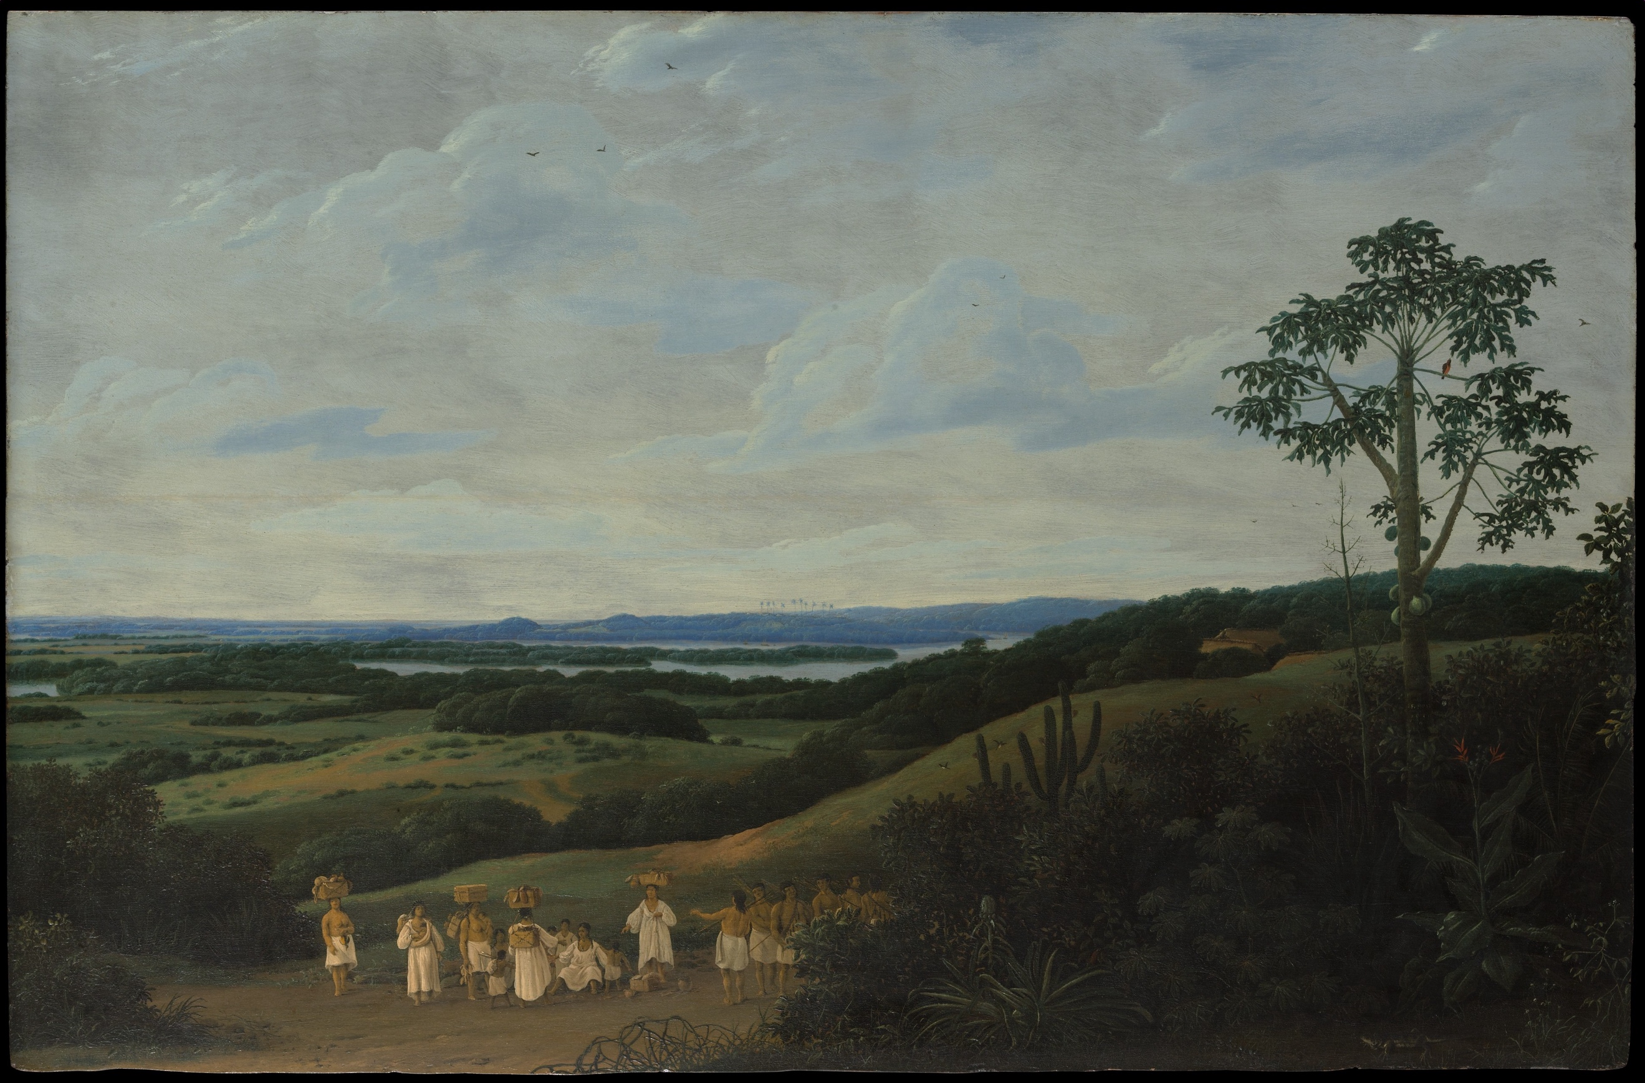
The Sleeping Well in the Early Modern World team invites papers for our end-of-project conference on the topic of ‘Bodies and Environments’ in early modernity.

Scholarship on early modern embodiment has emphasised the body’s porosity, permeability and instability. Early modern bodies did not end at the skin, but rather their interior and exterior worlds were in constant material exchange. Close engagement with, and management of, the body’s surroundings was thus essential for ensuring health and wellbeing. European theories of embodiment drew on Hippocratic-Galenic medical teachings in which bodies shared a common elemental make-up with the world around them. Healthcare knowledge and practice could be localised and geo-specific, therefore, as the ecological profiles of different places informed a ‘geo-humoral’ health paradigm in which bodies were understood to become accustomed to particular locales over time. Other cultures conceptualised the relationship between bodies and their surroundings differently. Indigenous communities across the Atlantic, for example, placed greater emphasis on the permeability and interconnectedness of all beings and understood animals and plants as relations to, rather than resources for, human bodies. In a variety of global contexts, flora and fauna were enfolded in practices of health preservation and restoration in diverse ways, often with broader environmental implications. The interdependencies of bodies and environments meant that processes of environmental change likewise impacted on healthcare knowledge and practice.

The entanglement of early modern bodies and environments lies at the heart of our research for the Sleeping Well project, as we investigate how early modern people engaged with their physical surroundings in an effort to sleep well. Our project has uncovered an environmentally informed culture of ‘sleep care’ in this period, which we approach by applying the concept of ‘environing’ to sleep care practices. We conceptualise environing as processes through which humans and nature co-produce environments, and we examine how early modern people engaged in environing practices to safeguard their health.

We invite papers examining the relationship between bodies and environments in any context and geographical location c. 1500-1750. Topics may include but are not limited to:

- Practices of ‘environing’ (or human engagements with physical surroundings) aimed at preserving or restoring health
- The health or embodied consequences of environmental interventions or ‘improvements’
- The use of place-specific materials for practices of bodily management and health preservation
- Multispecies approaches to health and wellbeing
- ‘Geo-humoral’ concepts of embodiment

Please send an abstract (max. 300 words) and a short bio (100 words) to eleanor.shaw@manchester.ac.uk by 3 February 2025. PhD students and ECRs are particularly encouraged to apply. Reasonable travel and accommodation expenses for speakers will be covered.

Keynote speakers: Marcy Norton (University of Pennsylvania) & Sara Miglietti (The Warburg Institute)

Call for Papers: Bodies and Environments in the Early Modern World
9-10 June 2025. John Rylands Research Institute, Manchester

