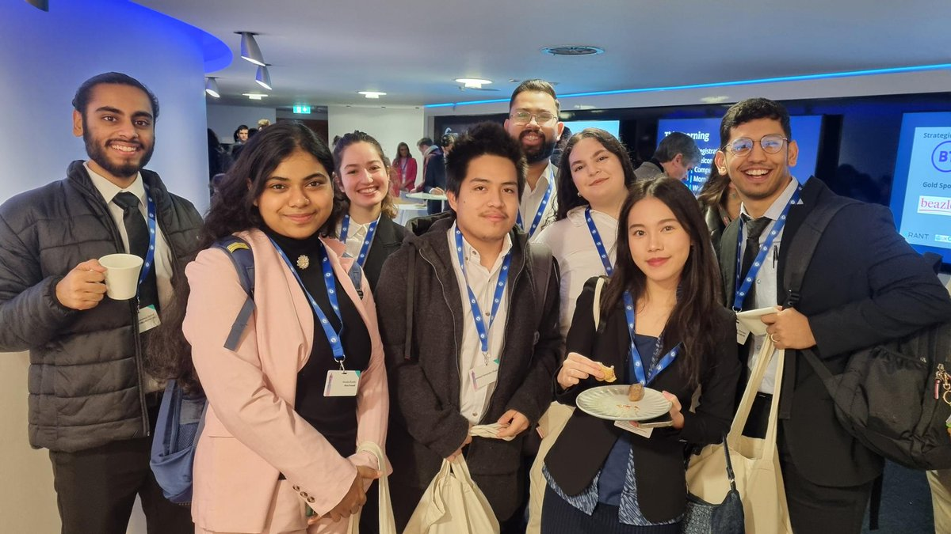
Make your mark in intelligence by applying to join the University of Manchester Team for the UK UK Cyber Leaders Challenge ((https://cyberleaderschallenge.com/). Critical thinking and communications skills essential; technical knowledge unnecessary and the selected team gets access to careers advice, cool prize opportunities, and the chance of an expenses-paid, 2-day trip to London, two days in the iconic BT Tower.

The successful 4 (or 8 if we get enough qualified for 2 teams) will make a play for a place at the finals to be held in person at the BT Tower in London (19 - 20 March 2025) and the deadline for teams to register will run out sooner than you think (see the team selection deadline below). Our objective is to build a team as diverse as possible in terms of EDI, background and academic discipline (you must not be experienced working in cyber, politics or warfare or have held positions that would give you an advantage).

The competition is an ideal experience in decision making during the time of a cyber crisis. You'll meet cyber security experts and representatives from across government and industry. Networking opportunities are unsurpassed for future career opportunities. Current and previous partners have included BT, UK Civil Service, Sage, NATO, Beazley, Standard Chartered bank and the Global Cyber Alliance.

You'll pit your wits other team as you all respond to a complex and escalating cyber-attack with national and international ramifications. Over two days, comprising three rounds, competing teams receive intelligence packs consisting of reports gathered from multiple sources. You''ll work together to analyse the report, analysis the national and international implications of the content and they present your analysis and recommendations to a panel of judges from government and industry.

Apply now by e-mailing Prof Danny Dresner (daniel.dresner@manchester.ac.uk) no later than midnight 29 November '24 with answers to the following questions:
- Introduce yourself and why you will be an asset to our University's team for the Cyber Leaders Challenge. (500 words)
- How would you describe the relationship between Cyber and Politics in the UK? How do you feel this relationship has changed in recent years? (500 words)
- In your opinion, how does the sharing of threat intelligence and knowledge between nation states both help and hinder the UK in reaching its goals laid out in the Cyber Security Strategy 2022? (500 words)

Let's make the world a safer place to live and work online!

