Successful Bids

2025
Time To Talk Day
Ping Pong T-shirts
Squash Wellbeing Events
Wellbeing Choir Keyboard
PCG Hulme Garden Centre Visit / Garden Planters
Humanities Staff / Postgrad 5-a-side
Staff Wellbeing Workshops With Experimental Archaeology Club

2023 / 2024
Time To Talk Day
SEED Stitch Social
Active Travel Event
Language Café
Ping Pong in Ellen Wilkinson and Arthur Lewis Buildings
Wellbeing Choir

2022 / 2023
Poetry Writing for Wellbeing Workshops
Develop Your Photography Skills
Walk Along The Cornbrook
Knitting, crochet and craft sessions organised by AMBS
Green Wellbeing
Deaf Awareness with Manchester Deaf Centre
Dementia Friends Awareness
Holistic therapy – one-hour sessions of shiatsu and reflexology
2024 – 2025
Time To Talk Day – Thursday 6th February 2025

Another successful Time to Talk Day event with colleagues from across the Faculty taking part, learning new skills and making new friends and contacts. A big congratulations to the eight lucky people who won a raffle prize. This is an important event in the wellbeing calendar and we hope to build on our successes year on year, and to involve colleagues external to the Faculty in future events. A special thank you to those who facilitated sessions, we really couldn’t do this without your help and support.
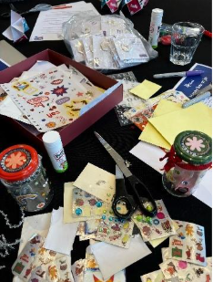
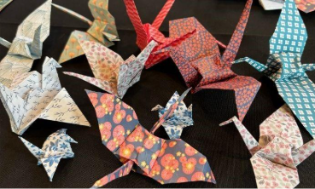
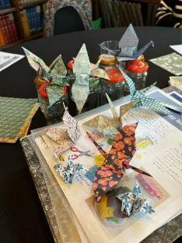

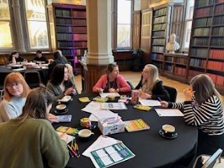
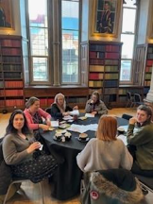
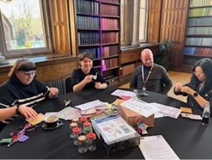

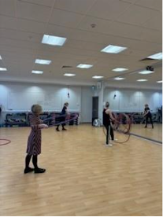

Total = £300-£350
Ping Pong T-shirts
Bid:
£294 was requested to pay for 11 personalised T-shirts from the University of Manchester Sports department for 11 Postgraduate Students and member of Staff.

Ping Pong Parlours have been developed with the help of the Wellbeing Fund at the University in the Arthur Lewis Building and Ellen Wilkinson Building. These Postgraduate Students and Staff have regularly met over the past year. Once building work is complete in ALB and EWB, it is hoped the Ping Pong Parlours will resume later this Semester and we can all wear our T-shirts when playing Table Tennis / Ping Pong.

The Ping Pong Parlours enabled the University of Manchester to get a team together made up of Postgraduate Students and Staff from across the University to publicise the GN Ping Hub in Manchester and to develop Table Tennis / Ping Pong in Manchester. This bid is for funds to buy T-shirts for those who participated in the events at the GN Ping Hub and for the regular attendees at the Ping Pong Parlours. The T-shirts will allow The University of Manchester's to further showcase its commitment to developing Table Tennis in Manchester and supporting those who represent the University.

Currently the UoM Table Tennis team is made up of Postgraduate Students and Staff from across the University. Photographs and videos from the events at the GN Ping Hub are on the Table Tennis England website and on YouTube. It would be amazing if for future events and activities that go on the Table Tennis England website on YouTube, we are all wearing our University of Manchester T-shirts. The audience would therefore be everyone at the University of Manchester and anyone who views the Table Tennis website or YouTube.

The Ping Pong Parlours are open and welcoming to all Postgraduate Students and Staff of all abilities from across the whole University.

The Ping Pong Parlours opened in May 2023. The University of Manchester Table Tennis Team made up of Postgraduate Students and Staff formed in January 2024. It is hoped that once the building work in complete in ALB and EWB the Ping Pong Parlours will resume and current and new members can meet up again to play Table Tennis / Ping Pong for a long time to come.

Mel Canham will continue to collaborate with Table Tennis England and their main equipment supplier, Cornilleau to gain further funds to support Table Tennis / Ping Pong at the University of Manchester. The GN Ping Hub has been nominated for an community award at the Manchester Sport Awards 2024. At this award ceremony on Saturday 16th November, Mel will be discussing future collaborations with Table Tennis England and Cornilleau.

Total = £294

Squash Wellbeing Events
10th March 2025 | Robbie Watt, Lecturer in Politics – robert.watt@manchester.ac.uk
We held two events at lunchtimes on Wednesday 26th February and Wednesday 5th March 2025 from 1-2.20pm at the Sugden Centre. We had six squash courts available, a range of squash balls, and free racket hire for those who needed one. Clare Wright, a level 3 squash coach, organised the sessions and provided tips and advice.
The 1-1.40pm slots were prioritised for beginners and we had a range of participants trying the sport for the first time. Some others were seeking some coaching tips having only played a few times before. The 1.40-2.20pm slots were for more intermediate players. Colleagues were engaged in a range of different practice drills, rallies, and full games, learning more about the sport and connecting with other people in the process.
The budget from Humanities Wellbeing (£330.80) was sufficient to cover court hire, racket hire, squash ball purchase (balls can be re-used in future events if they occur), and the coach’s fees. Sugden Centre were helpful, offering a reduced rate for court hire for university bookings. The events were promoted through Wellbeing Champions and UoM Sport channels, plus posters.
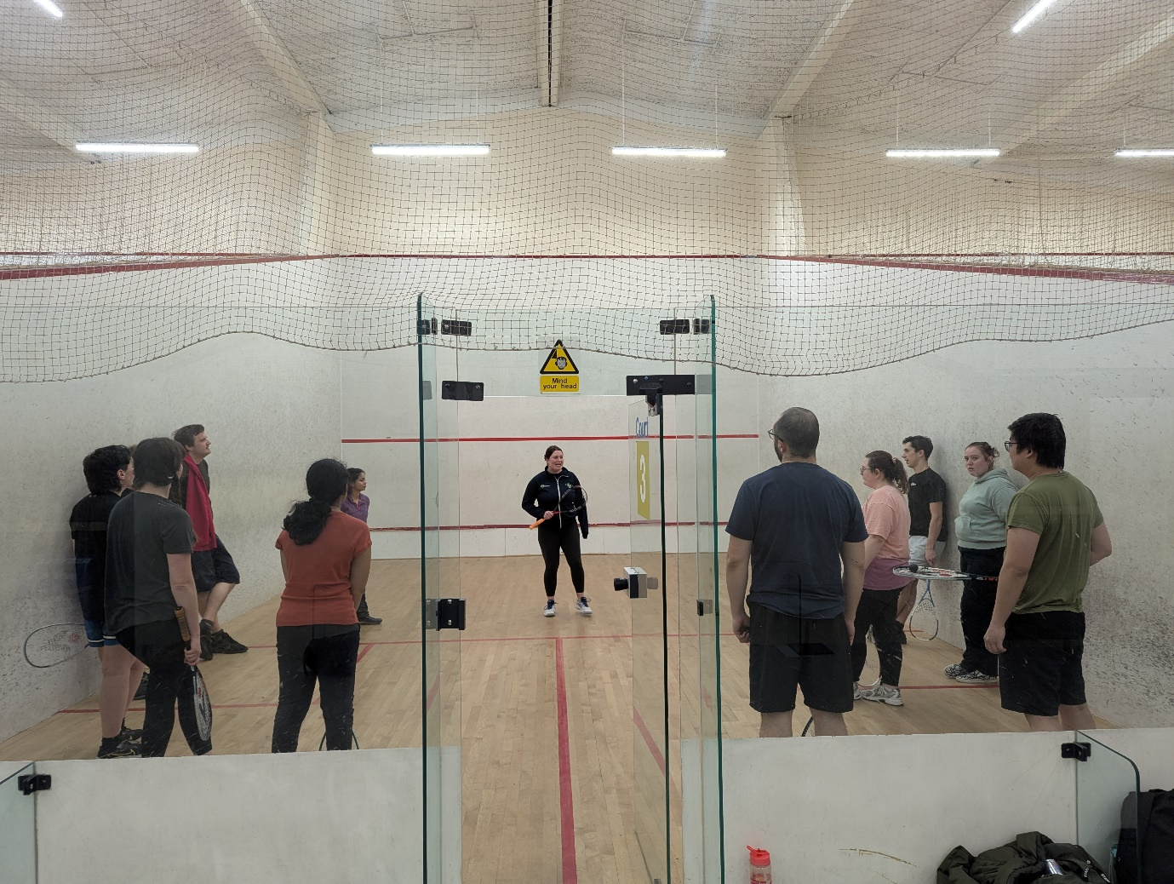
Photo: Coach Clare Wright offers squash tips at the beginners' session, Sugden Centre, 26th Feb.
Attendance
On February 26th we had 12 beginners and 4 intermediate players. On March 5th the beginners’ session was fully booked (capped at 24 participants) with some attendance drop-off. The intermediate session had approximately a dozen participants. These numbers meant we were making good use of the booked facilities and the coach, without experiencing overcrowding. Most participants were staff from across the University; some postgraduate researchers also attended.
Feedback
Many participants expressed that they enjoyed the events and were glad to have the opportunity to play for free and to get some coaching advice. Some commented that the activity was a challenging workout. One person indicated that some colleagues had not heard about the event until late on, and that it was difficult to attend, and would like to hear about future events.
Possible future events
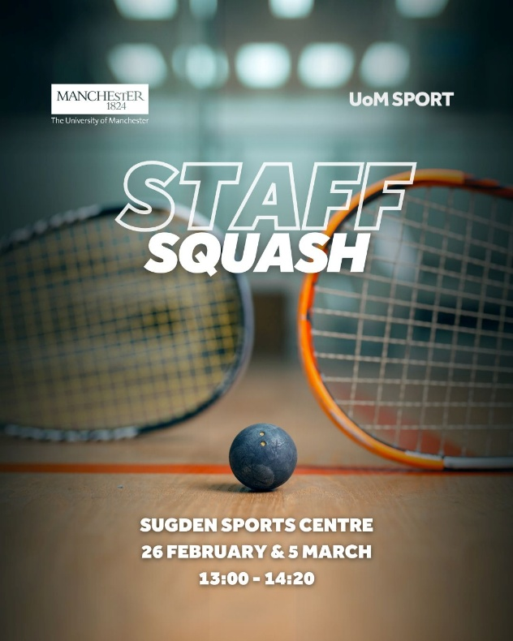
UoM Sport were helpful in providing advice and arranging a booking system. They are proposing to support some continuation of the squash sessions through the Sporticipate system, for which they may be able to provide some additional funding. The coach, Clare Wright (clare.wright94@hotmail.com), is interested in continuing to provide coaching at Sugden Centre including, if possible, through Sporticipate.
Lots of participants were asking about the plans for continuing the sessions so that squash is a more regular sporting opportunity. Approximate 10 people have expressed interest in future events, having been unable to attend these sessions that were funded by Humanities Wellbeing. Contact details have been collected for participants and for those who could not participate but who are interested in a network. Information about future events will be communicated to them. This could involve more formally organised sessions, or a more informal system of arranging some practice and games.
Total = £331
New Keyboard for Wellbeing Choir
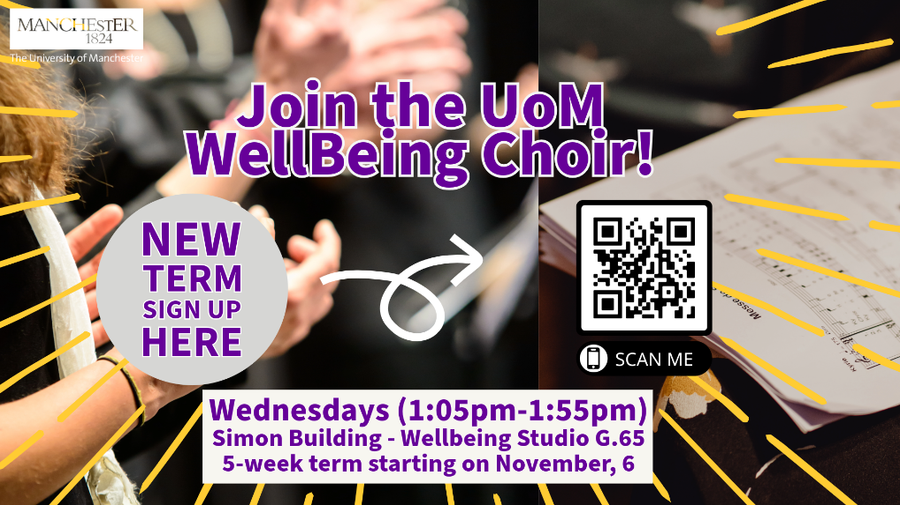
New keyboard in action!
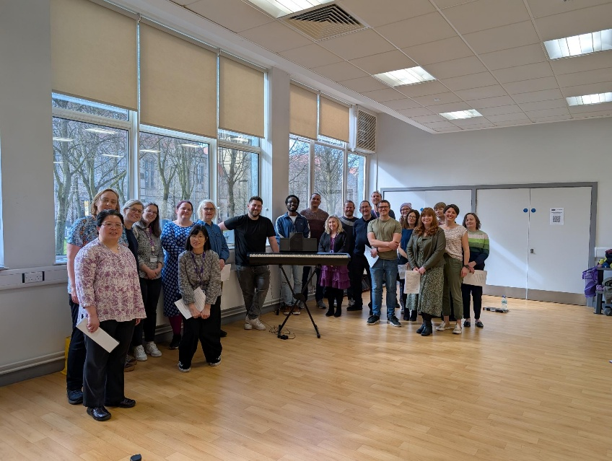
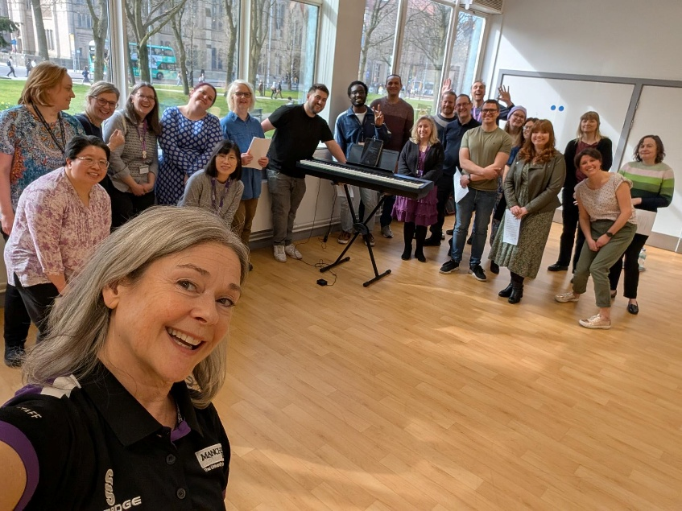
Total = £699
PCG Hulme Garden Centre Visit / Garden Planters
The first PCG wellbeing gardening activity took place earlier this year and was created on the basis of what was, originally, two separate wellbeing bids. The first was for a half day tour and activities at Hulme Garden Centre, the second, a bid for plants for staff of 182-184 to plant and nurture in the additional planters acquired from UoM colleagues. The bids were merged, and the Team took part in a learning session with Kath from the Garden centre on a warm and sunny day in April.
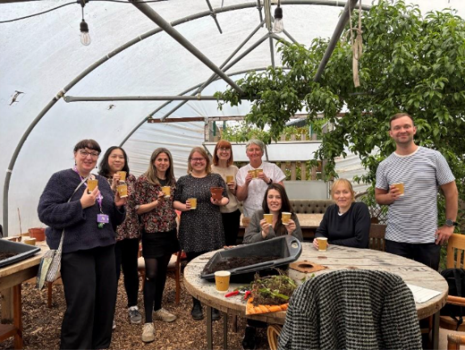
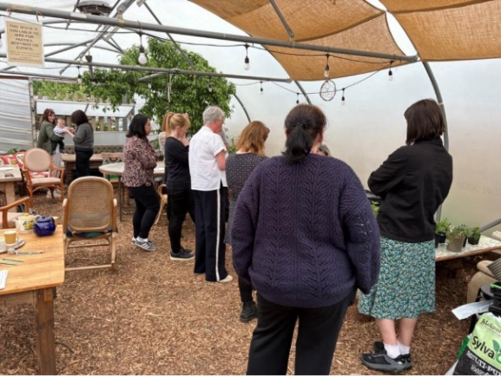

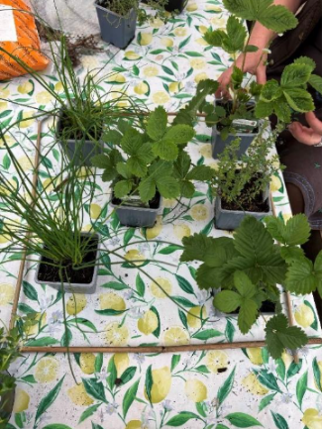
We learnt about the different types of mint, how to plant different types of plants, what worked best in sun / shade, etc. We had a tour of the facilities and were offered the opportunity to ask Kath questions about a variety of planting issues as well as learning more about the fantastic work of the Garden Centre.
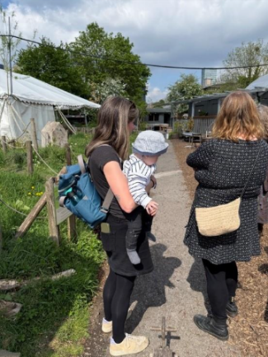
Team members agreed that the afternoon provided a welcome break from the office, fresh air and sun and a chance to get to know each other better in a non-working environment. The plants have been looked after by various members of the Team and we are keen to get the planters back to full bloom once the winter season is over.

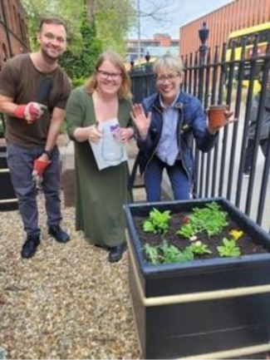
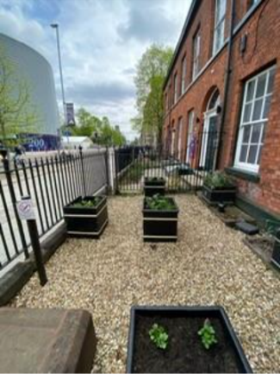
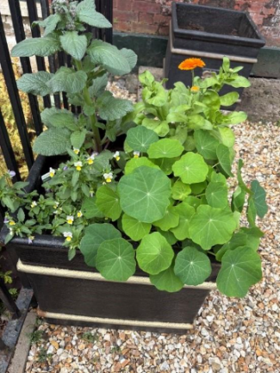

Humanities Staff / Postgrad 5-a-side
The Humanities lunchtime 5-a-side football has been a vibrant and inclusive part of our university life for over 25 years. It began at the Sports Development Centre on Denmark Road and now takes place at The Sugden Centre. The game is open to all abilities, genders, staff, and students, and has welcomed more than 300 players.
Over the years, the positive impact on players’ wellbeing has been profound and far-reaching. The benefits include:
- Physical health – cardiovascular and general fitness.
- Mental health – stress relief and an active break from work in the office or lab.
- Team bonding – we have made so many good friends with people we would never got to know. We have many examples of players working together on new research projects, helping along work issues and networking as a result of playing together.
- It gives a sense of belonging as part of the university and in an inclusive environment
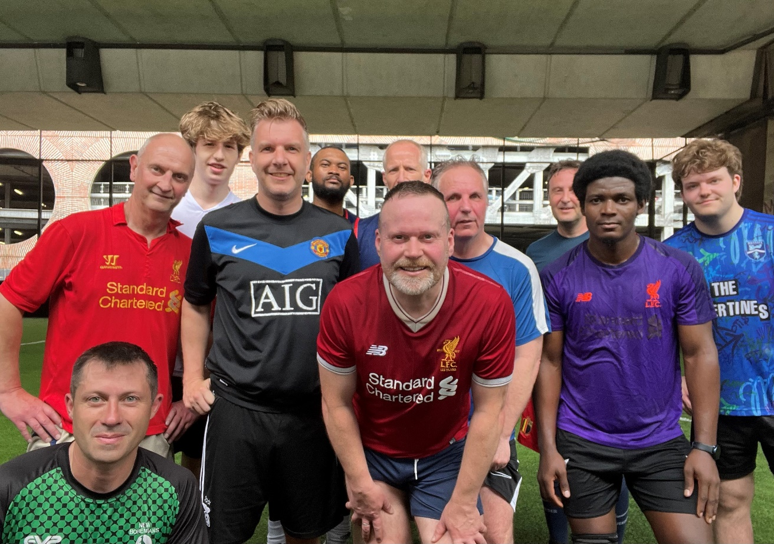
Earlier this year, we experienced a dip in player numbers due to students completing their studies and staff moving on to new roles outside the university. Thanks to the support from our successful wellbeing bid, we were able to keep the game running during this quieter period. Over the summer, we’ve recruited a healthy number of new players, and the Tuesday lunchtime game continues to thrive.
I asked for some feedback from our current players on what benefits they felt through playing the lunchtime game:
It's definitely been beneficial for my mental and physical health – especially over the summer it was a really good way to keep connected with others and a positive reason to be in the office. I've also enjoyed meeting many others beyond my department through playing, who I probably wouldn't ever have met otherwise.
Rob Richardson, Lecturer in Urban Planning & Placemaking
I really appreciate how spending a lunchtime chasing a ball around a small pitch energises me, releases stress and enables new connections with colleagues outside of my regular work network.
Clare Cummings, Bicentenary Fellow
For me, the regular Tuesday football gives me multiple benefits. For at least one hour I must break from the screen and give my brain a rest. More than this, it gives me much needed exercise in a job that requires a lot of desk hours, and I get to spend it with a range of people from different people from across SEED – from professional services and academia. Ultimately, it's great for heart, mind and soul!
Ian Thornhill, Senior Lecturer – Planning
- Physically, I feel full of energy for the rest of the week.
- Mentally, it takes the pressure away and helps you cope better with work: deadlines are less stressful when you look forward to a game of football with your colleagues.
- It is a genuine bonding exercise: you get to know your colleagues, and they get to know you, in a meaningful way.
Antonio Savoia, Reader in Development Economics

I have played in the weekly staff and student football game for over ten years. Over that period of time, the contribution of this event to my physical and mental wellbeing is really hard to overstate! It has kept me fit, and equally importantly seeing a great bunch of colleagues in the fresh air for an hour or so during the working day. Doing that on a regular basis is so valuable to health and happiness!
Chris Lyon, PhD student

I think Tuesday lunchtime footy is just great for many reasons. Great to get a run around for an hour after being in the office all morning, gives you something to look forward to and break up the day. Good for the fitness, 5 aside always deceptive with how much running you can actually do. You also get to meet people from different parts of the university that you might not ever necessarily cross paths with.
Christian Park, Customer Services Assistant
The weekly football game was introduced to me on my first day working in Arthur Lewis by John Moore. I have now been playing for 15 years and love looking forward to this every week.
As well as the benefits from keeping fit, the friendships and the mental wellbeing are just as important to me as the physical side.
I love it as I meet people from all different backgrounds from all over the world and still have contact with ones who have moved away with their various careers.
We always hold a students v staff football match annually and it’s great to meet the students.
It’s a fully inclusive game, no matter what gender and this is what I love about UoM and our weekly get together.
I will play on and on until my body no longer lets me.
Paul Henshall, Senior Research Finance Officer
I see lunchtime 5-aside as essentials to my mental and physical health.
Being mostly office based it is hugely beneficial to go out in the fresh air and exercise and be part of a team. In my opinion team sports promote inclusivity and a positive mind set.
The lunchtime football that you have organised for a number of years is a shining example of how to bring different groups together, we have staff and students from a range of different cultures, backgrounds, age and skill level. All are welcome and are made to feel welcome, even if like me you're not very good but there is no judgment.
This group provides a welcome escape form work and home pressures and creates camaraderie and friendships that are difficult to replicate in a normal working environment, all of which serve to promote physical and mental wellbeing.
I really couldn't do without this.
John Ashton, Access Control Manager
The five-a-side game organised by John is a real boost for both physical and mental health. It's a great way to break up the workday, get moving, and connect with different colleagues outside of a strictly work context. It was of particular benefit to me when I first joined the school as a way to meet new people. I hope that it will continue for many years into the future.
Andy Milne, Management Information Analyst

Total = £360

Staff Wellbeing Workshops With Experimental Archaeology Club
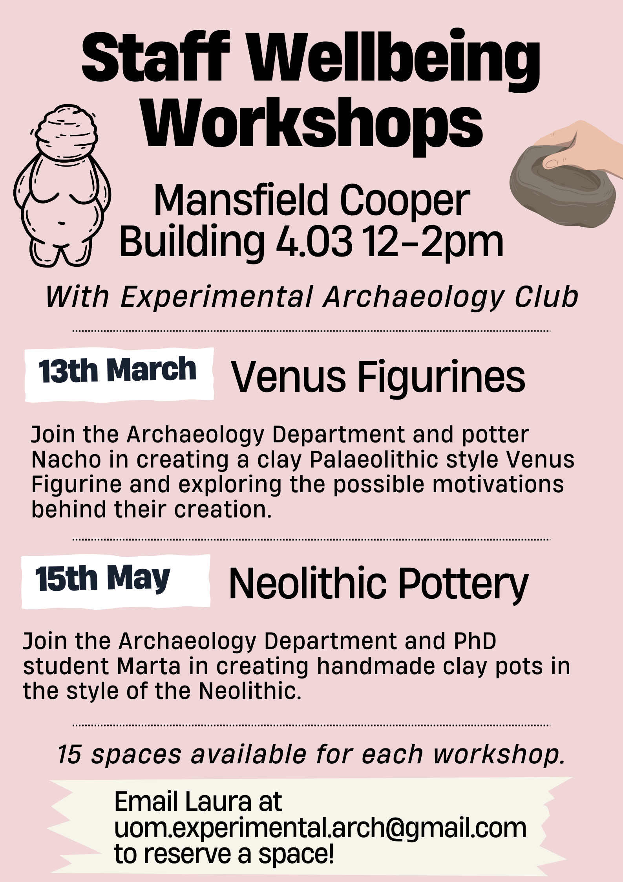

Wellbeing Palaeolithic ‘Venus’ workshop
On the 12th March, Experimental Archaeology Club carried out one in a series of Wellbeing Workshops at the University of Manchester. We invited staff across the University to the Mansfield Cooper Archaeology Labs to explore the history of ‘Venus’ figurines and produce a recreation under the guidance of a professional potter.
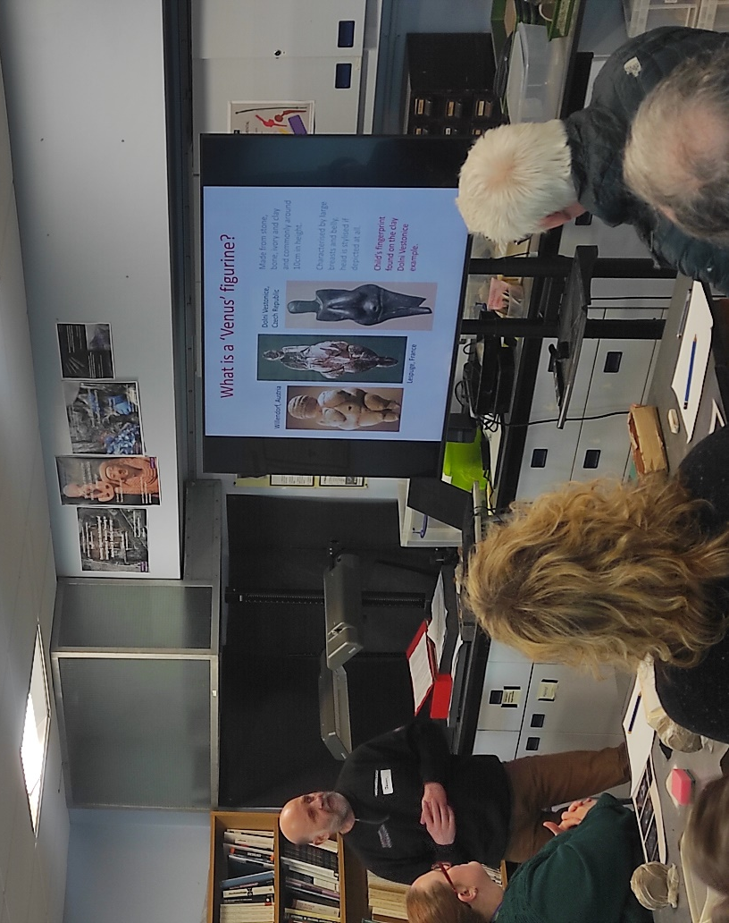
The aim of the workshop was to introduce people to the different interpretations of these artefacts, allow them to create one themselves, and then form their own interpretations.
We wanted to encourage a positive community and social environment which allowed staff to meet other colleagues they may not have the opportunity to otherwise. This session provided a break from the regular working day, allowed for a chance to reflect and introduced experimental archaeology as a mindful practice.
We asked participants to feedback on their experience….
“It was a great topic to pick the "Venus" figurine history. The different interpretations were fascinating. I will be on the lookout to attend another one!”
“I also really enjoyed the mindfulness of focusing on something new / different”.
“An excellent workshop for wellbeing, I felt very relaxed, and it was very interesting and very friendly, enthusiastic people running and organising the session. I loved it!”
“I also enjoyed meeting members of staff that I wouldn't normally meet in my day-to-day activities!”
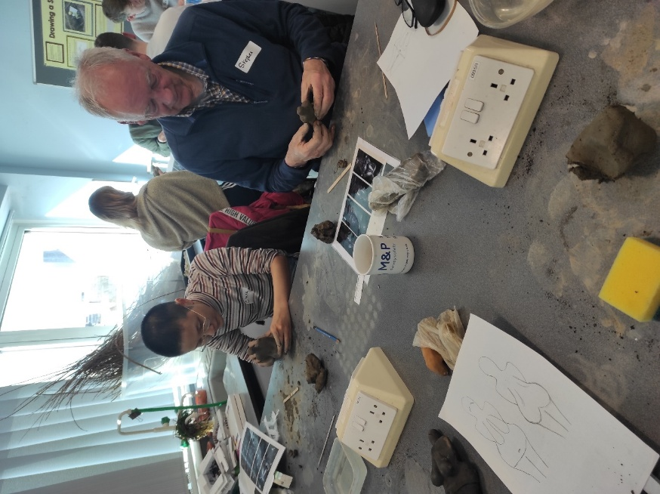
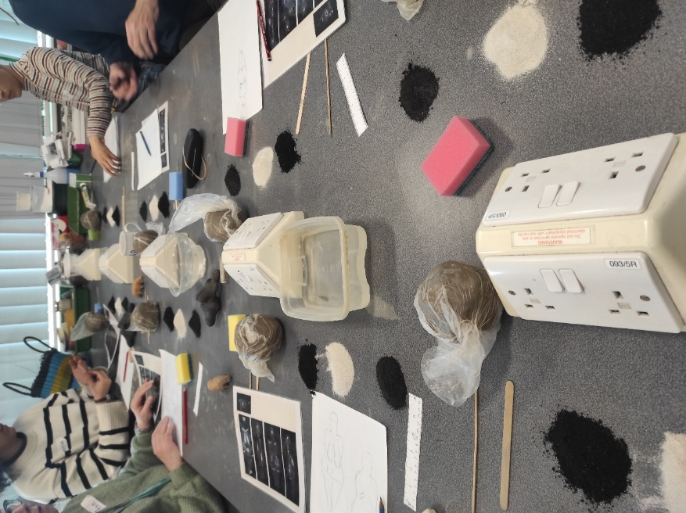
“I enjoyed being focused on creating the figurine…it was really mindful, and it was so nice to create something physical”.
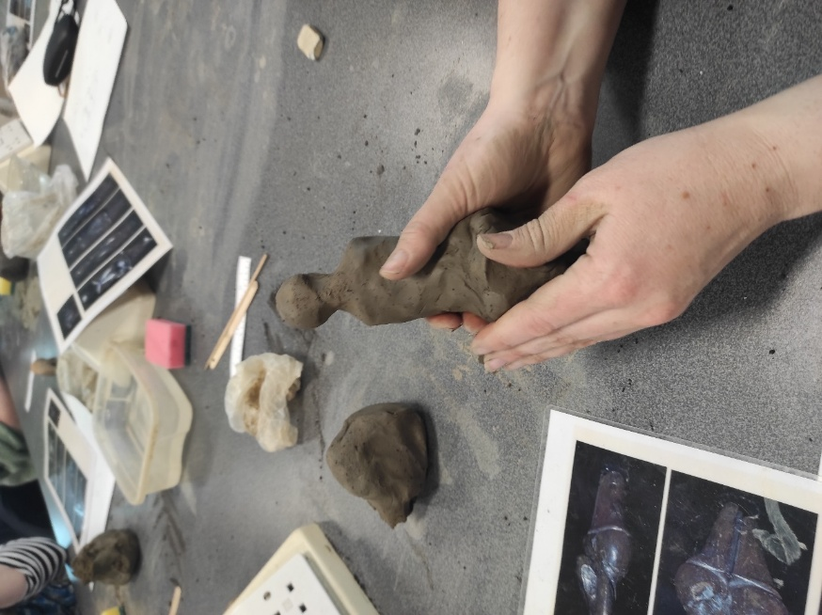
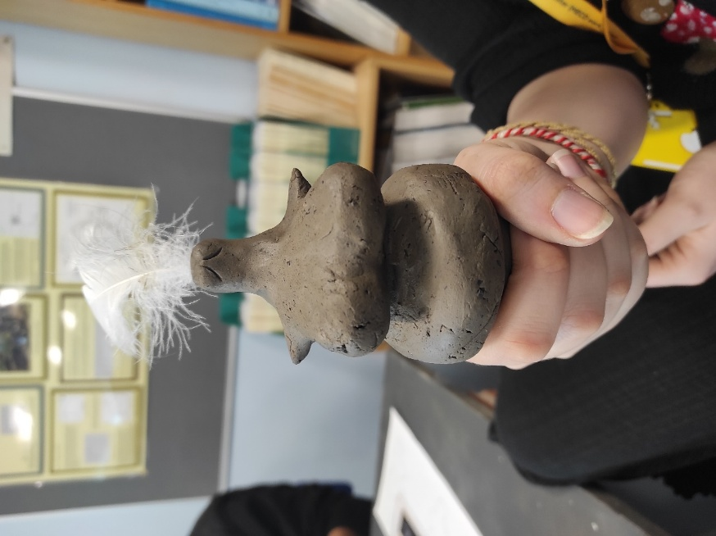
“It was great as I was able to partake during my lunch hour (sadly couldn’t stay for the full 2 hours but really enjoyed the time spent)”.
“I enjoyed seeing what other people made! And I was really pleased with my figurine, it’s my favourite one I’ve made yet. I can't wait for her to dry”.
“Venus now lives in SALC wellbeing amongst the plants, still sporting her feather!”
With such positive feedback, Experimental Archaeology Club is now planning future workshops to continue this great community spirit and introduce more people to the wonders of ancient material culture and craft through mindful practices.
To find out more, you can follow our Instagram page @uomexperimentalarch or join our mailing list at: https://www.jiscmail.ac.uk/cgi-bin/webadmin?SUBED1=EXPERIMENTAL-ARCHAEOLOGY-CLUB&A=1 [jiscmail.ac.uk]

Total = £350

2023 – 2024
Time To Talk Day – 1 February 2024
The Dean’s office held a Time to Talk event on Time to Talk Day 2024. The event was well attended throughout the afternoon by a range of colleagues across the board including the Dean, Head of SEED, Vice-Dean, Exec Director of Faculty Ops, TLSE and RBES colleagues, Wellbeing Champions and a surprise visit by the Director of P&OD. Helen Brewis also called in to say hello and stayed for a very entertaining origami workshop!
Feedback so far indicates that all workshop sessions were valuable, engaging and provided a chance to have a break and a chat with others. The skills of our volunteer workshop leaders was exceptional and we all learnt a lot from the sessions. Our office is keen to keep the conversation going and we hope to broaden the event to a larger number of colleagues next year.
Thank you to everyone who took part in supporting by donating their time, skills and funding for the event.
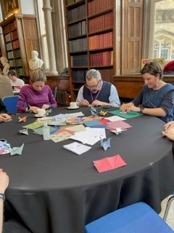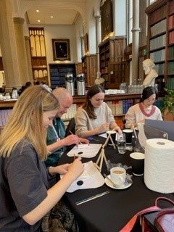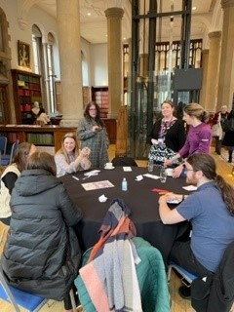

SEED Stitch Social
The SEED Stitch Social celebration event on 12/06/2024 was supported by the SR Wellbeing funds. The event went well, we had a lovely group who joined for the full two hours and had several new attendees with lots of interest in the work we've been doing.

You are warmly invited to the SEED Stitch Social sharing event, in collaboration with SEED Zine Making, on Wednesday 12th June 2024, 14:00-15:00 In Samuel Alexander W2.19.
This event brings together and celebrates the connections and creations made through the stitch and zine-making socials / workshops between December 2023 and May 2024.
This event is open to staff and students from across the University who would like to learn more about the community we have established through the Stitch Socials and Zine Making workshops. Attendees will have a chance to learn more about the fantastic locations, organisations, and artists we have worked with, and to see and handle some of our stitched and folded creations.
During this open event, all attendees were also invited to have a go at stitching. Instructions and materials were provided so attendees could explore these creative processes and get a taste for the kind of activities which take place at the monthly meet ups. Taking part in the crafting session is not compulsory and those attending are welcome to bring along a different craft project that they are already working on, or just join us for a chat!

Attendees were encouraged to bring along their lunch and refreshments were provided.
This event was kindly funded by the Wellbeing Fund and the SEED Catalyst Fund.
For further information, email Poppy at: poppy.budworth@manchester.ac.uk.

Active Travel Events
On 31 January, Roz Webster and Lynda Rowlinson hosted an Active Travel Breakfast event to encourage and support colleagues to walk, cycle, wheel, or run to The University of Manchester. It was a brilliant morning with over 80 colleagues from the Faculty of Humanities and beyond. Lovely to spend time chatting over a coffee and a pastry in a sea of hi-vis.
Another event took place on Wednesday 19 June, partly funded by the Central Wellbeing and Sustainability Teams, with over 100 colleagues taking part.
A number of colleagues led runs and rides to campus. At the event, there were also some colleagues from partner organisations with information and giveaways – Dr Bike was available outside AMBS to do basic bike checks and UoM Sport arranged for a physio to attend to give advice and do check ups.
Attendees were encouraged to bring their old running trainers to be recycled via JogOn
https://www.jogonagain.com/.
A raffle prize draw was held for all attendees – prizes included a month’s gym membership; cycle hire vouchers; clothing; and more!
Many thanks to Ellen Stephenson , Julia Durkan, Helen Brewis, and Maizy Jenner for supporting with this initiative. We are really pleased that the University has now committed to hosting more Active Travel Breakfast events in 2024-25, watch this space!
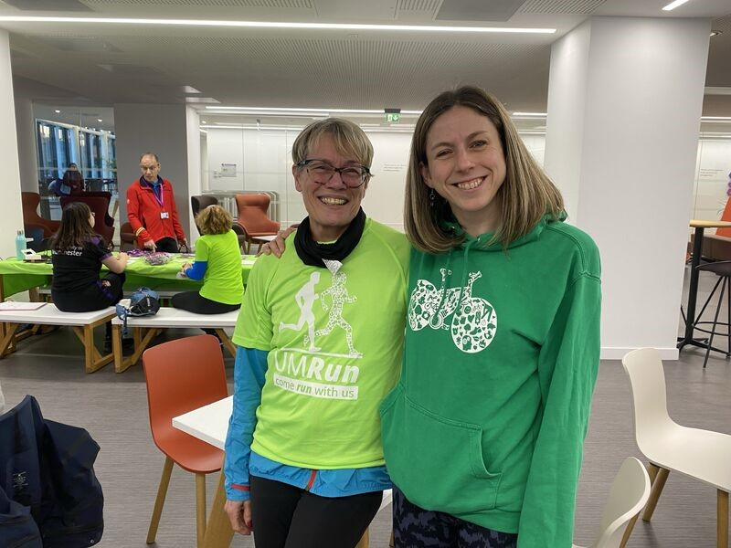
Language Café
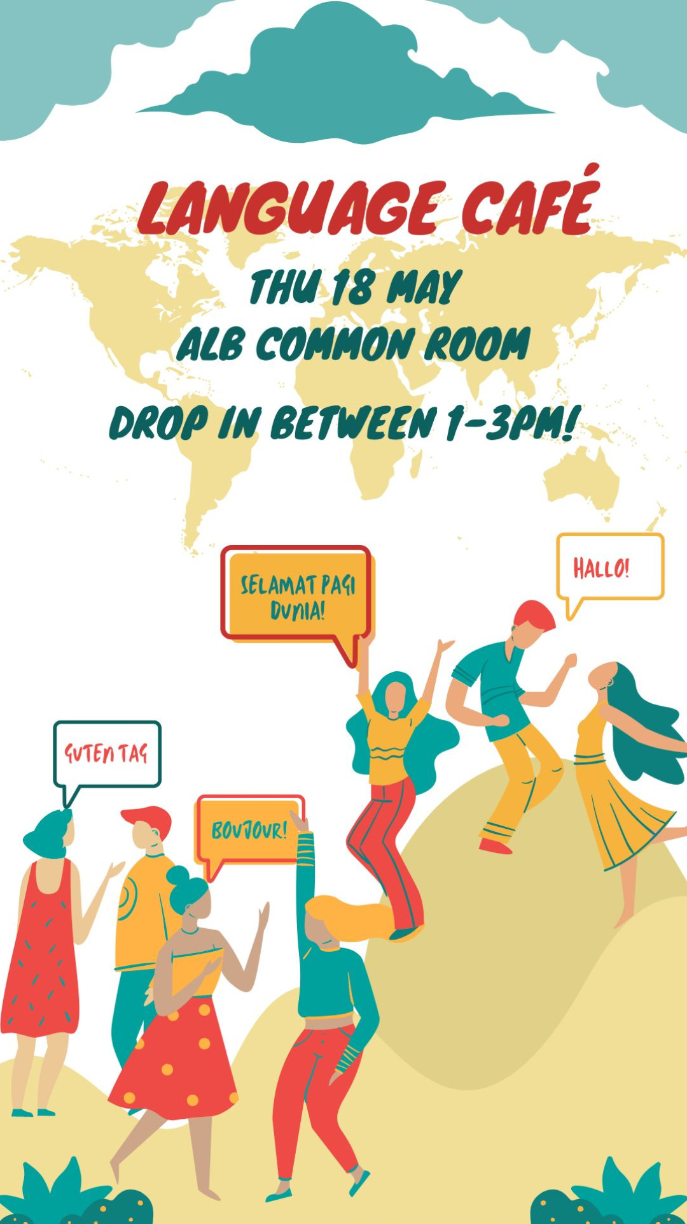
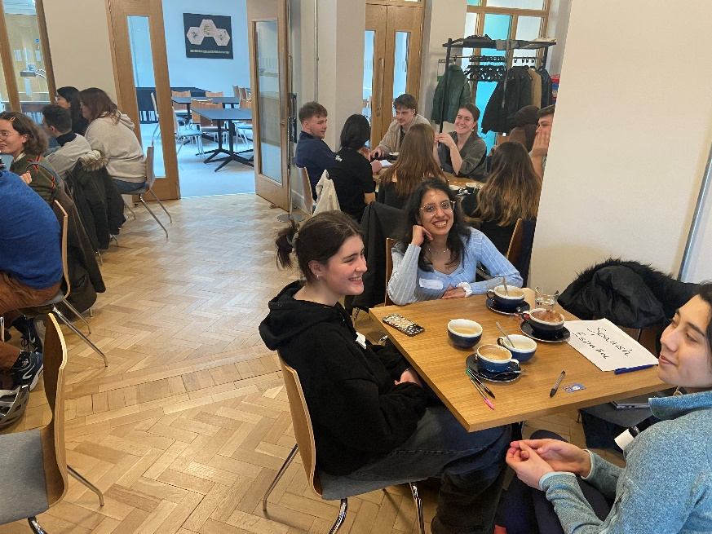
What did you like most about the event?
- Opportunity to speak other languages
- Meeting new people and the seating arrangement
- Speaking to new people
- People and staff here are so nice
- The opportunity to practise other languages

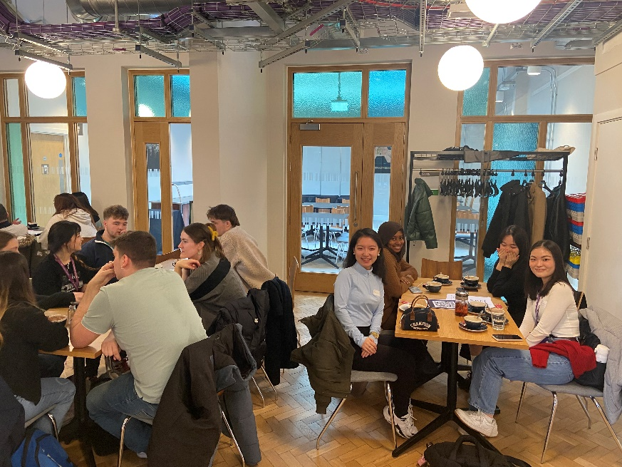
How could the event be improved?
- Wider variety of languages.
- Marketed better so more people learn about the event
- Maybe some resources for different languages so we have something to start off of
- Maybe better advertised? I only knew about it from a friend
- Hold more frequently
- More frequent, More languages, More publicity

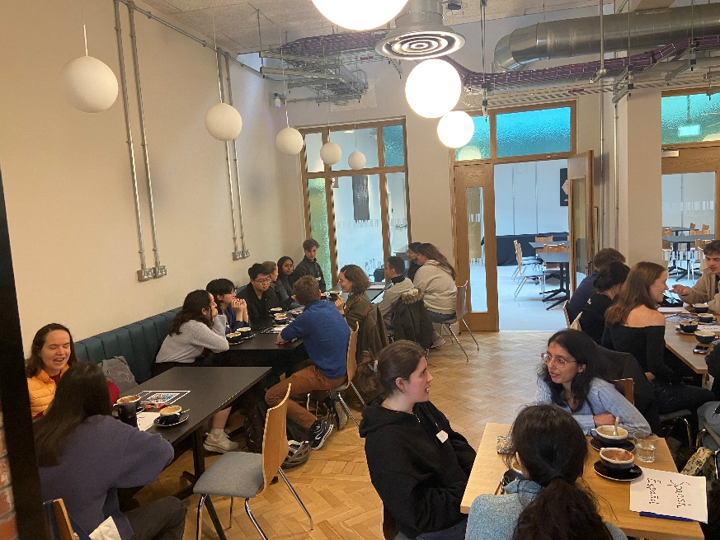
Ping Pong in Ellen Wilkinson and Arthur Lewis Buildings
Ping Pong Parlours have been developed with the help of the Wellbeing Fund at the University in the Arthur Lewis Building and Ellen Wilkinson Building enabling the University of Manchester to get a team together made up of Postgraduate students and staff from across the University to publicise the GN Ping Hub in Manchester and to develop table tennis / ping pong in Manchester.
Varsity match at Ping! Hub a first-class success – Table Tennis England
Manchester University's Varsity Match | GNW Ping Hub | TT Clubs
Postgraduate students and staff have regularly met over the past year. Once building work in complete in ALB and EWB, it is hoped the Ping Pong Parlous will resume.
Photos from the UoM Sport session on 02/07/2024, 1-2pm in the EWB Ping Pong Parlour – Room CG.49 and sessions held during June Wellbeing Month in the EWB Ping Pong Parlour.

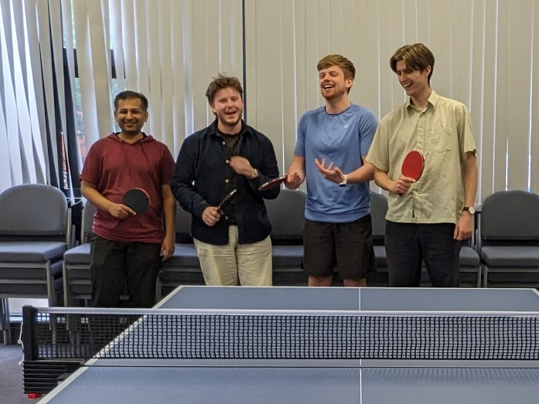
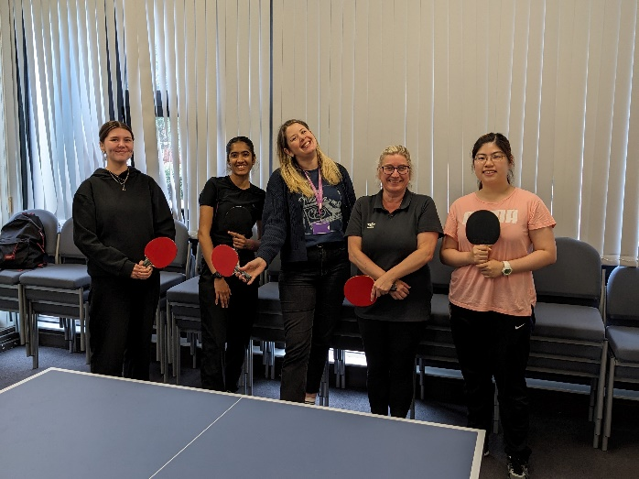
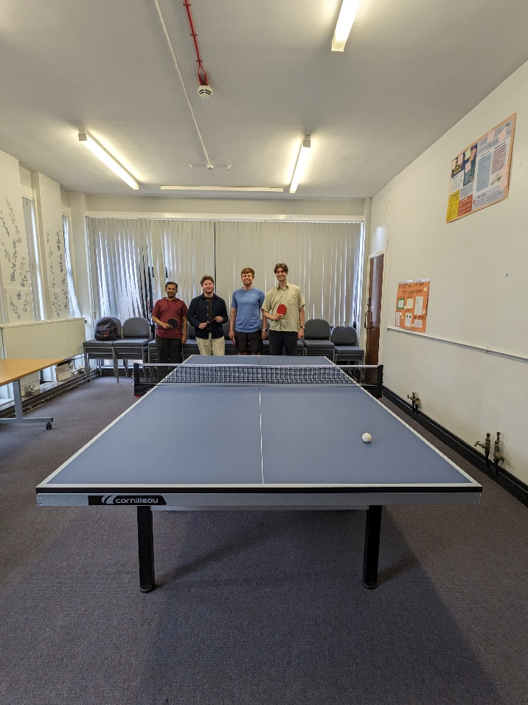
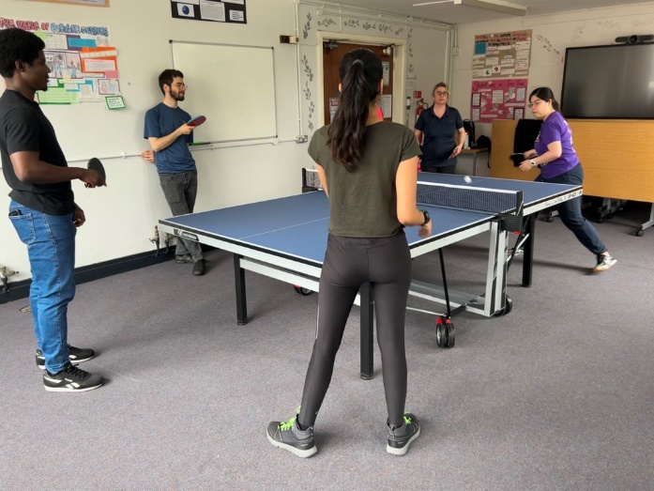
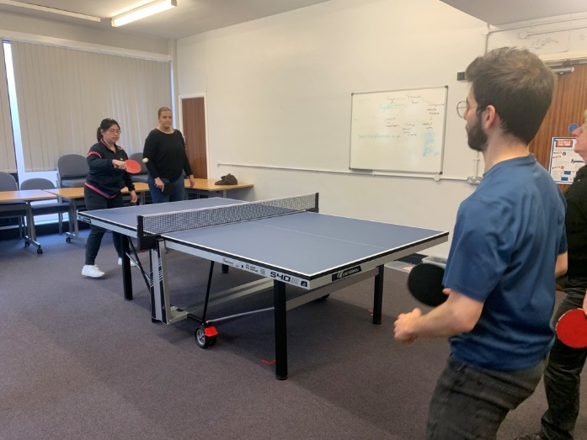
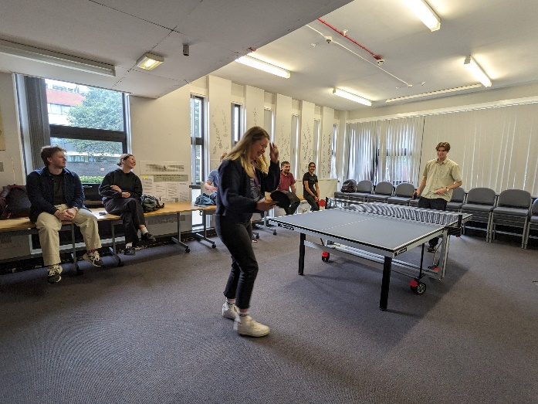
Wellbeing Choir
This activity was funded in 2023 and partly funded in 2024. The choir has been embraced by a range of colleagues throughout the University and continues to thrive.
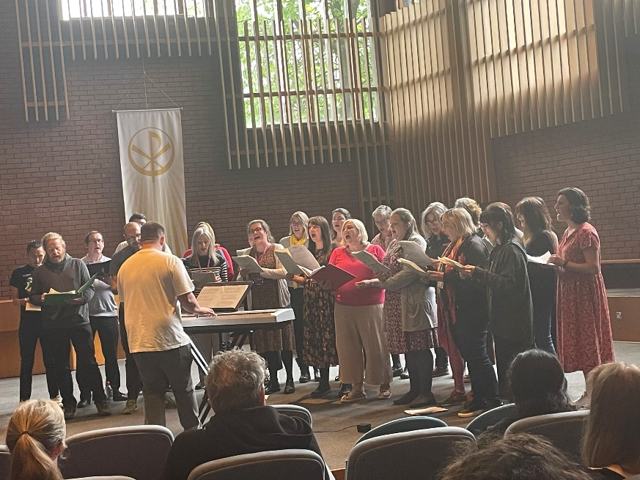
The Wellbeing Choir mini concert on 17th May 2023 went down well. Here is a video if you want to have a listen: https://photos.app.goo.gl/nUsivF4U4ZeVUh6K7
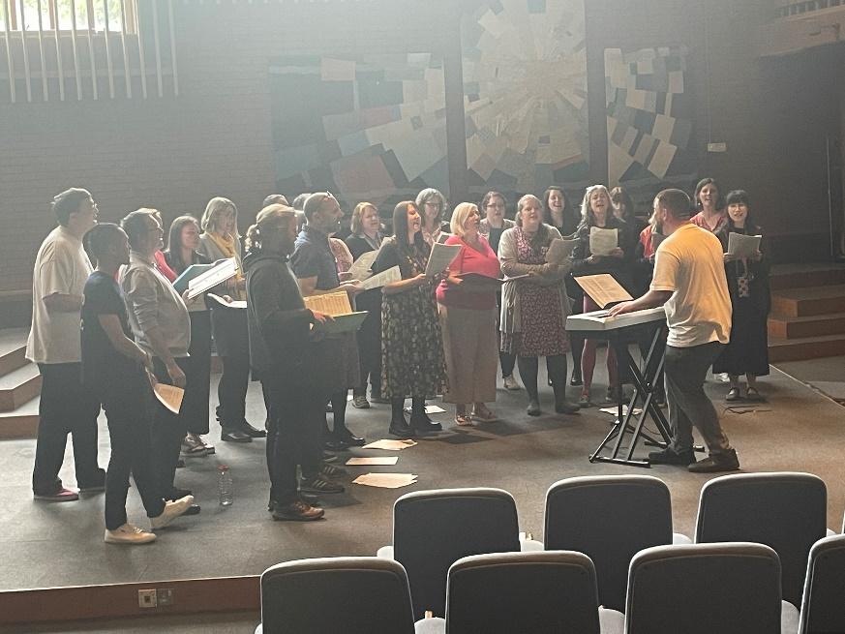
The Choir were also asked to perform at this year’s Bi-Centenary Festival.

2022 – 2023
Poetry Writing for Wellbeing Workshops
Two Poetry Writing for Wellbeing Workshops ran in March 2023, booked through Creative Manchester, with Rebecca Hurst as the facilitator.

The remit for the workshops was:
Expressing yourself and crafting an object have long been studied and considered a way to relieve stress and emotional turbulence. We are told that “talking helps” and that making “something out of nothing” can make us feel better. Writing is a form of speech. And so the Faculty of Humanities Social and Wellbeing Actions Group (FoHSWAG) would like to invite staff from across the University to take part in a Poetry Workshop which will be facilitated by poet Rebecca Hurst, from the School of Arts, Languages and Culture as part of their Creative Manchester work.
Creative Manchester projects have involved working with readers and writers from all walks of life and backgrounds, and have included poetry competition for Schools, micropoetry built for Twitter, book clubs discussing classic and new poems, moonbounce sessions at Jodrell Bank which saw new poems written and sent to the moon (and back), and wellbeing sessions with AMBS and at the city’s libraries, museums and galleries. We know first-hand the effects that poetry can have, and we are delighted that Rebecca will run sessions for interested readers and writers, and those who are curious about poetry, this spring.
The first session will be aimed at supporting you in getting started with your poetry; whilst the second will be to review and refine the work you have been producing. No creative writing or poetry writing experience is needed to take part in this workshop.

This was the second year that FoHSWAG have ran the workshops. Unfortunately, only verbal feedback was captured last year, but the feedback was extremely positive which is why they were put on again. This year, FoHSWAG have captured feedback following the events with input from both Creative Manchester and Rebecca Hurst.

The workshops took place over 90 minutes on two consecutive Thursdays and attendees could attend either date or both.

There were 14 attendees on Thursday 23 March, 8 attendees on Thursday 30 March and these included 5 attendees who attended both workshops. There were two attendees who had attended the previous year. The maximum number of attendees per workshop was 15.

The feedback captured on MS Forms is as follows:
- Thursday 23 March 2023
- Thursday 30 March 2023
- Thursday 23 and Thursday 30 March 2023

Main takeaways from the feedback are that people would like to see these workshops running on a more regular basis.

Develop Your Photography Skills
What is your biggest take away from the workshops?
What is your biggest take away from the workshops?
What is your biggest take away from the workshops?
Really enjoyed meeting new colleagues, developing new skills and engaging with the local environment – overall a very positive and enjoyable experience.
Finding connections through my passion for photography.
Meeting new colleagues was a really big take away for me, it was great to meet many academics who I've not seen in the School before!
Learning new tips and tricks and being with people of like mind and interests
My understanding of photography technics grew by leaps and bounds during these workshops, which in itself made me feel good about myself!
Please provide a brief testimonial based on your experience
Please provide a brief testimonial based on your experience
Please provide a brief testimonial based on your experience
Excellent activity that was very well delivered!
The workshop acted as a lens that expanded my connections with colleagues (those across different schools) and that provided insights into discovering Manchester. Heather B made it very accessible to all who had different experiences in photography.
The photography classes were my escape every week. It was an opportunity to focus on myself and learn new skills which boosted motivation and positivity and allowed me to connect with new colleagues. I've finally learnt how to use my camera and enjoyed exploring different locations to experiment with my new skills. The final trip to the Northern Quarter was fantastic, it made me see the area from a different perspective and it was lovely to come together as a group at the end. Heather (and John!) were fantastic teachers, always supportive, and on hand to reassure and provide guidance. I wouldn't hesitate to recommend this course to anyone!
An excellent series of workshops that were led by very supportive and engaging people. Fingers crossed that there will be another series and another opportunity to learn new things!
I thought the workshops were an opportunity to do something I enjoy (photography), but I did not expect to have so much fun! I met some amazing colleagues, we had a great time, and we learned a lot. Heather, the instructor, and John are both amazing photographers and brilliant people! Absolutely golden experience, and my photography skills grew by leaps and bounds!
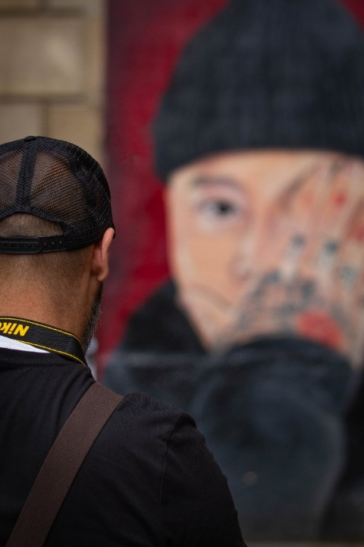






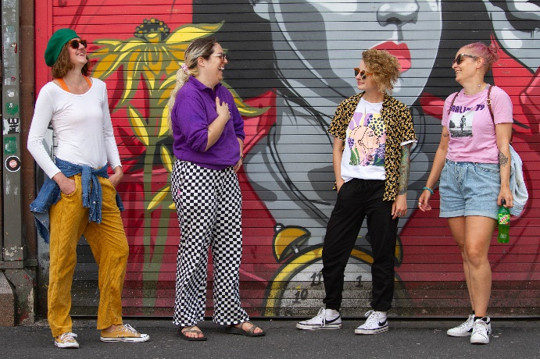

A walk along the Cornbrook feedback (led by John Piprani and Martin Dodge)
Wednesday 17 May 2023
“It was great to take some time out to take part in the walking tour and connect with colleagues. We learned about the history of the campus and its relationship to the path of the Cornbrook, as well as getting an insight into the architectural phases of the local area. The event ended with a tour and film showing at Cornerstone. The charity does amazing supportive and preventative work with the local homeless population and since the trip we have begun to explore how the University and our students can support Cornerstone in the future.”
Roz Webster
Social Responsibility and Environmental Sustainability Projects Officer
Faculty Office – Faculty of Humanities

It was a very well-organized walk with many surprising bits of information about our campus. I thought I knew it well but now I look at it afresh. Linking the campus with some of the residential areas was very good. I came away with several ideas for activities with students. I would like to go on more walks like this.
Dr Katja Stuerzenhofecker |Lecturer in Gender Studies in Religion | she/her | Religions and Theology | School of Arts, Languages & Cultures

Yesterday's wellbeing walk along the Cornbrook was the highlight of my week!
Organised by Martin Dodge and John Piprani, we followed the culverted Cornbrook river, learning about the history of campus buildings and stopping at the Cornerstone Day Centre for Rafe's film premiere. Rafe's touching and inspiring film starred a number of amazing colleagues, Cornerstone staff and people who have used the services provided by the Cornerstone.
The evening ended at the Old Abbey Taphouse, one of the oldest pubs in the area to learn more about their social responsibility projects. If you would like to learn more about the Cornerstone Day Centre or even find a volunteering opportunity please find the link here.
Take a look at the beautiful smiles I managed to catch on camera too!
Tora Jordyn
Administrative Assistant (apprentice)
Faculty of Humanities Administration

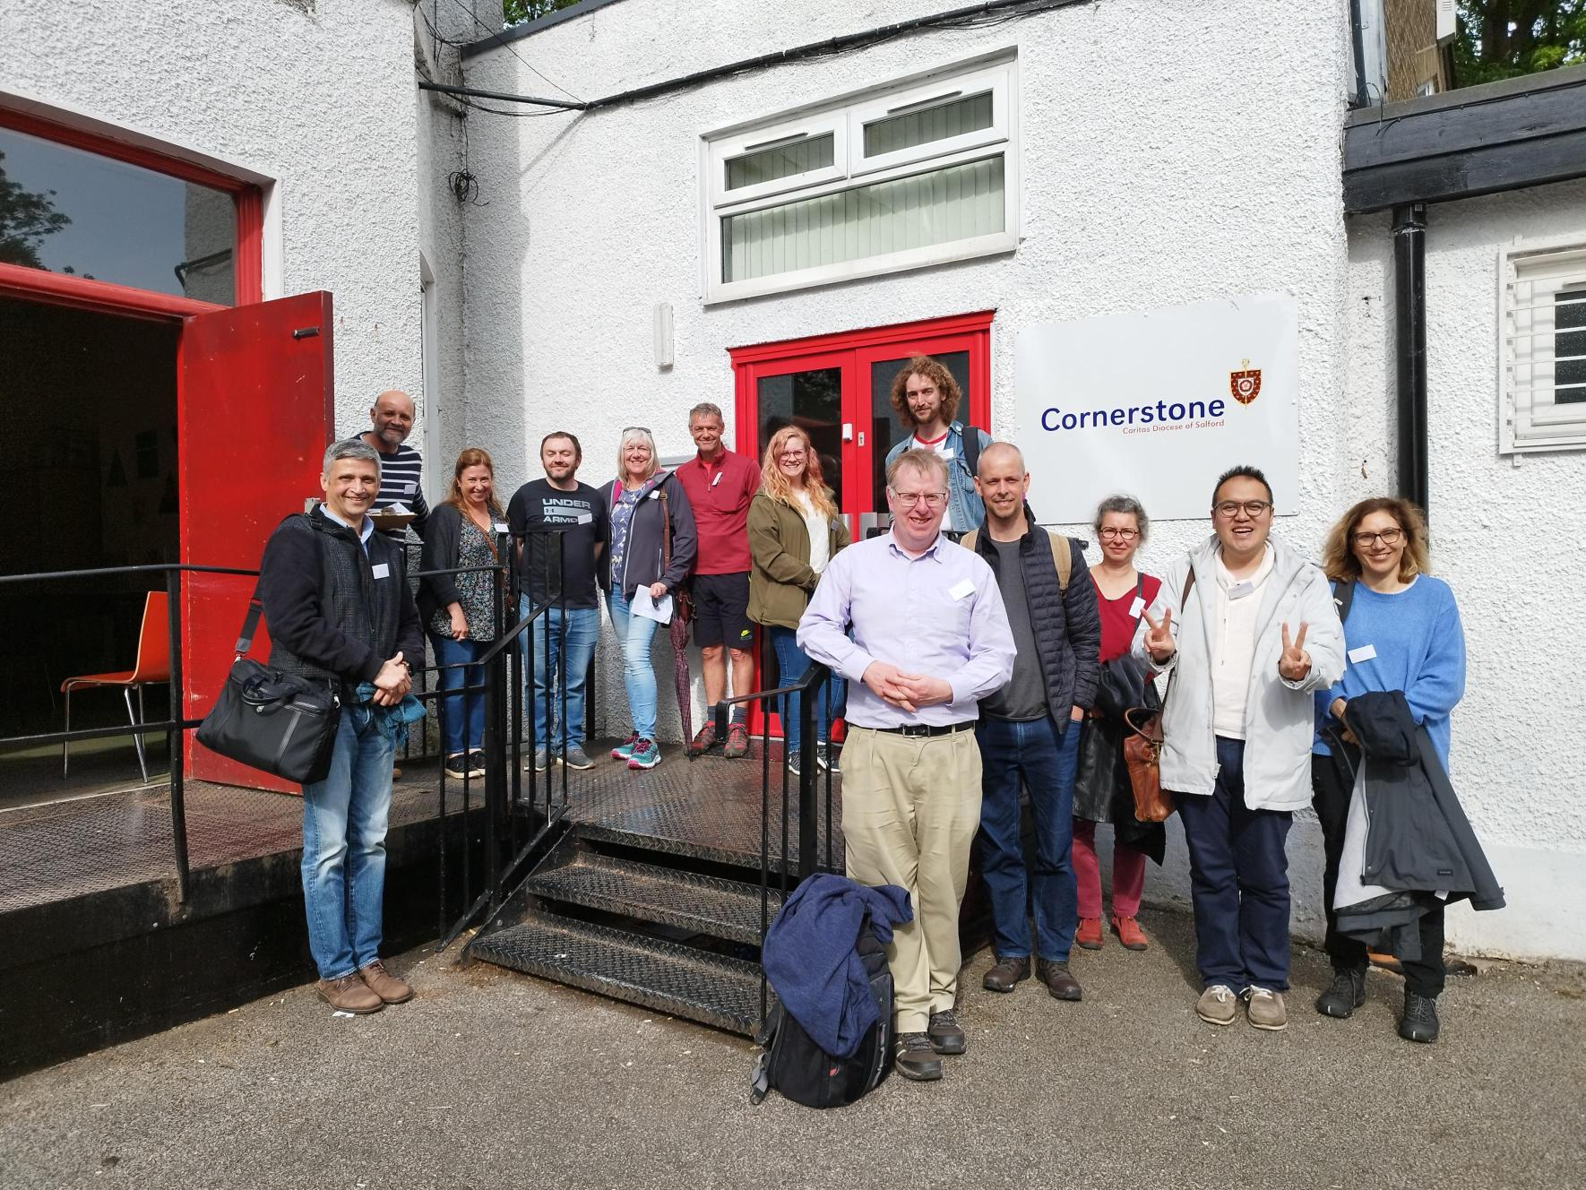
Knitting, crochet and craft sessions organised by AMBS (update at August 2023)
Andy & Alexus
- Last semester, with support from the FoH Social and Wellbeing activities fund, we engaged in piloting our knit and knatter wellbeing format.
- We organised an informal weekly group in the open plan of the third floor of the Arthur Lewis building, 12-2pm on a Wednesday.
- A key aim was to explore whether we could bring together permanent members of academic staff and temporary contract members, professional services staff and PhD students to participate in knitting and informal chat. Helping people connect with others and learn a new skill.
- We usually had between 4 and 10 people visit to participate over each 2 hour session. Most people stayed for around an hour. And we got a great mix of people from our different target groups most weeks. We also attracted some people from outside of the Arthur Lewis building.
- We engaged people in knitting, crochet and other textiles crafts to see what worked for people of different ability levels. We found that people enjoyed being able to try new things, and so it will be good for the coming year for us to maintain the options available to people.
- We tried out some more directed activities (i.e. working towards a goal) but found that most people preferred to have a relaxed disposition, allowing them to knit or crochet more informally, without the obligation or expectation that they produce anything specific. However, a small number of more experienced people did seem to want to have more direction. So we will try to cater for both groups in the coming year by offering the chance to knit or crochet towards a departmental well-being blanket. We had participants fill in postcards about their experiences during the knit and knatter
- In the coming year, we will expand the knit and knatter beyond the third floor of the Arthur Lewis building, and explore how we manage the group with a larger number of participants.
Emily
- I started a weekly “learn how to knit” group which I promoted in the AMBS eNewsletter and via posters around the building. It started out well, with around 5-6 participants each week (some returning, some new faces).
- My aim was to focus on teaching some basic skills and recruiting some more experienced knitters to help me, unfortunately I was unable to do this but will try again after the busy period.
- Part of my proposal was to knit for charitable causes, we did look to do this with innocent big knit but unfortunately due to the family situation, I had to take an extended period of time out of the office (physically) so instead I left the wool with one of the regulars and asked her to manage and then with summer and annual leave the numbers have dwindled slightly.
- I am looking to re-launch again in September with the intention of making some Halloween pumpkins (these always seem to draw the crowds in) with the intention of making some bits of the annual Christmas dinner – I am going to be less ambitious and have fortnightly sessions and push for a sign up rather than a turn up so I can anticipate numbers better.

Green Wellbeing
Rewind back to early Summer 2023. You are returning back to your old-times office which has been barely inhabited during the pandemic. After some proper feng-shui, you pack your most beloved things so that a company can take them over to a new place: Crawford house.
Fast forward to late summer. You are now in Crawford House but neither the furniture nor IT equipment have arrived due to a global supply shortage. In addition, some serious drilling, scaffolding and dust makes you wish you had never moved!
Now move to the present: Spring is coming, Crawford house corridors are alive with people coming and going, the kitchen’s water is drinkable and the open plan office is now greened up. Ahh this is now wellbeing, in fact green wellbeing!
In December 2022 the Humanities eLearning team submitted a bid to the Faculty of Humanities Social and Wellbeing Actions Group (FoHSWAG) for support to fund a wellbeing activity, notably the greening up of the new Crawford House offices. A panel, comprising of P&OD Partner, Head of Wellbeing, Head of Occupational Health Services, Head of Planning, Compliance & Governance and Executive & Compliance Support Manager warmly supported the proposal and agreed to grant the amount requested (£300) to create a welcoming and warm office environment by greening-up the open-plan office space.
We had read somewhere… Whilst the majority of people agree that plants may “look nice” in an office and add a little life and interest to a workplace, they may not realise the science behind why plants can actually have significant benefits for our health and wellbeing, both physical and mental.
Plants boost aesthetic value especially in soulless open-plan workplaces. Plants reduces stress levels. While it is not quite the same charging boost that one gets from spending time outdoors, daily interaction with plans is a de-stressor.
Plants help towards creating a quieter environment. Plants help to absorb excess noise and can be used to create spaces for privacy. Clearly ours are still small to do so but before long …
Plants prevent sickness. Indoor air can become polluted and stale (photocopiers, printers and even opening a window if you’re based in the city), but plants remove some of these toxins, helping create a clean air environment.
Thus, armed with the science behind plants, and the moneys, the rest was just about putting it all into action. Adelaide and Stuart sorted the compost, got two types of gravel, a hygrometer - we did say it was a science! Then followed a trip to IKEA to get the actual plants, pots and plant feeder (see the team in action - pic.). We loaded the cars and the result … well you can see by yourself if you live in Crawford House Mezzanine, or if you pay a visit.
We hope you enjoy the space and our green wellbeing. We certainly enjoyed both the process and the result. A big thank you to the Wellbeing Fund!
Adelaide, Elsa, Lisa, Andy, Stuart, Anna (Humanities Faculty Office)

