KEY COLLECTION FOR BURKHARDT HOUSE

FINDING YOUR WAY TO THE HALL
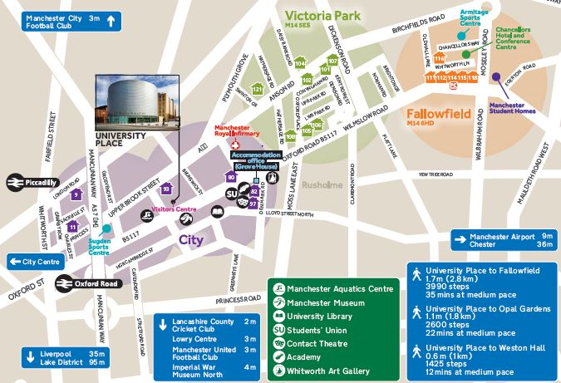
Burkhardt House

ALSO CHECK GOOGLE MAPS: HERE
In the ENQUIRY BOX Put in MANCHESTER M14 5RR for the UNITED KINGDOM and press FIND. This is an interactive map and gives you lots of information.

ARRIVING IN HALL
The entrance to the Hall is on Oxford Place. Enter into the gates and head to Reception. Please go straight to the Hulme Hall Reception to collect your room keys.

KEY COLLECTION
Check in is available after 10am on the scheduled date of arrival. The hall reception is open from 9am to 5pm Monday to Friday (excluding bank holidays).

OUT OF HOURS KEY COLLECTION
Students arriving out of hours must follow the instructions advertised at reception to collect keys. All students collecting keys will require a mobile telephone to contact the out of hours team –the number is advertised at reception.

BY ROAD Burkhardt House is situated on Oxford Place. Oxford Place is off Upper Brook Street which leads from the City Centre and connects to the Mancunian Way (A57M) which links into the M56, M6, M60 (Manchester Orbital Motorway), M61, M62, M66, M67 and M602 Motorways. From the A57M, follow the signs for the University of Manchester.

PARKING: Parking is not available at Burkhardt House however, you can arrange parking for a short period of time for unloading/loading belongings.

BY AIR Manchester International Airport is 12 km to the south of the city. Taxis cost around £30 - £35 from International Arrivals to the hall. There is also an express Rail Shuttle running every 10 minutes or so from the Airport Station to Piccadilly Station. Taxis are cheap and available from Piccadilly to Hulme Hall. A bus runs from Grosvenor Street to the airport.

BY COACH Burkhardt House is a 35 minute walk from Manchester International Express Coach terminal on Chorlton Street. Taxis are cheap and available from the bust station to Hulme Hall.

BY RAIL Piccadilly main line station is approximately 2 miles away from Burkhardt House.
National Rail Enquiries: 08457 484950, National Rail Enquiries from overseas (Please note: International rates apply): +44(0)20 7278 5240 or web link: http://www.nationalrail.co.uk/contact/

Burkhardt House, The University of Manchester, Oxford Place, Victoria Park, Manchester, M14 5RR
Telephone +44 161 306 9840
Email: accommodation@manchester.ac.uk

