KEY COLLECTION & ARRIVAL FOR WHITWORTH PARK

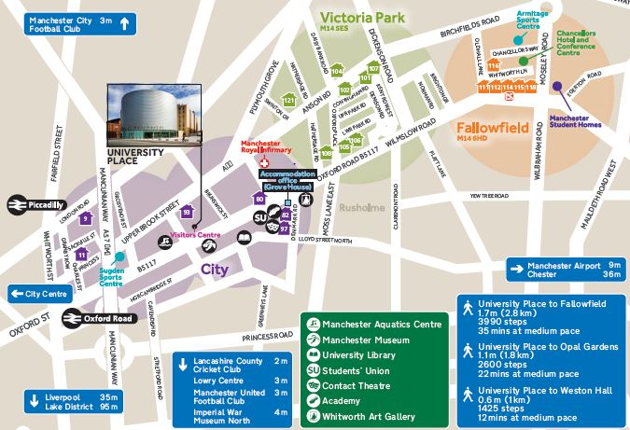
Whitworth Park
(Building 82)
rosvenor Halls
(Standard
Accommodation)

Location of the hall of residence can be viewed using Google Maps
In enquiry box, enter MANCHESTER M13 9WJ for the UNITED KINGDOM and press FIND.
To get directions from the hall to the University of Manchester, use post code MANCHESTER M13 9PL.

KEY COLLECTION
Check in is available after 10am on the scheduled date of arrival. The hall reception is open from 9am to 5pm Monday to Friday (excluding bank holidays).

OUT OF HOURS KEY COLLECTION
Students arriving out of hours must follow the instructions advertised at reception to collect keys. All students collecting keys will require a mobile telephone to contact the out of hours team – number advertised at reception.

ARRIVING IN HALL
Whitworth Park is based on the City Campus. The entrance is directly off the main road. Please go straight to the Reception to collect your room keys.

PROOF OF BOOKING
Please ensure that you bring a copy of the email received at the time of booking for your proof of booking.

BY ROAD Whitworth Park is situated on Oxford Road within sight of the Mancunian Way (A57M) which links into the M56, M6, M60 (Manchester Orbital Motorway), M61, M62, M66, M67 and M602 Motorways. From the A57M, follow the signs for the University of Manchester. Please note that there is no parking on site.

BY AIR Manchester International Airport is 12 km to the south of the city. Taxis cost around £30 - £35 from International Arrivals to the hall. There is also an express Rail Shuttle running every 10 minutes or so from the Airport Station to Piccadilly Station. Taxis are cheap and available from Piccadilly to Whitworth Park Residence. A bus runs from Oxford Road to the airport.

BY COACH
Whitworth Park is a 25 minute walk from Manchester International Express Coach terminal on Chorlton Street. Taxis are cheap and available from the bust station to Whitworth Park Residence.

BY RAIL Piccadilly main line station is approximately 2 mile away from Whitworth Park Residence.
National Rail Enquiries: 08457 484950, National Rail Enquiries from overseas (Please note: International rates apply): +44(0)20 7278 5240 or web link: http://www.nationalrail.co.uk/contact

Whitworth Park, University of Manchester, 316 Oxford Road, Manchester, M13 9WJ
Telephone +44 161 275 4950
Email: accommodation@manchester.ac.uk

