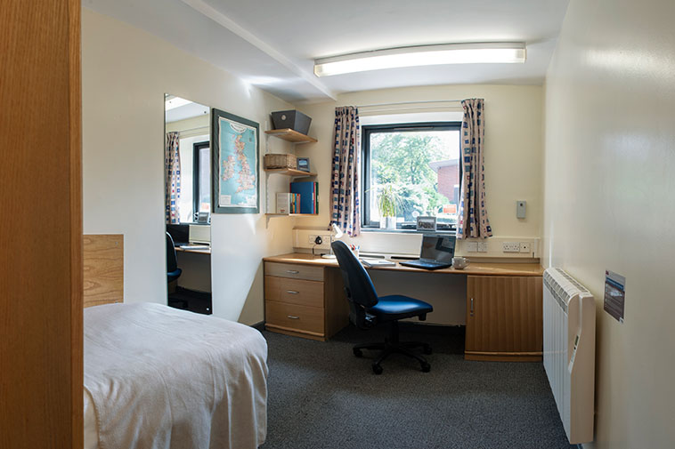

BURKHARDT HOUSE - VICTORIA PARK
En-suite Self-Catering Accommodation - £185.50 per week, per person
Location | Victoria Park Campus
Bedroom | Single bedded room
 | Wardrobe
 | Desk and chair
 | Ethernet Computer Point
Bathroom Facilities | Within bedroom includes shower, washbasin and toilet. Toilet tissue not provided.
Flats/Corridors | Approx. 10 bedrooms share one flat. Single and mix gender flats.
Kitchen/Lounge | Approx. 10 bedrooms share kitchen / lounge facilities.
Kitchen | Cooker x 1
 | Fridge / Freezer x 1
 | Microwave x 1
 | Kettle x 1
 | Iron and Ironing Board x 1
Kitchen Packs | Includes:1 tea towel, 1 dinner plate, 1 side plate, 1 bowl, 1 fork, 1 knife, 1 dessert spoon, 1 teaspoon, 1 plastic tumbler, 1 mug, 1 pan, 1 sharp knife, 1 wok, 1 tin opener, 1 chopping board.
Bedding | A Bedding Pack is provided and includes a duvet, a duvet cover, a pillow, a pillowcase and a sheet. Residents wash their own bedding during the period of stay. Towels and toiletries are not provided. Bedding packs are free and students are advised to take it with them at the end of their stay. .
Cleaning | Kitchens/lounge and communal areas typically cleaned twice weekly. Bedrooms, kitchen pots/pans must be cleaned by residents. Residents are also responsible for removing rubbish and recycling to appropriate receptacles outside the accommodation blocks.
Arrival | We do not require you to inform us of your expected arrival time unless you are arriving out of normal office hours. Office hours are Monday to Friday, 9am to 5pm or if you are arriving later than your booked arrival date.  Further details regarding arrival will be sent to students prior to arrival.
ResLife Team | Available outside of office hours seven days a week. Contact details for ResLife Team will be given to you on arrival and can also be found in your bedroom pack.
Internet / Wi-Fi | All bedrooms have access to extensive Wi-Fi coverage.
Hall Administration Office | Reception Situated in Hulme Hall and is open 9am to 5pm Monday – Friday
Laundry | The laundrette is located on the ground floor of Oaklands block. Guests must download the app in order to use the machines. Information on ow to download the app will be available in your bedroom pack on arrival
Sport Facilities  Maintenance | Please see sport facilities at the University of Manchester.  The halls will be carrying out building maintenance during the summer. The University will endeavour to cause at least disruption as possible to guests. All Workers will carry a form of Identification.

Booking Dates and Fees

Course Code | Room  Available  From | Room  Available  To** | Weeks | En-suite  Self-catering  Price
PS10 | Saturday 29 June 2024 | Saturday 7 September 2024 | 10 | £1855.00
PS6 | Saturday 27th July 2024 | Saturday 7 September 2024 | 6 | £1113.00
PS4 | Saturday 10th August 2024 | Saturday 7 September 2024 | 4 | £742.00

**PLEASE NOTE THAT ROOMS MUST BE VACATED BY 10:00HRS ON THE DATES SHOWN ABOVE**

All students are advised to read and understand the Terms and Conditions 2024 before making a booking.

Summer hall accommodation is not guaranteed and therefore students should apply for accommodation as early as possible. Where accommodation cannot be arranged through UCAE, students are asked to make their own arrangements.

Location of the University, Halls of Residences and City of Manchester can be viewed here.
University Accommodation Map

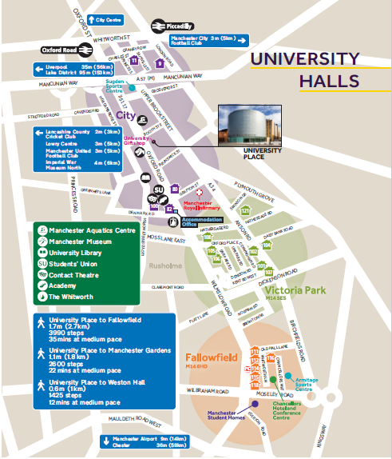
UCAE
Samuel Alexander
Building (67 not shown)
Sheavyn House
En-Suite Accommodation (112)

