Whitworth Park – CITY
Standard Self-Catering Accommodation - £154.00 per week, per person
Location | City Residences
Bedroom | Single bedded room
 | Wardrobe
 | Desk and chair
Bathroom  Facilities | 7 - 9 bedrooms share 2 shower rooms, 2 toilets and approximately 4 wash basins.
Flats/Corridors | 7 - 9 bedrooms share one flat. Single and mix gender flats.
Kitchen/Lounge | 7 – 9 bedrooms share kitchen / lounge facilities.
Kitchen | Cooker x 1
 | Fridge/Freezer x 1
 | Microwave x 1
Kettle x 1
Iron & Ironing Board x 1

Residents must supply their own kitchen utensils, cutlery, crockery, pots and pans.

Bedding | Residents must supply their own bedding and take it with them upon departure. Bedding Packs can be purchased from Unikitout UniKitOut - #1 Student Pack supplier Trusted by over 250 Universities. Get a 10% discount code by using: KITMEOUT.
Cleaning | Kitchens/lounge and communal areas typically cleaned twice weekly. Bedrooms, kitchen pots/pans must be cleaned by residents. Residents are also responsible for removing rubbish and recycling to appropriate receptacles outside the accommodation blocks.
Hall Reception/  Administration Office | Reception Situated in Grove House (within the Whitworth Park complex) and is open 8an to 6pm Monday – Friday

Arrival: | We do not require you to inform us of your expected arrival time unless you are arriving out of normal office hours. Office hours which are Monday to Friday 9am to 5pm or if you are arriving later than your booked arrival date.  Further details regarding arrival will be sent to students prior to arrival.
ResLife Team (pastoral care) | Available outside of office hours seven days a week. Contact details for ResLife Team will be given to you on arrival and can also be found in your bedroom packs
Internet / Wi-Fi | All bedrooms have access extensive Wi-Fi coverage in Hall.
Communal Lounge: | Communal areas available within flats.
Laundry | The Laundrette is located in Grove House. Guests must download the app to use the machines. Information on how to download the app will be available in the bedroom pack issued on arrival.
Computer Cluster | Located in Grove House.
Sport Facilities | Please see sport facilities at the University of Manchester.
Hall Maintenance: | The halls will be carrying out building maintenance during the summer. The University will endeavour to cause at least disruption as possible to guests. All Workers will carry a form of Identification

Booking Dates and Fees

Course Code | Room  Available  From | Room  Available  To** | Weeks | Standard  Self-catering  Price
PS10 | Saturday 28 June 2025 | Saturday 6 September 2025 | 10 | £1540.00
PS6 | Saturday 26 July 2025 | Saturday 6 September 2025 | 6 | £924.00
PS4 | Saturday 9 August 2025 | Saturday 6 September 2025 | 4 | £616.00
ESP | Saturday before course start date | Saturday after course  finish date |  | £154.00 x ….... weeks = £ ……..

**PLEASE NOTE THAT ROOMS MUST BE VACATED BY 0900HRS ON THE DATES SHOWN ABOVE**

All students are advised to read and understand the Terms and Conditions 2024 before making a booking.

Summer hall accommodation is not guaranteed and therefore students should apply for accommodation as early as possible. Where accommodation cannot be arranged through UCAE, students are asked to make their own arrangements.

Location of the University, Halls of Residences and City of Manchester can be viewed here.

University Accommodation Map

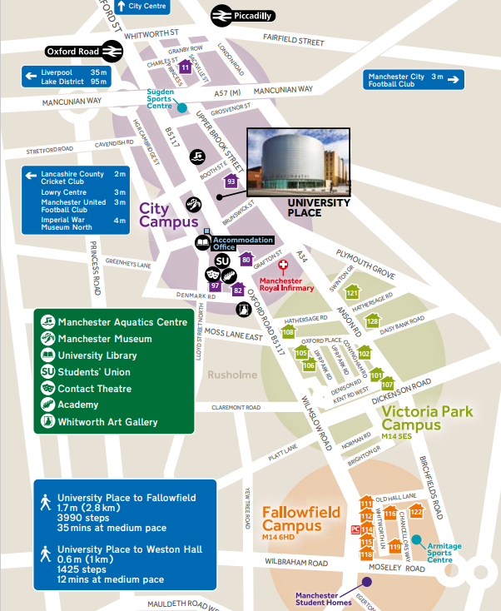
Whitworth Park Halls
Standard
Accommodation (82)
UCAE
Samuel Alexander
Building (67 not shown)

