

Black, Asian and Minority Ethnic (BAME) Staff Network Group: Nomination for co-chair
Name:
Position:
Please detail what skills and experience you can bring to the role and how you would lead the Network forward (200 words max)

Deadline for return of nomination form is 5pm on Friday 23rd February 2024

Please return your nomination form by pdf email attachment to:

Banji Adewumi
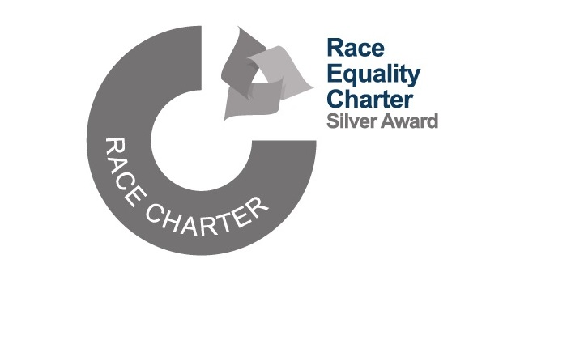
Director of Equality, Diversity and Inclusion
banji.adewumi@manchester.ac.uk

