From: Equality And Diversity <equalityanddiversity@manchester.ac.uk>
Sent: Thursday, January 18, 2024 3:29 PM
To: DISABLED-STAFF@listserv.manchester.ac.uk
Subject: [DISABLED-STAFF] Staff Network Group Digest: January 2024

Welcome to the first SNG Diest of 2024! We hope you have all had a great start to the year 😊
We certainly have with the launch of our new look intranet pages. You can take a look here: https://www.staffnet.manchester.ac.uk/equality-diversity-inclusion/

There’s already plenty more to tell you, so keep reading!

Diversity Calendar 2024

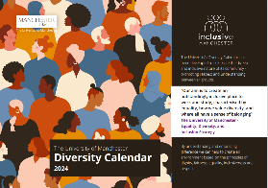
Our calendar is now available! We had some delays, but we wanted to make sure we had the most up to date info available for you all. Hard copies will be available soon. If you would like one (and don’t think you are on our distribution list) please drop a message to:
equalityanddiversity@manchester.ac.uk

Staff Network Group Day – SAVE THE DATE

Mark Wednesday 8th May in your diaries for National Staff Network Groups Day.

This is always a great time to meet other members, talk to other networks and learn from each other.

We’re already planning activities and more details will be released soon – so keep an eye on the digest next month.

If you’d like to find out more you can visit this page: https://www.nationaldayforstaffnetworks.co.uk/

Or take a look at 2023 events: StaffNet Article May 2023

LGBT+ History Month

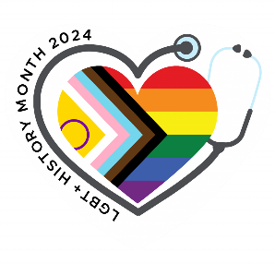
Once again we will mark LGBT+ History Month throughout February.
An exciting programme of events is already planned with film screenings, special guest speakers, training opportunities and of course social events.
You can already book on the Lunch and Learn for Sexual Orientation Data on Monday 26th February: https://app.manchester.ac.uk/TSLD2023

Look out for the full timetable here: https://www.staffnet.manchester.ac.uk/equality-diversity-inclusion/news/

It’s Election Time


With some changes in personnel, we will soon be launching elections for both ALLOUT and the BAME Network to join the current co-chairs.
To bring everything in line we will be looking to appoint two new co-chairs to each group – one from PS and one from our academic staff.
Details will soon be on StaffNet, with a detailed timeline and voting process – whilst positions are open to everyone we’d really encourage academics/PGRs to consider these roles so we have amplified voices on the groups.

Multifaith Survey


We’d appreciate everyone’s input into a short survey which will inform our new Multifaith Strategy.

https://www.qualtrics.manchester.ac.uk/jfe/form/SV_bjipVde8y3IBG86

The survey will be open until noon on Monday 12th February.

Future Leaders


In early February the 2024 recruitment round for the PS Future Leaders graduate development programme will be launched.

Future Leaders is a 3-year structured development programme for graduates who wish to develop their career at the University within the Professional Services (PS) team. The scheme is open to candidates who graduated from The University of Manchester in the past 2 years, and to current employees of the University who graduated from any institution within the past 2 years. (minimum 2:2 in each case)

We welcome applications from people of all backgrounds, especially those from under-represented groups.

For more information, please see visit the Future Leaders website - Future Leaders | The University of Manchester, which will continue to be updated as we approach the ‘go live’ date for 2024 applications.

Manchester Access Programme

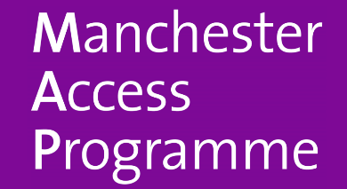
A message from the MAP Team:
We are currently recruiting new tutors for the Manchester Access Programme (MAP), the university’s flagship post-16 widening access scheme. If you are an academic member of staff or a PhD student and are highly motivated to support young people from backgrounds underrepresented at universities such as Manchester, we would love to hear from you!

Please see the following article on Staffnet, which includes a link to the application form and further details about the role.

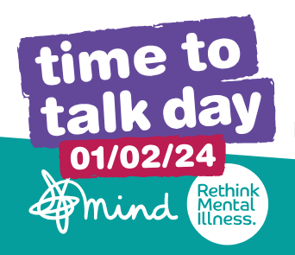
Time to Talk Day, Thursday 1st February

The University will be supporting Time to Talk Day Thursday 1st February as part of the Wellbeing Team ‘Starting Wellbeing in 2024’ campaign. This brilliant campaign is the nation’s biggest mental health conversation encouraging families, friends, and communities to have more conversations and most importantly more conversations about mental health.

We are asking colleagues across the university to take some time over the coming weeks to have more conversations. This can be a 1:1 with a fellow colleague checking in after the festive break, or it can be bringing together the team to check-in with each other and get talking.

Time to Talk Day have lots of super resources available to help support, promote and host a conversation event.

That’s everything for January – if you have anything you would like featured in the February edition, please send to equalityanddiversity@manchester.ac.uk by Monday 19th February.

G.035, John Owens Building, The University of Manchester, Oxford Road, Manchester M13 9PL
Find out more about the team:
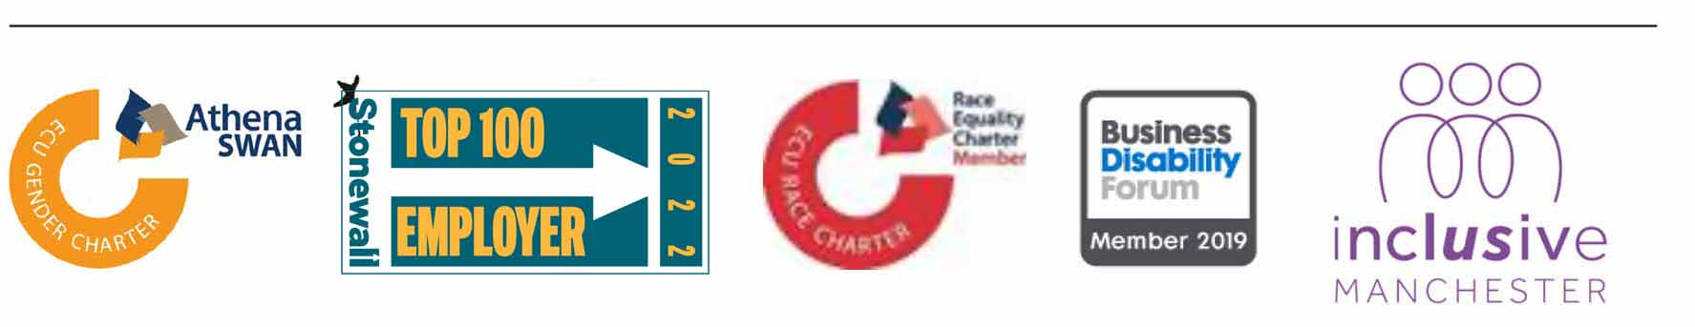

This month, our Diversity Calendar focuses on the University’s Bi-Centennial Anniversary. We are celebrating 200 years of change with a variety of events taking place throughout the year. Staff, students, alumni, local residents and our wider, global community are all welcome to attend. You can visit the Bi-Centennial webpage for more information.

