From: Climate Network <climatenetwork@manchester.ac.uk>
Sent: Monday, January 8, 2024 2:43 AM
To: CLIMATE-NETWORK@listserv.manchester.ac.uk
Subject: [CLIMATE-NETWORK] Newsletter

Hi everyone, welcome back – we hope 2024 is going to be a great year! J

UoM Climate Network

Our recorded talks are now available on our YouTube channel.

UoM Events

Natural Cultural Health Service
The Whitworth
A range of nature-based activities at varying times
https://www.whitworth.manchester.ac.uk/getinvolved/nchs/

Climate Cafés
Manchester Museum
In-person events running every 2 months from 4 Oct 2023 onwards – 17:30 - 19:00
https://www.eventbrite.com/e/climate-cafes-tickets-520550379197

Digital Humanities Seminar: James Baker, 'Data Environmentalism'
School of Arts, Languages and Cultures
24 Jan 2024 – 13:00 - 14:00
https://events.manchester.ac.uk/event/event:l2ah-loybvwiz-ddghyx

Never let a crisis go to waste: Speculation, rent-seeking and rent-extraction in the food sector
Global Development Institute
25 Jan 2024 – 13:00 - 14:00
https://events.manchester.ac.uk/event/event:j2gy-lqduemhx-ilejyd

“LEAF (labs) and ES-related projects (education)” and “Embedding sustainability into project delivery capabilities in government”
Sustainable Futures
25 Jan 2024 – 14:00 - 15:00
https://www.eventbrite.co.uk/e/sustainable-futures-january-2024-seminar-series-tickets-763340049637

Climate Café
Department of Public Health, UoM
26 Jan 2024 – 12:00 - 13:00
https://www.eventbrite.co.uk/e/climate-cafe-tickets-725978610567

PAID EVENT: “More than a Foul Drain”: A Historical Walking Tour of Manchester's Water
Elemental Tours (previously via School of Arts, Languages and Cultures)
26 Jan & 24 Feb 2024 – 13:00 - 15:00
https://www.eventbrite.co.uk/e/more-than-a-foul-drain-a-historical-walking-tour-of-manchesters-water-tickets-752208845907
https://www.eventbrite.co.uk/e/more-than-a-foul-drain-a-historical-walking-tour-of-manchesters-water-tickets-752208875997

PAID EVENT: “If Stones Could Talk”: A Historical Walking Tour of Manchester's Stone
Elemental Tours (previously via School of Arts, Languages and Cultures)
27 Jan & 23 Feb 2024 – 13:00 - 15:00
https://www.eventbrite.co.uk/e/if-stones-could-talk-a-historical-walking-tour-of-manchesters-stone-tickets-752207752637
https://www.eventbrite.co.uk/e/if-stones-could-talk-a-historical-walking-tour-of-manchesters-stone-tickets-752207842907

The Albatross Lecture 2024: Professor Mark Miodownik
Sustainable Futures
30 Jan 2024 – 11:00 - 14:00
https://events.manchester.ac.uk/event/event:n28f-loipdiqp-5jxzp7

Only For UoM Early Career Researchers: Creative Qualitative Methods for Researching Environmental Sustainability
Sustainable Futures
23 Feb 2024 – 12:00 - 13:00
https://www.eventbrite.co.uk/e/creative-qualitative-methods-for-researching-environmental-sustainability-tickets-769805578207

Low carbon Chinatown
Sustainable Futures
4 Mar 2024 – 18:00 - 19:00
https://events.manchester.ac.uk/event/event:z2ff-lq1019z4-b7wwix

• UoM Earth and Environmental Science PhD student Kaydee Barker and environmentalist Cody Sanford have co-created the Livable Future Podcast focussed around current global challenges and how we can work together to create a more liveable future.

• For any sustainable actions you carry out as a staff or student member, you can log them via 50,000 actions webpage can be accessed here.

• UoM’s Environmental Sustainability Team has launched a new environmental sustainability strategy (2023-2028); the update is provided here.

• Harriet Bickley has created an Easy Everyday Eco Actions booklet full of practical info to help UoM staff & students live, work & study in a more eco-friendly manner.

• Pooja Kishinani and Marion Smith, students at The University of Manchester, have created a Student Guide to the Climate Crisis centred around three themes: the emotions, basic information, and activist advice of climate change.

• Want Not Waste have recorded their various environmental talks, which you can view on their YouTube channel.

Greater Manchester Events

Fossil Free Greater Manchester campaign meeting
Fossil Free Greater Manchester
Online meeting on 2nd and 4th Monday of every month – 18:30 - 20:00
https://www.manchesterfoe.org.uk/events/event/fossil-free-greater-manchester-campaign-meeting-39/

Manchester Extinction Rebellion Groups meeting
XR Manchester
In-person meeting on 2nd Monday of every month – 19:00 - 20:30
https://www.manchesterfoe.org.uk/events/event/manchester-extinction-rebellion-groups-meeting/

Olinda Community Garden volunteering morning
Olinda Community Gardens
Every Tuesday (for the foreseeable future) – 10:00 - 12:30
http://www.manchesterfoe.org.uk/events/event/olinda-community-garden-volunteering-morning/

EcoHome Lab: Monthly meetup and skill share
EcoHome Lab
Online meeting on 2nd Thursday of every month – 18:00 - 19:30
https://www.manchesterfoe.org.uk/events/event/ecohome-lab-monthly-meetup-and-skill-share-13/

Levenshulme Repair Café
Levenshulme Repair Café
Third Saturday of every month (for the foreseeable future) starting 20 Jan 2024 – 10:00 - 12:00
https://www.manchesterfoe.org.uk/events/event/levenshulme-repair-cafe-6/

Gardening and Clean Up
Olinda Community Gardens
First Sunday of every month (for the foreseeable future) starting 1 Jan 2023 – 10:30 - 13:30
https://www.manchesterfoe.org.uk/events/event/gardening-and-clean-up-2/

Peer Support Group
Climate Conversations
In-person meeting every fortnight from 4 May 2023 onwards – 19:00 - 21:00
https://www.manchesterfoe.org.uk/events/event/climate-conversations-peer-support-group/

Birchfield Park Forest Garden work session
Birchfields Park Wildlife and Biodiversity Group
Various Days @ Various Times
https://www.manchesterfoe.org.uk/events/event/birchfield-park-forest-garden-work-session/

Tree Planting day
Ardwick Climate Action + Sow the City
9 Jan 2024 – 09:45 - 12:00
https://www.manchesterfoe.org.uk/events/event/tree-planting-day-ardwick-climate-action/

Hedgehog Friendly litter picks
Salford Ranger Team and the University of Salford Environment & Sustainability Team
16 Jan 2024 – 12:00 - 13:00
https://www.manchesterfoe.org.uk/events/event/hedgehog-friendly-litter-picks-peel-park/

Fruit Tree Planting, Crowcroft Park, Manchester
The Orchard Project and SNUG
17 Jan 2024 – 11:00 - 14:00
https://www.manchesterfoe.org.uk/events/event/fruit-tree-planting-crowcroft-park-manchester-orchard-project-and-snug/

Manchester - People, Planet, Pint: Better Business Summit Afterparty!
Small99
18 Jan 2024 – 17:00 - 21:00
https://www.eventbrite.co.uk/e/manchester-people-planet-pint-better-business-summit-afterparty-tickets-789432051517

PAID EVENT: How can we make our cities greener? Andy Burnham on transforming Manchester
The Manchester Literary and Philosophical Society
18 Jan 2024 – 18:30 - 20:00
https://www.manlitphil.ac.uk/events/how-can-we-make-our-cities-greener-andy-burnham-on-transforming-manchester/

“From Letterboxes to Lofts”: A free information event about retrofitting your home.
People Place Planet - Didsbury
18 Jan 2024 – 19:00 - 20:30
https://www.eventbrite.com/e/from-letterboxes-to-lofts-tickets-764877417947

Annual Wassail celebration (Grass Roots Community Orchard)
Northern Lily CIC
20 Jan 2024 – 12:00 - 14:00
https://www.manchesterfoe.org.uk/events/event/annual-wassail-celebration/

• There are a number of ways that you can recycle single-use plastics both within Manchester and further afield:

(1) Co-op have been running a soft plastics recycling scheme for plastic bags and product wrapping (plastics that can be scrunched and that ‘ping’ back) at their stores. As an aside, yet still very much relevant to sustainability, Co-op are also helping to expand Hubbub’s Community Fridge Network, a programme that can potentially tackle a number of societal ills, including: food waste, food poverty, and social isolation.

(2) Stockport-based Plastic Shed have reignited their collections of specific types of plastic lids, soft stretchy plastic packaging, vinyl banners, straws, and plant pots to creatively recycle and repurpose them into useful items; they particularly need your plastic donations between Oct 2023 – Feb 2024 in order to build a sculpture after receiving funding via UK SPF. They also hold workshops and act as a community space; they share their Merseyway Workshop with a community-focussed design studio called Easy Peel Studios, who also run their own events too.

(3) An organisation called ReFactory (previously ReWorked) have partnered with a number of organisations, including Boots, to promote better recycling practices in the UK. A number of recycled household products can be purchased from their online shop, as well as a wide range of recycling boxes for a variety of plastic waste, such as for lateral flow tests, face masks, disposable gloves, visors etc. (starting at £72 per box).

• Manchester Climate Change Agency recommend 15 actions to take to become a zero carbon city

Other Events

Heading for Extinction (and what to do about it)
Extinction Rebellion
Online meeting on 2nd Wednesday of every month – 19:00 - 20:30
https://www.manchesterfoe.org.uk/events/event/heading-for-extinction-and-what-to-do-about-it-extinction-rebellion-2/

Sharing our stories: campaigning on air pollution
Friends of the Earth
11 Jan 2024 – 19:00 - 20:15
https://www.manchesterfoe.org.uk/events/event/sharing-our-stories-campaigning-on-air-pollution-friends-of-the-earth/

Demystifying green heating webinar
Green Economy
16 Jan 2024 – 12:00 - 13:00
https://www.manchesterfoe.org.uk/events/event/demystifying-green-heating-webinar-green-economy/

Health and Nature with Royal Botanic Gardens, Kew
5x15
22 Jan 2024 - 18:30 - 19:30
https://www.eventbrite.co.uk/e/5x15-on-health-and-nature-with-royal-botanic-gardens-kew-tickets-763457420697

Reflections on COP28: Talking the talk or walking the walk?
Grantham Centre for Sustainable Futures
6 Feb 2024 - 13:00 - 16:00
https://www.eventbrite.co.uk/e/reflections-on-cop28-talking-the-talk-or-walking-the-walk-tickets-778405430597

PAID EVENT: What are you drinking? A look at chemicals in the urban water cycle (Dr. Leon Barron)
The Manchester Literary and Philosophical Society
6 Feb 2024 – 18:30 - 19:45
https://www.manlitphil.ac.uk/events/what-are-you-drinking-a-look-at-chemicals-in-the-urban-water-cycle/

PAID EVENT: Plastic Ocean (Mandy Barker)
The Manchester Literary and Philosophical Society
19 Feb 2024 – 18:30 - 19:45
https://www.manlitphil.ac.uk/events/plastic-ocean/

• Dr. Emily Heath of Scientists for Global Responsibility has shared 9 tips to encourage a culture of climate activism in universities.

• In Spring 2022, the Department for Education (DfE) released a new policy paper entitled ‘Sustainability and climate change: a strategy for the education and children’s services systems’, setting out key goals such as the introduction of a Natural History GCSE, a National Education Nature Park (NENP), a Climate Leaders Award (CLA), and a National Climate Education Action Plan (NCEAP). MMU are champions of the NENP and CLA, whereas The University of Reading will lead the implementation of the NCEAP.

• UCL’s Generation One collective have created their own Climate Podcast.

• The new Sustainable Futures careers course, aimed at providing teaching professionals with content suitable for a teenage audience (14-18y.o.), has been developed by WWF-UK in an attempt to bolster the next generation with a greater awareness of sustainability as they decide upon their future careers.

• Kudos, an online tool for improving research impact, created a climate change knowledge cooperative to aid the sharing of the latest climate change research in a non-technical / comprehensible format.

• A better future for our woodlands: 12 ideas to help British forests grow

• The WeAre8 app can be downloaded on smartphones – launched in 2020, it became the world's first B corp-certified social media ecosystem, built to transform the digital advertising sector and address the broken and divisive state of the social media industry. The app’s purpose is to make a big impact through small daily actions; you can earn rewards for watching videos that support social and environmental causes.

• Skoot is no longer the app it used to be (which allowed you to plant free trees for every car journey), its model changed after it succeeded in its ‘1 million free tree challenge’, it is now an award-winning climate change platform dedicated to helping its subscribers – both businesses and individuals – to reducing their carbon footprints through a variety of off-setting methods.

• Downloading the Treekly app on a smartphone allows you to plant 1 tree each week for free (seemingly in Madagascar); by tracking your footsteps, using either your phone’s built-in pedometer or a fitness tracker/smartwatch, you can convert your 25,000 steps per week [5,000 each day for 5 days] into the planting of a tree.

• Downloading the TreeApp app on a smartphone allows you to plant a tree for free, in an area that it’s needed e.g. often in the Global South but now also in the UK, every single day (and now there’s no daily limit). Also, if you own land (or know of potentially suitable land) for tree planting? Fill in this form and let the people behind TreeApp know.

• AllotMe – originally marketed as the ‘Airbnb for your Garden’ sounds like a great concept – whereby individuals can rent green spaces to grow food within major cities/urban environments, and garden owners can monetise their land (although many garden spaces appear to be free to use).

• Spare 3 minutes to fill in Currensea’s Sustainability survey and each completed survey removes 100 plastic bottles from the oceans (thanks to their Plastic Bank partnership).

• A CO2 widget created to communicate daily levels of CO2 by Matthew Shribman, his colleagues, and University of Cambridge / Cambridge Zero. There is also the Climate Action Tracker (CAT) that can be used to keep track of global climate action.

• Some suggested climate actions have been listed by Ecologi on their It’s Time website.

• Really useful links to organisations who are promoting circular economy initiatives; besides many organisations will now offer their own in-house recycling schemes, as is the case for Google Devices; yet there are many other organisations, like Music Magpie and Mazuma Mobile, that will pay you for items that you trade in.

• Please take a look at the Students Organising for Sustainability UK (SOS-UK) website as well as two current campaigns they are running:
1. Invest for Change
2. Carbon Targets

Social Media

You can now connect to the Climate Network on:

1. Facebook

2. Yammer

How To Subscribe To Us

Feel free to forward this newsletter on, but also please pay a visit to our website below (where you can subscribe to our mailing list and see a sample of the environmental groups affiliated with UoM):

https://climatenetwork.uk/universityofmanchester/
-------------------------------------------------------------------------------------------------------
Digital Futures – Manchester Prize

Applications for the Manchester Prize are now open, with a deadline of 12:00 GMT on 1st February
2024.

To help to ensure coherence, avoid duplication, and maximise the strength of UoM applications, Digital Futures are operating a light touch process of internal review and support, with senior input via a pan-University panel.

The first Manchester Prize will be awarded to the most innovative and impactful AI solution which demonstrates social benefit by overcoming challenges in the fields of energy, environment, and infrastructure. If you propose to lead on a Manchester Prize application or if you propose to play a substantive role in one please complete the form below by 16:00 on 15th January 2024.

For more information click here: https://www.manchester.ac.uk/discover/news/manchester-prize-digital-futures-expression-of-interest-process-review-deadline-15th-january/

If you have any questions or need anything else from me then please do let me know.

Best wishes

Stan

stanislas.galliers-demetz@manchester.ac.uk | Events, Projects and Communications Support | Research Platforms Team Digital Futures & Sustainable Futures |
The University of Manchester
4.01 IT Building | The University of Manchester
Oxford Road | M13 9PL
-------------------------------------------------------------------------------------------------------
2024 Making a Difference Awards now open for entries and nominations
Entries and nominations are now open for the 2024 Making a Difference Awards until 16th January 2024 (as per the below flyer).

The link to the Awards page is here: https://www.socialresponsibility.manchester.ac.uk/get-involved/awards/

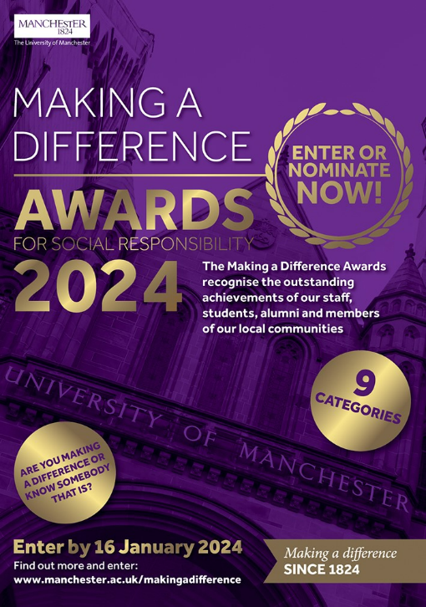

-------------------------------------------------------------------------------------------------------
Can you help to shape/organise community events and would you like to help improve climate change education and upskilling?

Envirolution are looking for volunteers to help their organisation and take their initiatives further over the coming years. If interested, please contact Bob Walley at bwalley1@uclan.ac.uk

Envirolution Cooperative is a Manchester-based community benefit society that has been running annual large-scale, climate change education and community engagement festivals since 2010. These are free to attend, positive, and solution-focused events, which aim to be as inclusive as possible by appealing to the wide and diverse demographic of communities who get involved. Envirolution creates an atmosphere where attendees can learn new skills, meet new people, and explore pro-active responses to the climate emergency which are relevant and appropriate to them.

Everyone is welcome at Envirolution, though the target audience are people who do not currently engage with the challenges of climate change, or are not sure which actions are of the most value. The event has a fun non-judgemental atmosphere, with world music playing from its solar-powered stages, vegan food stalls, games and creative activities for children, talks and interactive workshops, provided by organisations and groups making real and positive change in communities. Attendees can then join groups, volunteer, receive training. This increases employability for local people in the sustainability and green jobs sector and decreases social isolation and loneliness. Around 5,000 people attend the event each year, creating a unique opportunity for workshop providers, speakers, and others to engage audiences they may otherwise find it difficult to access. Envirolution is a colourful, vibrant, fun, inclusive, positive, and safe space for people to learn together how they can respond positively and proactively to the challenges faced by the climate and ecological emergency. The value and impact of Envirolution and the groups events can be seen on their website.
-------------------------------------------------------------------------------------------------------
Would you, or a student you know of, like to help solve the climate issues of today and tomorrow?

The University Living Lab (ULL) provides opportunities for students to undertake sustainability-focussed projects that aim to provide tangible benefits to local and wider society by creating solutions for issues that businesses and other organisations may encounter.

With it being estimated that a quarter of all students at UoM (approx. 10,000) are already studying subjects that are directly related to sustainability, if each of those students dedicated half of their study hours (approx. 750 hours) to a ULL project it would equate to approx. 7,500,000 hours of research towards sustainable solutions to real-life problems. Yet, there are many more areas of study that aren’t directly related to sustainability that could potentially also contribute!

Please take a look at the ULL website to see how you could get involved: https://www.universitylivinglab.org/
-------------------------------------------------------------------------------------------------------
Job Opportunities

- 2 x UoM-based environment/sustainability-focussed research roles:
- Nuclear Compliance Environment Lead [2 years, approx. £36k pro rata], (application deadline = 8 Jan 2024 @ 23:59)
- Research Associate “Sphagnum Moss on the Hills” [15 months, approx. £36k-£44k DOE], (application deadline = 24 Jan 2024 @ 23:59)

- 1 x Climate Risk and Adaptation Specialist, Manchester-based (Fixed Term, application deadline = 31 Jan 2024 @ 23:59; salary unknown) with WSP.

- 1 x Apprentice Data Science Consultant, Manchester-based (salary and application deadline unknown) with Arcadis.

- 1 x Associate Sustainability Consultant, Manchester-based (salary and application deadline unknown) with Buro Happold.
-------------------------------------------------------------------------------------------------------
Volunteering Opportunities

Depending upon what you would like to get involved in, there’s plenty of choice when it comes to eco-volunteering:

• UoM People & Planet are looking for committed students to assist with its campaigning activities, a successful example of which has been its Fossil Free Campaign. They can be contacted via email peopleandplanetmcr@gmail.com and have a Facebook community.

• UoM’s Students’ Union offers a range of options for students to support the local community, including via various sustainability projects (such as those listed by the ‘Student Action’ group): https://manchesterstudentsunion.com/volunteering-and-fundraising

• Plastic Shed in Stockport are looking for marketing assistants, graphic & website designers, photography & filmmaking content creators, business advisors, social & environmental impact analysts, fundraising advisors, volunteer coordinators, shop volunteers, workshop volunteers, and plastic recycling volunteers. If interested, get in touch with Caitlin (Co-Director): caitlin@plasticshed.org

• Cracking Good Food, a not-for-profit social enterprise, are looking for volunteers, mainly around the Stockport area, to help them in their goal to encourage and support more people to cook affordable, seasonal, and nutritious homemade food from scratch.

• The Kindling Trust offers regular hands-on agricultural volunteering at both its Woodbank Community Food Hub (Offerton) and Agroforestry Tree Nursery (Glazebury): https://kindling.org.uk/Calendar?field_event_type_target_id=7

• Manchester Friends of the Earth Manchester can be supported in a number of ways, from campaigning to officer roles – you could join the Young FOE Manchester or help the communications team: https://www.manchesterfoe.org.uk/current-volunteering-opportunities/

• Manchester Greenpeace support Greenpeace campaigns in the local area; there are wide range of activities that they get involved in as a local Greenpeace group.

• City of Trees want to hear from everyone – whether you’re a green guru, an eager novice, or just fancy helping out occasionally at some tree planting or orchard creation: https://www.cityoftrees.org.uk/volunteer

• Sow The City are in regular need of help in a variety of ways, including: constructing or maintaining community gardens and planting fruit and vegetables: https://www.sowthecity.org/jobs%20and%20volunteering.htm

-------------------------------------------------------------------------------------------------------

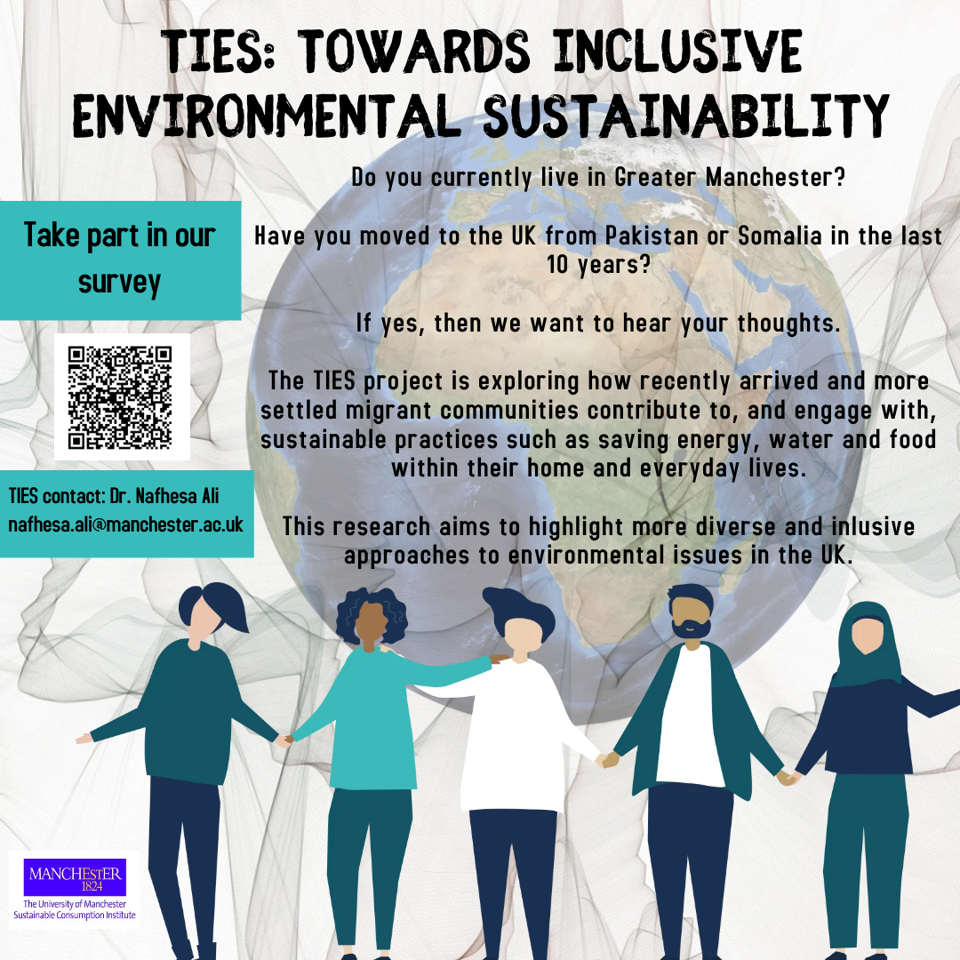

Here’s the link in case the QR doesn’t work (below).
-------------------------------------------------------------------------------------------------------
The Climate and Ecological Emergency (CEE) Bill

118 MPs are now supporting the CEE Bill, tabled by Caroline Lucas MP, across all nations of the UK

Parliament declared a Climate Emergency back in 2019 – but actions haven’t matched their words. An emergency requires strong, decisive action to reverse the climate and ecological crisis … Enter the CEE Bill.

The Bill requires the UK to take responsibility for its fair share of greenhouse gas emissions, to actively restore biodiverse habitats, and to stop damaging our natural world through the production, transportation and disposal of the goods we consume.

You can pledge your support for the CEE Bill as an individual here: https://www.ceebill.uk/sign-up
-------------------------------------------------------------------------------------------------------
The Co-operative Party’s Petition to Ban Bee-Killing Pesticides

Close the loophole on bee-killing pesticides

Earlier this year, when the Government announced it would use a loophole to temporarily allow the “emergency” use of banned bee-killing pesticides by sugar farmers, the Co-operative Party fought until the Government reversed its decision.

The Government has already said they “anticipate” that the emergency authorisations loophole – which allows bee-killing pesticides to be used – may be “needed” again in 2022 and 2023.

Please sign the Co-operative Party’s Petition here to protect our bees: https://party.coop/bees
-------------------------------------------------------------------------------------------------------
The 6R Sustainability Approach

- Follow the 6R protocol to manage plastics sustainably at home and on campus or in the labs

- These UoM videos and texts can answer all your questions about recycling (plastics and other items)

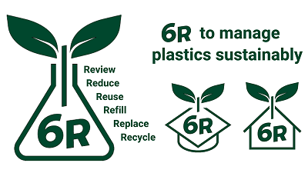

Best wishes

The UoM Climate Network
The CLIMATE-NETWORK list is archived at: http://listserv.manchester.ac.uk/cgi-bin/wa?A0=CLIMATE-NETWORK

