From: Equality And Diversity <equalityanddiversity@manchester.ac.uk>
Sent: Tuesday, October 24, 2023 1:35 PM
To: DISABLED-STAFF@listserv.manchester.ac.uk
Subject: [DISABLED-STAFF] Staff Network Digest: October 2023
PGR Parents Network – Event Tomorrow Wednesday 25th October!

The PGR Parents Network are hosting a fantastic opportunity to get together tomorrow Wednesday 25th October from 9:30am-12pm in the Engineering Building.
With it being primary and secondary school half-term this is a great chance to bring your kids onto campus to experience the Engineering Building’s Makerspace.

Refreshments will be provided just make sure to sign-up here: https://www.eventbrite.co.uk/e/family-science-networking-event-tickets-734271986277?

Black History Month - EDI Lunch and Learn: Diversity in Data

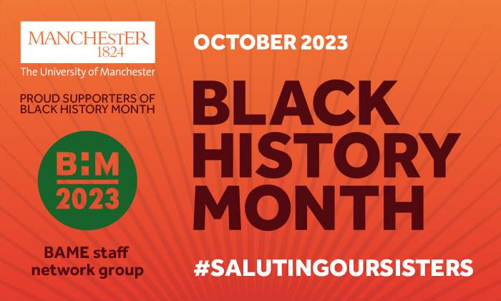
We are repeating the EDI Lunch and Learn: Diversity in Data session as a part of Black History Month, this Thursday 26th October at 12:00. So if there are any colleagues who could not join us earlier in the month then this is your opportunity!
You can sign up for the session through the learning catalogue: https://app.manchester.ac.uk/training/profile.aspx?unitid=10...
The session will be delivered online and lead by Sami Karamalla-Gaiballa, EDI Partner (Data Analyst Lead) and Lauren Stella EDI Data Analyst Assistant.

StellarHE leadership programme - apply before Friday, 24 November 2023


StellarHE is a leadership development programme for Black, Asian, and Ethnically Diverse individuals in higher education. Our University is pleased to support this programme which has been designed specifically to develop and implement leadership strategies that reflect the unique challenges and experiences of Black, Asian, and Ethnically Diverse academic and professional staff across higher education.
Who is eligible? The programme is open to Black, Asian, and Ethnically Diverse PS staff, Academics and Researchers at a middle management level. All applicants should have the support of their Line Manager as their support and involvement will be critical to the programme.
How many places are available? Our University will support eight places in total. These will be for two people per Faculty or Professional Services area and will be funded by the respective Faculty/Professional Services area.
How to apply
- Application forms can be completed via an online form by Friday, 24 November 2023.
- Applicants are also asked to complete the Equality and Diversity monitoring form.
Line Managers are asked to complete the Line Manager Support Form.
Staff Network Relaunch: Age Friendly Network


Everyone has an age. And that's probably why we forget that age is actually a protected characteristic.
As a result, we'd love to resurrect the Age Network. The aim of the Age Network is to have a network that is for everyone, but also that intersects with every other network. We want to build intergenerational friendships for our staff across different departments, and we also want our staff to be able to learn about the experience of others.
So, expect coffee roulette with other members of the network, and expect joint events with the other networks.
To start with we want to understand the interest in this group, so ask you to complete this one question survey:
https://www.qualtrics.manchester.ac.uk/jfe/form/SV_6V7eMtfqxmOfVpY

Parents and Carers Peer Support Group


Following our last lovely catch-ups since the relaunch of the parents and carers peer support group, our next dates our coming up:
Monday 6th November, 12.30pm, Christie's Bistro
Thursday 9th November, 12.30pm, on Teams Click here to join the meeting
These meet-ups are really informal (and optional) but are a nice chance to meet colleagues for a chat and some peer support. We will be sharing a poll to look at dates for December catch-ups, so look out for that on our Teams space – please join if you haven’t done so already: Join the parents and carers peer support group Teams space.
If you would like to help organise future catch-ups, talks or events, please email Francesca.guratsky@manchester.ac.uk

Black British History: Postgraduate Take Over with Olivia Wyatt & Renée Landell - Interested in PhD study? An event for students and staff.


Two exceptional PhD students in Black Studies, Renée Landell and Olivia Wyatt from the University of London will join us to speak about their PhD experience on Tuesday 7th November from 2pm in University Place 6.210. Their presentations will cover how to apply, what it is like and how to be successful as a PhD. Undergraduate and MA students will have the chance to ask questions and talk to Renée and Olivia over coffee and cake to find out more about their experiences of being a PhD student.

Please contact Dr Jack Webb for further information jack.webb@manchester.ac.uk

Academic Staff Opportunity: Deputy Director of the Sustainable Future Platform

The University invites applications from members of academic staff of the University for the position of Deputy Director of the Sustainable Futures Platform. The position is for 3 years in the first instance at 0.3 FTE.
Job description is attached with this email.
Applications: A brief curriculum vitae and a 2 page max. supporting letter outlining how you meet the criteria and your vision for the role. Applications should be emailed to katrina.farrugia@manchester.ac.uk
Interested colleagues are welcome to discuss the position with Professor Mike Shaver, Director of Sustainable Futures, michael.shaver@manchester.ac.uk
Deadline for applications: Friday 10th November 2023

Disability History Month: Guest Lecture – Dr Shani Dhanda

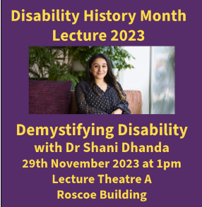
The Directorate of Equality, Diversity and Inclusion at The University of Manchester are excited to welcome Dr Shani Dhanda for our Disability History Month Lecture and networking. This will take place on Wednesday 29th November at 1pm in Roscoe Lecture Theatre A with a light lunch available afterwards in the Roscoe reception. This event will be hybrid and we will have BSL interpreters in attendance.
Dr Dhanda will demystify disability allowing you understand the social model of disability and give you the confidence to talk to your disabled colleagues and students and become their ally. We invite all staff and students who would like to learn more about disability.
Tickets are available here: https://www.ticketsource.co.uk/the-university-of-manchester/demystifying-disability-with-dr-shani-dhanda/2023-11-29/13:00/t-rprrqez

Good Course: Feedback sought


We have been talking to GoodCourse about a training solution focussing on equality, bias, bullying and harassment and would like feedback from all Network Groups.
Using the QR code here, please take a look and let Helen know you thoughts on content, delivery and the ‘so what?’ factor.
Any experiential feedback and views are very welcome. Ideally, responses back in before the end of October please, directly to Helen at:
Helen Ashley helen.ashley@manchester.ac.uk

Other news and upcoming important dates:

October: Black History Month events continue: https://www.staffnet.manchester.ac.uk/news/display/?id=30345
Standing Together Against Hate (support): https://www.staffnet.manchester.ac.uk/news/display/?id=30466
24 October: Dussehra

November: Islamophobia Awareness Month
12 November: Diwali
19 November: International Men’s Day
20 November: Trans Day of Remembrance

That’s all for this month – as always – if you would like anything included here, please let us know: equalityanddiversity@manchester.ac.uk

And just a reminder that if you are on different LISTSERVs you will only receive this message once. Also, if you receive this message to a non UoM account, can you please update to your .manchester.ac.uk account please.

G.035, John Owens Building, The University of Manchester, Oxford Road, Manchester M13 9PL
Find out more about the team:
