PGR Course unit outline 2026-27

Unit code: | BMAN80450 Component Unit
Title: | Introduction to Qualitative Data Analysis using NVivo
Credit value: | Component Unit of 15-credit BMAN80450
Semester: | 2
Course Coordinator name and  contact details: | Dr Aarti Krishnan  aarti.krishnan-2@manchester.ac.uk
Other staff involved contact details: | N/A
Pre-requisites  Co-requisites  Dependent course units  Restrictions | The course is suitable for all PGRs. No previous knowledge of NVivo is required. The course is designed for a complete beginner, but could also be useful for almost-beginners wanting to refresh their skills.
Course unit overview
This course provides an introduction to NVivo (using version 14). The course will provide background understanding as to what NVivo can and cannot do, and its role in assisting qualitative data analysis.

This will be followed by a hands-on overview of NVivo using a sample project, while lecture 3 aims for researchers to develop their own project .

Aims
The course provides PGRs with hands-on experience of using NVivo to support rigorous and transparent qualitative data analysis. Rather than treating NVivo as a methodology or as a substitute for researcher judgement, the course develops students’ ability to connect their research questions, analytical strategies and qualitative evidence with appropriate NVivo tools and workflows.

Across three linked sessions, PGRs will develop confidence in organising and familiarising themselves with qualitative data; coding and developing codebooks; using annotations and analytical memos; constructing cases and classifications; comparing evidence within and across cases; using framework matrices, queries and visualisations; identifying negative or deviant cases; and moving from coded material towards defensible interpretation and explanation. This reflects the course-wide principle that the analytical question should precede the software action, rather than allowing available NVivo functions to determine the analysis.

The course progressively moves from guided analysis of a shared qualitative dataset to the development of students’ own NVivo projects. By the end of the course, PGRs should be able to make informed and justified decisions about how NVivo can support their particular research design, data and analytical approach, while recognising the limitations of software and the continuing importance of interpretation, reflexivity and researcher judgement.

Objectives (Learning outcomes)
On completion of this unit successful students will be able to:
- explain the role, advantages and limitations of NVivo in qualitative analysis;
- distinguish analytical strategy from software technique;
- organise, code and interpret qualitative data using appropriate coding strategies;
- use memos, cases, classifications, matrices and queries to support comparison and analysis;
- critically interpret NVivo outputs, including identifying variation, negative cases and alternative explanations;
- design and justify an NVivo workflow appropriate to their own research question, data and analytical approach;
- document and reflect on key analytical decisions for use in their thesis and wider research.
Syllabus content
The course combines conceptual teaching with guided practical work across three linked sessions.
Lecture 1: Making Sense of Qualitative Evidence introduces NVivo as a tool for supporting qualitative analysis. Students work with different forms of qualitative evidence and develop skills in familiarisation, coding, codebook development, annotations, memoing and initial interpretation.
Lecture 2: From Codes to Comparative Explanation focuses on moving beyond coding to systematic comparison. Students work with cases, classifications, attributes, framework matrices and queries, while considering patterns, variation, negative cases and alternative explanations.
Lecture 3: From Research Question to Analytic Strategy brings the previous sessions together. Students work on their own NVivo project, translating their research question into an appropriate analytical strategy, refining project structure and coding, undertaking a relevant analytical operation, and producing an analytical memo and next-step plan.
Throughout the course, emphasis is placed on using NVivo in a way that is methodologically appropriate, transparent and driven by the research question rather than by the software itself.

Methods of delivery
Lectures/Seminars |  | 9-hours in-person
Independent Study |  | 41 hours (this includes the developmental activity of PGRs following completion of the taught part of this course)
Total Study Hours |  | 50 hours
Reading List
This course is primarily practical in nature. Following an introduction to Nvivo, there will be an emphasis on ‘doing,’ and working with data and the NVivo software package. Additional electronic resources will be recommended alongside the asynchronous lecture material. The following book will be used and is available as an online resource via the UoM library.

- Woolf, N.H. and Silver, C. (2018) Qualitative analysis using NVivo: the five-level QDA method, Routledge (available here)

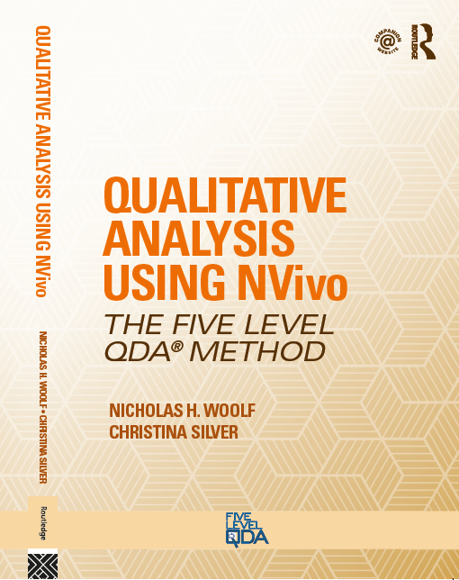

Please also see the reading list (via Canvas) for other recommendations

Assessment
Mode of Assessment | Length required | Weighting within unit
Those PGRs taking this course for assessment are required to write a reflective report about how NVivo could be used for their research project/focus. The nature of this report will differ depending on the stage that individual PGRs are at with their research. This report should incorporate a sense of the opportunities and also the drawbacks or challenges of using NVivo over other approaches to analysis (e.g. paper-based methods).  This assignment is deliberately kept fairly open in order to make it as useful/relevant to your needs as possible. You are encouraged to discuss the precise focus with your PGR supervisor (e.g. you may decide to focus on how NVivo could/will be used as an overall project management tool, or perhaps specifically for your literature review, or for its most common use in organising/analysing qualitative data). | 2000 words (max -no +10%)  This includes all body content of the report but not references | 100%
Resits: Resubmission of the assignment | 2000 words (max -no +10%)  This includes all body content of the report but not references | 100%
Feedback methods
PGRs will receive feedback by peers and the course convenor within the workshop sessions. They will also have opportunities to discuss their projects, with a view to how they will develop their assessed report.
Course participants will receive a link for a course unit evaluation questionnaire after the completion of the course. In addition, PGRs are encouraged to provide feedback through emails and conversations at any time.

Social Responsibility

AMBS aims for our graduates to develop not only academic and professional skills, but also a sense of social, ethical and environmental responsibility towards the societies of which they are part. Please give details of how social responsibility is addressed in your course unit by highlighting any knowledge or skills that support students’ social and ethical understanding and conduct.

This course is focused on the use of software to assist in qualitative data analysis. Used correctly, NVivo can support researchers to develop high quality interpretations that demonstrate transparency in terms of approach and ethical standards, in order to develop responsible research.
The workshops themselves are designed to be inclusive spaces where PGRs can try out ideas in a supportive environment. The assignment guidance takes into account the diversity of projects/analytic approaches that PGRs will be working on, allowing them to tailor their report to their own research which may feature particular SDGs.

 | A UN SDGs* |  | Environmental Sustainability
 | Other (please specify)

The above will vary depending on PGRs own research focus

