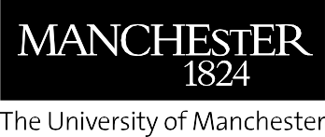

About us
The University of Manchester is recognised globally for its pioneering research, outstanding teaching and learning, and commitment to social responsibility. Part of the Russell Group, we’re ranked 40th in the QS World University Rankings, 2026 (7th in the UK) and 46th in the Academic Ranking of World Universities, 2025.
The power of our social and environmental impact has been recognised on a global scale, ranking number one for progress towards the UN Sustainable Development Goals in the 2026 Times Higher Education (THE) Sustainability Impact Ratings. We are the only university to feature in the top ten every year since they began in 2019, and the only to rank in the top ten in both these ratings and the QS World Sustainability Rankings. Our university is a powerhouse of research and discovery; 26 Nobel laureates are among our former staff and students, and we were ranked fifth for research power – the quality and scale of research and impact – in the Research Excellence Framework (REF), 2021.
Ranked 20th most international university in the world according to THE (2025), our community includes more than 46,000 students, 12,800 staff and 580,000 alumni from
190 countries, working together to tackle the world’s biggest challenges.
We’re one of the most popular institutions in the UK for undergraduate applications, according to UCAS, and were the most targeted university by the UK’s leading employers in 2026 (The Graduate Market).

From the Directorate of Communications,
Marketing and student Recruitment

July 2026
manchester.ac.uk

