


The University of Manchester Campus Biodiversity Project – Using iNaturalist
Contents
How to use iNaturalist: record and identify wildlife 1
Make an Observation: 1
How to upload an observation: 3
How to explore other user’s sightings 10
Identify other users sightings: 14
Need a little more help: 17

How to use iNaturalist: record and identify wildlife
Keen to learn about nature on campus and beyond? Do you want to contribute to science and the conservation of species? To get started, you’ll need to download and create an account on the iNaturalist app (on Google Play or the App Store) or use on the web. It’s free and has a global user base of over one million people.
The app allows you to upload photos and map the locations of the wildlife you see around you. Your observations can then be verified by other users. Equally, you can view and help identify the observations of others.
Once uploaded, your sightings form part of a global database that can be used by scientists to inform the conservation of species.

Make an Observation:
- Seen an animal, plant or fungus you’d like to identify or create a record of?
- Get out your camera and take some photos.
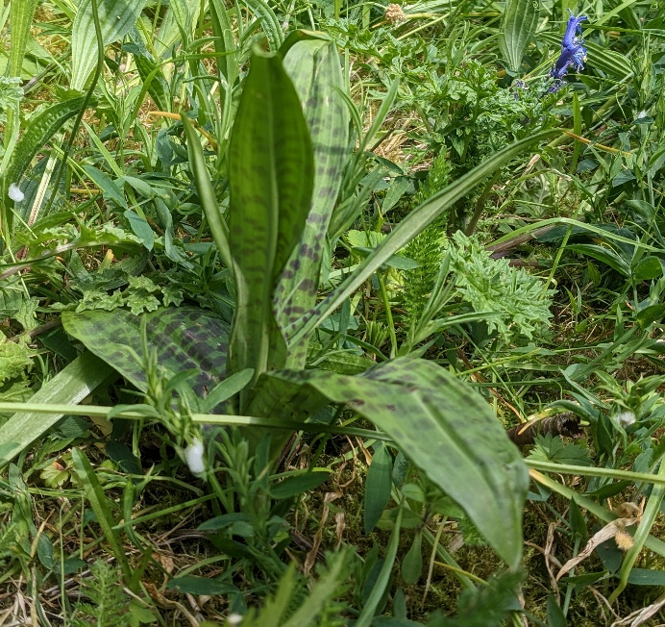
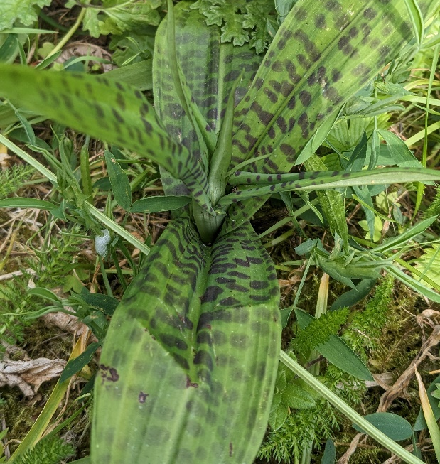
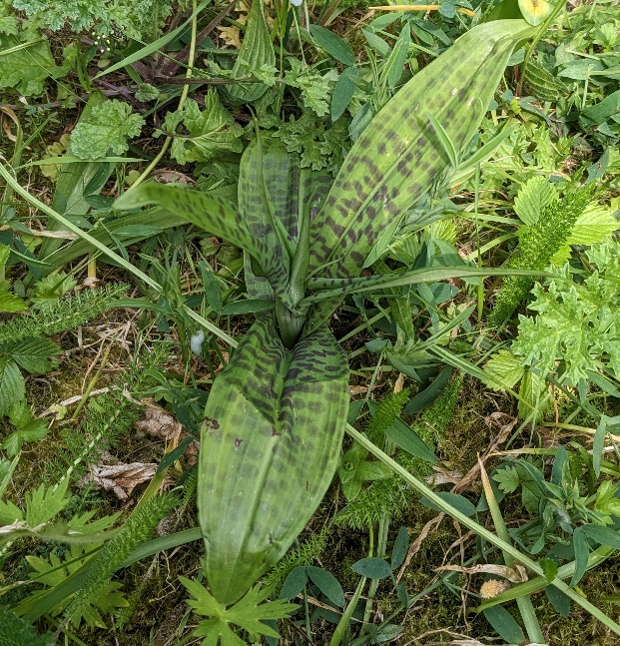
- Make sure to take multiple photos from various angles – this will make it much easier to correctly identify your species. See the example below.
- You are also able to record and upload calls made by animals – try and make sure there is as little background noise as possible.
- If your phone doesn’t do so automatically, make a note of where you have made your observation.

How to upload an observation:
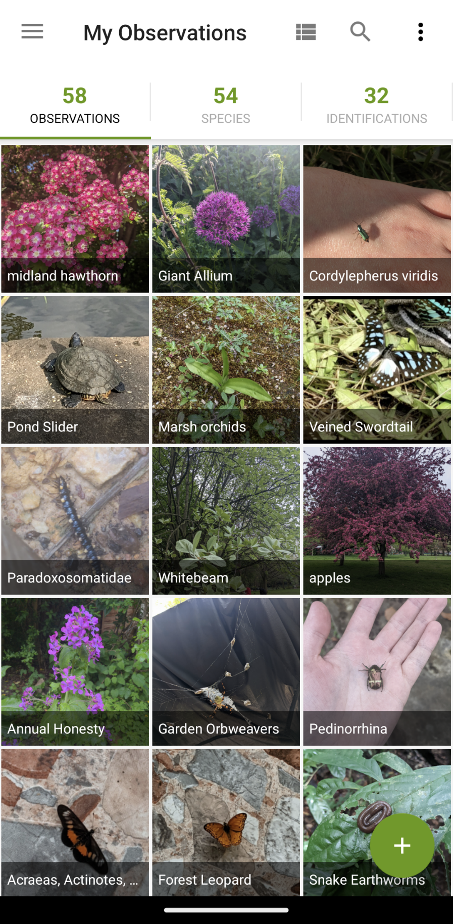
- Tap Observe

- Add your photos as evidence.
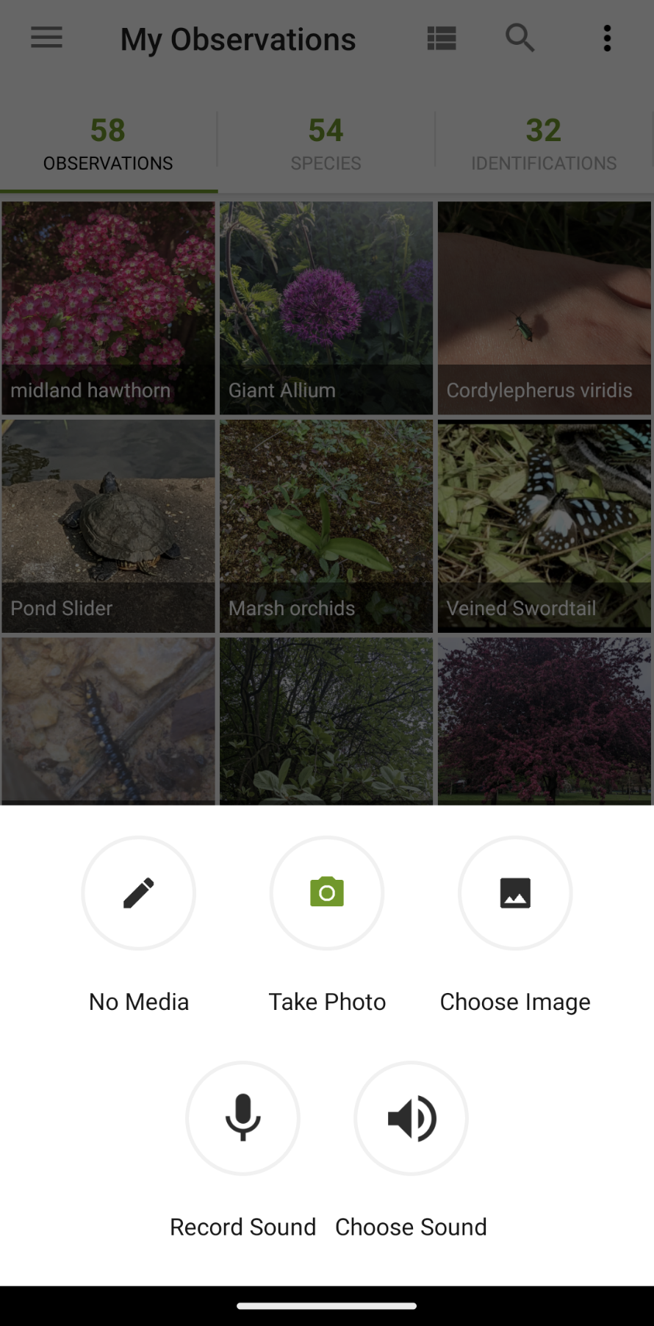

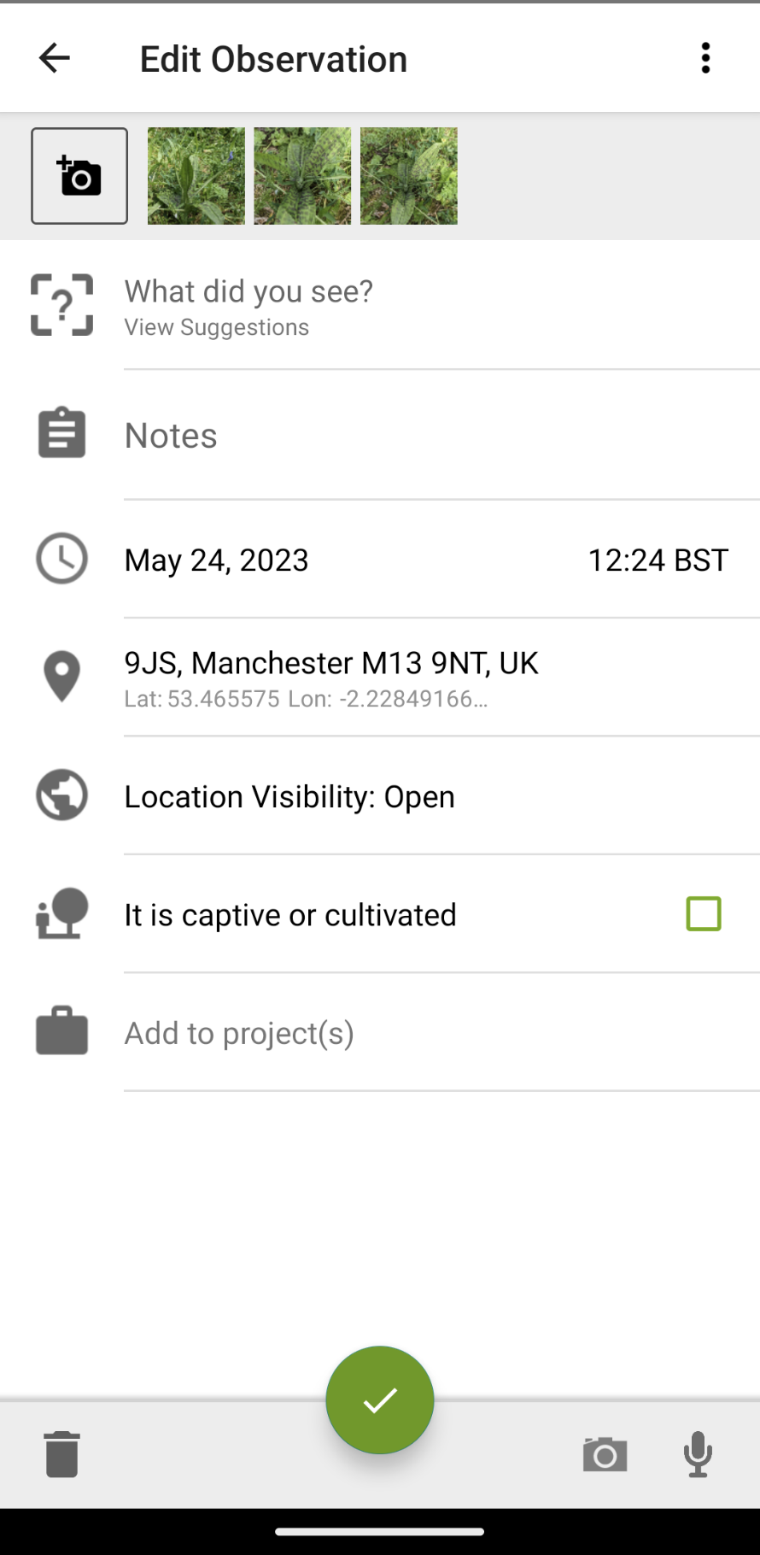
- Press ‘what did you see?’ to choose what you saw. iNaturalist will suggest some species but these aren’t always correct. If you are unsure, it is better to choose a broad descriptor, rather than a specific species.
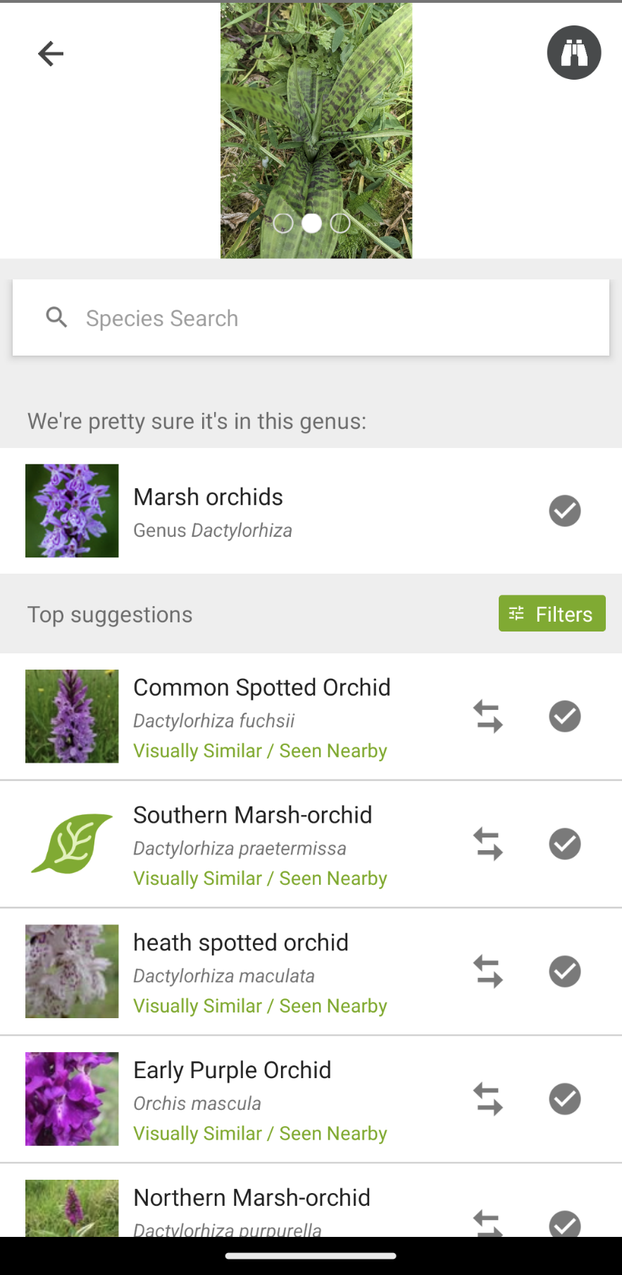
- Using AI, iNaturalist will suggest a visually similar species and highlight those that have already been found nearby. To confirm your species, press the tick symbol. If you want to compare your photos with the photographs of another species, press the ⇆ symbol.
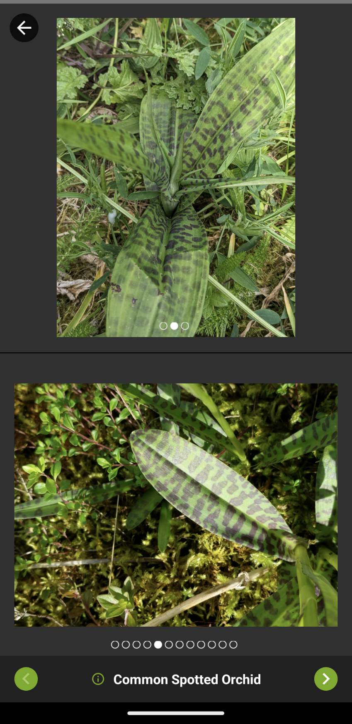
- After comparing, we can see that our species appears very similar to that of the Common Spotted Orchid. We are confident that this species is correct, so we will confirm the Common Spotted Orchid as our species identity.

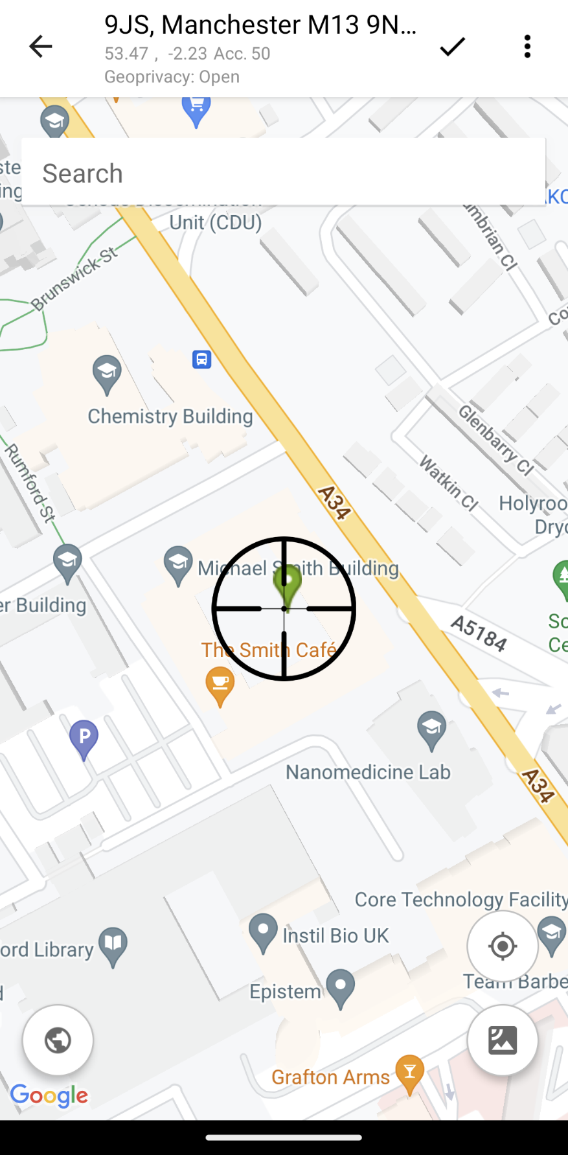
- If your location was on at the time of the photograph, it should be uploaded automatically, otherwise you can add your location manually.

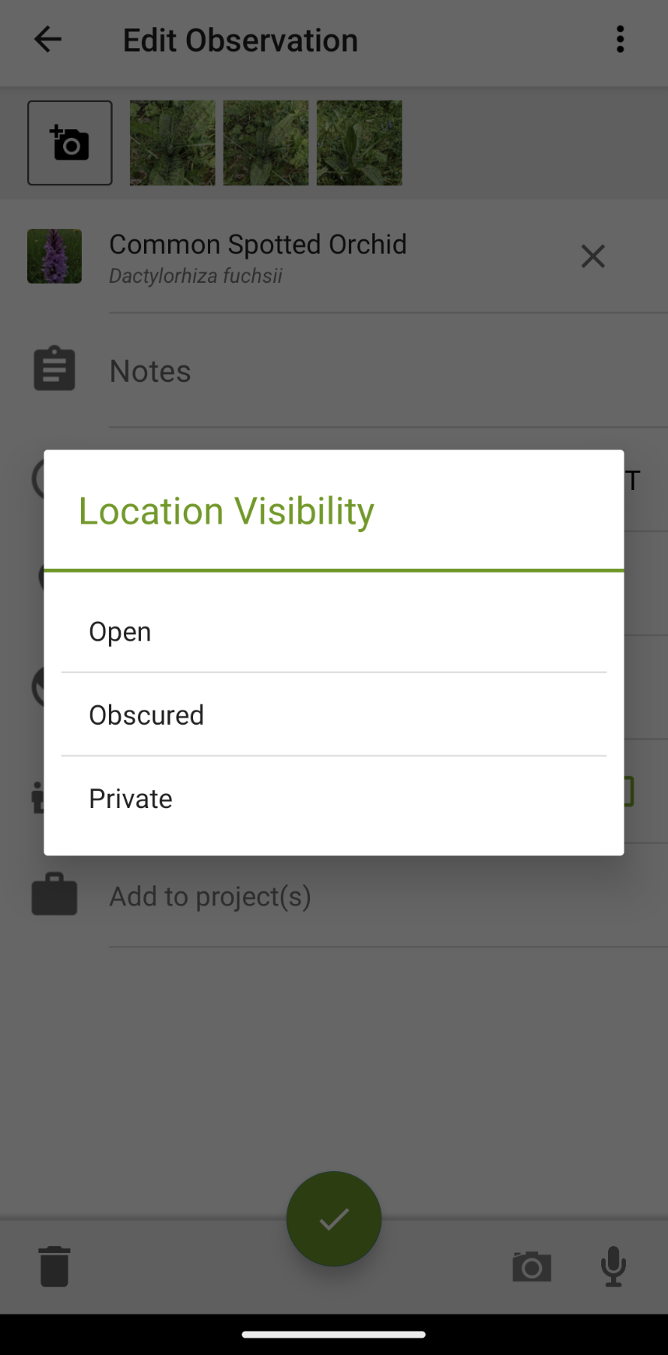
- Sometimes you might not always want to reveal the exact location of your species to others, for example if the species is sensitive or rare. Setting location visibility as obscured will provide a general location, whereas private will hide the species from public view.
- If you believe your species isn’t wild and may be captive or cultivated, you can tick a box to select this.

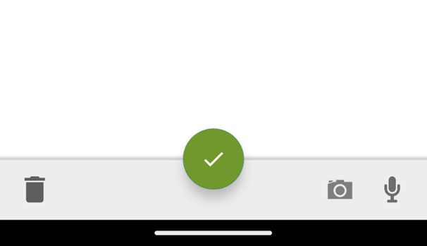
- Once you are happy, save and upload your observation with the green tick at the bottom of the observation screen.

- The community will then help you confirm the identity of your species.

How to explore other user’s sightings
An important part of iNaturalist is being able to view and review the sightings of others. You can view millions of observations of plant and animal observations across the globe.
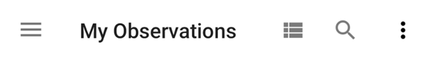
- At the top of the observation screen, you will see a triple dashed line. Press this to go to the app menu.

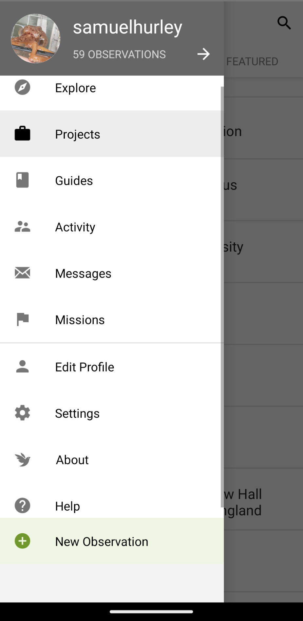
- Press ‘Explore’ to take a look at other people’s sightings.

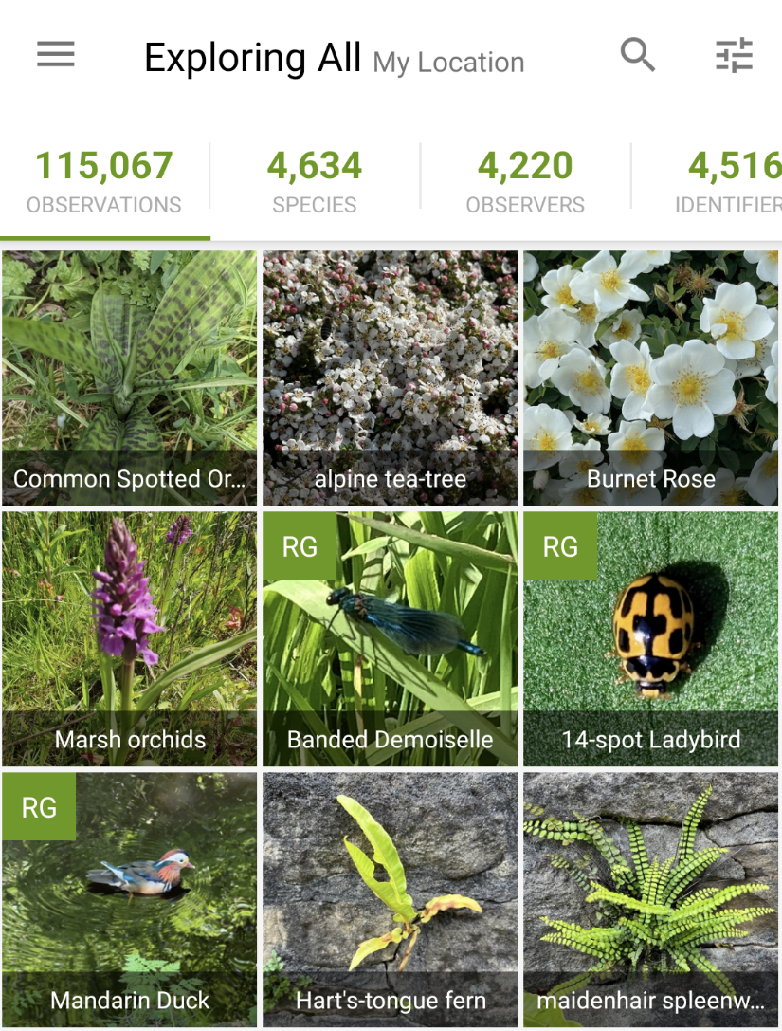
- Here you can see what wildlife people have sighted nearby. Species with RG next to their name are research grade, meaning they can be used in scientific studies. Those that don’t are graded as ‘Needs ID’.

- To help ensure that species observations are correctly identified, it is important that other iNaturalist users help to identity observations. You can help sightings become research grade by suggesting species ID. Once at least 2/3 of users agree on an observation, the observation receives RG status.

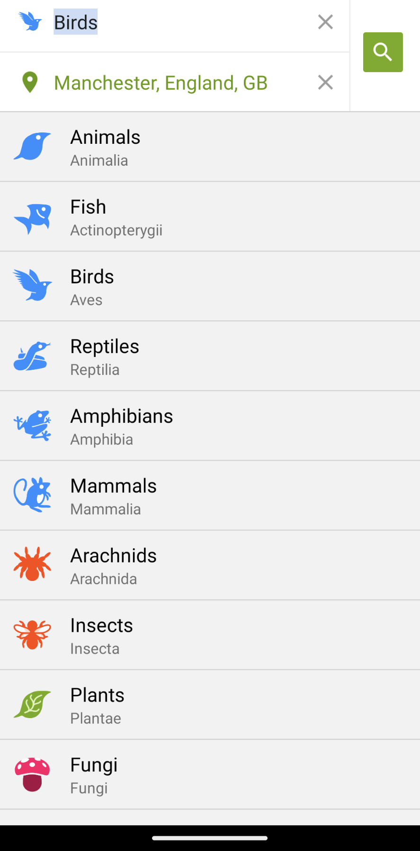
- On the observations page, you can filter by species, location and more. Get exploring!

Identify other users’ sightings:
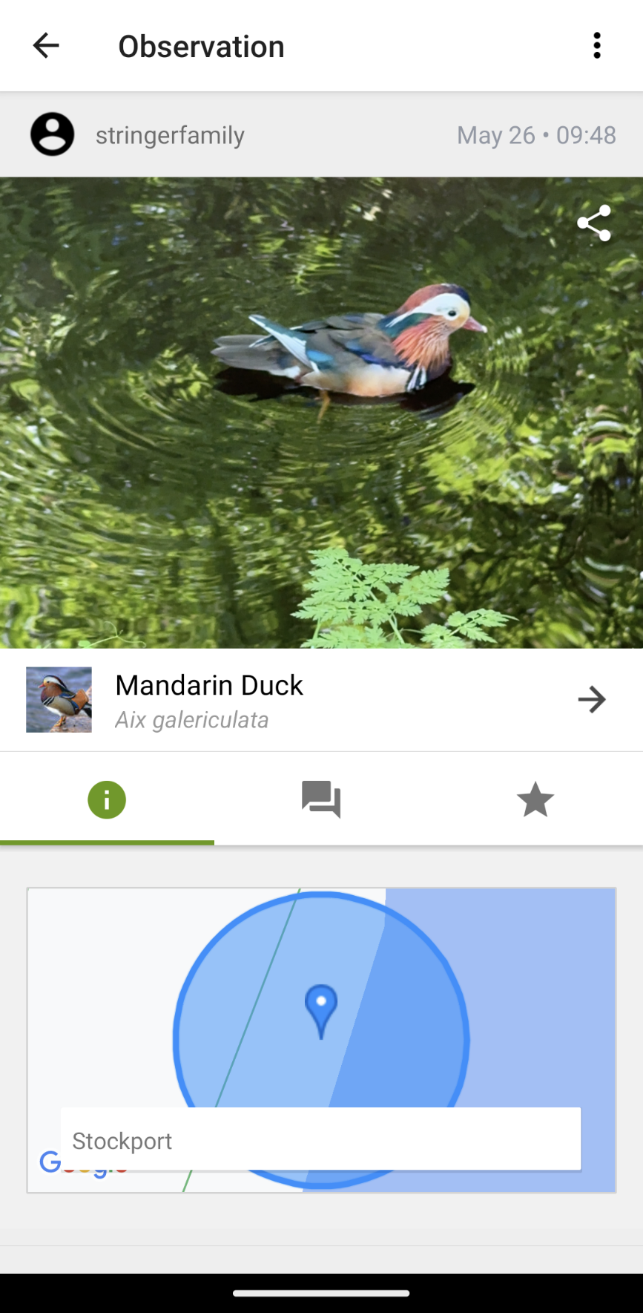
- To view someone else’s observation, click on the photograph of their sighting. Here you can see information on species location, observation status and any other notes the observer provided.

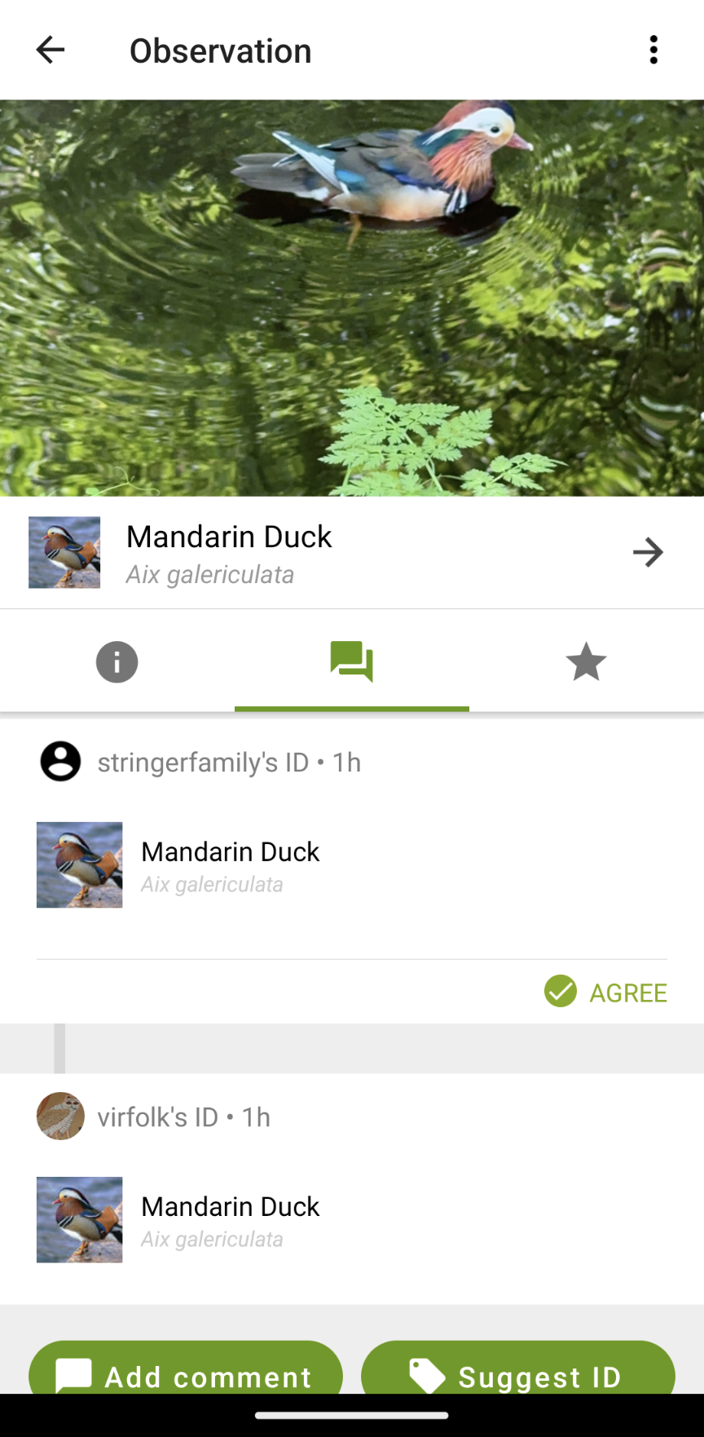
- When reviewing other users’ observations, we can either agree or suggest another species if we think it is something else. Here, we can see the users initial ID was a Mandarin duck. Another user then agreed, also identifying the species as a Mandarin duck.
- In this case, we agree with the identifications, so we press agree. If we wanted to suggest another species, we would press ‘Suggest ID’.
- We can now see our identification alongside other users.
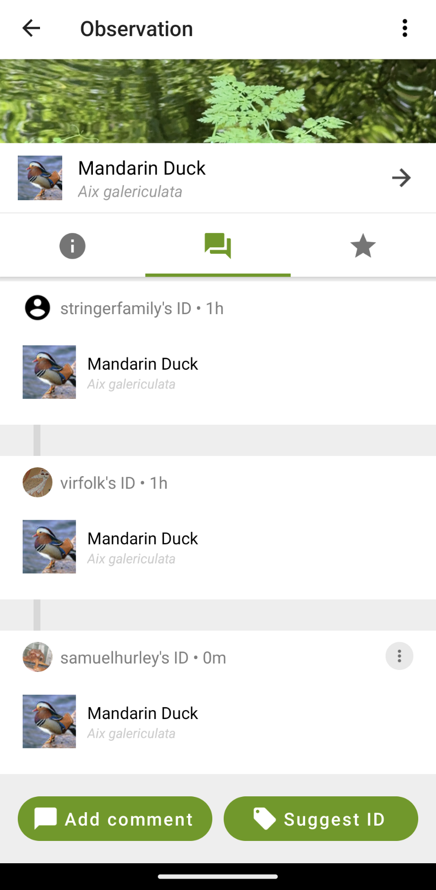
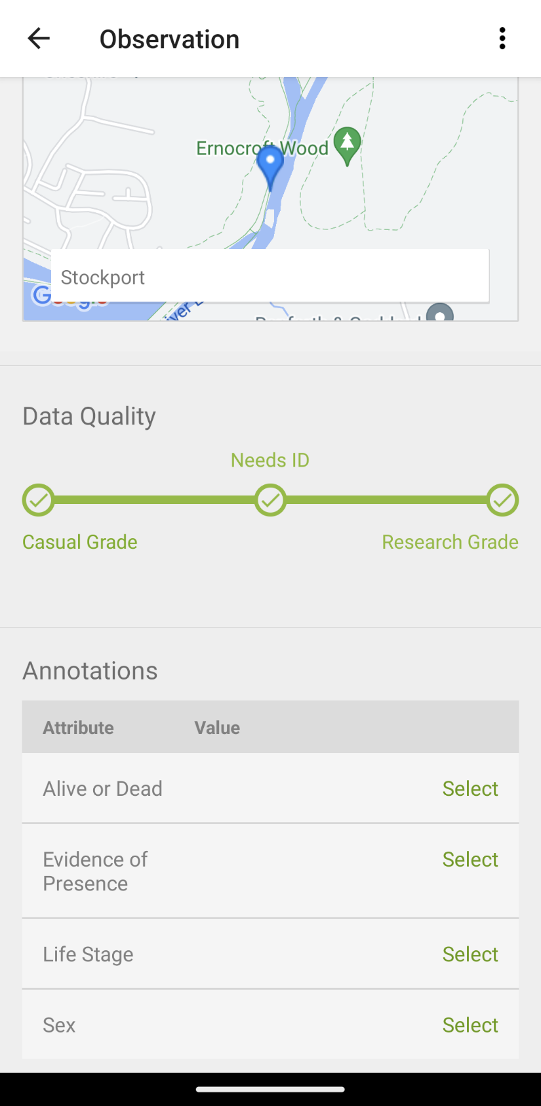
- As 2/3 of users have agreed the species is a Mandarin duck, the observation becomes research grade.

Need a little more help:
Visit the iNaturalist pages “Getting Started” and “Video Tutorials” for more detail on how upload your observations and to join a project.
The Natural History Consortium have also produced some great instructional videos and documents on using iNaturalist.

