Signing up to OpenStreetMap

In preparation for the session, can you please create an OpenStreetMap account. Instructions are as follows.

Step One
Go to www.openstreetmap.org and click Sign Up in the top right corner:

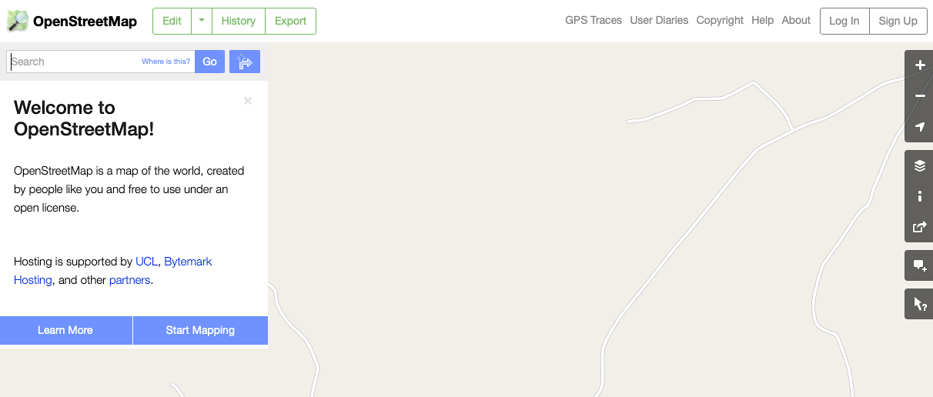

Step two
Fill out the boxes below and click Sign Up – we recommend using your university e-mail address.

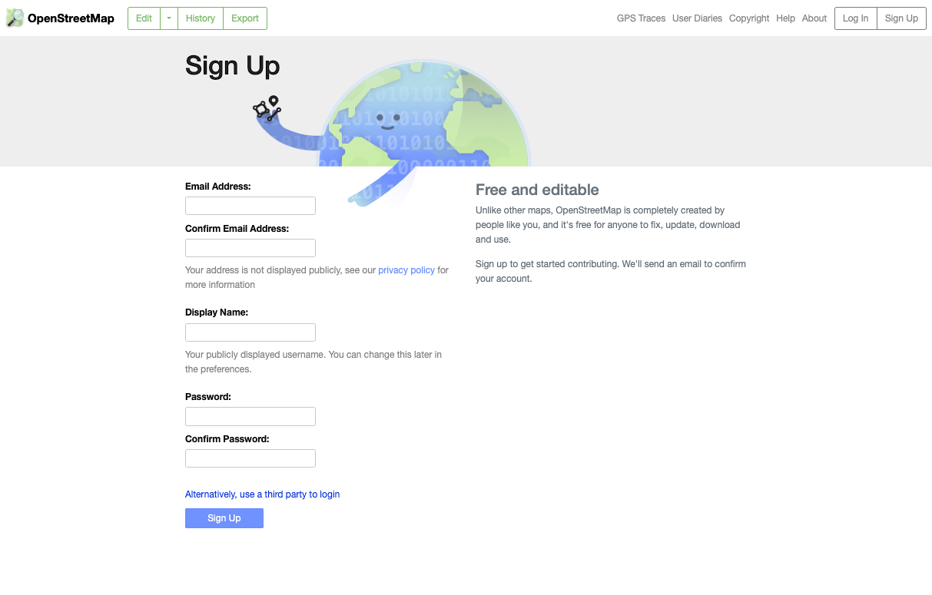

Step 3
Read the Contributor terms and terms of use. If happy, agree to the terms.

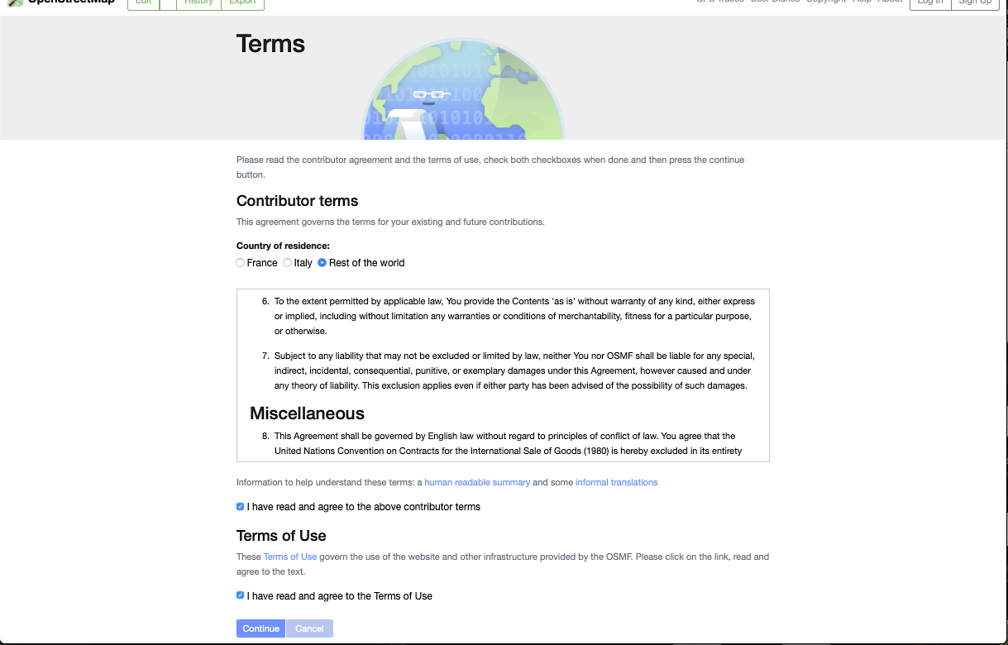

Step four
Check your e-mail you used to sign up for a confirmation e-mail.

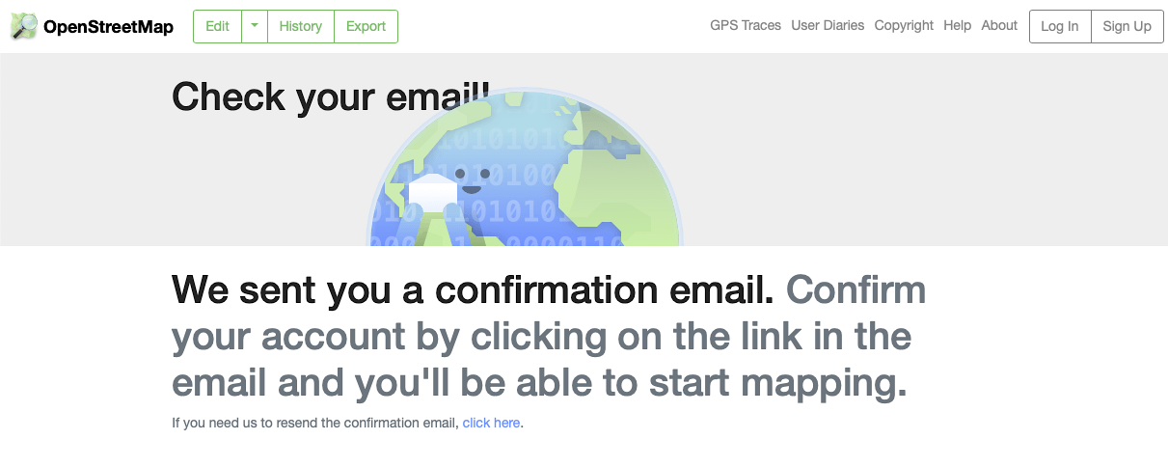

Step five
Go to your e-mail account and check for a confirmation e-mail. It should come through relatively quickly. Make sure it is from web@noreplyopenstreetmap and click the link in the e-mail.

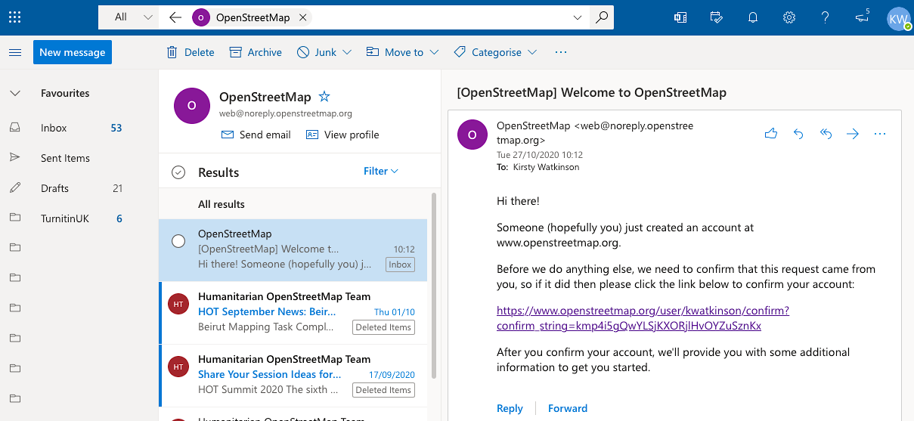

Step six
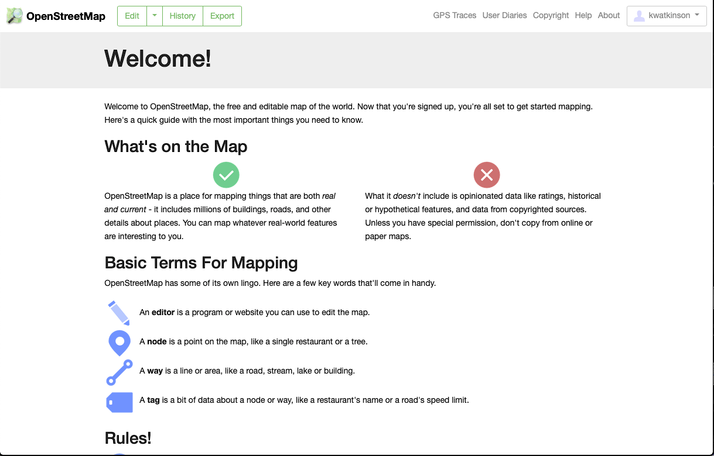
After clicking the link you will be taken to welcome page. Feel free to have read. You are now signed up and ready for the seminar. It would perhaps be useful to note down your e-mail address and password so you don’t forget.

