From: Equality And Diversity <equalityanddiversity@manchester.ac.uk>
Sent: 16 February 2023 09:55
To: DISABLED-STAFF@listserv.manchester.ac.uk
Subject: [DISABLED-STAFF] Staff Network Digest - February 2023

February is rushing by and we’ve lots to tell you about to keep you going until the end of the month

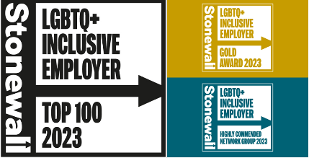

Hot off the Press – Stonewall result

Results of the Stonewall WEI were released today and we have some great news!
This annual ranking shows how LGBT+ inclusive organisations are.
We’re so proud to be in the Top 100 for the 8th year running showing our commitment to LGBT+ inclusivity for our staff, students and visitors.
This year we are ranked 30th and have achieved a Gold award for our commitment to specific areas of LGBT+ inclusivity.
We are also delighted that ALLOUT has been awarded a Highly Commended Network Group award, to celebrate the achievements of their work.
Congratulations to the team who contributed to our application this year

Focus Groups


The Directorate of EDI has added another date to its programme of focus groups – Friday 10 March, 1.00-2.30pm (online). This session is open to members of any staff network and has been scheduled to avoid any planned strike days to enable interested staff to participate. The session will provide a safe space for colleagues to speak about a range of topics related to equality and diversity and give our team an opportunity to meet, listen to and learn from colleagues to hear first-hand about their lived experiences as part of our University community.
Find out more and register.

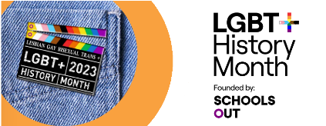

LGBT+ History Month

Events are continuing and there’s still time to sign up to a few here:
LGBT+ History Month 2023 events
There are also separate events you may be interested in:
- At Royce: Are You Proud Film Screening Thursday 16th 1pm
- in FBMH: Pronouns, People and Pride on Monday 20th 12.30pm
If you cannot make an event, why not: sign up as an LGBT+ ally; Listen to our LGBT+ podcasts; Add a backdrop to your online meetings; or support a local LGBT+ charity through workplace giving.

Join our EDI Committee in FBMH


The FBMH EDI Committee is looking for a new member from our BAME staff to sit on their committee ensuring issues from this equality group are heard and discussed at Faculty Level.
The group meets quarterly.
If you work I FBMH and are interested in finding out more, please contact: Natalie Gardiner Natalie.Gardiner@manchester.ac.uk

Job / Fellowship Vacancies

Three relevant vacancies we’ve been alerted to this month:
- Assistant eLearning Manager (3-year post) in the Faculty of Biology Medicine and Health: https://www.jobs.manchester.ac.uk/displayjob.aspx?jobid=23474
- Social Justice Manager role in Manchester Museum: https://www.jobs.manchester.ac.uk/internal/displayjob.aspx?jobid=24437
- Health Foundation EDI Fellowship: https://www.thisinstitute.cam.ac.uk/fellowships/strengthening-equity-and-diversity-in-healthcare-improvement/

Post Occupancy Focus Groups

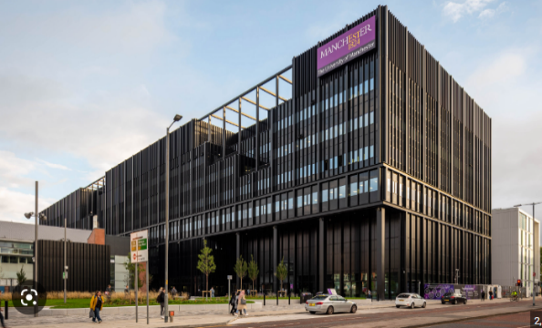
If you work in Engineering building A or B, did you know there are a number of post-occupancy focus groups taking place?

You can find out dates, times, area of focus and how to register here:
https://www.staffnet.manchester.ac.uk/fse/mecd/were-just-getting-started/ways-to-have-your-say---upcoming-activities/

Public Engagement Watermark Survey

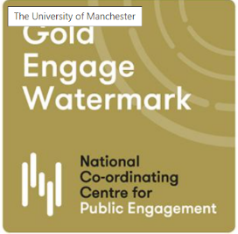
The survey for the watermark application for public engagement - which is something The University uses as evidence of our quality public and policy engagement is now live- we need a 1% response rate of all staff/PGR to comply so please do participate and promote!
More info about the watermark and the link to the survey is here:

https://www.staffnet.manchester.ac.uk/news/display/?id=29363

Sustainability Event

Rochdale Science Extravaganza
Date: Sunday 19 March 2023 – 10am-5pm Location: Number One Rochdale

This family science festival organised by the Rochdale Bangladeshi community is looking for stands and hands-on activities related to sustainability and climate change. A weekend an hour away from campus is a big ask but it’s shaping up to be really exciting with lots of diverse involvement from both STEM organisations and climate action groups. One of the organisers’ main aims is for the local community to feel represented so involvement of staff or students who are of South Asian heritage and/or Muslim would be especially welcome.
There’s some more info on the event on this Sharepoint page at https://livemanchesterac.sharepoint.com/sites/UOM-FSE-SR-Outreach/SitePages/[External-event]-Rochdale-Science-Extravaganza---Sunday-19-March.aspx

Wall of Women – continues 20th February

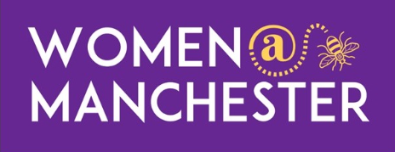
As you may know we are creating a 'Wall of Women' for International Women’s Day – over 75 women took part at the first session yesterday.
There’s another opportunity to participate on Monday 20th from 10am-5pm
Full details are here: https://www.staffnet.manchester.ac.uk/news/display/?id=29306
We have also published our timetable for International Women’s Day: https://www.staffnet.manchester.ac.uk/news/display/?id=29403

What else is coming up?

6th-7th: Purim
8th March: International Women’s Day
22nd March: Start of Ramadan (link to be updated with 2023 dates)
31st March: Transgender Day of Visibility (TDOV)

If you would like something to be featured in March’s edition, please send to equalityanddiversity@manchester.ac.uk by Tuesday 14th February

G.035, John Owens Building, The University of Manchester, Oxford Road, Manchester M13 9PL
Find out more about the team:
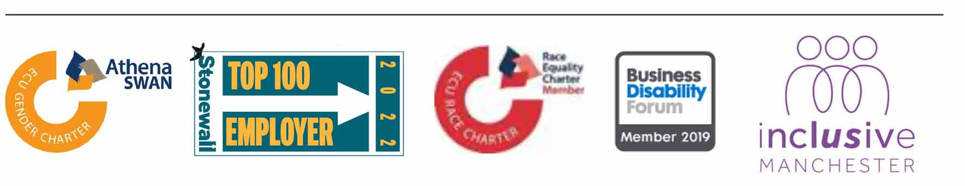
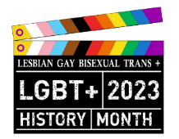

This month, our Diversity Calendar focuses on LGBT+ History Month. Colleagues have the opportunity to recognise and appreciate our LGBT+ history at a number of events taking place across the University. You can find out more about how you can get involved in this year’s LGBT History Month on our StaffNet Pages.

