Ingredients  If using prepared ingredient name of manufacturer i.e. Hellman’s Mayonnaise | 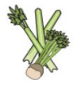 | 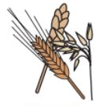 | 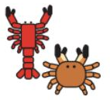 |  |  | 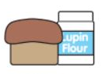 | 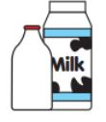   |  | 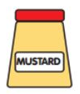 | 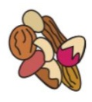 | 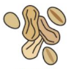 | 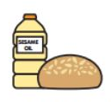 | 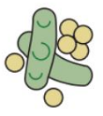 | 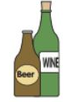
 | Celery | Cereals containing gluten (name cereal) | Crustaceans | Eggs | Fish | Lupin | Milk | Molluscs | Mustard | Nuts (state type of nut) | Peanuts | Sesame seeds | Soya | Sulphur dioxide
Pork Sausage
Chicken Sausage |  | (Wheat)
Vegan Sausage |  | (Wheat)
Spaghetti Hoops |  | (Wheat)
Baked Beans
Frittata
Hash Brown |  | mc |  | mc |  |  | mc
Plum Tomato
Egg / Boiled Egg
Scram Egg
Sweet Waffles |  | (Wheat) |  |  |  |  | MC
Portuguese Tart |  | (Wheat) |  |  |  |  |  |  |  | mc |  |  | mc | mc
Croissants |  | (Wheat) |  | MC |  |  |  |  |  | MC (Tree, Almond, Hazel, Walnut, Cashew, Pecan, Brazil,  Pistachio, Macadam |  |  | mc
Vegan Croissants |  | (Wheat, Barley) |  | MC |  |  | MC |  |  | MC |  | mc | mc
Porridge |  | (Wheat, Oats)
Granola |  | (Wheat, Oats. Barley |  |  |  |  |  |  |  | MC(Tree) | MC
Yum Yums |  | (Wheat) |  |  |  |  |  |  |  | mc |  |  | mc
Pan aux Choc |  | (Wheat) |  | MC |  |  |  |  |  | MC (Tree, Almond, Hazel, Walnut, Cashew, Pecan, Brazil,  Pistachio, Macadam
Cinnamon Roll |  | (Wheat) |  |  |  |  |  |  |  | MC (Almond, Hazel, Pecan, Walnut)
Bread, Bloomer, Bagels, |  | (Wheat)
Cheese Btretzel | mc | (Wheat) |  |  | mc |  |  |  |  | mc |  | mc | mc
Vegan Pancake |  | (Wheat) |  | MC |  |  | MC
Tata Tots
Overnight Oats |  | (Oats)
Coconut Yoghurt
Greek Yoghurt
Hummus
Cornflakes |  | (Barley) |  |  |  |  |  |  |  |  |  |  | Mc
Rice Krispie |  | (Barley) |  |  |  |  |  |  |  |  |  |  | Mc
Coco Pops |  | (Barley) |  |  |  |  |  |  |  |  |  |  | mc
Bran Flakes |  | (Barley) |  |  |  |  |  |  |  |  |  |  | mc
Weetabix |  | (Barley)

