From: Equality And Diversity <equalityanddiversity@manchester.ac.uk>
Sent: 21 April 2022 12:07
To: DISABLED-STAFF@listserv.manchester.ac.uk
Subject: [DISABLED-STAFF] Staff Network Group Digest -April 2022

Are you ready for a bumper edition of the Staff Network Group Digest!?

Harassment Support Advisors

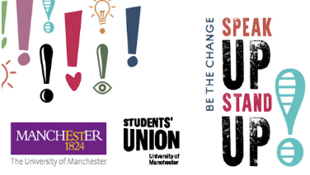
We’re looking to add to our group of volunteer Harassment Support Advisors who play a vital role in the informal stages of our Dignity at Work and Study Policy and Processes.
Full training and ongoing support is given in the role.
You can find out more by attending one of the info sessions in May – full details can be seen in this StaffNet Article:
- Harassment Support Advisors 2022
We also offer people the opportunity to request an advisor from a particular equality group – with this in mind, we are keen to hear from BAME, disabled, LGBT+, male and religious staff who are currently underrepresented amongst our HSA volunteers.

Ramadan/Eid and updated guidance for all


Our Muslim colleagues are currently observing the period of Ramadan and will soon be celebrating Eid al Fitr at the start of May.
In recognition of this important time of the calendar, we have updated our guidance for Ramadan to help both the group of people fasting as well as those supporting and working with them.
You can find out more here on the recently relaunched pages of the Muslim Staff Network group:
- Muslim staff Network Group
These page also contains links to places of worship on campus as well as our Inclusive Celebrations Guidance

IDAHOBIT 2022

Once again, we will mark International Day Against Homophobia, Biphobia and Transphobia (IDAHOBIT) which falls on 17 May.
There will be activities for everyone to join in with and these will be updated on our dedicated pages here:
- IDAHOBIT 2022
One thing we can all do in advance of this to support our LGBT+ colleagues is update our pronouns on signatures and video calling screens. There’s some guidance of how to do this, and why it’s important, here:
- Update your Pronouns

Staff Network Groups Day

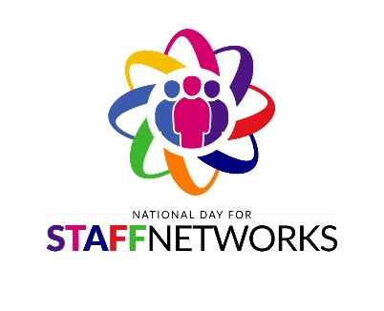
May 11 is National Staff Network Groups Day!
It’s a great opportunity for us all to showcase the work our networks have been involved in throughout the year; to talk about future plans and to recruit new members.
Chairs and leads of the various groups have been contacted and hopefully you are aware of the event/request to join your stall.
We’ll have a dedicated are in the Benugo café zone of Simon Building from 11.30am-1.30pm.
Please let Miriam.amies@manchester.ac.uk from the EDI team know if you’ll be there and she’ll be able to inform you what support and resources are available from the team.
Hope to see you all then!

Arthur Lewis Lecture 2022 – Disability Rights: A Global Phenomenon?

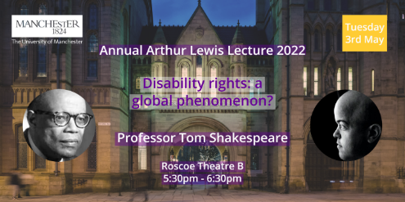
We are delighted that Sir Tom Shakespeare CBE, will be presenting the 2022 Annual Arthur Lewis lecture in Manchester on Tuesday 3rd May.

Tom is Professor of Disability Research at London School of Hygiene and Tropical Medicine, having previously worked at the Medical School at UEA and for the World Health Organisation.
Tom will join us to offer an overview of the disability movement, in Britain, America and across the world, and talk about his experience of disability and development research. Is the idea of disability rights something which activists in the Global North have imposed on the Global South? Or is this a genuinely global movement, free of cultural imperialism?
Please register via Eventbrite to attend in person.
This event will also be livestreamed over our Facebook page for those unable to attend in person. Like us on Facebook to keep updated!

Free Disability Inclusion and Counselling Events


Disability Confident Leader, AbilityNet, aims to make the digital world accessible for everyone. It supports employers in building a workplace that uses technology to enable all employees to perform at their best.
AbilityNet hosts a number of free events to help businesses flourish with a focus on disability inclusion. Register for training and webinar opportunities.
- Tuesday 26 April: Free webinar: Employee support and adjustments in the age of Covid
- Wednesday 4 May: Free training: How to build a disability inclusive workplace

Also attached is the April – June Timetable of classes and workshops available at the Counselling Service

Inclusive Manchester


Inclusive Manchester is an institution-wide initiative which encourages all members of our community to contribute to an inclusive and welcoming environment. It supports the University’s Equality, Diversity and Inclusion Operational Strategy by providing a series of activities that intend to engage, inspire and support people to take individual and collective action to make Manchester inclusive.

The University is developing a campaign which includes distributing a poster across the campus to encourage everyone to undertake at least one activity. Along with these posters we are providing some helpful hints and tips on how people might engage with activities and complete their chosen action.
Use this link and tell us, what actions could people take to make The University of Manchester more inclusive?
100 Ways to Inclusion

Hidden LIVE


We would like to invite you to join us for Hidden LIVE, an immersive performance that will challenge you to encounter life as a young person struggling with their mental health. This multi-media theatre piece uses imagination and experiences of ‘real people’ and asks you to question what you can do to help.

Where: RNCM Concert Hall, 124 Oxford Road, Manchester, M13 9RD
When: Wednesday 11th May 2022, 1.30pm
Duration: 90 minutes
How to book: Book your free tickets here: Eventbrite
This performance is taking place during Mental Health Awareness week 2022. The event is free and open to anyone. We would encourage young people, parents, teachers, mental health professionals and those working in the 3rd sector to attend and share this event and attached flyer through their networks. Access support is available, please contact Karon Mee karon.mee@manchester.ac.uk for more details.

That’s all for April – keep your information coming through for May equalityanddiversity@manchester.ac.uk

G.035, John Owens Building, The University of Manchester, Oxford Road, Manchester M13 9PL
Find out more about the team:

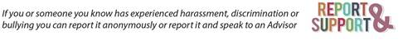
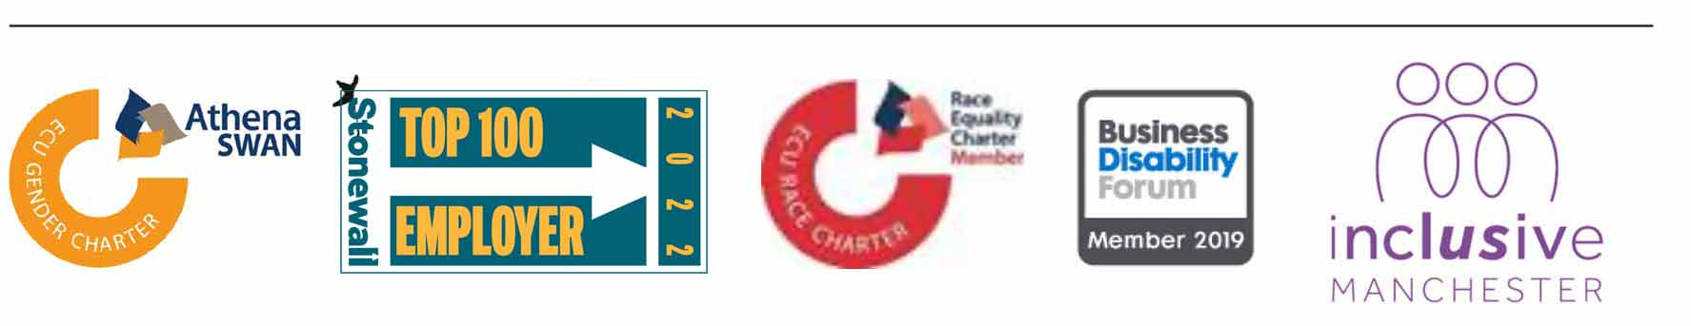


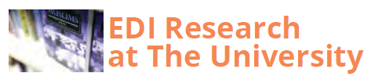

Our Diversity Calendar focuses on EDI Research at The University. You can find out more about The University’s research on Religions and Theology here.

