Royce Hub Building - Waste Management

This guidance document has been prepared by the Royce Technical Services and Safety Team. Please contact safety@royce.ac.uk and technicalservices@royce.ac.uk with any questions. The Directorate of Estates manages over 60 waste streams, most of which are recycled/re-used. Their online document details the disposal/recycling arrangements for all these wastes, listed in alphabetical order A - Z of waste types.

General Building Waste (Non-Lab Spaces)

Our waste removal activities are managed centrally and link in with arrangements elsewhere on campus. We have summarised our main disposal routes below:
- Paper, plastic (non hazardous) and cans: recycling bins are available throughout the building. Please rinse out plastic containers and food cans/containers before putting in the bins.
- General rubbish: bins are available throughout the building.
- Confidential waste: Restore Datashred consoles are available on each floor by the printers.
- Batteries: a battery recycling bin is located in reception.
- Cardboard packaging: waste should be flattened and left neatly by the recycling bins on your floor ready to be collected by House Services. Large amounts of cardboard can be taken to the cardboard crate in the bin store which is located next to the loading bay on the ground floor.
- Electrical and specialist disposal/recycling: should be arranged via the Technical Services team.
- Glass bottles/jars: can be taken (carefully and in an appropriate container) to the bin store and disposed of in the glass recycling bin. Please rinse glass before disposal and ensure that the bottle is labelled as ‘rinsed’. No glass containing any hazardous waste should be placed in this bin – see further down for what to do with lab glass waste/lab contaminated glass waste.
- Food waste: We are currently looking at options for food waste collection and we will update you in future.

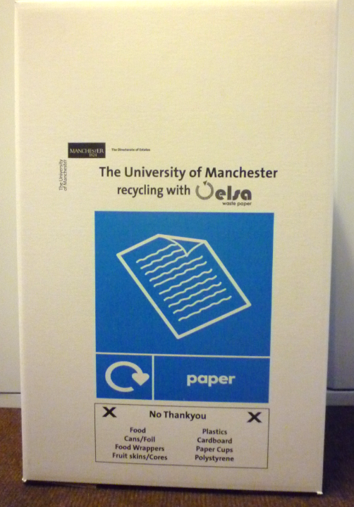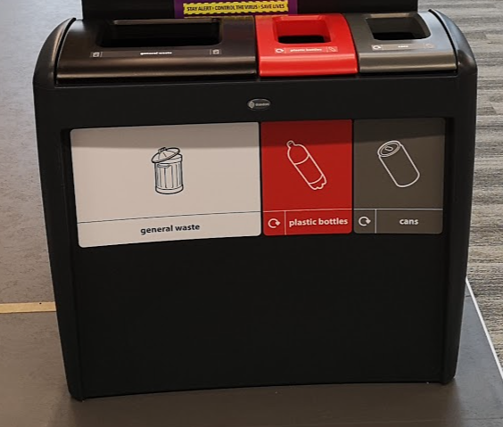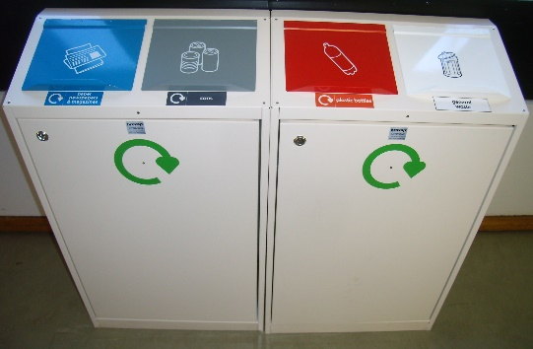
Spillages

In the event of a spillage please clean the spill up immediately and where safe to do so. There is a dustpan, brush, blue roll and cleaning spray in each office space and Community Hub/kitchenette area. For large liquid spills in busy areas, make sure you use one of the wet floor signs until you’re able to mop up the spill. For liquid spills on carpet or furniture, please contact technicalservices@royce.ac.uk so cleaning can be arranged (if required).
Please take care when moving about the building and be mindful of any slip or trip hazards presented by materials awaiting recycling or clear up. Ensure pathways are clear at all times.

Laboratory Waste
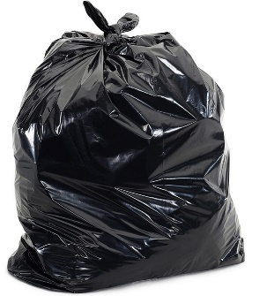
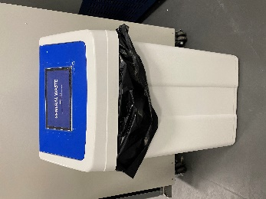
- General waste (Non-hazardous): Blue lidded bins with black bin bags.
This includes general laboratory waste such as non-contaminated paper, plastics, packaging etc. These should be disposed of in general laboratory bins designated and labelled as non-hazardous waste. Full, tied off general waste bags can then be deposited in the blue trolleys on the back corridor and these will be taken down to the Royce Bin Store by House Services staff on a daily basis.

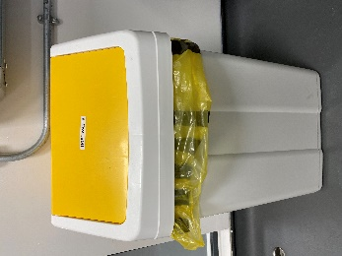
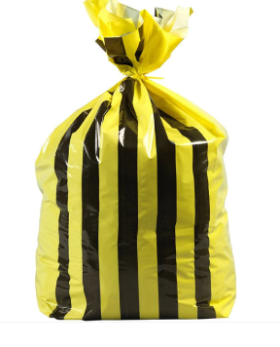
- *Offensive waste (tiger waste): Note – this is NOT hazardous waste – Yellow lidded bins with yellow and black striped bin bags. When bin bags are full, they should be sealed and placed into the yellow and black striped wheelie bin on the back corridor.

Please ensure that the offensive waste bags go into the correct bin and not into the yellow clinical waste wheelie bin. A biweekly collection will then be coordinated with House Services on a Wednesday and Friday morning.

*Offensive Waste is composed of waste that could feasibly be misconstrued by members of the public as containing bodily fluids, secretions or excretions such as disposable face masks, gloves, centrifuge tubes and tips etc., but which is not infectious. It is NOT Clinical Waste and it is NOT hazardous waste and thereby does not require specialist treatment or disposal. Offensive waste can be sent to landfill.

- Hazardous (Chemical) Waste; Hazardous chemical waste must be disposed of via a licenced, ethical hazardous waste company such as CSG. You must arrange with Tim Neale (Stores Manager) to take any hazardous waste down to the Chemical waste store on the ground floor so that it can then be collected by CSG. CSG collections are carried out generally every week. You must ensure that incompatible materials are not mixed or stored next to each other. Ensure that waste is correctly labelled and that a record is kept with details of date, volume/weight, chemical name, state and concentration and the name of person disposing of waste. When you are ready to dispose of your waste arrange a time with Tim Neale to take it downstairs using the locked-out goods lift in accordance with the guidance document for the goods lift. DO NOT travel in the lift with the chemical waste.
CSG will require a full list of chemicals, volumes/weights and relevant MSDS sheets for each collection and a transport of chemicals/hazardous materials risk assessment must be in place.

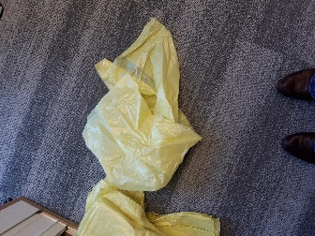
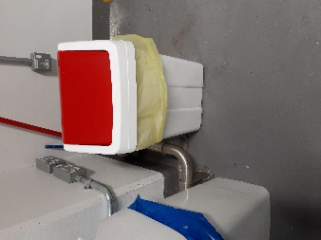
3a. Solid Hazardous Waste: Red lidded bins and pale yellow bin bags.
When full secure ends of bag and place in yellow wheelie bins on back corridor of the building near to goods lift. When the yellow wheelie bin is full you can then arrange with Tim Neale to take it down to the chemical waste stores using the goods lift for disposal and collection by CSG.
On L5 there are also some metal bins that are being used for hazardous solid waste to reduce risk of fire from flammable materials.

3b. Liquid Hazardous Waste: Can be stored in suitable and appropriate containers (fully labelled) and stored in an appropriate cabinet until such time as it can be brought downstairs to Waste chemical stores for collection by CSG.

- Non-hazardous liquid waste: Aqueous solutions of harmless inorganic substances and soluble organic compounds should be neutralised and well diluted before disposal down the drain in accordance with specific relevant Chemical Risk Assessment.

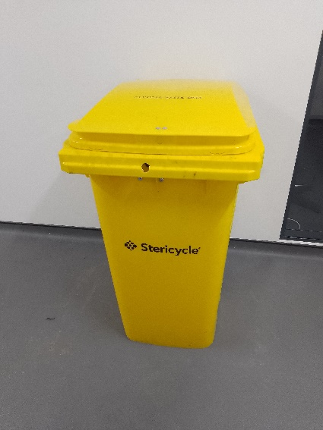
- Clinical Waste: There is only one clinical waste yellow wheelie bin currently located on the 4th floor. This bin is removed to the bin store every Friday night then emptied by Stericycle first thing on a Monday Morning. If you wish to organise the disposal of clinical waste but are not located in the fourth floor Bio labs then please speak to Simon Atkinson, University waste Coordinator simon.atkinson@manchester.ac.uk (cc’d to Cath Davies and Karen Theis).
Clinical waste is waste that:
(a) contains viable micro-organisms or their toxins which are known or reliably believed to cause disease in humans or other living organisms,
(b) contains or is contaminated with a medicine that contains a biologically active pharmaceutical agent, or
(c) is a sharp, or a body fluid or other biological material (including human and animal tissue) containing or contaminated with a dangerous substance.

- Autoclavable Biological Waste: biowaste bins are lined with autoclave bags so that waste can be autoclaved before being added to the offensive (tiger) waste bin. You must contact the L4 technical support team to arrange autoclave of waste.
This waste is for solid lab waste, gloves and disposables contaminated with biological material. This waste must NOT contain any sharps i.e. no needles, razors etc.

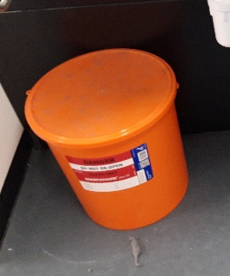
- Broken Glass: Examine all glassware before use and reject any which is chipped or damaged. Dispose of broken glassware in the designated orange broken glass bins or cardboard broken glass bins using a dustpan and brush or thick cut resistant gloves (EN388); never put broken glass into general waste. When full, take down to Tim Neale to have the broken glass bins collected by CSG Waste.

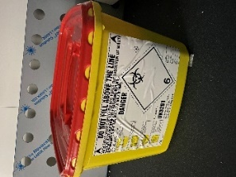
- Sharps Waste: This includes needles, scalpel blades, razors, etc. These items MUST go into the designated sharps bin. They MUST NOT be placed into any other waste bins/bags. When the fill line has been reached close the lid and seal the bin. The sharps bin can then be stored appropriately until it can be collected by Stericycle. Please liaise with the Royce Safety Advisor to organise collection.

- Empty chemical and solvent containers/bottles: All empty chemical and solvent containers/bottles must be thoroughly washed out with water (with the exception of the containers that have contained chemicals that react with water – these should be disposed of as hazardous waste). Any container for volatile substances (e.g. acetone, chloroform, etc.) MUST be placed in a fume cupboard until all vapour/odour has been eliminated. ALL containers must then have their contents labels crossed/blanked out and marked with ‘rinsed out’ or ‘washed’ in indelible marker pen. Clean glass containers can then be placed in the glass recycling bin in the Royce bin store and clean plastic containers can go in special recycled waste container in the bin store.

- Fridges and Freezers; old and/or broken fridges and freezers must be decontaminated before disposal and an equipment decontamination form must be completed. This can then be sent to technicalservices@royce.ac.uk with request for disposal.

- Mercury or mercury containing items. All mercury and contaminated/containing items should be well secured to prevent possibility of breakage and leaking of mercury. Mercury must be disposed of by a mercury specialist – NOT IN hazardous waste. Please contact safety@royce.ac.uk to find out more: “Loose” mercury should be contained within a well-sealed, labelled container. Mercury-containing glass items such as thermometers should be well-wrapped in protective material (e.g. bubble-wrap).

- Ethidium bromide** waste:
Please ensure that you are registed with occupational health if you are working with this substance and that you have read and are aware of the potential dangers of handling ethidium bromide.
Please see safety services information on the safe use and disposal of ethidium bromide: https://documents.manchester.ac.uk/display.aspx?DocID=15543
- Solid waste contaminated with small amounts of ethidium bromide (e.g. gels, gloves, tissue, etc.) should be placed in the yellow bins. They MUST NOT be placed into any other waste bins/bags. Once full, the bin should be sealed and taken to the yellow wheelie bin for disposal by incineration via a specialist waste contractor.
- Liquid waste contaminated with <0.5mg/ml ethidium bromide (e.g. gel running buffer, etc.) should be decontaminated overnight using a de-staining bag which can remove the ethidium bromide from solutions. The waste solution can then be safely poured down the sink, and the de-staining bag placed in the yellow gel bin for incineration – NEVER dispose of solutions containing ethidium bromide down the sink unless they have been decontaminated overnight with the de-staining bag. Each bag can absorb 5mg dry weight of ethidium bromide (approx. 10 litres of buffer which has a final concentration of 0.5ug/ml).
- If liquid waste is contaminated with >0.5mg/ml then water should be added to dilute EtBr concentration to less than 0.5mg/ml and then treated as stated above.
- **where possible, safer alternatives to ethidium bromide (e.g. SABR-Red) should be used.

- Radioactive Waste: Radioactive waste disposal must comply with legal regulations and is allowed for authorized personnel only. Contact the Radiation Protection Supervisor if you intend to work with radioactive materials. Solid radioactive waste must be segregated according to radionuclide and collected in white buckets clearly labelled with the radionuclide, activity and date. Buckets are then stored until decay or sent for incineration.

Guidance prepared by Karen Theis, Institute Safety Advisor, Cath Davies, Technical Operations Manager, and Julia Lawson, Project Officer with input and photos from L4 technical staff, Miley Li.
Reviewed by Cath Davies, Technical Operations Manager and Emma Brown, Technical Project Manager
Issued: 06.03.2024 v3.0

