From: Equality And Diversity <equalityanddiversity@manchester.ac.uk>
Sent: 21 October 2021 12:24
To: DISABLED-STAFF@listserv.manchester.ac.uk
Subject: [DISABLED-STAFF] Staff Network Group Digest: October 2021
Here’s a roundup of things we think will be useful for you!

Hybrid Workshops

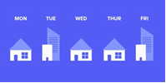
A number of hybrid working focus groups, from an equality perspective, have been set up. This first set of focus groups will be an opportunity for us to discuss, learn together and create solutions and tangible actions to support the inclusion of hybrid work.
If you would like to take part please book via the Staff Learning and Development Calendar: https://app.manchester.ac.uk/TSLD139
Dates and themes: Tuesday 9 Nov, 10am-11.30am All Staff ; Thursday 11 Nov, 11am-12.30pm Carers; Wednesday 17 Nov, 2pm-3.30pm Working Parents; Monday 22 Nov, 10am-11.30am Disabled staff; Wednesday 1 Dec, 11am-12.30pm All staff

If you cannot attend any of these workshops but would like to attend a future one, please email hybrid@manchester.ac.uk

Disability Standard
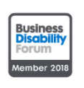
As you will be aware we currently hold the Disability Confident Employer accreditation from DWP. Our ambition is to be awarded the Disability Confident – Leader award by this time next year. To get to this point we will also be engaging with the Business Disability Forum Disability Smart Audit which involves a self-assessment and audit. The assessment has ten sections including Leadership, Learning & Development, Workplace Adjustments, Recruitment, Customers and Service Users, Procurement, Communication, Build Environment and Technology. We are looking for representatives from each section within the University who can help answer the questions given.

If you would be interested in helping with this project please email Kathryn.bradley@manchester.ac.uk stating which section you would be able to assist with by Tuesday 2nd November.

Islamophobia (November)
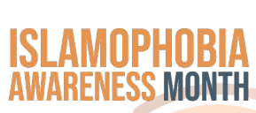
In November we mark Islamophobia Awareness Month in our Diversity Calendar.
The BAME SNG are looking for some volunteers to help plan and support an event to mark Islamophobia awareness week is to discuss how Muslims feel in the University and what message they want to send to their colleagues.
The second reason to recruit more members to UM-BAME network. Islamophobia is a form of racism and stereotyping Muslims.
If you are interested, please message: BME.Chairs@manchester.ac.uk

Trans Day of Remembrance (20 November)


Once again we will be collaborating with St Peter’s House to mark this important day for our trans staff, students and wider community.
Further details will be communicated soon, but in the meantime, please save the date: Thursday 18th November 6pm for the event.
You can register for a ticket here:
- TDOR 2021 tickets

Calendar 2022 Charity

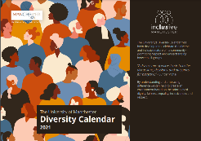
We are currently planning and writing our 2022 calendar and we’re delighted to announce that there WILL be a printed version for next year.
We have a ‘charity of the year’ as part of the calendar and it’s time to send in your nominations for the 2022/2023 editions.
You can nominate any charity that you support, but we would like to see those which are local to the University and have an interest or specialism which relates to Diversity, equality or inclusion.
Please send nominations with your reasons for nominations to equalityanddiversity@manchester.ac.uk before Monday 1 November

New Signature and logos


You may notice (if you’ve read this far!) our new snazzy signature.
We’ve included all the latest logos, links and also a hyperlink banner to Report and Support
If you do use any of our equality linked badges on your signature can you please ensure they match ones below and remove any old or out of date ones.
You can also include the R&S Banner too.
And whilst there, why not include your pronouns to show full inclusivity!

That’s all for October – if you would like anything in a future digest, please forward this to equalityanddiversity@manchester.ac.uk

G.035 John Owens Building, The University of Manchester, Oxford Road, Manchester M13 9PL
Tel: 0161 306 5857

Find out more about the team:
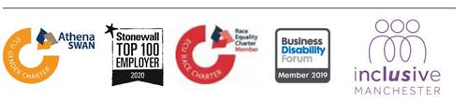a

