Managing Hybrid Working Successfully
Pre-learning



Managing Hybrid Working Successfully

Pre-learning and preparation

The links to videos, podcasts and reading are designed to help you consider Hybrid Working in advance of the session and preparing you to share your learning and experiences. The time it will take to complete is approx. 60mins

Watch the video 2.21mins from Skills Booster to refresh or introduce the model.

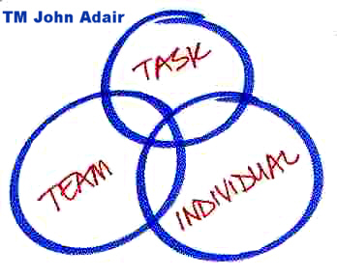

On the next page is an exercise pages 3 - 5 where you can add your comments aligned to the three areas, and you focus on hybrid working aligned to your responsibilities. At the end of the exercise page 6 you can make an assessment of which points you think you would like to pay more attention in relation to hybrid working. Discuss your thoughts with your line manager and / or team.

Adair’s Model of Managers’ Responsibilities:
- Your responsibilities as a manager for achieving the task are:  - identify aims and vision for the group, purpose, and direction - define the activity (the task)  - identify resources, people, processes, systems and tools (including. financials, communications, IT)  - create the plan to achieve the task - deliverables, measures, timescales, strategy and tactics  - establish responsibilities, objectives, accountabilities and measures, by agreement and delegation  - set standards, quality, time and reporting parameters control and maintain activities against parameters  - monitor and maintain overall performance against plan  - report on progress towards the group's aim  - review, re-assess, adjust plan, methods and targets as necessary | Your comments

- Your responsibilities as a manager for the team are:  - establish, agree and communicate standards of performance and behaviour  - establish style, culture, approach of the group - soft skill elements  - monitor and maintain discipline, ethics, integrity and focus on objectives  - anticipate and resolve group conflict, struggles or disagreements  - assess and change as necessary the balance and composition of the group  - develop team-working, cooperation, morale and team-spirit  - develop the collective maturity and capability of the group - progressively increase group freedom and authority  - encourage the team towards objectives and aims - motivate the group and provide a collective sense of purpose  - identify, develop and agree team- and project-leadership roles within group  - enable, facilitate and ensure effective internal and external group communications  - identify and meet, training needs  - give feedback to the group on overall progress; consult with, and seek feedback and input from the group | Your comments
- Your responsibilities as a manager for each individual are:  - understand the team members as individuals - personality, skills, strengths, needs, aims and fears  - assist and support individuals - plans, problems, challenges, highs and lows  - identify and agree appropriate individual responsibilities and objectives  - give recognition and praise to individuals - acknowledge effort and good work  - where appropriate reward individuals with extra responsibility, advancement and status  - identify, develop and utilise each individual's capabilities and strengths  - train and develop individual team members  - develop individual freedom and authority | Your comments

Make an assessment of which points you think you would like to pay more attention in relation to Hybrid Working. Discuss your thoughts with your line manager and / or team.

What I’m doing well and need to keep doing . . .

Things I need to do more of . . .

To create balance in Adair’s 3 areas I need to . . .

Building Trust

Pre-learning

How to build trust and relationships 3.09 mins video (Ref Dale Carnegie)

Trust. The heart of flex and hybrid. | People Stuff (hrgemblog.com) 4mins (Gemma Dale)

Notes:

Effective Communications

Pre-learning

Effective Communications LinkedIn Intro 2.07mins

Line Manager Guide on supporting Hybrid Working CIPD 4 May 2021
(Further reading required for key considerations in more depth)

Notes:

Out-come based performance

Pre-learning

Changes trends in performance management 1.52mins CIPD

New one minute manager 15mins podcast L&D Toolkit

Notes:

Inclusion (EDI)

Pre-learning

Guidance on hybrid work and supporting disabled staff UoM Managers Guidance

Equality, Diversity and Inclusion | StaffNet | The University of Manchester

Notes:

Wellbeing

Pre-learning

How to support the wellbeing of Hybrid Workers UoM Managers Guide

10 tips for Hybrid successful working UoM Managers Guide

Wellbeing at work CIPD

Notes:
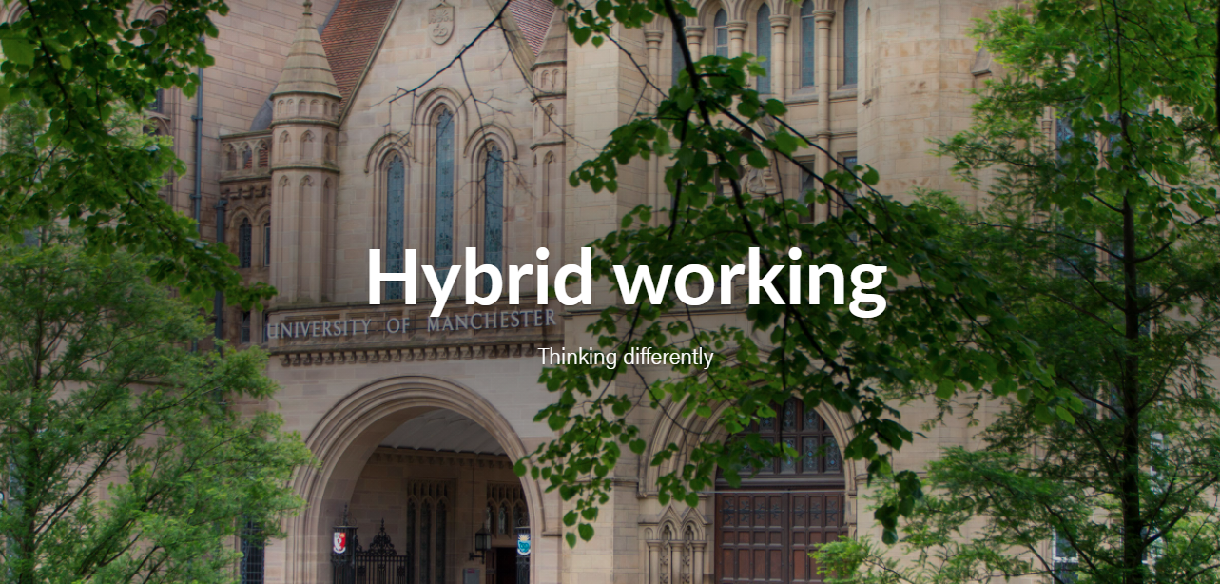

Managing Hybrid Working Successfully
Workbook

Managing Hybrid Working Successfully

Welcome

Purpose of this session: To support people managers following the communications and transactional interactions, and is an update on our ‘Managing Remotely & Hybrid Working’ sessions from 2020.

- Town Hall – May
- Managers Briefings – May / June
- How to help your team work flexibly – June, July and August

Why: To ensure managers have the skills, ability and confidence to implement and manage Hybrid Working successfully, so that they develop and influence a more agile way of working and create a ‘new norm’ culture.

Why are we introducing hybrid working now?

Colleagues have shared working remotely experiences through the ‘What works?’ project and pulse surveys - some staff want to work in a hybrid way and stated the benefits i.e. more productive, feeling more empowered and having a better work-life balance.

The University wants to support colleagues to work in a hybrid way, where possible, provided this does not have a detrimental impact on operational requirements, performance or the student experience. Staff who wish to continue to work 100% at their contractual place of work at the University will be able to do so.

As part of this experiment, Managers are encouraged to consider how hybrid working can be implemented for their teams, taking into account the hybrid working principles (see below). Where staff believe their role is eligible for hybrid working, they may ask their manager to consider implementing hybrid working. Hybrid Working is about assessing the whole team / direct reports desires. For guidance and support on how to put hybrid working into practice, see below. More information on other forms of flexible working is available in the University’s Flexible Working Policy.

A brief summary of Hybrid Working at the UoM:

- Working Smarter, Living Better project board
- 26 May 2021 – all managers communication with all staff comms 7 June
- Focus on Professional Services
- Flexible Working for permanent change
- Hybrid Working Principles to support experiment from June 2021 until Aug 2022
- 100+ Flexible Working Champions to support
- Managers Essentials for Flexible and Hybrid info

Objectives

By the end of this session participants will:

- Recognise the benefits of Building Trust with your team members
- Know how to adapt your communications to ensure these are effective for all your team members
- Share current good practice for out-come based performance and consider new ways of reviewing
- Ensure all team members know how to gain access to Wellbeing and the relevant support
- Ensure all team members are included (EDI) within Hybrid Working wherever, whenever and however they work

Your objectives

“People expect their Leaders to help them to achieve the common task, to build the synergy of teamwork and to respond to individuals and meet their needs.”

John Adair

Key Learning
- Managers’ have an increased confidence in their skill and ability to implement Hybrid Working in line with the transactional knowledge
- Managers’ are able to plan their teams requests effectively in line with the operational needs
- Teams work well in finding the best solution for the groups working patterns while balancing the work requirements
- Teams are more agile with their working patterns and place of work, and able to adapt to changes that emerge
- Employees feel requests for Hybrid Working and the conversations exploring individuals desires are discussed effectively
- Employees are clear about expectations and feel empowered to deliver the team and individual results

Share your findings

Video 2.21mins from Skills Booster to refresh or introduce the model.

According to John Adair, there are three elements to all leadership situations. They are:

- The achievement of a goal or task. Effective groups have clear goals shared by all members. Often the task is what brings the group together in the first place.

- The group of people performing the task. It is likely that the task will only be achieved if all members of the group work together to the common good. Therefore, the group itself has to be understood as an entity in its own right.

- Each individual member of the group involved in the task. While the group will take on a life of its own, individuals do not lose their own identity. Their needs as people must continue to be met if their allegiance to the group, and their motivation to achieve the task, is to be sustained.

This approach, "Action-Centred Leadership", is centred on the actions of the leader. The leader has to balance the needs from each of the three elements. The effective leader is the one who keeps all three in balance; that is who attends to all three at the same time. If any one element is ignored, the others are unlikely to succeed. Action Centred Leadership article https://www.businessballs.com/leadership-styles/action-centred-leadership-john-adair-4335/

Advantages of embracing Hybrid Working

This session will follow on from the transactional support sessions delivered by Gemma Dale where some attendees will be familiar with the Trust model.
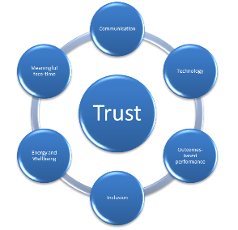
For those determined to make the change and make a more flexible future, we need to support the practical aspects and think about culture.

Each element of the Trust Model will be a line manager capability shift. Some managers may find elements easier than others, and may find a need to develop these elements further. The University wants to trial Hybrid Working for a year and review the impact.

Detail the advantages here:

Building Trust

Pre-learning

How to build trust and relationships 3.09 mins video (Ref Dale Carnegie)

Trust. The heart of flex and hybrid. | People Stuff (hrgemblog.com) 4mins (Gemma Dale)

Notes:

Building Trust is at the centre of the Hybrid Working model but also the centre of how staff should feel in achieving their roles and results - TRUSTED. To enable that culture shift people managers have a key role to play in creating this change. Empowering people to do their best work, anywhere they are located.

Managers get the best out of their team and individuals when they adapt to the person and situation. John Adair’s model is one which can help managers focus on achieving this by making sure all three elements are considered. Hybrid Working is a recent hot topic, and one of many that a managers have to ensure their team’s desires and work is met.

Being at work is one thing but delivering great results from anywhere helps to develop a more agile culture and way of working, where people feel empowered to get their jobs done with autonomy and choice and avoid being micro-management.

Quotes and words to describe Trust

Q: How do you feel when you have worked for a manager and in a team where these are characteristics are present?

Q: How will you ensure your Hybrid Working teams will continue to feel this way?

For an organisation to be successful, it needs to be able to rely on the knowledge, skills and creativity of its people. So, it’s vital that the University encourages their people to take responsibility for themselves and for their workloads. But, how can you give people the freedom to do this, while also making sure that they deliver what you want and working in a Hybrid way? The answer is empowerment and delegation. When you empower and delegate people, you trust them to make their own decisions, and you encourage them to become more accountable and to use their initiative. This allows you to take a step back, so that you can focus on high-level priorities. (Mind Tools).

Q: What stops you from empowering and delegating?

What are your opportunities to delegate?

Individually consider the opportunities to delegate by answering the 3 questions below. Not only should you establish area’s to delegate but also consider areas of work not relevant. This model helps you ensure tasks are allocated and shared across the team.

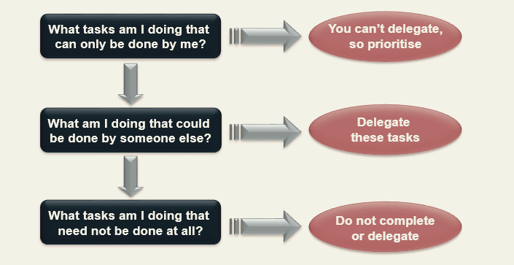

What tasks am I doing that can be done by me? | What am I doing that could be done by someone else? | What tasks am I doing that need not be done at all?

Nine steps to effective delegation

- Define the task​
- Select the individual​
- Assess ability and training needs​
- Explain the reasons​
- State required results​
- Consider resources and adjustments required​
- Agree deadlines​
- Support and communicate​
- Feedback on results.

Summary:

- Be clear on personal autonomy
- Reinforce good performance (in the way you think will be most meaningful for the individual, or collectively for the team)
- Recognise competence in navigating unusual situations
- Transparency for colleagues working with adjustments?


Checkpoint
Q: What will you do differently to build trust to implement
Hybrid Working effectively?

Post-learning

The Delegation-Empowerment Continuum Model L&D Toolkit 3mins read

Empowerment and Delegation skill book L&D Toolkit 60 mins Mind Tools

TLMS115 Successful Delegation 1:30 mins SL&D Open Programme

Effective Communications

Pre-learning

Effective Communications LinkedIn 2.07mins

One of the challenges in any team is effective communications. Certainly a new experience for all has been how we have had to be communicate during the pandemic, virtually rather than face to face. While this has become the new norm, we now need to consider how managers communicate with their Hybrid Teams.

Communications have been virtual for over a year where managers have had to consider the best medium for teams in different places, at different times, on different days.

For information / updates / decisions / awareness / review to be effective, consider:

The need for regular face to face, especially in hybrid working

For Meetings you need to consider:

- Extroverts / introverts needs: pre-reading, send thoughts after meetings
- Space in meetings for questions and discussion – make use of breakouts
- Part time workers
- Core hours

CIPD 4 May 2021 – Line Manager Guide on supporting Hybrid Working
(Further reading required for key considerations in more depth)

- Communication needs to be more intentional and planned in a hybrid environment
- Communicating will vary depending on team size and the types of roles
- Employees need information in a timely way, to successfully undertake their work
- Good communication is a shared responsibility across the team
- Engage the team in a discussion about the best ways to communicate
- Check in on absent employees to see they understand, or nominate someone?

One of the most important factors in communicating with a hybrid team is ensuring that information reaches everyone, wherever, whenever and however they are working. Equal access to information and knowledge is key to preventing communication issues and feelings of unfairness.

Listening is key, from the exercise what needs to be demonstrated to ensure effective communications:

Speaker | Listener

Summary: Effective communications are as much about being a good listener as speaker. Show levels of listening and ask attendees to review where they are?

- Meaningful face time
- Having difficult conversations
- Agreeing new norms
- Tailored to the context
- Using the technology to support
- More than just meetings
- Shared responsibility (mgrs key role)

Checkpoint
Q: What will you do differently to communicate effectively
with your Hybrid Working teams?

Post-learning

How to communicate with a hybrid team UoM Managers Guide

Setting communication principles for hybrid teams UoM Managers Guide

Having difficult conversations 2:30hrs SL&D Training Catalogue

Out-come based performance

Pre-learning

Changes trends in performance management 1.52mins CIPD

New one minute manager 15mins podcast L&D Toolkit

Performance Management CIPD (optional read)

CIPD have been reviewing Performance Management, while this session is not about changing our Performance & Development Review process (although that is in scope for changing) we want to consider how to adapt to out-come based performance as part of Hybrid Working.

Performance may be harder to identify when people are working flexibly. However lots of performance is hard to observe. Managing by outcomes brings out the best in people.

What is good practice about performance management hasn’t changed – timely conversations, honest feedback, a coaching approach, looking forward and back. It is the HOW we assess performance that must change.

Remember – a person's presence in the workplace does not necessarily mean they are working. However, we tend to conflate performance and presence. Consider – who gets rewarded and recognised? Who gets promoted or a pay rise? Who gets the good assignments or projects, or access to learning and development? This is how presence bias can show up inadvertently even when we think we are treating everyone the same.

Details examples of how out-based performance is measure now. This is a good opportunity to share good practice, be innovative and take away some new ways of work to trial.

Summary: Low control / low autonomy is correlated with poor wellbeing. High autonomy – supports motivation.

- Objective setting
- Remember all the best practice
- Moving beyond presenteeism
- Results, outcomes, contribution
- Data driven
- Ensuring frequent conversation
- A coaching approach

Checkpoint
Q: What will you do differently to review outcome-based
performance Hybrid Working?

Post Learning

Leveraging Virtual and Hybrid Teams for Improved Effectiveness LinkedIn 29mins

Coaching | Staff Learning and Development | StaffNet | The University of Manchester

How to set objectives (The University of Manchester)

Setting Direction | Directorate of Human Resources | StaffNet | The University of Manchester

Inclusion (EDI)

Pre-learning

Guidance on hybrid work and supporting disabled staff UoM Managers Guidance

Equality, Diversity and Inclusion | StaffNet | The University of Manchester

Watch video 3:36mins Inclusion starts with I (Accenture)

Discuss and share good practice in your areas, what do you do to ensure
everyone feel included in a Hybrid Working?

Summary:

- Fairness in approach to implementation
- Preventing the 2-tier workforce
- Avoiding presence disparity
- Defaulting online
- Pay attention to bias, address flex stigma
- Include all: wherever, whenever they work

Checkpoint
Q: What will you do differently to ensure your teams are fully
included and considered when Hybrid Working?

Post Learning

Inclusion top tips for hybrid working CIPD

The Inclusion Initiative 4.38mins

Wellbeing

Pre-learning

How to support the wellbeing of Hybrid Workers UoM Managers Guide

10 tips for Hybrid successful working UoM Managers Guide

Wellbeing at work CIPD

CIPD 2021 Health and wellbeing at work survey report found that more than 80% of organisations were concerned about the impact of COVID-19 on employees’ mental health. While we have adapted, line managers have still got to ensure the ongoing guidance needed to support their teams is available, so they can have sensitive conversations with individuals and signpost to expert help where needed.

What potential wellbeing issues can arise from hybrid work?

Possible strategies
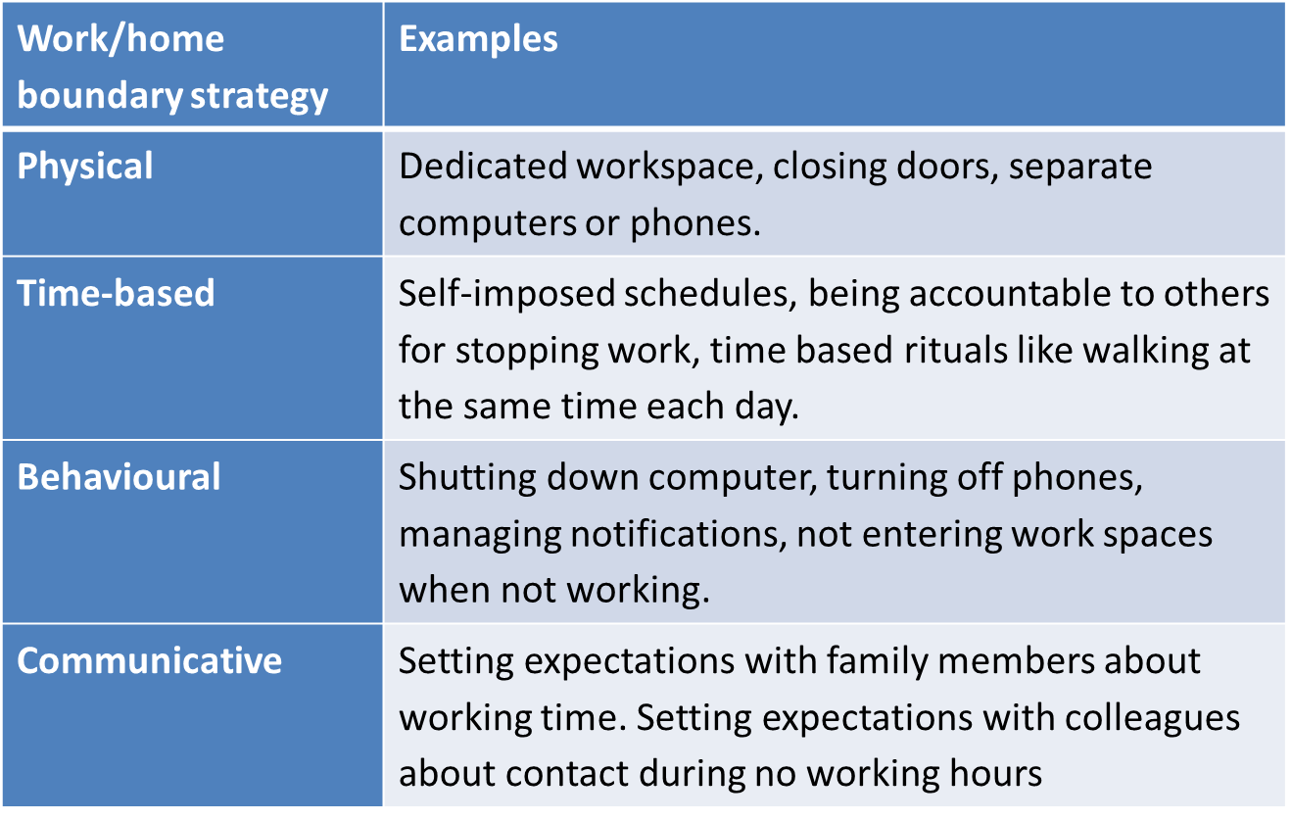

Reminder of sources of support:

Managing and supporting remote workers: a guide for line managers | Guides | CIPD

Work life balance webinar on the SLD Training Catalogue calendar

Supporting Wellbeing | Directorate of Human Resources | StaffNet | The University of Manchester

Summary: Personnel Today found in fact, when implemented effectively, wellbeing programmes can see an 80% improvement in performance. Organisations that make a commitment to employee wellbeing can also expect a similar return in areas such as resilience and enhanced positive regard for the employer.

Checkpoint
Q: What will you do differently to ensure your teams wellbeing
when Hybrid Working? What considerations can you think of for
different groups of people?

Post Learning

Coping with uncertainty L&D Toolkit 3.40mins

Who moved my cheese (Change and Wellbeing) Dr Spencer Johnson 12.08mins

Summary

We’ve used the Trust Model as a guide for managers to consider some of the skills required to ensure Hybrid Working is a success during this experiment. A review will tell us more in August 2022

As managers we need to also consider John Adair’s principles ensuring we address the needs of Task Team Individual. You can seek out area’s you need to develop further using some of the links / suggestions provided and by exploring our webpages:

Staff Learning and Development | StaffNet | The University of Manchester

Working UoM Policy and Procedures

Hybrid Working

