General Risk Assessment Form

Date:  [insert date] | Assessed by:  [insert assessor] | Checked / Validated* by:  [insert lab/project PI]  Karen Theis  Cath Davies | Location:  Royce Hub Building  [insert lab numbers] | Assessment ref no  Royce_ Labs_(Floor x)_Covid Lab RA_[lab PI]_v1.0 | Review date:  Three weeks or sooner.
Task / premises:
Managing risk of COVID-19 transmission for workers in [insert lab numbers] in Royce Hub Building. Max occupancy for [lab number] is x (25%) and max occupancy for [lab number] is x (25%). Once the labs have been approved for opening, a poster will be placed on the lab door displaying the maximum occupancy. Maximum occupancy of the lab must not be exceeded.

This risk assessment is in addition to the Royce Hub Building_Risk Assessment_General COVID19 measures_v1.4 which must be read and signed and a copy placed in the lab.

- The sections below detail building specific controls and laboratory specific controls.
- There is further information related to personal protective equipment and general information.
- A separate specific risk assessment must be completed for any further hazards not covered by this generic risk assessment e.g. lone working and supervision.
- Responsible persons/supervisor/manager should cross reference this generic risk assessment and the relevant pre-existing local risk assessments to confirm compliance with all relevant risk assessments.

Activity | Hazard | Who might be harmed and how | Existing measures to control risk | Risk rating | Result
AUTHORISED WORKER REQUIREMENTS
Pre-work planning | Transmission of  COVID-19 | Anyone present  COVID-19, through close contact or the contact with surfaces which may have been contaminated | - All staff and students to inform the University (following current procedure for online reporting) and self-isolate if they display symptoms of COVID-19 or have been advised via contact tracing that they must self-isolate.  - All staff and students will read Campus Reopening and Corporate Support Guidance prior to attending site.  - All staff and students will be given specific instructions on where their work and rest areas are (within a single building).  - Maximum occupancy of each room will be achieved via users booking space on the [insert name of booking system] booking system. Specific maximum room occupancies for each laboratory are detailed in the attached documentation. When on site, users must also refer to lab door signage for occupancy information.  - [How are the labs organised – do all users use all labs or are they separated]. As such, all users included on the team log can access laboratories 7am-7pm Monday to Friday, subject to room and equipment bookings (to ensure room capacity is not exceeded). | Med | A
On-site requirements | Transmission of  COVID-19 |  | - Public transport is used according to national guidelines, but own transport is recommended. If using public transport, mandatory face coverings will be worn.  - All staff and students authorised to come on site must have their university card with them at all times and have had their card activated. Users must not allow tailgating or lend out swipe card  - Users will be alert to suspicious activity on or around campus and inform Security immediately on 0161 306 9966 should any concerns arise.  - All staff and students must maintain 2m social distancing at all times.  - All staff and students, on entry to the building, will use hand sanitiser or wash their hands and continue to wash or sanitise regularly and before leaving the building.  - All staff and students to follow the one-way system put in place.  - All staff and students to clean down their workspace before and after use or at the end of the day  - All staff and students authorised to come on site must complete and have recorded a return to campus induction and a local area induction.  - Movements are limited to the designated areas in the building plus nearest designated welfare facilities.  - Chemistry and Schuster stores are currently open and will email the recipient when the item has been delivered. To request items from Stores, please send an email. When Royce stores are up and running then items can be delivered here. Again, you will be informed by email when the item has arrived. | Med | A
BUILDING ARRANGEMENTS
Coming to work and leaving work  Moving around buildings | Transmission of  COVID-19 | Anyone present  COVID-19, through close contact or the contact with surfaces which may have been contaminated | - Estates and the Institute reopening group will complete a building checklist/risk assessment to sign off the building.  - A one-way circulation system has been installed around the building and at entry and exit points. This will be communicated at the building induction and reinforced at the local laboratory induction. Individual routes for the laboratories have been demonstrated in this document. Where there is two way travel please ensure that you keep left or wait until the path is clear.  - Signage and instructions displayed around the building should be followed.  - Access to the building is restricted to those with approved access via card control.  - The building will be operational and open between 7am and 7pm. All operations will be kept within these times.  - The laboratory and rest areas have been added to the list of rooms in use to ensure cleaning schedules for Estates managed areas are adapted.  - All research to start will be authorised first by the Head of School via CEO of Institute.  - On arrival and on exiting a building people must sanitize or wash their hands following government guidance on doing so.  - Face coverings must be worn in all communal areas when indoors, and are recommended for use in outdoor spaces, except where medical exemption applies  - Passenger lifts are subject to occupancy limits. Use the stairs where possible, or adhere to signage for lift capacity.  - Toilets are single occupancy only. Research groups to use the facilities on their floor to reduce risk of transfer of covid to other building users.  - The kitchen areas are located in the Floor 3 community hubs. If area around sink/fridge is being used then the next user must wait until this area is clear. There will be access to hot and cold water, a fridge and a microwave. Users must bring their own food for breaks. Do not use any communal cutlery or crockery.  - Individuals will need to declare their arrival and departure from the building with their group, arrangements need to be in place to facilitate this. Users must use the ‘buddy system’ to ensure team members and PI know when the user has arrived and left site.  - People must wash or sanitize their hands every time they enter or leave a laboratory or office space following government guidance on doing so. | Med | A
Common areas | Transmission of  COVID-19 | Anyone present  COVID-19, through close contact or the contact with surfaces which may have been contaminated | - 2m distancing should be maintained at all times.  - Outside areas should be used for breaks where possible.  - Face coverings must be worn in all communal areas when indoors, and are recommended for use in outdoor spaces, except where medical exemption applies  - Users encouraged to bring prepared food from home and to remain on-site (fridges are available). When not possible, maintain social distancing while off-site.  - The kitchen areas are located in the 3rd floor community hubs. If area around sink/fridge is being used then the next user must wait until this area is clear. There will be access to hot and cold water, a fridge and a microwave. Users must bring their own food for breaks. Do not use any communal cutlery or crockery.  - Only eat in designated areas i.e. mezzanine and 3rd floor community hub areas. Tables with a single seat have been set up so that users can take a break and maintain the required 2m distance. Do not exceed the max occupancy of the area. All lab users will be given information on usage of shared areas at induction (via zoom) Users will only use areas that have been opened for use and have been specifically designated for them, they will not travel to other parts of the building.  - All items that have been touched in communal area should be sanitised by the user. User will be required to clean down the space before and after use. Cleaning products will be available. | Med | A
Coming into work | Working with minimal support on campus | Staff/students/others authorised to work on site  Vulnerable when lone working | - Rota has been scheduled to avoid lone working  - Individuals should check in / out with their team leader. All users are to sign in and out of the Royce Hub Building so that the duty Operational Compliance Supervisor is aware of the number of staff/students in the building at any given time.  - There will be a poster in the reception area of the Royce Hub Building that will display the details of the OCS on duty and the on duty first aider for the building. Users must make a note of this on entry. The OCS/first aider will be on duty from 8am to 5pm Monday to Friday.  - Limit movement to the designated areas in the building plus nearest designated welfare facilities. Lab areas on all other floors are out of bounds for users of the Floor [x] lab facilities. Access to Floors 2 and 6 is prohibited as they are still under Contractor control. Sections of the Floor 5 lab area will also be out of bounds to lab users as they are still under BBK control – these areas will be cordoned off and signage will be in place.  - Be alert to suspicious activity on or around campus, inform Security immediately on 0161 306 9966. | Med | A
Meetings / desk-based activities. | Transmission of  COVID-19 | Anyone present  COVID-19, through close contact or the contact with surfaces which may have been contaminated | - Users will work from home whenever possible.  - Meetings will be held remotely.  - Desk work will only be carried out during breaks from laboratory work as users should leave the building once laboratory work is complete.  - On arrival and on exiting people will sanitise or wash their hands following government guidance on doing so. Posters are available to build awareness of good handwashing technique.  - Display Screen Equipment (DSE) requirements associated with equipment should be assessed if prolonged use is necessary – seek advice from the Display Screen Equipment Safety Advisor Julia Lawson. Users should take a break for ten minutes every hour and ensure that they re-focus their eyes away from the screen frequently. Users must also ensure that they adjust their seat so that it is comfortable for the user. General office work should be carried out at home.  - The layout of the space has been reviewed to enable the maintenance of 2m social distancing.  - Users are designated individually assigned seats/workspaces reconfigured as necessary, to maintain spacing and reduce face-to-face interactions.  - Circulation routes through the space have been defined to maintain social distancing and included on an overall floorplan for the space.  - One-way systems for access and egress to the space have been assessed and applied where possible. In areas which require two way travel, users should check through the door vision panels that spaces are clear before entering and that a 2m distance can be maintained.  - Floor and workspace signage will be installed to help people maintain social distancing.  - Break times are staggered and planned so that users remain within their designated group/bubble and do not interact with others.  - Minimise use of high-touch items and shared office equipment (e.g. printers). All touched items should be sanitised before and after use.  - Users will clean work/rest spaces between different occupants including shared equipment as per Faculty guidance. | Med | A
Accidents, security and other incidents | Transmission of  COVID-19 | Anyone present  COVID-19, through close contact or the contact with surfaces which may have been contaminated | - First aid and Operational Compliance Supervisor cover will be displayed at the building entrance.  - First aiders have been given guidance on additional precautions to take due to COVID 19 and provided with any necessary additional PPE.  - In the event of a need for building evacuation for example, a chemical spill, fire or break-in, the priority is to leave as quickly as possible via the nearest and most direct fire exit route. In the event of an emergency all one way routes are revoked and user is to evacuate via the nearest emergency exit route.  - Staff or students may need to break social distancing rules during an emergency. This is acceptable for a short period of time e.g. while evacuating out of a building.  - Once outside, people should wait at the designated assembly points and ensure at least 2 metre social distancing.  - All accidents and incidents must be reported to the Operational Compliance Supervisor.  - It is important that users keep to their designated areas and do not mix. | Med | A
Cleaning the workplace | Transmission of COVID-19 | Anyone present  COVID-19, through close contact or the contact with surfaces which may have been contaminated | - Keeping the workplace clean by users  - Workspaces that are opened (labs and rest spaces) to be thoroughly cleaned before and after work.  - Frequent cleaning of work areas and equipment between uses  - Frequent cleaning of objects and surfaces that are touched  - Clearing workspaces and remove waste to external bins at the end of each work session/day.  Faculty guidance will be followed to complete these cleaning tasks.  - Keeping the workplace clean by House Services  - Posters to build awareness of good handwashing technique  - Only one person in the toilet or marked out kitchen area at any one time  - Enhanced cleaning of busy areas.  - Report to Operational Compliance Supervisor any welfare facilities that require additional cleaning products. | Med | A
LABORATORY SPECIFIC ARRANGEMENTS
Lab 5.006/5.007 | Transmission of  COVID-19 | Anyone present  COVID-19, through close contact with other people, or the contact with surfaces which may have been contaminated | - The max occupancy certificate will be placed on laboratory entrance door once approval for opening has been given.  - The responsible person has completed a Laboratory Team Log form for each individual or team returning which will be sent to FLT via CEO of Institute. An on-duty Team Leader for each team has been identified.  - Maximum occupancy of lab will be achieved via users booking space [insert booking system] booking system. Specific maximum room occupancies for each laboratory are detailed in the attached documentation. When onsite, users must also refer to lab door signage for occupancy information.  - Work is restricted 7am-7pm, so the possibility of lone working in Henry Royce Institute is low. Where lone working is authorised on a risk assessment and is to take place, users must use the ‘buddy system’ to ensure team members and PI know when the user has arrived and left site.  - The responsible person has completed a PI Laboratory Checklist form for each area being re-opened and sent to SLT via CEO of Institute.  - Once access to the laboratory is available, the responsible person will ensure that a checklist is completed to ensure that all equipment within the lab is safe to operate and all emergency measures are suitably in place.  - The responsible person has reviewed the laboratory circulation routes to ensure that social distancing is achievable wherever possible including one-way entry and exit systems. The circulation routes have been communicated to lab users in induction. Users MUST abide by the circulation routes, communicate with other lab users when in the lab (particularly where there are identified ‘pinch points’, and on entrance and exit from the room), and seek clarification from PI/other responsible person if there is any uncertainty about lab circulation routes. A copy of circulation route information is attached to this assessment.  - The responsible person has reviewed the workstation layout to ensure that social distancing is achievable wherever possible with useable and non-useable workstations marked out.  - Team log with occupancy of the laboratory will be displayed on the lab door and be reviewed regularly, along with contact details of the responsible person. All users MUST adhere to the room occupancies and raise any safety concerns with the responsible person.  - All team members will undertake the online fire marshal training.  - Signage will be installed to highlight the circulation routes and workstation usage.  - Workstations will be assigned to individuals and not shared.  - No activity in these labs should require workers to be closer than 2m.  - All existing activity risk assessments will be reviewed to ensure compatibility with this risk assessment. Any significant findings will be recorded. Prior commencing work, users must ensure that they have either updated or read and confirmed that all activity risk assessments control COVID-19 related risks. prior to commencing work  - All lab users will receive a specific laboratory induction to incorporate COVID-19 measures into existing induction information. This will take place via Zoom with [insert name of person carrying out lab inductions].  - Users should wash or sanitise their hands thoroughly when entering and exiting the laboratory. Users must let the team leader know if there are issues with handwashing facilities.  - A cleaning regime is in place (with record keeping) for equipment, high touch surfaces/items and workstations to be cleaned frequently and at the start and end of the work session/day. Following the FSE cleaning guidance “FSE - General Cleaning in the Workplace to Prevent Transmission of Covid-19” For Shaver laboratories, the schedule and procedures will be communicated on induction and displayed on the inside of each laboratory.  - General waste will be removed to the external bins at the end of each work session/day by the lab users. Tiger and hazardous solid waste will be placed in designated laboratory bins. Laboratory staff will empty the bins as required.  - The laboratory will meet and maintain high housekeeping standards prior to and during opening to enable activities to resume safely and so that surfaces/equipment can be easily cleaned after use.  - Be mindful of other users in the laboratory and ask people/give way to people whilst navigating the fumehood/bench areas, always ensuring that a 2m social distance is maintained at all times. When moving between labs, check through the windows in the doors to ensure that a 2m social distance is maintained at all times and that the max occupancy of the lab will not be exceeded.  - Barriers are in place to separate UoM controlled areas and contractor controlled areas. UoM personnel are not to cross the barriers without prior express agreement and arrangement with Dr Dan Tate (e.g. to move cylinders, requiring the use of the goods lift, which is located in a contractor controlled area).  - When not required to be in the laboratory users will move to designated rest points.  - Users will leave site upon completion of laboratory work.  - Rapid shutdown procedures must be in place, in preparation for campus shut down or an individual team needs to self-isolate due to a member becoming symptomatic or being in contact with someone else who is symptomatic. The labs [insert lab numbers] have a shutdown procedure and checklist. This is circulated at induction and is regularly reviewed. All users are expected to immediately cease work and aid shutdown procedures where it is identified that shutdown must occur. | Med | A
PERSONAL PROTECTIVE EQUIPMENT
Personal Protective Equipment | Transmission of  COVID-19 | Anyone present  COVID-19, through close contact or the contact with surfaces which may have been contaminated | - Disposable face coverings must be worn in labs at all times, except where risk assessment shows that the use of a face covering increases risk or if user is exempt. Disposable face coverings should be changed every 4 hours or when they become damp or suspected of being contaminated. If a specific activity is to be carried out requiring additional PPE that may be affected by the wearing of the mask then a separate risk assessment must be carried out. This will determine whether it is safe to continue wearing the face covering or if this will negatively impact the additional PPE, this will include activities such as the use of hazardous chemicals and substances where safety glasses, dust masks or RPE may be required.  - Where PPE is already specified for a work activity to protect against non-COVID-19 risks, this will continue.  - Primary source of PPE will be sourced from Stores.  - All PPE (lab coats, safety eyewear) will be assigned to an individual and not be shared.  - Lab coats may be left within the individual workstations where safe to do so until the end of the session/day. Where this is not possible, individuals will store their PPE in a clear plastic bag, with users name clearly displayed, and stored in a laboratory cupboard.  - Shared PPE (heat resistant gloves, cryogloves) must only be worn after first donning clean nitrile gloves. Individuals must refrain from touching face/hair/skin/mouth once wearing the shared PPE. Once outer gloves are removed, the nitrile gloves must be discarded. If the gloves become potentially contaminated, they should sprayed with 70% IMS, allowed to dry and then be placed in a plastic bag and stored for 72 hours at room temperature.  - Shared PPE (face visors) must only be worn after first donning clean nitrile gloves. Individuals must wipe the visor before and after use with 70% IMS, paying particular attention to the headband and inside surface of the visor. Nitrile gloves must be discarded after removing the visor  - Safety glasses will be kept with the individual so that they can be utilised on entering the laboratory although they should be cleaned regularly to prevent contamination from both chemicals and COVID-19. | Med | A

Action plan (14)
Ref No | Further action required | Action by whom | Action by when | Done
1 | Personal risk assessment may be required and completed by the line manager due to any positive answers in self-declaration forms. | Line manager / academic supervisor | Prior to operation
3 | Academic supervisor for the group to complete the Academic Supervisors’ Health and Safety online training if required. | Academic Supervisor | Prior to operation
4 | Additional risk assessment to address any other hazards, such as working <2m with another person | Line Manager / academic supervisor | Prior to operation

Floor 5, Royce Hub Building: CIRCULATION INFORMATION
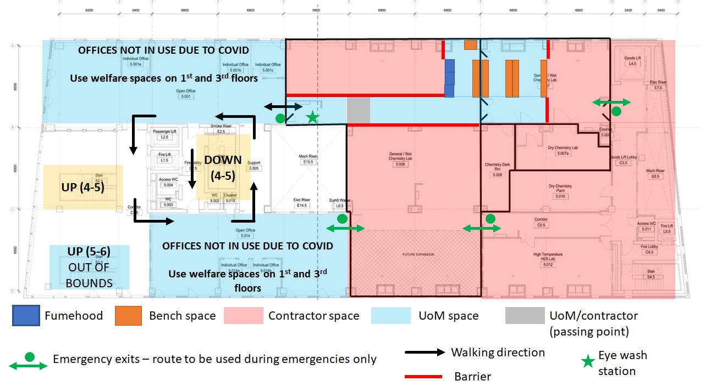

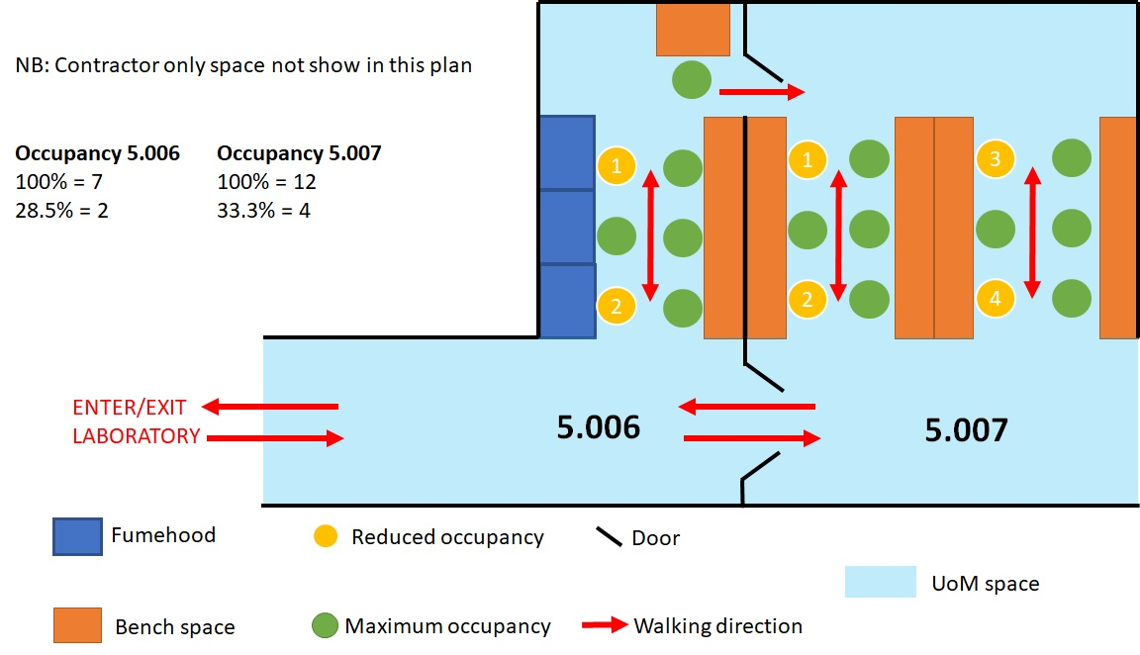
Be mindful of other users in the laboratory and ask people to move/give way to people whilst navigating the fumehood/bench areas, always ensuring that a 2m social distance is maintained at all times. When moving between 5.006 and 5.007, check through the windows in the doors to ensure that a 2m social distance is maintained at all times and that lab occupancy is not exceeded.

